|  |  |
| --- | --- |
|  | **FPT ACADEMY INTERNATIONAL**  **FPT - APTECH COMPUTER EDUCATION** |

***RESORT MANAGEMENT***

|  |  |  |  |
| --- | --- | --- | --- |
| **Center Name** | | ACE-HCMC-2-FPT  Address: 590 Cach Mang Thang Tam, District 3, HCMC, Vietnam. | |
| **Instructor** | | Mr. Tran Phuoc Sinh | |
| **Class** | | T1.1809.A0 | |
| **Group** | | 02 | |
| **Group members** | | **Name** | **Student ID** |
| Trinh Thiem Bao | Student1141125 |
| Ly Thi Thuy Tien | Student1140017 |
| Nguyen Quoc Thai | Student1140019 |
| **Duration** | **Start date** | July 08th 2020 | |
| **End date** | August 07th 2020 | |

This is to certify that

Mr. Trinh Thiem Bao

Mrs. Ly Thi Thuy Tien

Mr. Nguyen Quoc Thai



have successfully designed and

developed 

Submitted by:

Date of Issue: July 08th 2020 07________

Authorized Signature: ___________

**Mr. Tran Phuoc Sinh**Mr. Tran Phuoc Sinh


**Table of Contents**

REVIEW 1 4

**I. ACKNOWLEDGEMENT 5**

**II. PROBLEM DEFINITION 6**

**III. REQUIREMENT SPECIFICATION 6**

**IV. System REQUIREMENT SPECIFICATIONS 7**

1. Server requirements 7

2. Client requirements: 7

3. Technology : 7

REVIEW 2 10

**I. ARCHITECTURE & DESIGN OF THE PROJECT** *11*

1. Web Tier 11

2. Enterprise Tier 12

**II. USE CASE DIAGRAMS** 12

3. Admin use case 12

4. Employee use case 13

5. User use case 14

**REVIEW 1**

## ACKNOWLEDGEMENT

We would like to acknowledge all those who have given support and help us make the project a success .

We wish to express our deep gratitude to all teachers who have been devoting their lives to teach us how to stand-alone and walk ahead .

We are grateful to our families who take care and encourage us even though we are successful or failed, also to our friends who are always care of us. They never leave us alone and always look forward to us when we are on any road of the life .

We are much thankful to the entire staff and chairpersons at the Head Office of Aptech Worldwide, Aptech – Vietnam, and FPT – Aptech Center who have been organizing and looking after our studying course .

There are no words to show our appreciation for teachers of FPT Aptech Centre who have been organizing and looking after us during our studying course to finish this project. Our special thanks Mr Tran Phuoc Sinh who works day by day to teach and guide us, e-Project Team at the Head Office who instruct and help us .

Finally, we would like to offer many thanks to all our schoolfellows for their valuable suggestions .

We would like to thank sincerely !

## PROBLEM DEFINITION

1. **Introduction**
2. Haven Deluxe is an application site where users can choose to book rooms and resort services online. After authentication, we will send users a QRCode to check in at the resort .
3. Haven Deluxe is the perfect choice for consumers who don't have time to book and the services needed to enjoy the holiday.

## REQUIREMENT SPECIFICATION

1. **WEBSITE:**
2. The website must contain all rooms in the resort and entertainment services..
3. The homepage must be well designed and formatted with all navigation links, appropriate headers and footers of the site, Links to login in the site.
4. It should contain links such as Booking, Services ,Location , About Us, Cart, sign in and Sign up for new customers.
5. **ADMIN:**
6. Administrators can delete all Item (no longer active)
7. Administrators can create accounts (including employee and customer accounts), change any account status to active or inactive (except for Administrator accounts that can only be edited ).
8. Administrators can create, update and delete information in the pages About Us, Service, Location and Rooms.
9. Administrators are the only ones who can delete feedback from users.
10. Administrators can delete orders, change order status.
11. **EMPLOYEE:**
12. Employee is checking customer information .
13. Employees can activate QRCode of customers .
14. The employee can read the order and change the status of the order after verification (verification, payment) .
15. **USER (not logged in):**
16. Users can view rooms, entertainment services.
17. Users can send feedback to the store.
18. Users can register for a new account.
19. **USER (logged in):** 
    * 1. The user can do anything like a User that is not logged in .
      2. Users of their payment history.
      3. Users can add, edit and delete accessories from the cart.
20. **Note:** Constraint validation must be provided wherever necessary. And the website should have the smooth navigations.

## System REQUIREMENT SPECIFICATIONS

### Server requirements

* Hardware:

|  |  |
| --- | --- |
| Component | Requirement |
| CPU | Processor type:  Pentium IV-compatible processor or faster  Processor speed:  Recommended: 2.0 GHz or faster |
| OS | Microsoft Windows XP or higher with IIS |
| Memory (RAM) | RAM: Minimum: 512 MB  Recommended: 2 GB or more |
| Hard Drive | Free space:  Minimum: 200 MB  Recommended: 50 GB or more  Maximum: Operating system maximum |

* Software:

|  |  |
| --- | --- |
| Component | Requirement |
| Microsoft .NET Framework | Version 4.5.1 |
| RDBMS | Microsoft SQL Server 2012 |

### Client requirements:

* Hardware:

|  |  |
| --- | --- |
| Component | Requirement |
| CPU | Processor type:  Pentium III-compatible processor or faster  Processor speed:  Recommended: 1.0 GHz or faster |
| OS | All OS (Window, Linux, Android, Mac OS …) |
| Memory (RAM) | RAM: Minimum: 512 MB  Recommended: 1 GB or more  Maximum: Operating system maximum |
| Hard Drive | Free space: Minimum: 10 MB |

* Software:

|  |  |
| --- | --- |
| Component | Requirement |
| Web Browser | IE 4.0, Firefox 3.0, Chrome or Higher…. |

**3.** T**echnology:** JPA, JSP-Servlet,Resful Service.

**Review I**

|  |  |  |  |  |  |  |  |  |
| --- | --- | --- | --- | --- | --- | --- | --- | --- |
| Project Ref. No.: | | Project Title: | Activity Plan Prepared By: | Date of Preparation of Activity Plan: | | | | |
| No. | Task | Actual Start Date | Actual Days | Teammate Names | Status |
| 1 | Acknowledgement | Resort Management | Nguyen Quoc Thai | 08/07/2020 | 1 | All member | Completed |
| 2 | Problem Definition | 08/07/2020 | 1 | All member | Completed |
| 3 | Requirement Specification | 08/07/2020 | 1 | All member | Completed |
| 4 | Task sheet review | 08/07/2020 | 1 | All member | Completed |

|  |  |
| --- | --- |
| **Date: 08/07/2020** | |
| Signature of Instructor:  **Mr. Tran Phuoc Sinh** | Signature of Team Leader:  **Trinh Thiem Bao** |

**REVIEW 2**

## ARCHITECTURE & DESIGN OF THE PROJECT

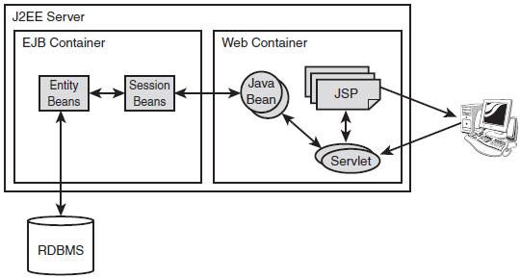

1. **Web Tier :**

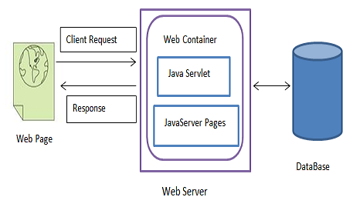

* + Technology: JSP- Servlet
  + Model- This level is responsible for all kinds of business logic operations. It has the classes which have the connection with the database .
  + View- This is the presentation layer which consists of HTML, JSP pages. This layer is responsible for displaying the application’s output to the end users.
  + Controller- This layer handles the HTTP requests and sends to the appropriate . Model layer for data processing, and once the data are processed and sent back to the controller and then displayed on the View layer .

### Enterprise Tier :

* Techology: Resful Webservice, JPA .
* RESTful Web Services are Web Services written based on the REST architecture. REST has been widely used as an alternative to SOAP and WSDL-based Web Services. RESTful Web Service is lightweight (lightweigh), easy to extend and maintain .
* Java Persistence API (JPA) is a source to store business entities as relational entities. It shows how to define a PLAIN OLD JAVA OBJECT (POJO) as an entity and how to manage entities with relations .

## USE CASE DIAGRAMS :

### Admin use case :

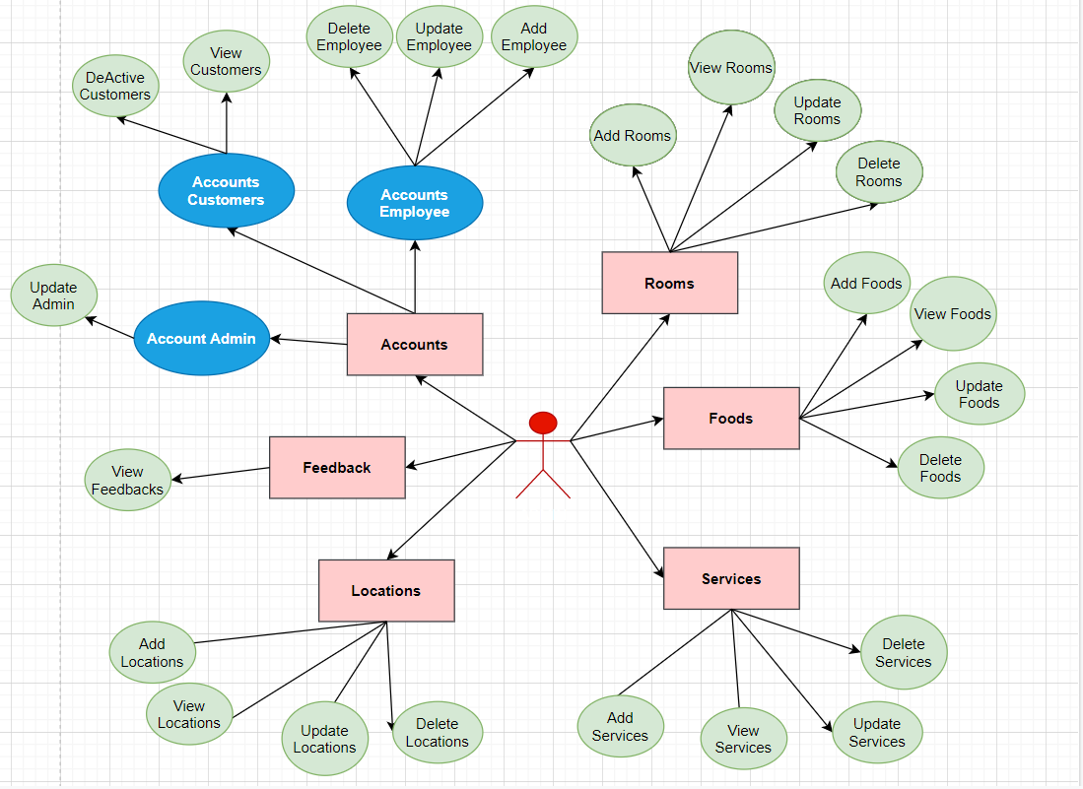

### Employee use case :

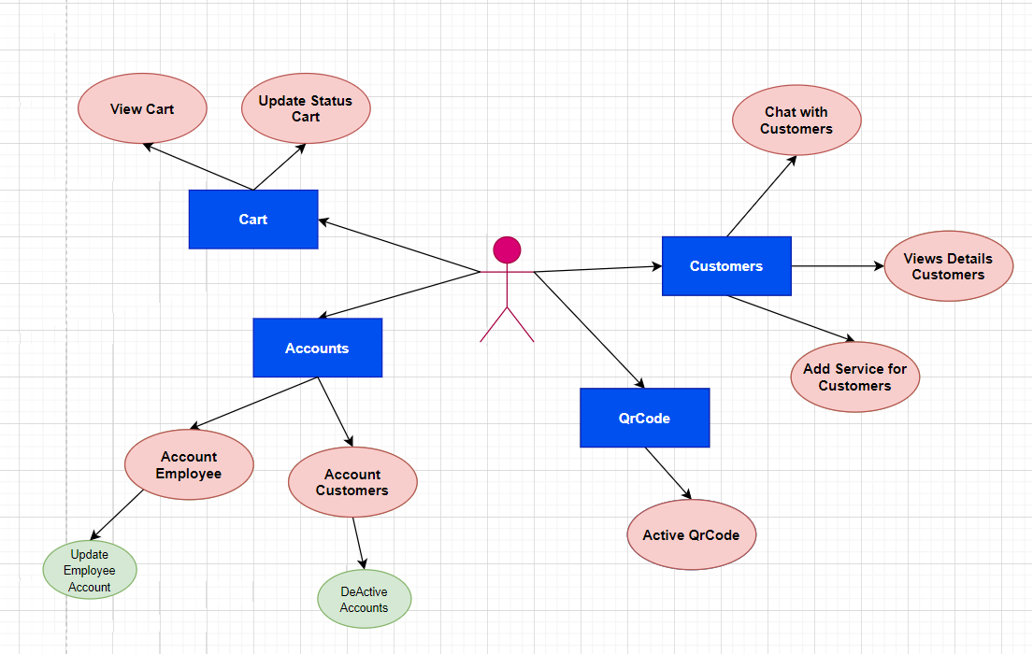

### User use case :

