1.Software Figure2图片替换
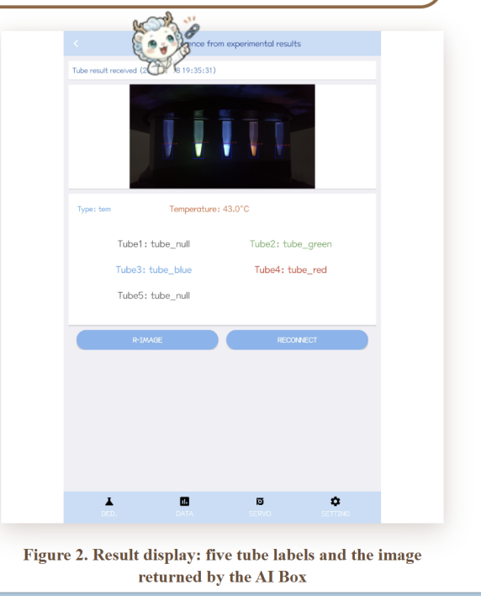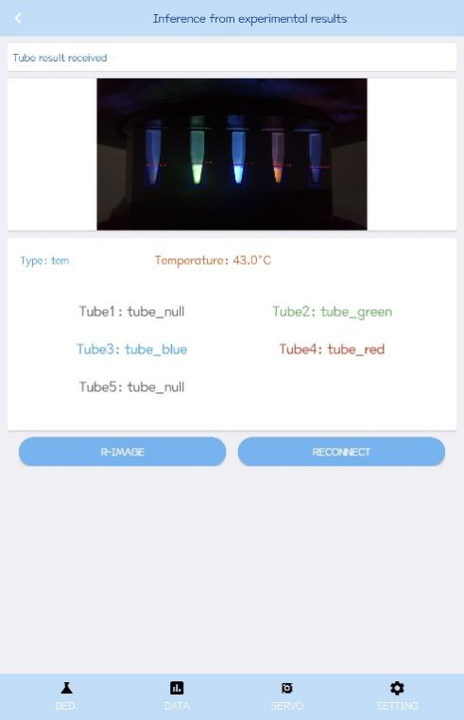
2.Hardware
(1)table1.这句话删掉
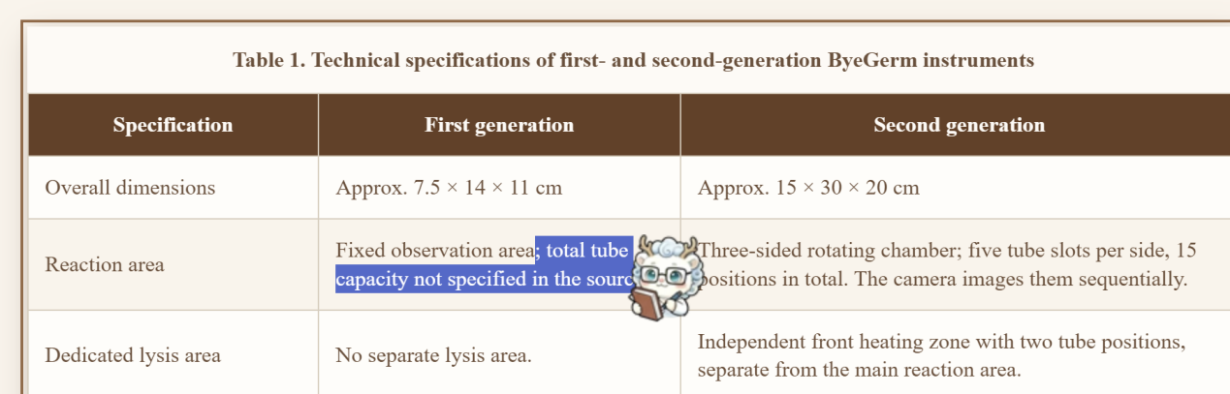
改为：Fixed observation area.
(2) 这段话更改：
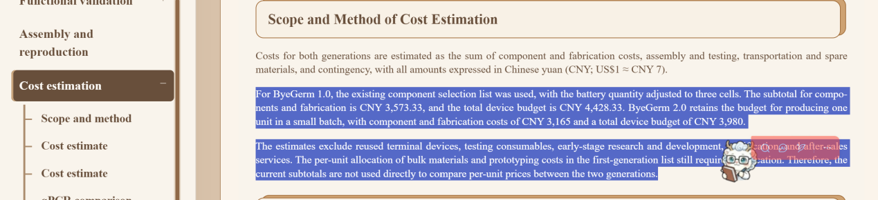第二段：For ByeGerm 1.0, the subtotal for components and manufacturing costs is 3,573.33 RMB, with a total equipment budget of 4,428.33 RMB. For ByeGerm 2.0, the components and manufacturing costs amount to 3,165 RMB, with a total equipment budget of 3,980 RMB.
第三段：The estimates do not include reused terminal equipment, test consumables, early-stage R&D, certification, or after-sales services.
（3）这几段高亮的话整段删掉