1.overview
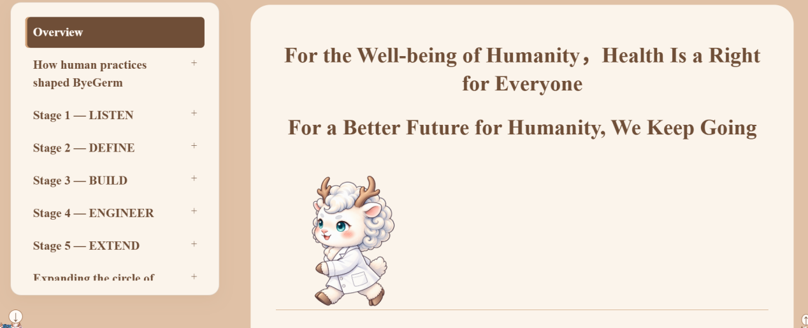
现在的白泽和文字有些大，要求二者在一行。不要单独再放一个框内，放在第一个框的结尾，和overview在一个框内，字放在白泽后面，随滑动一起从右向左，文字排布方式见ppt图2
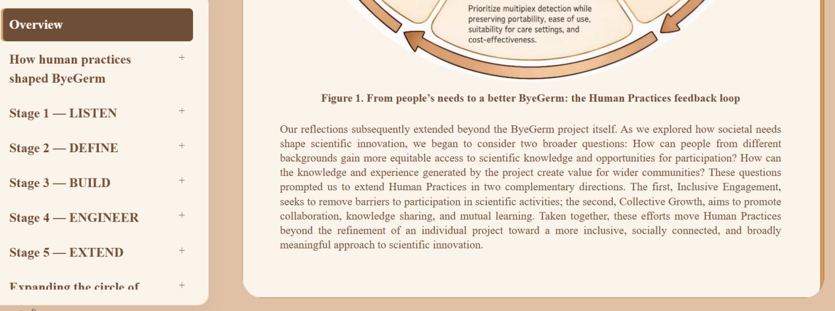
放在这段文字的下面即可，不单独放框。

2.去掉Expanding板块的collective growth的overwiew这个词和地球图标和外框
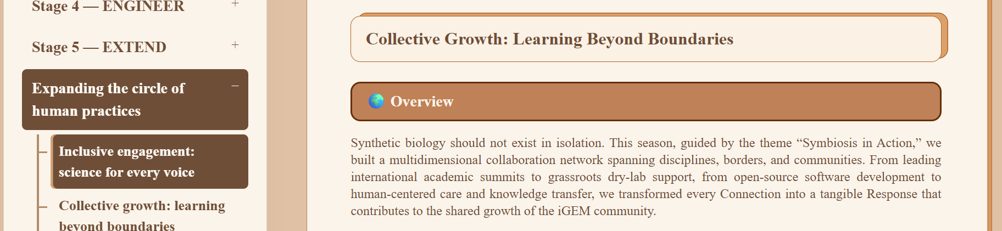
3overview的770对应的框和其他不一样大，保持大小一致，参照ppt图2
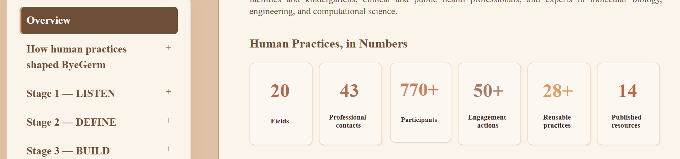
4.Summary的图标图注
5.网页中summary第一个图下面的context和iteration前面的小图标看不见，显露出来，参照ppt中图1
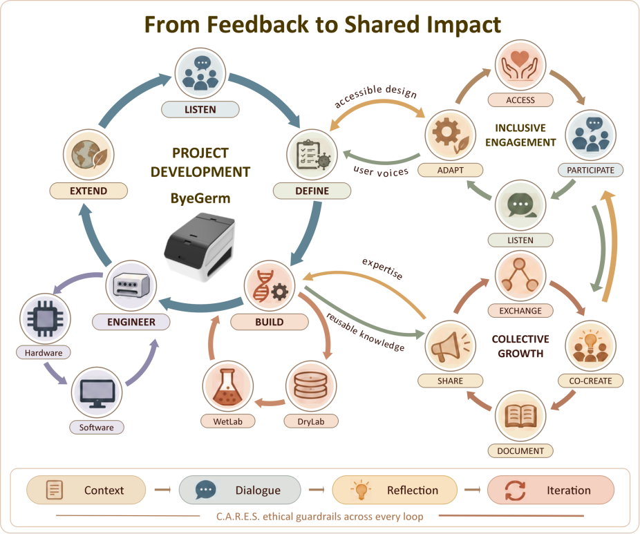
6.stage2访谈提到的五种病原体全称斜体，缩写不斜体，整体校正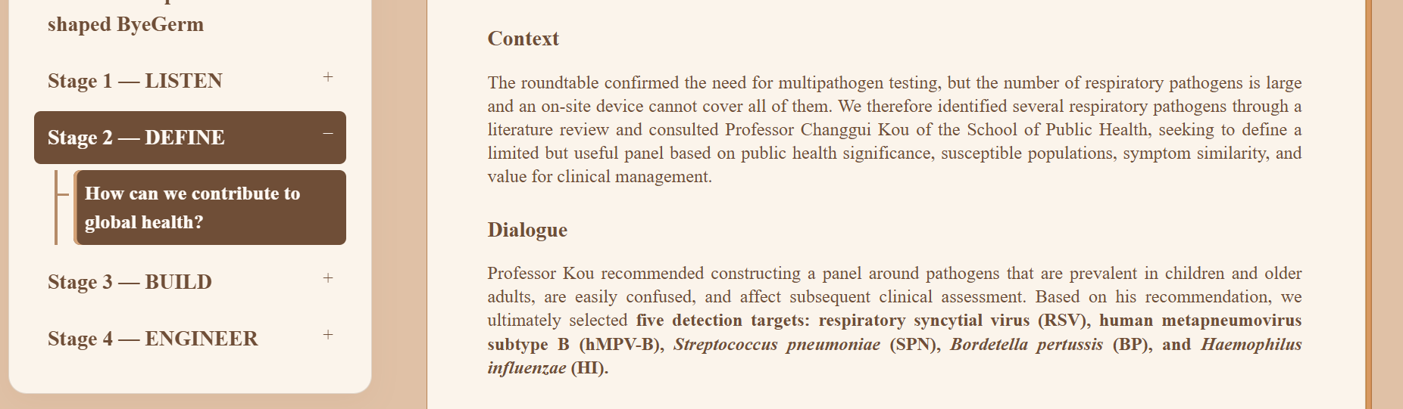
7.stakeholder strategy开篇这段话结尾加上：Click the four steps to explore！ 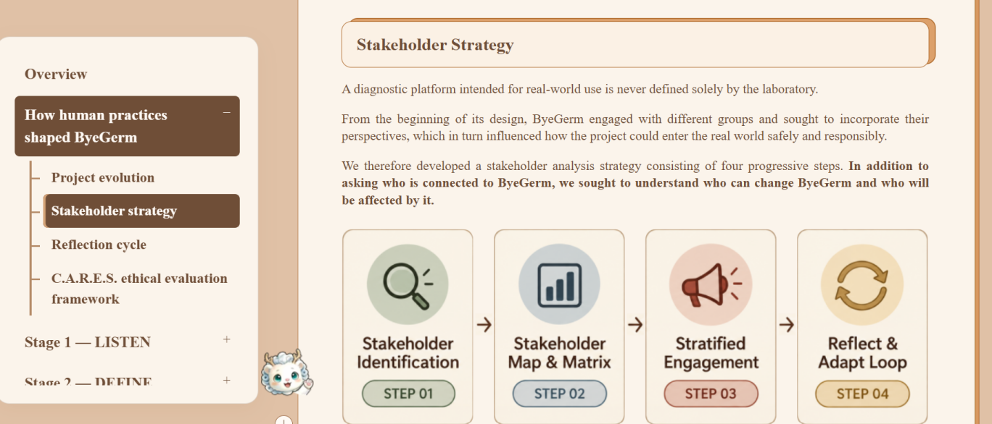
8.overview部分这段格言，框大小和字体大小都很完美保持不变，这句话的排版变成这样：，for everyone放在下一行，都居中，who向右对齐，
“Health is a human right, not a privilege,
for everyone, everywhere.”

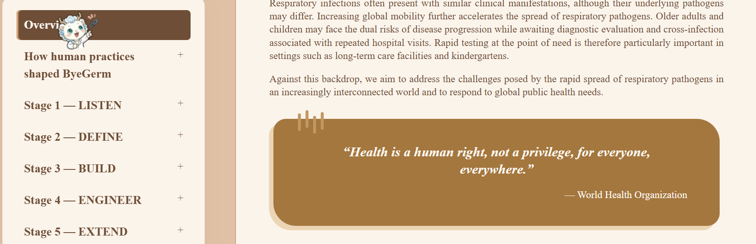
9.同时overview棕色框左下角放一个小图标，和网页底部的图标一致，不需要做动画效果，放置位置参考图见ppt的第四页，记得抠图，只要白泽图案不要周围那个棕色边框，白泽图案可适当调节大小，不要遮挡字体。

10.summary内的二级标题的边框都去掉，保留原文字内容，不设置边框
11.figure71照片换成：

12.How Human Practices Shaped ByeGerm
的project evolution中explore the activities下面的文字改成：

Explore the activities
Click on each colorful circle! Each color represents a different type of activity. You'll find exciting photos from our events, and you can flip them to reveal a brief description of the activity.
You can also click on the glowing test tubes and ByeGerm to discover how IHP has contributed to other teams and helped drive the project forward!
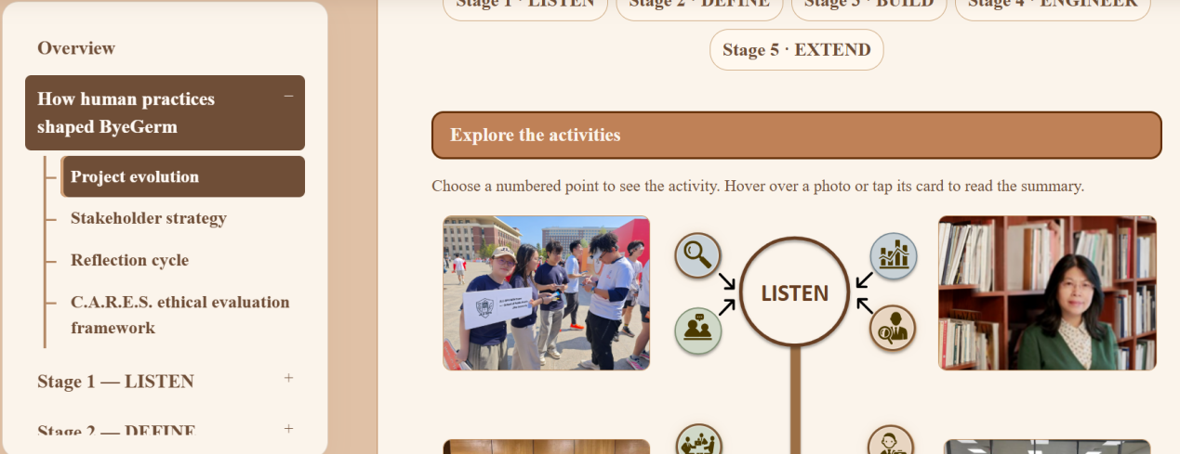
13.在listen右下角的棕色图标右下角（鼠标所在位置）放一个小图标，提醒人们去点击他，图标如下，不要太大，别遮挡其他内容，图标下面写很小的click


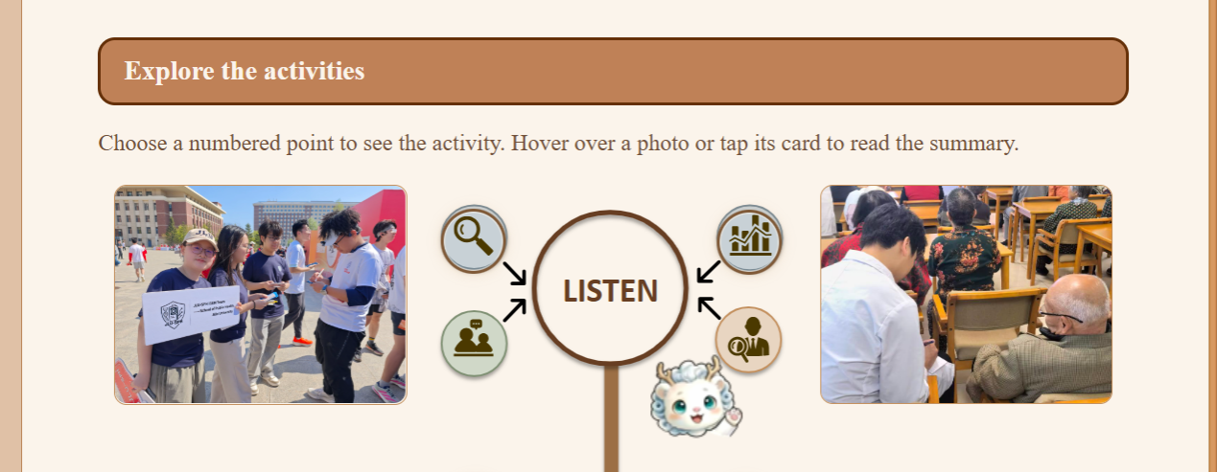
14,Project evolution开篇文字改为：

Project Evolution

From Questions to Decisions: How Human Practices Shaped ByeGerm
ByeGerm did not emerge fully formed from an initial blueprint; it gradually took shape through continuous dialogue with stakeholders, critical reflection, and successive responses to real-world needs.
Our Human Practices journey began with a fundamental question:
What Global Health Challenges Matter Most?
By listening to the experiences of patients, caregivers, and frontline professionals, we gradually identified the unmet needs of vulnerable populations and clarified the purpose of our project.
Please click the five questions to explore.
15.
Stage1开篇这段话所有文字直立，不要斜体
We responded to international public health needs by addressing the major challenge of rapid, on-site testing for emerging and acute infectious diseases. Through extensive surveys and interviews across Changchun, we identified respiratory infectious diseases as a critical public health issue and established the need for portable, intelligent monitoring. We then conducted targeted research with patients and high-risk populations, including older adults and young children, carried out random interviews in a hospital, and visited sentinel nursing homes and kindergartens in Changchun, where we learned about the difficulties vulnerable populations face in receiving treatment for infectious diseases. These findings motivated us to explore an intelligent platform for acute respiratory infectious disease detection that could perform rapid in vitro testing and automated analysis. In a subsequent interview with Professor Li Juan, Former Dean of the School of Public Health, Jilin University, we gained further insight, confirmed our research direction, and established the principles of multiplex testing in a single run, rapid testing in a single run, and testing accessible to everyone.
16.figure45和46的照片换成：

上图为45，下图为46
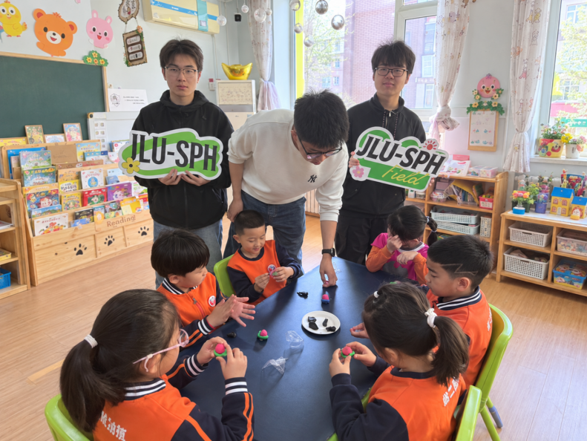
- figure71换成
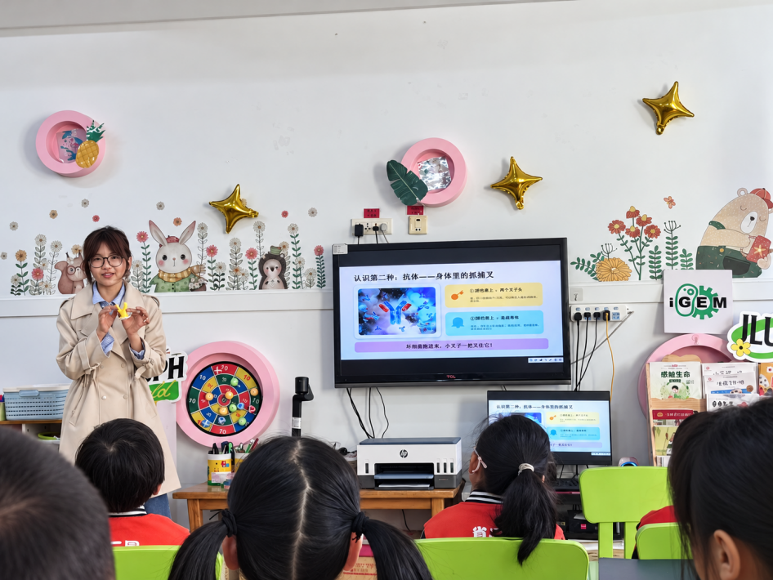
- figure1再小一点，直径小2cm

