CONSOLIDATED REPORT
Project Activity Records
29 core activity records, complemented by 16 inclusive-engagement and collective-growth activities.
45  TOTAL ACTIVITIES | 29  CORE ACTIVITIES | 16  EXTENDED ACTIVITIES
Breakdown by activity type · 29 core records
CATEGORY | ACTIVITIES | SHARE
Expert interview | 17 | 58.6%
Field visit | 5 | 17.2%
Voting | 3 | 10.3%
Presentation | 2 | 6.9%
Survey | 1 | 3.4%
Gamified engagement | 1 | 3.4%
Breakdown by project stage · 5 core stages
STAGE | FOCUS | COUNT
01 | Explore the Context (LISTEN) | 5
02 | Turn Needs into Requirements | 7
03 | Shape the Science (BUILD) | 4
04 | Turn Science into an Instrument | 7
05 | Share and Carry Forward (EXTEND) | 6
Sources: original activity register and “ihp文稿English.docx”. All descriptions were condensed to one sentence (20 words or fewer). New activities use original source photographs where available.

COMPLETE ACTIVITY REGISTER
Core records follow five project stages; additional activities are grouped under two complementary engagement themes.
Stage 01 Explore the Context (LISTEN)
01 Listening to the Public
SURVEY
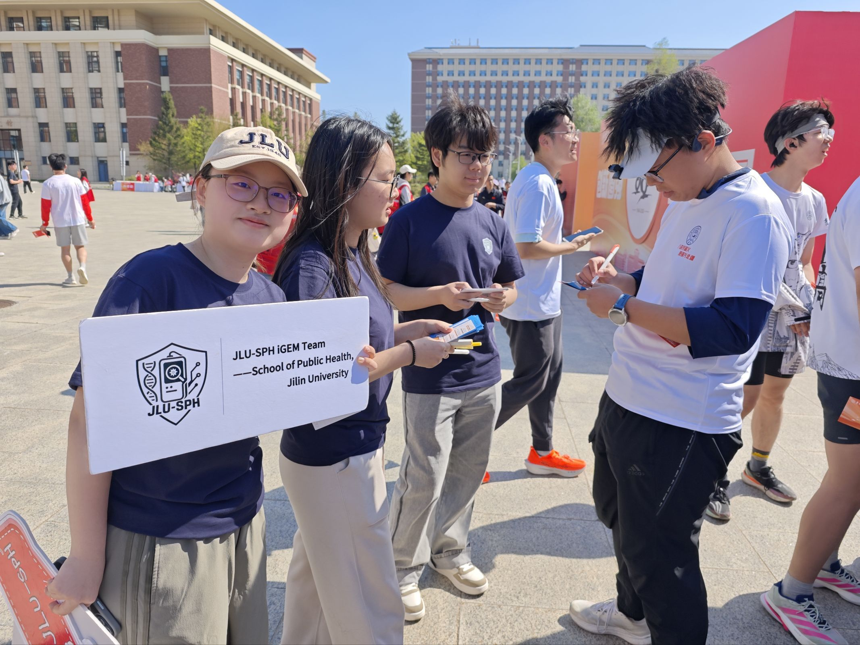 | Collected public feedback through surveys and interactive activities, revealing demand for portable respiratory pathogen testing.

02 Random Interviews at the Third Hospital of Harbin Medical University
FIELD VISIT
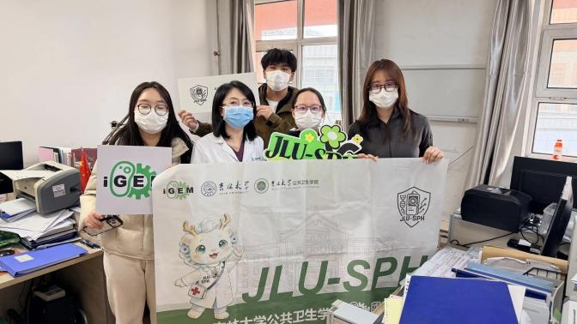 | Visited pediatric and geriatric departments, identifying mobility barriers and cross-infection risks that support local screening.

03 Interviews with Nursing Home Care Workers and Residents
SURVEY
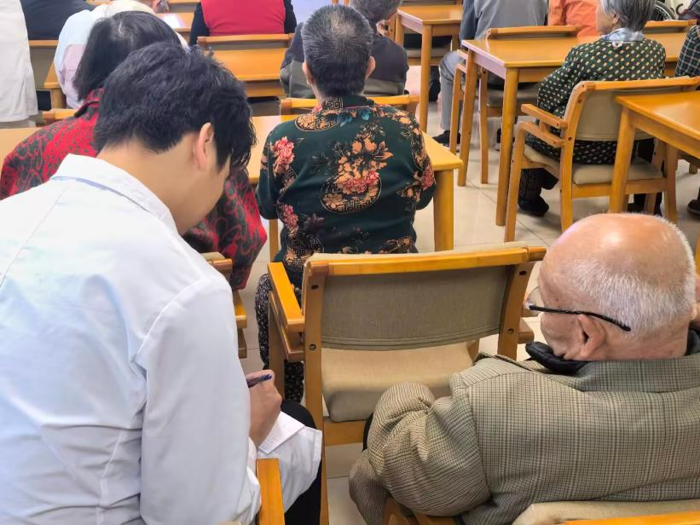 | Interviewed nursing home staff and residents, identifying the need for simple, rapid, on-site infection screening.

04 Interview with Interview with Professor Li Juan, Former Dean of the School of Public Health, Jilin University
EXPERT INTERVIEW
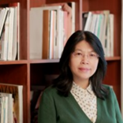 | Discussed primary-care needs with Dean Juan Li, defining a portable, rapid, multiplex pathogen detection goal.

Stage 02 Turn Needs into Requirements
05 Roundtable with Public Health and Disease Control Experts
EXPERT INTERVIEW
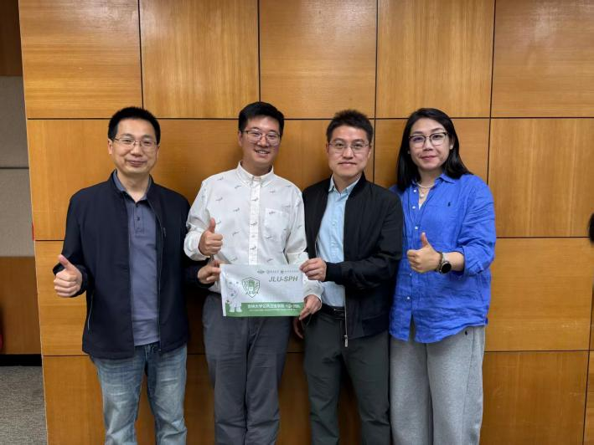 | Consulted disease-control experts to position ByeGerm as a community early-warning node and draft an emergency response guide.

06 Interview with Vice Dean Changgui Kou of the School of Public Health, Jilin University
EXPERT INTERVIEW
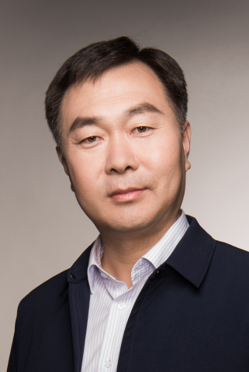 | Used epidemiological guidance to select five respiratory targets: RSV, hMPV-B, SPN, BP, and HI.

07 Interview with Dr. Junyao Li, Respiratory Medicine
EXPERT INTERVIEW
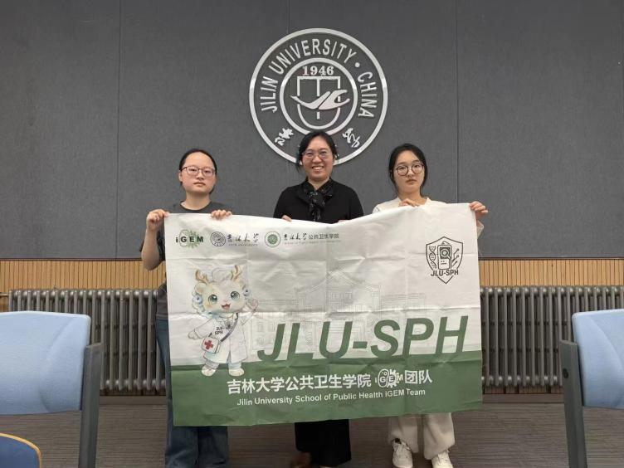 | Consulted respiratory clinicians to define ByeGerm as an out-of-hospital preliminary screening tool, not a laboratory replacement.

08 Interview with Dr. Huimin Li, Laboratory Medicine
EXPERT INTERVIEW
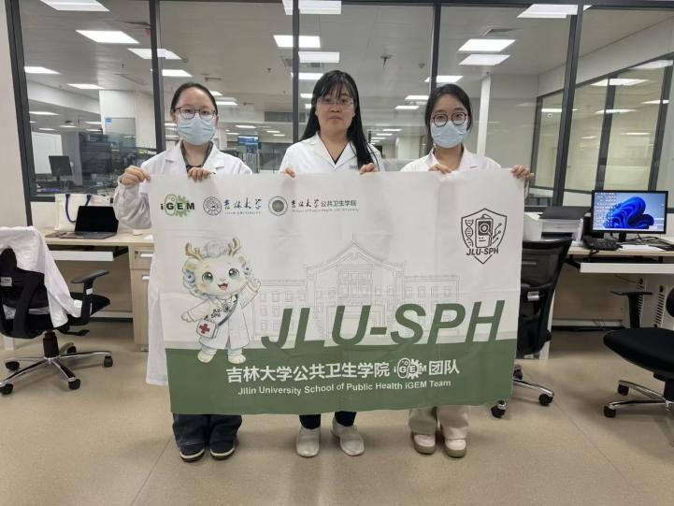 | Confirmed that on-site screening should complement, not replace, standardized laboratory confirmation.

9 Interview with Dr. Shangwei Ji, Infectious Diseases
EXPERT INTERVIEW
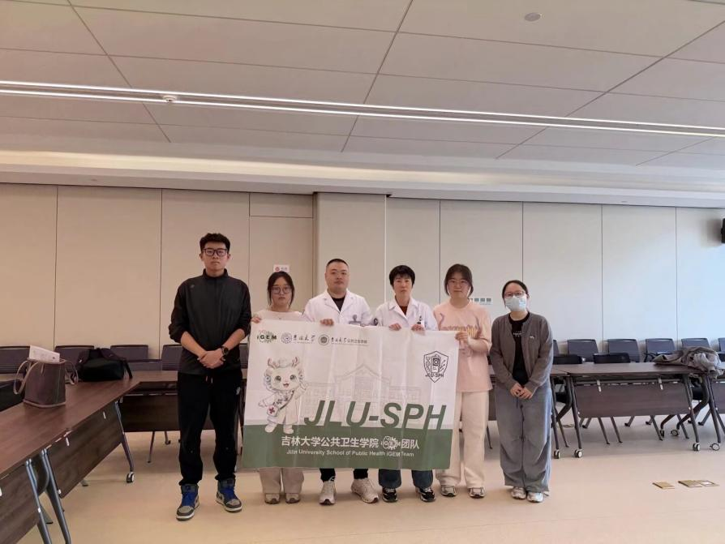 | Discussed on-site risk stratification to guide observation, isolation, and referral decisions.

10 Interview with Dr. Xin Tian, Pediatrics
EXPERT INTERVIEW
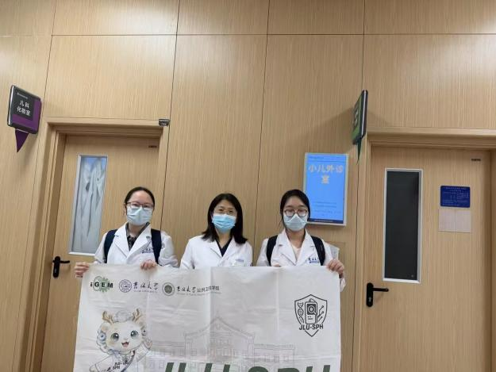 | Identified kindergarten and home screening opportunities to help caregivers recognize pediatric respiratory risks earlier.

Stage 03 Shape the Science (BUILD)
11 Interview with Professor X. Chris Le, University of Alberta
EXPERT INTERVIEW
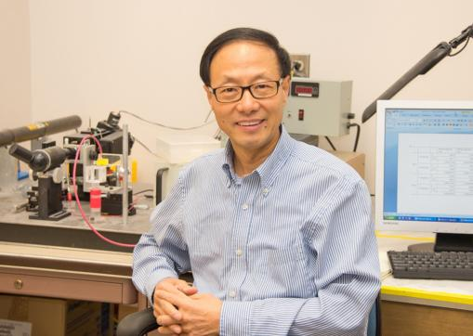 | Adopted expert advice to pursue a portable, one-pot RPA–CRISPR/Cas12a assay instead of conventional PCR.

12 Interview with Professor Tianyi Zhao, Harbin Institute of Technology
EXPERT INTERVIEW
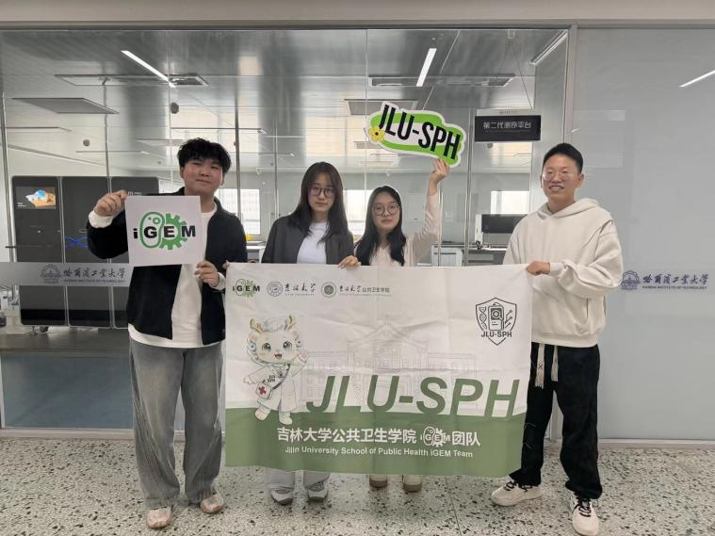 | Discussed DNABERT-based machine learning to improve candidate sequence screening and multiplex detection specificity.

13 Interview with Professor Xingfang Li, University of Alberta
EXPERT INTERVIEW
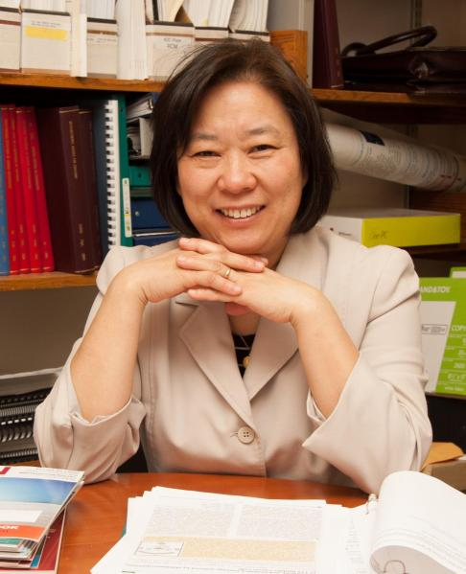 | Discussed molecular docking and dynamics simulations to assess candidate structural stability before wet-lab experiments.

14 Interview with Professor Tsan-Yuk Lam, University of Hong Kong
EXPERT INTERVIEW
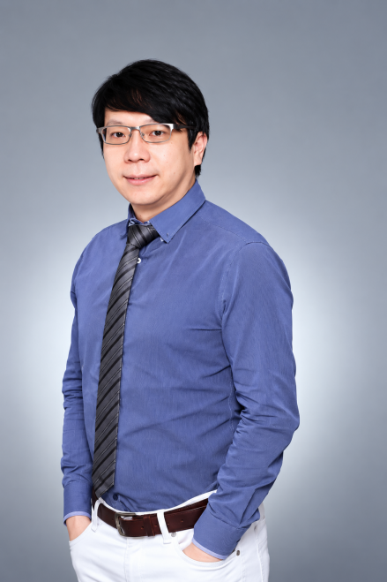 | Developed optimization strategies for one-pot interference using single-factor gradients and comprehensive controls.

Stage 04 Turn Science into an Instrument
15 Interview with Professor Zheng Hu and Professor Yingtao Zhang, Harbin Institute of Technology
EXPERT INTERVIEW
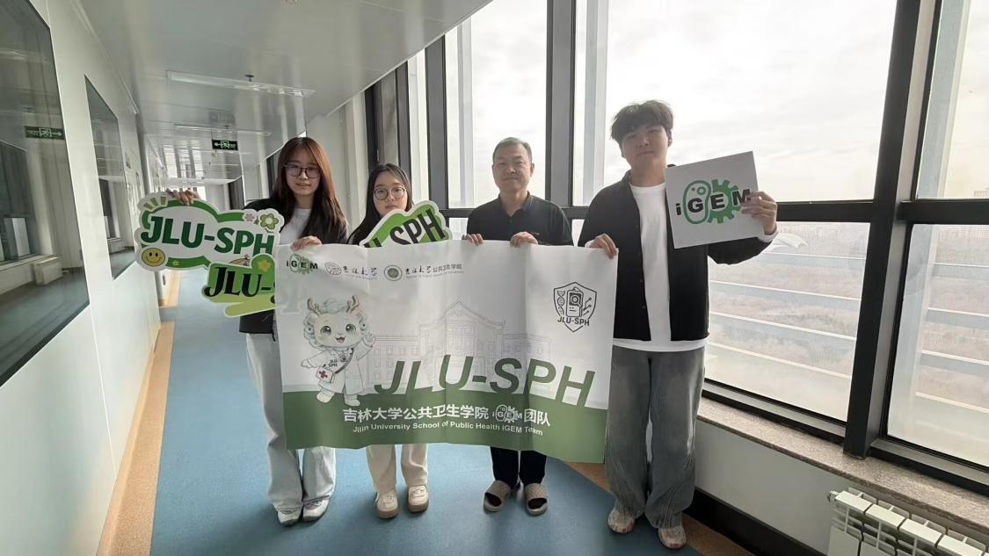 | Integrated expert recommendations on temperature control, microcomputing, and computer vision for automated fluorescence analysis.

16 Collecting First-Generation Instrument Feedback from Nursing Homes
FIELD VISIT
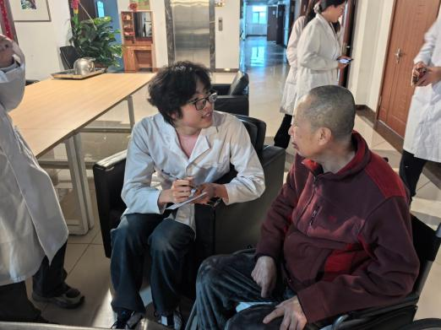 | Nursing-home trials revealed limitations of single-channel testing, motivating a multi-channel instrument upgrade.

17 Collecting First-Generation Instrument Feedback from Kindergartens
FIELD VISIT
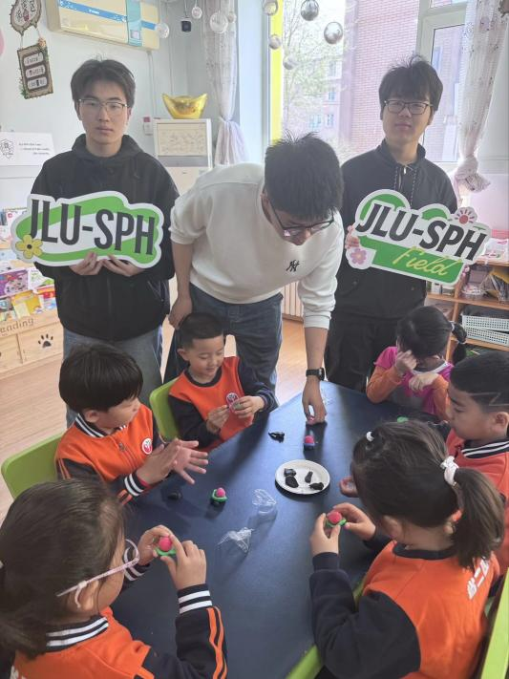 | Kindergarten feedback highlighted the need for faster, higher-throughput screening during sudden fevers.

18 Interview with Professor Ying Mou, Zhejiang University
EXPERT INTERVIEW
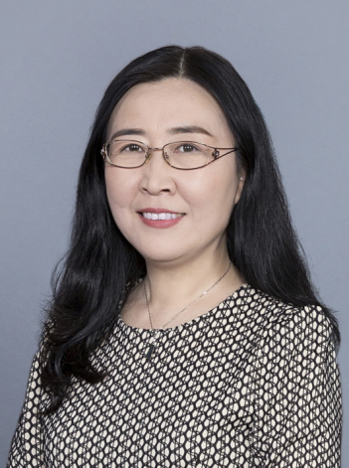 | Implemented rotational switching and thermal isolation recommendations in the second-generation 15-well instrument.

19 The “Auditory and Tactile” Blind-Testing Box for Older Adults and The “Monster Capture” Sticker Wall for Children

VOTING
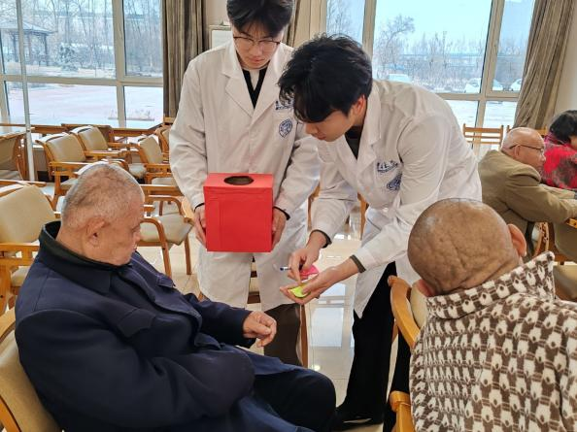
Collected 60 votes from older adults, with 70% positive feedback on device usability.

Used sticker voting with 50 children, finding 64% expressed positive feelings toward screening.

20 The Retrospective Empathy Survey for Patients
VOTING
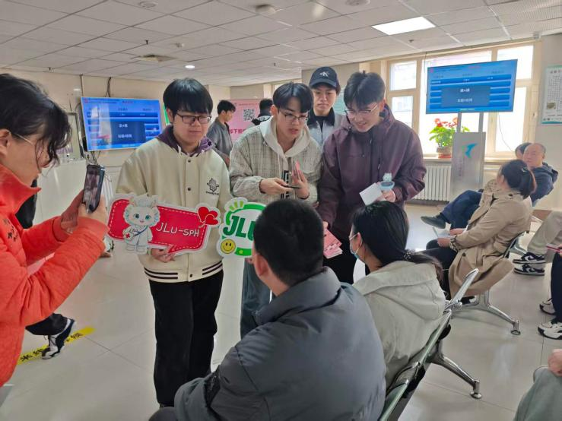
Surveyed 200 patients; 90% preferred mobile displays and 85% reported reduced anxiety with bedside testing.

Stage 05 Share and Carry Forward (EXTEND)
21 Interview with Director Linshen Xie, West China Fourth Hospital of Sichuan University
EXPERT INTERVIEW
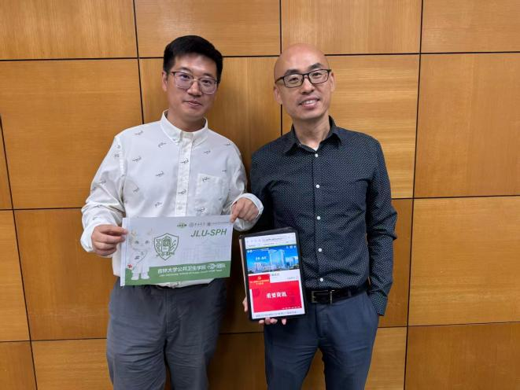 | Discussed quality control, exception handling, data traceability, and public health integration for responsible deployment.

22 Communication with Medical Device Manufacturing Enterprise
EXPERT INTERVIEW
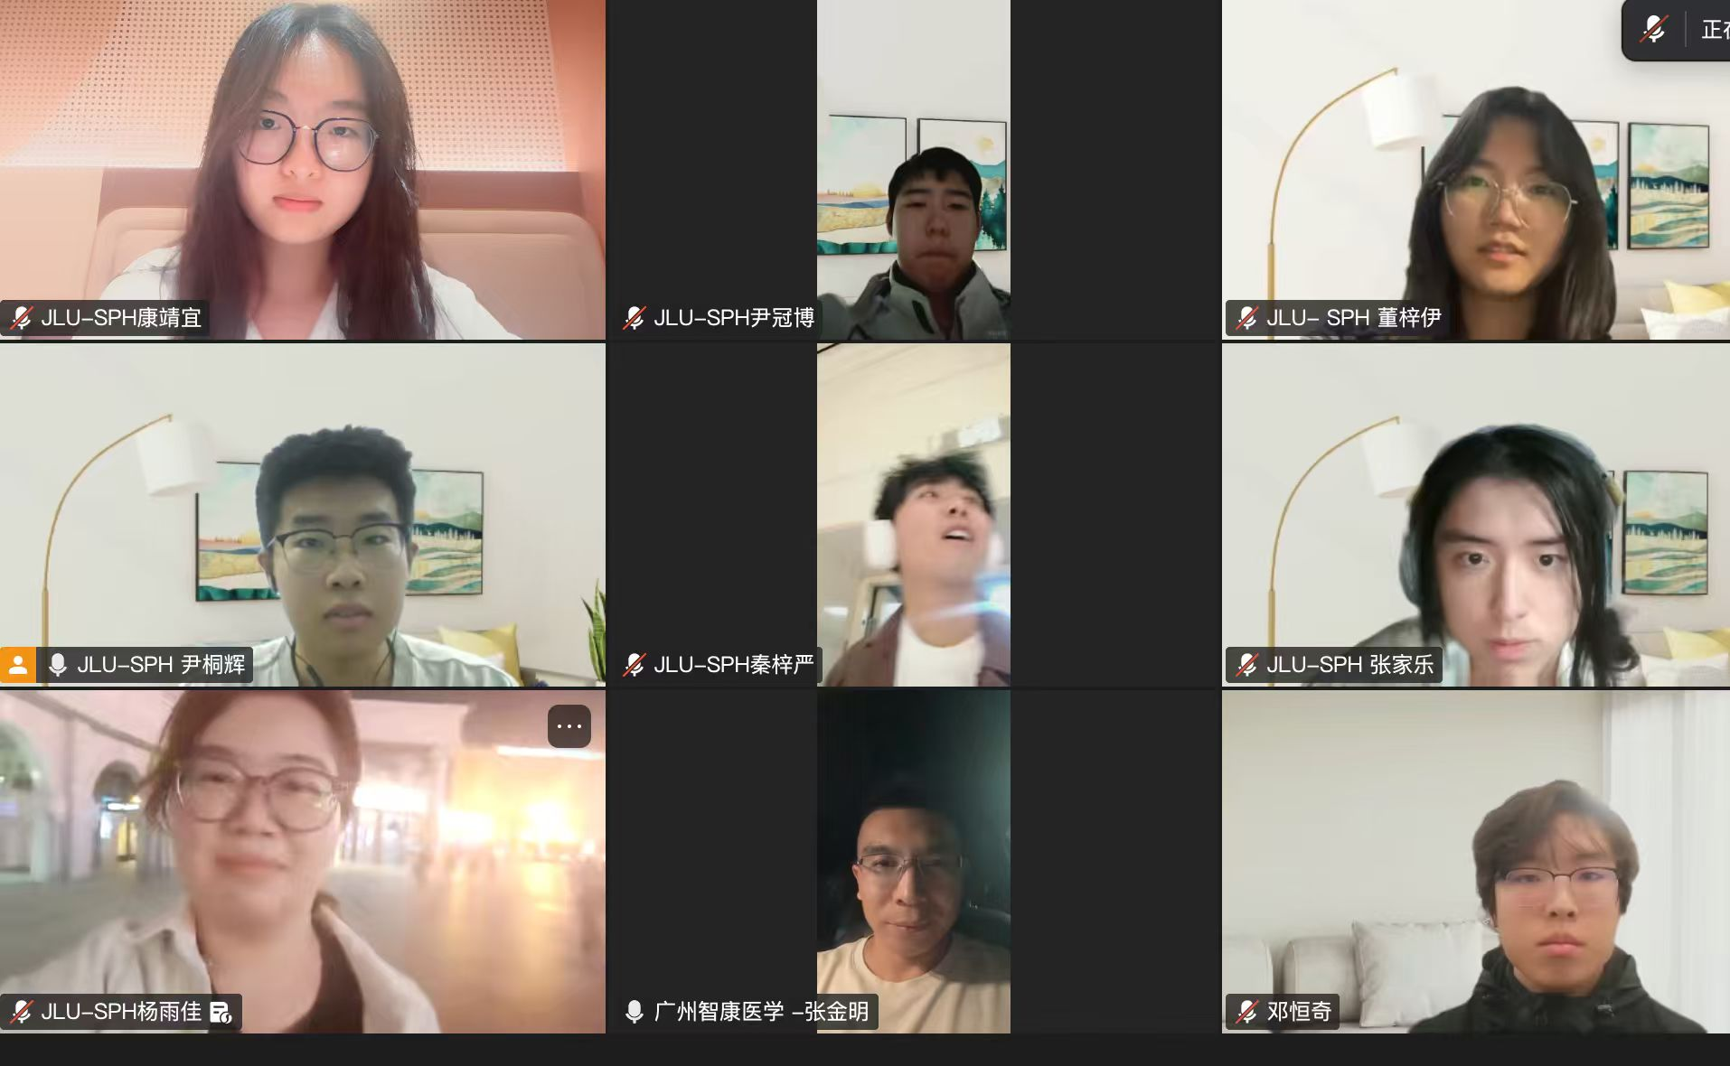 | Reviewed production feasibility, material safety, certification, and cost reduction with medical device engineers.

23 Age-Adapted and Child-Friendly Science Education
PRESENTATION
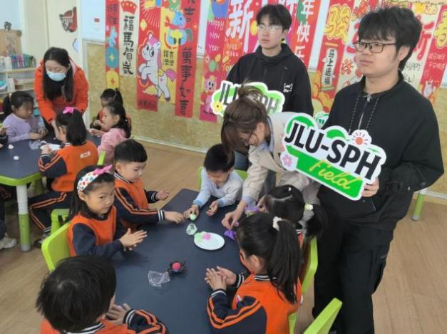 | Delivered age-adapted science education, increasing voluntary testing acceptance to 93% among older adults and 95% among children.

24 Respiratory Virus Detection Strategy Card Game Experience
GAMIFIED ENGAGEMENT
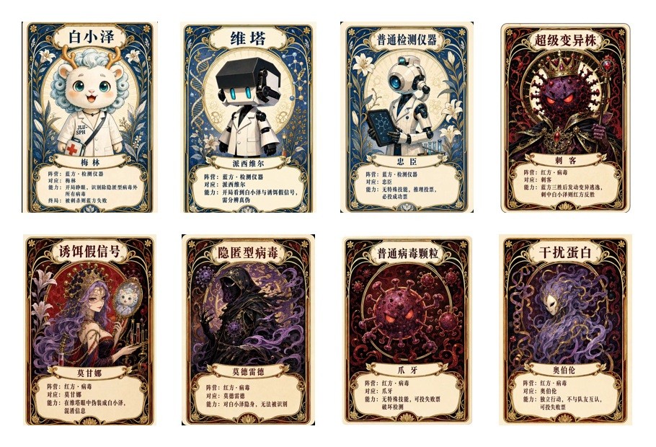 | Created a respiratory virus card game to explain transmission and detection through playful participation.

25 Volunteer Science Education in Tang County, Hebei
PRESENTATION
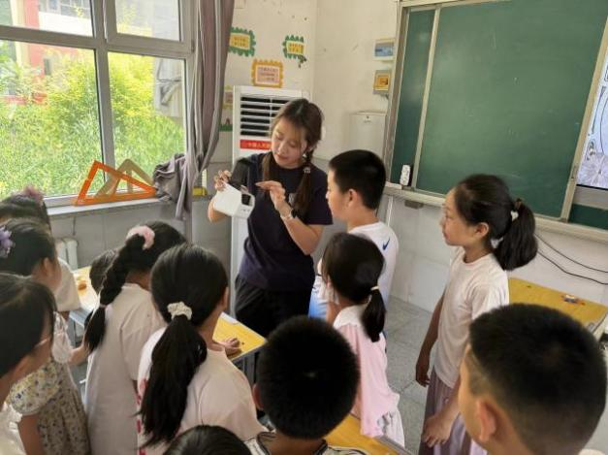 | Introduced device models and public health concepts in remote classrooms through demonstrations and hands-on learning.

26 Interview with Vice President Wei Ye, Nanjing Second Hospital
EXPERT INTERVIEW
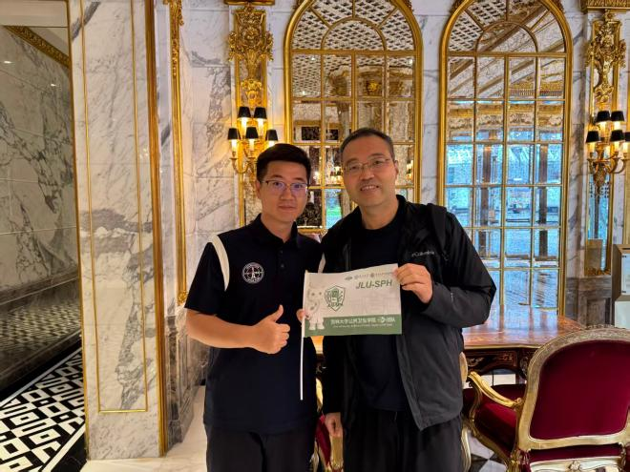 | Defined single-channel use for homes and small institutions and multi-channel screening for communities and disease-control centers.

Extension 01 Inclusive Engagement: Science for Every Voice
27 Wonderful Building Blocks of Life — Kindergarten Synthetic Biology
GAMIFIED ENGAGEMENT
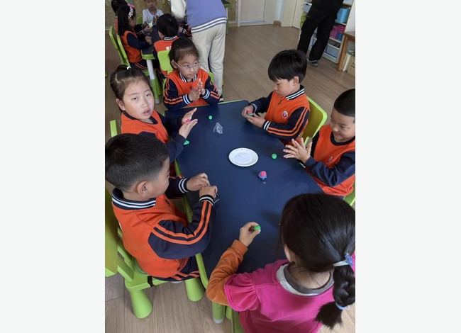 | Introduced synthetic biology to preschool children through storytelling, child-safe DNA crafts, and RNA role-play.

28 Beyond Mountains and Seas — Science in County Communities
PRESENTATION
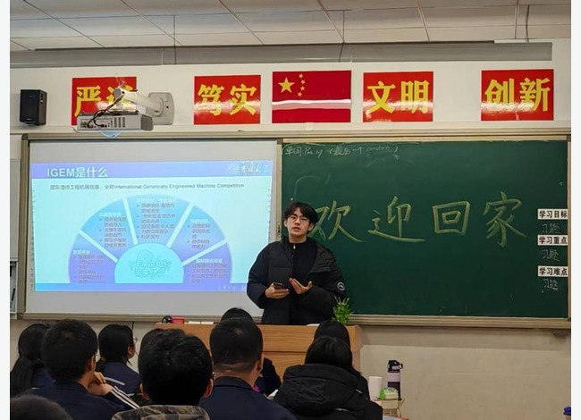 | Brought interactive synthetic biology lessons and hands-on models to students in county-level communities.

29 Wisdom in Silver Years — Science with Older Adults
PRESENTATION
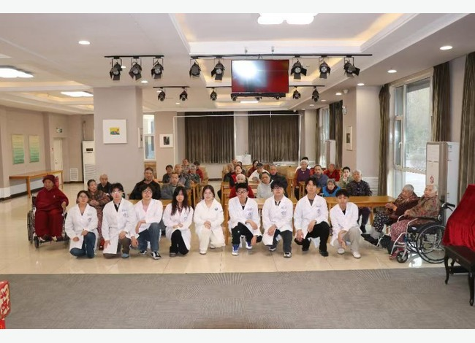 | Engaged older adults through tactile models, fermentation analogies, and discussions of respiratory health technologies.

30 Sound as a Bridge — Accessible Science for People with Visual Impairments
PRESENTATION
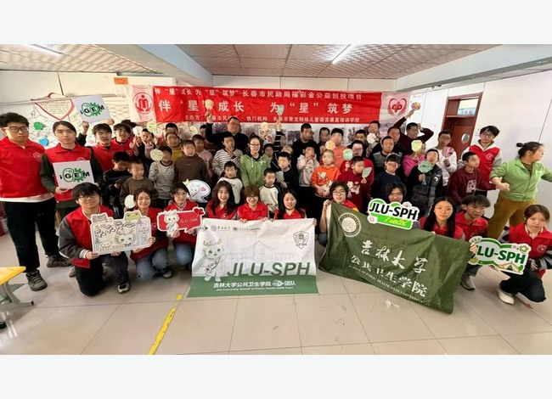 | Co-designed a multisensory synthetic biology workshop and accessible handbook for participants with visual impairments.

31 A Dialogue Across Continents — Global Youth Exchange
PRESENTATION
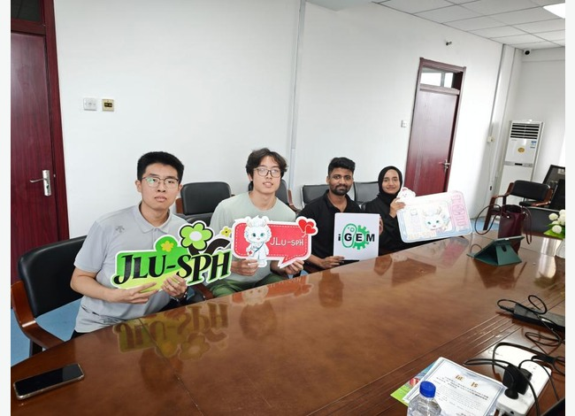 | Connected international students through roundtables and cross-cultural design challenges on synthetic biology applications.

32 Lighting a Spark in the Community — Public Health Dialogue
EXPERT INTERVIEW
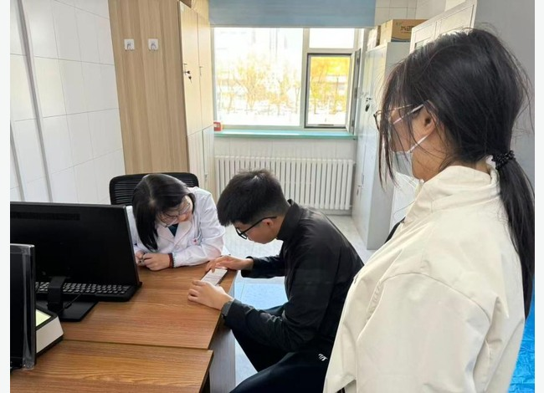 | Held community health salons with frontline professionals to discuss biosensors, screening needs, and deployment pathways.

Extension 02 Collective Growth: Learning Beyond Boundaries
33 CCiC & APIc Conferences
PRESENTATION
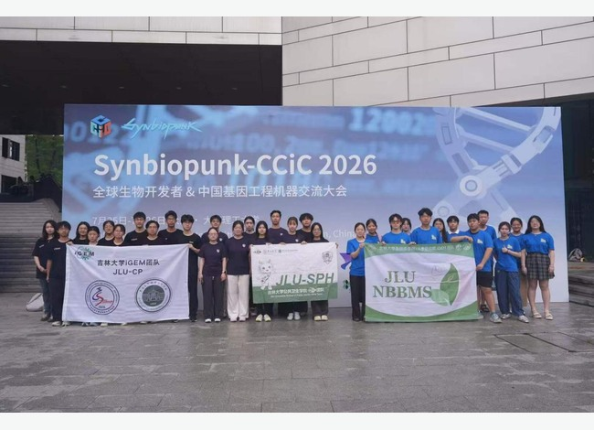 | Exchanged technical and regulatory perspectives with iGEM teams at CCiC and APIc conferences.

34 BioAI Agent Exchange and Summer Dry-Lab Camp
PRESENTATION
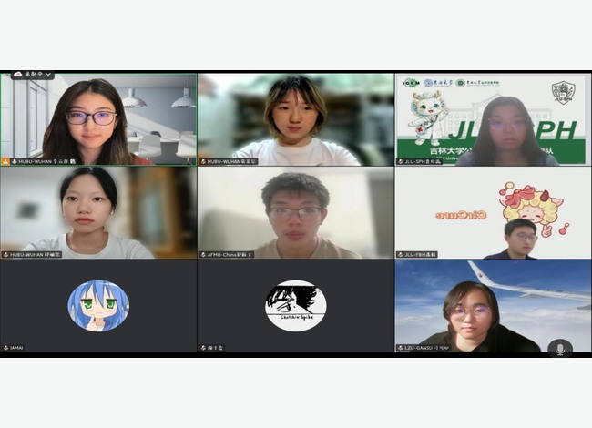 | Collaborated on BioAI Agent discussions and a dry-lab outreach lecture to share computational biology skills.

35 Dialogue with ZJUT-China at the Bio-manufacturing Expo
FIELD VISIT
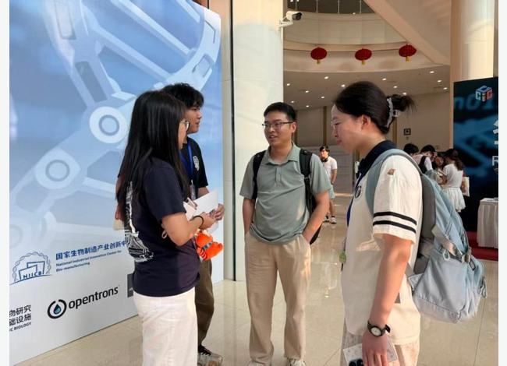 | Exchanged project ideas with ZJUT-China at the Bio-manufacturing Expo, inspiring participatory outreach formats.

36 iGEM New Team Development and Knowledge Transfer Handbook
PRESENTATION
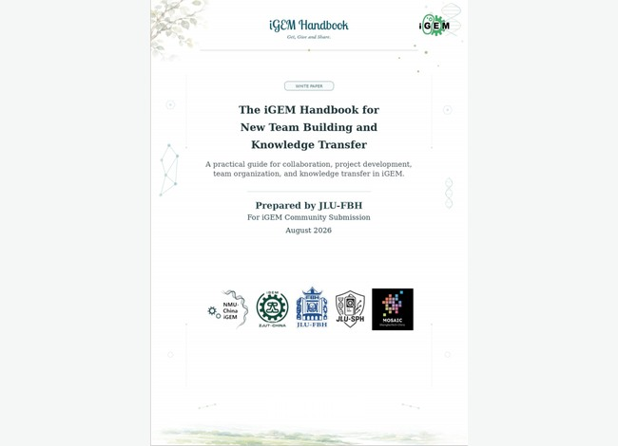 | Co-developed an iGEM team handbook with JLU-FBH to share management, troubleshooting, and knowledge-transfer practices.

37 AI × Synthetic Biology Collaborative Science Communication Handbook
PRESENTATION
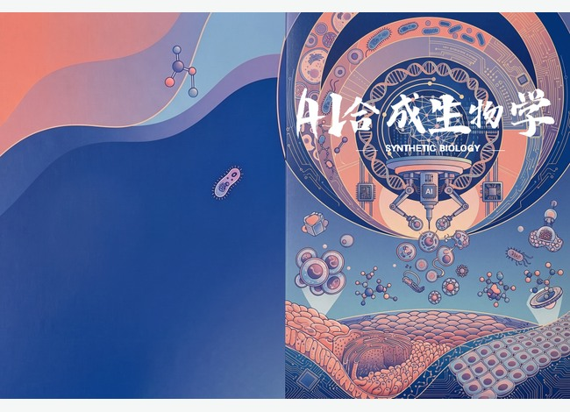 | Co-authored an AI–synthetic biology handbook with four iGEM teams, covering opportunities, limitations, and ethical considerations.

38 SBti Interactive Public Engagement
SURVEY
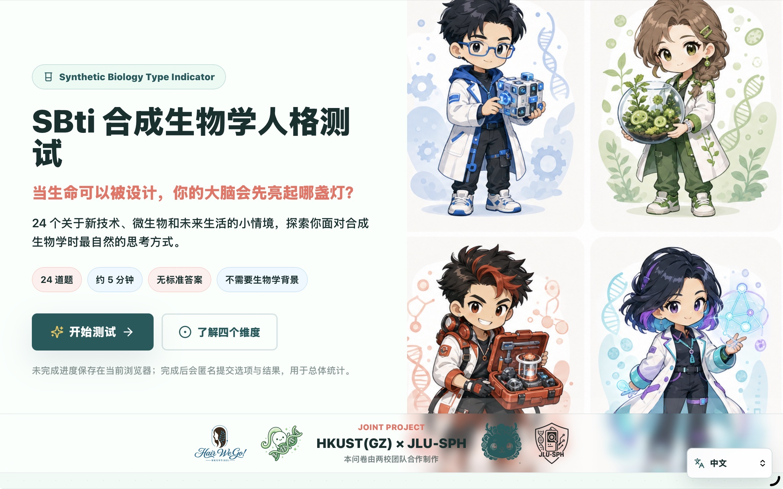
Developed the SBti interactive survey to gather public attitudes and tailor synthetic biology communication.

38 Tower-Defense Synthetic Biology Education Game
GAMIFIED ENGAGEMENT
Created an open-source tower-defense game to make synthetic biology mechanisms accessible through play.

40 Hike with Love · Embrace the Future — Social Inclusion
FIELD VISIT
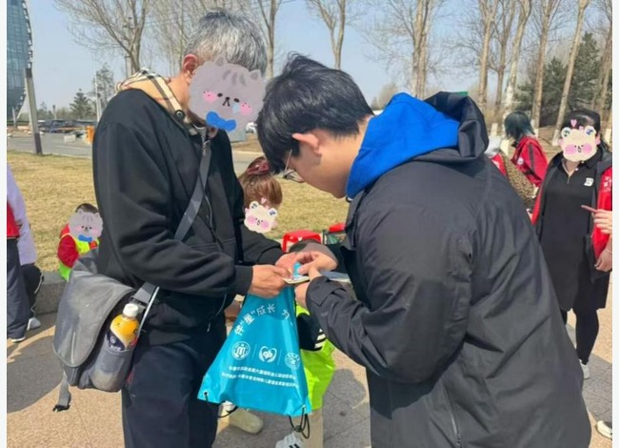 | Supported 100 young people with special needs through medical assistance and science outreach during an inclusive hike.

