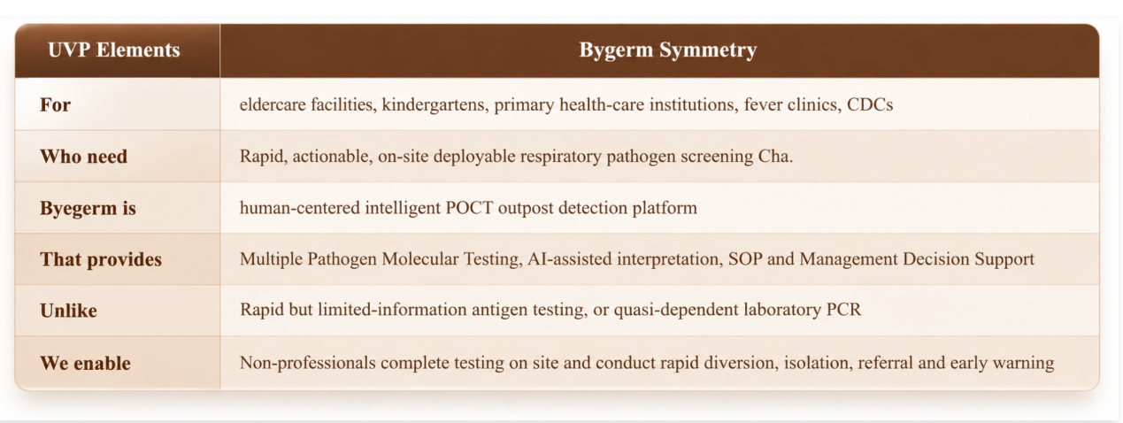
1创业所有还是主体为白底的表格替换为以上的配色，不用一模一样意思接近就行
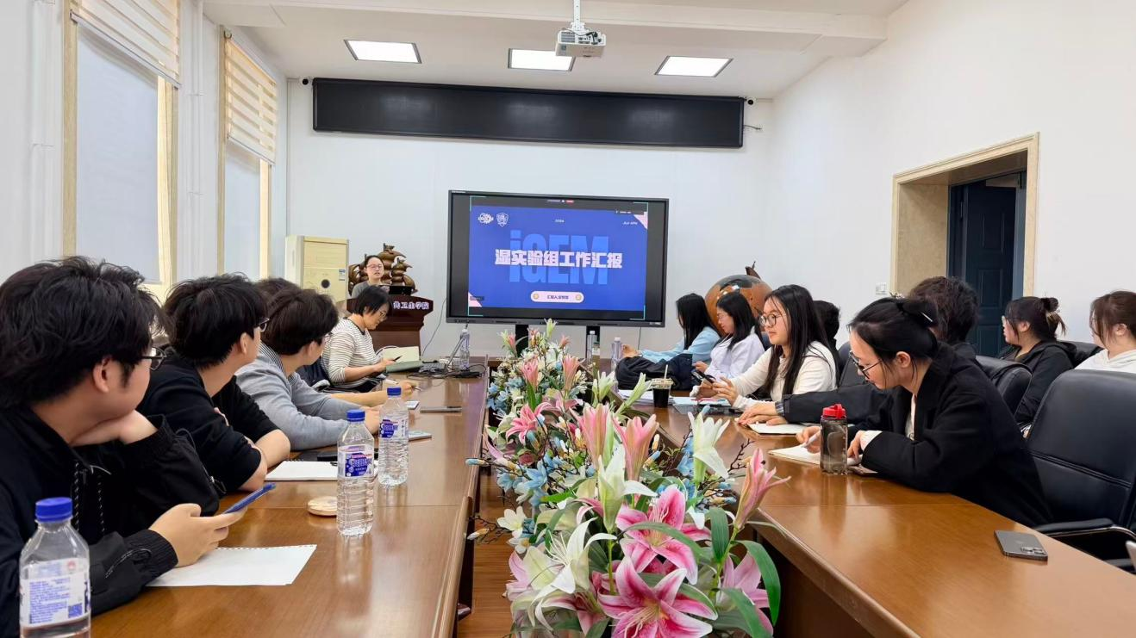
- 上图插在下方第二段后面，大图形式展示
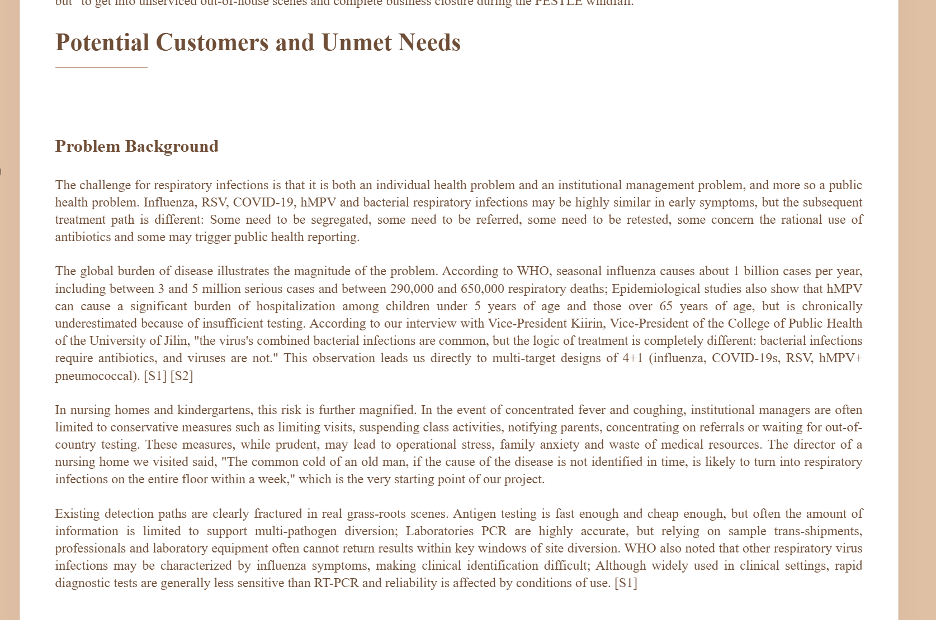
3.
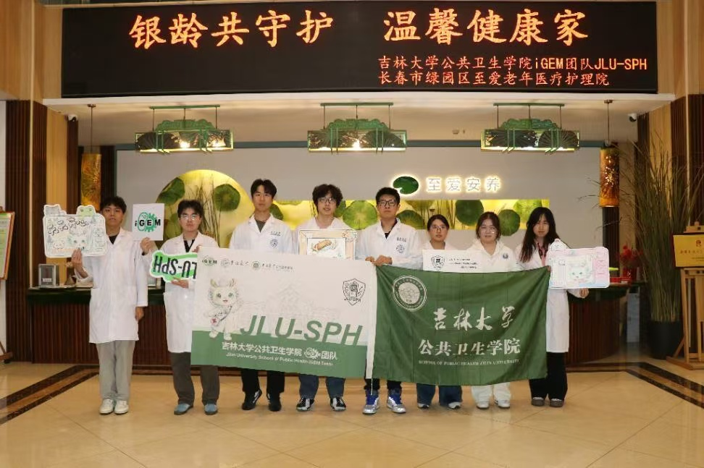
这个插在High-risk下面，第一段文字之前，大图展示
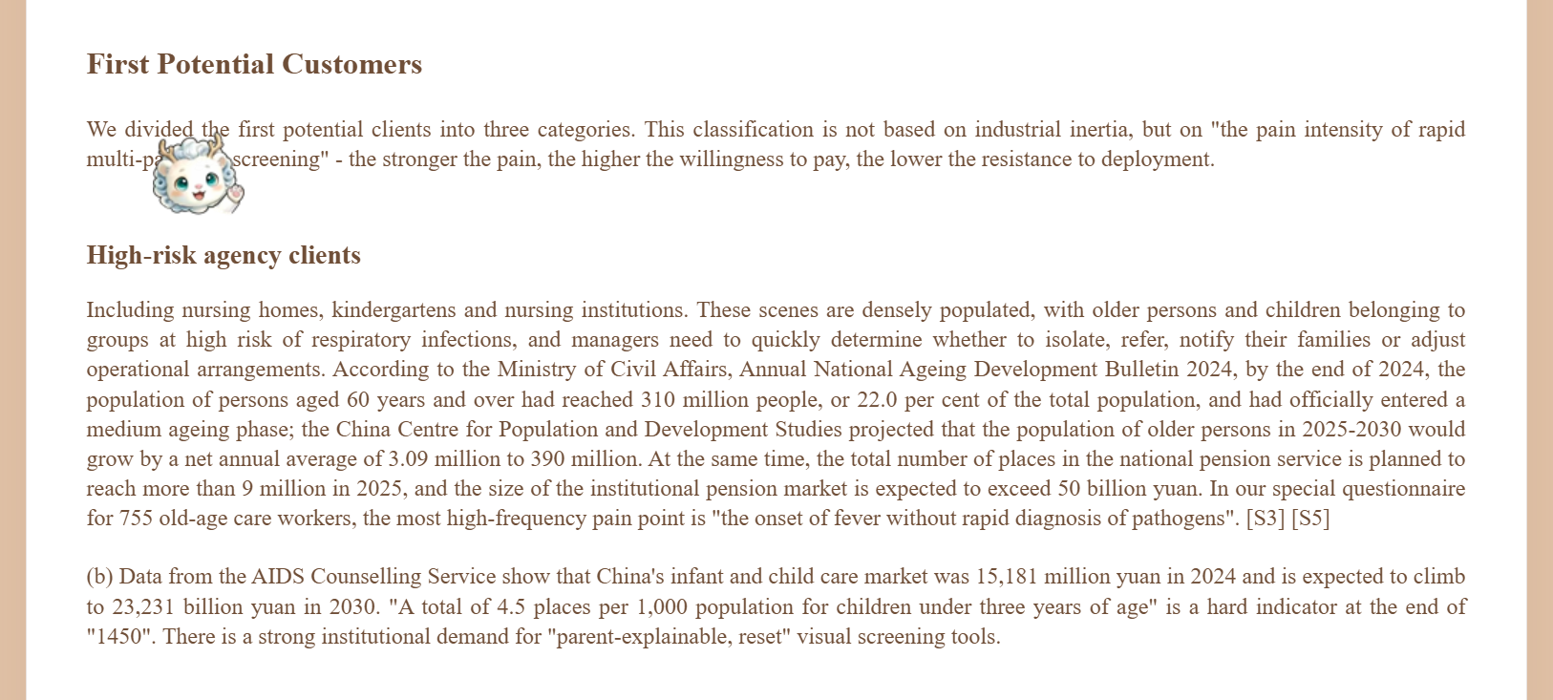
- 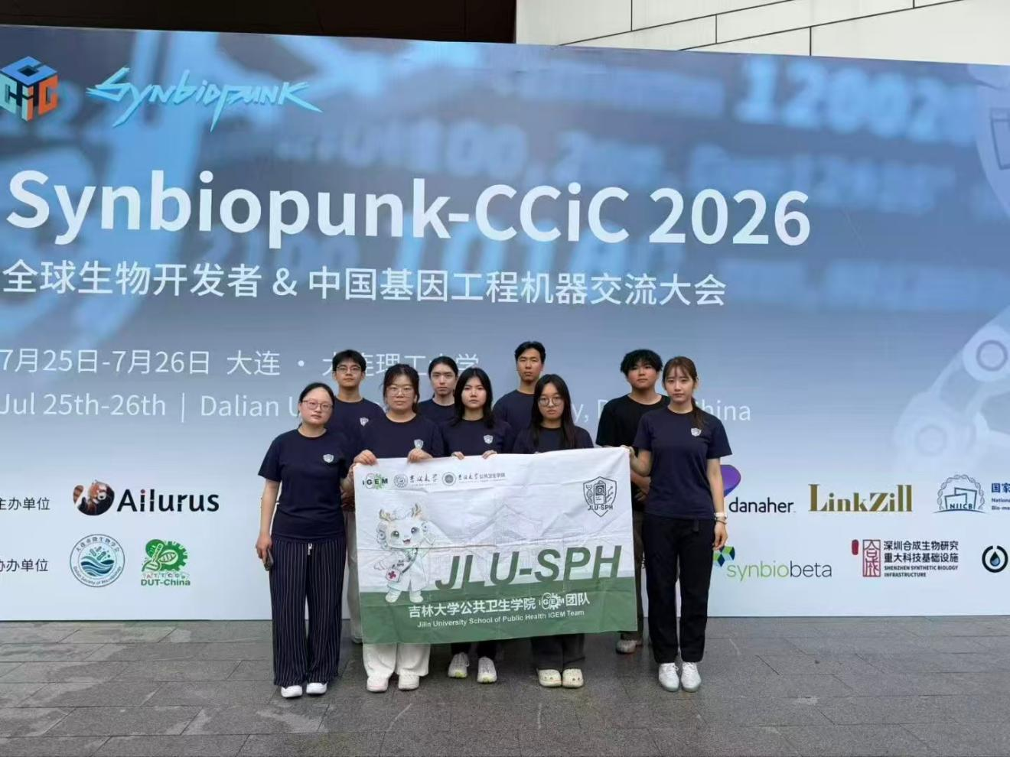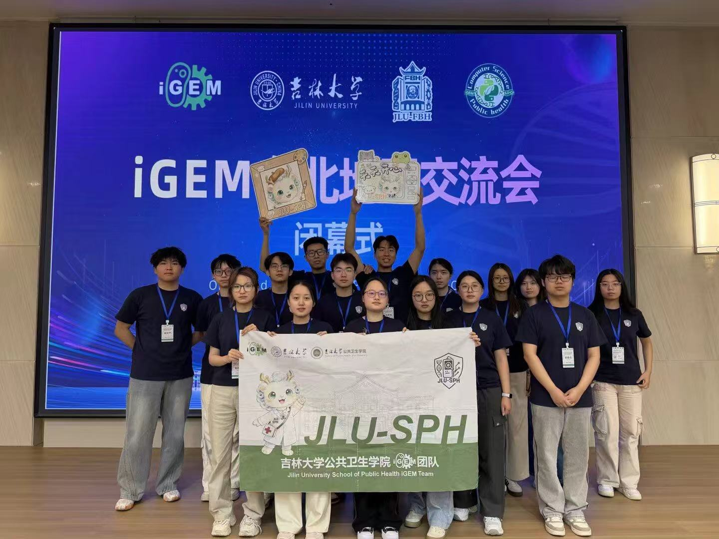
- 最后这两放在Reference上面，也就是第六部分最后
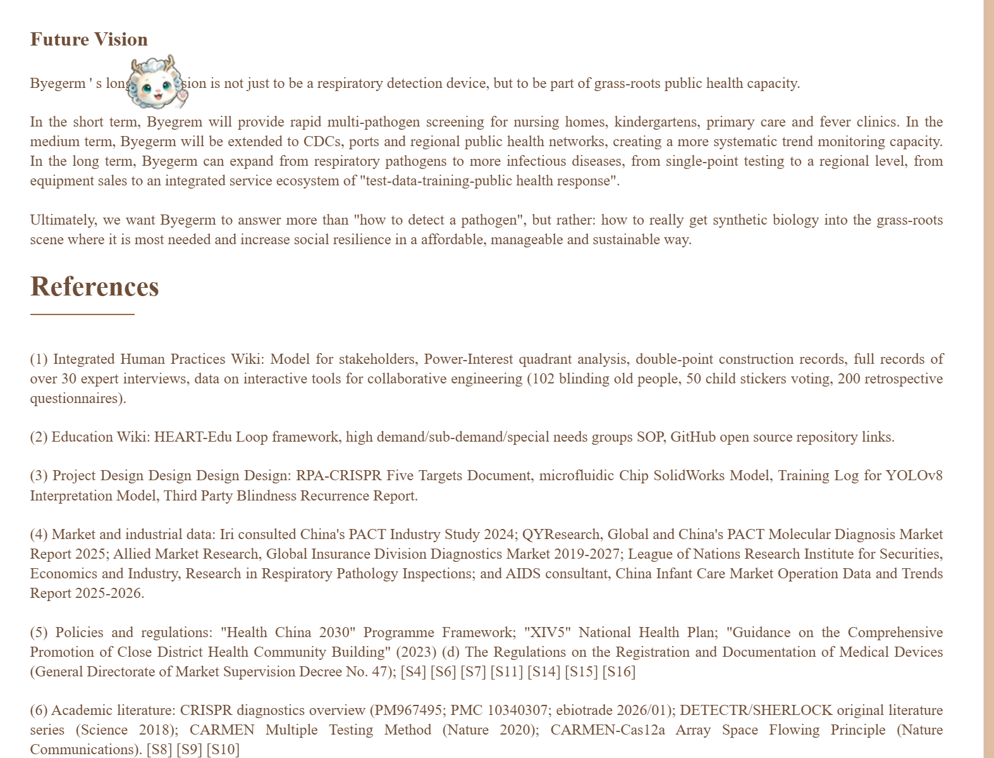
- Wiki右侧的目录拉动增加二级标题具体如下
Table of Contents
1. Executive Summary

1.1 What We Are Building

1.2 Unique Value Proposition (UVP)

1.3 Our Entrepreneurial Logic

1.4 Business Model Canvas

2. Potential Customers and Unmet Needs

2.1 The Problem We See

2.2 Our First Customers

2.3 Customer Discovery and IHP Evidence

2.4 Six Categories of Unmet Need

2.5 PESTLE Analysis

2.6 Market Sizing: TAM / SAM / SOM

3. Feasibility, Scalability and Inventivity

3.1 Scientific and Technical Feasibility

3.2 Minimum Viable Product (MVP)

3.3 Validation Strategy

3.4 Inventivity: What Sets Us Apart

3.5 Scalability

3.6 SWOT and Strategic Choices

3.7 Protectability: Intellectual Property and an Open-Access Strategy

4. Development Plans, Milestones, Resources and Risks

4.1 Product Development Roadmap

4.2 Registration and Clinical Pathway

4.3 Resources Required

4.4 Risk Matrix and Mitigation

4.5 Why This Plan Is Realistic

5. Required Capabilities, Funds and Stakeholders

5.1 Capability Map

5.2 Team Strengths and Gaps

5.3 Key Stakeholders: Five Rings, Four Flows

5.4 Financing Plan

5.5 Business Model

5.6 Financial Forecast

5.7 Return on Investment and Exit

5.8 Data Grading and Model Limitations

6. Long-term Impacts

6.1 Long-Term Positive Impact

6.2 Potential Negative Impact

6.3 Governance and Mitigation

6.4 Future Vision

7. References

7.1 Internal Project Materials

7.2 Market, Industry, and Capital-Markets Data

7.3 Table of Authoritative Sources
6.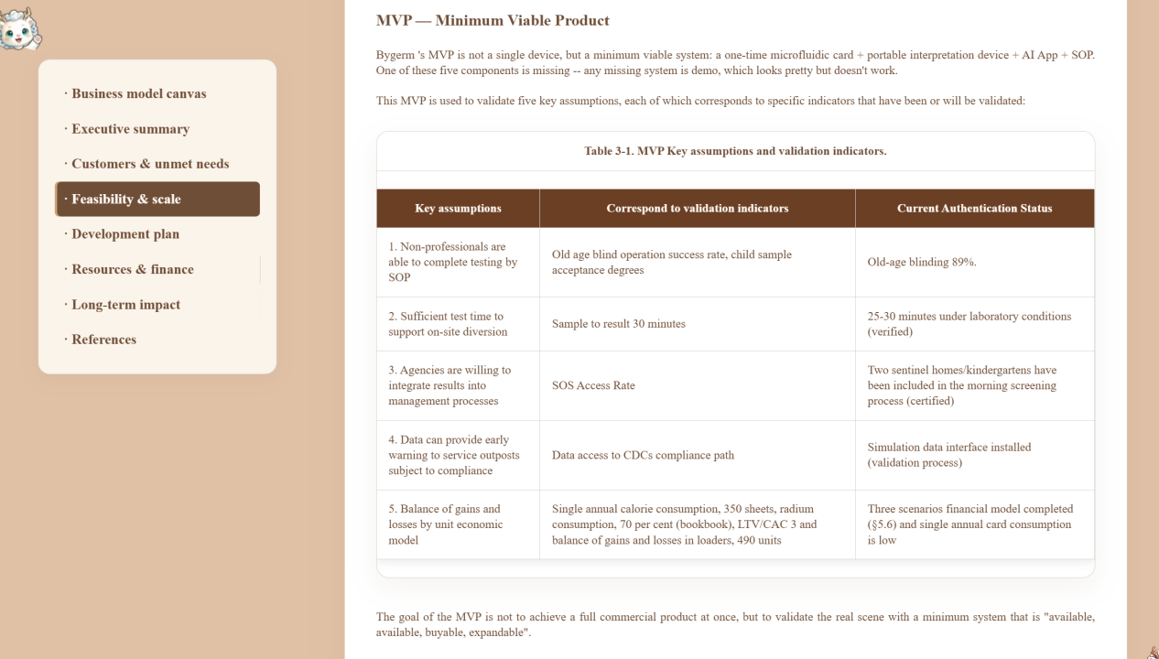
MVP下面第一段话完事插入下图
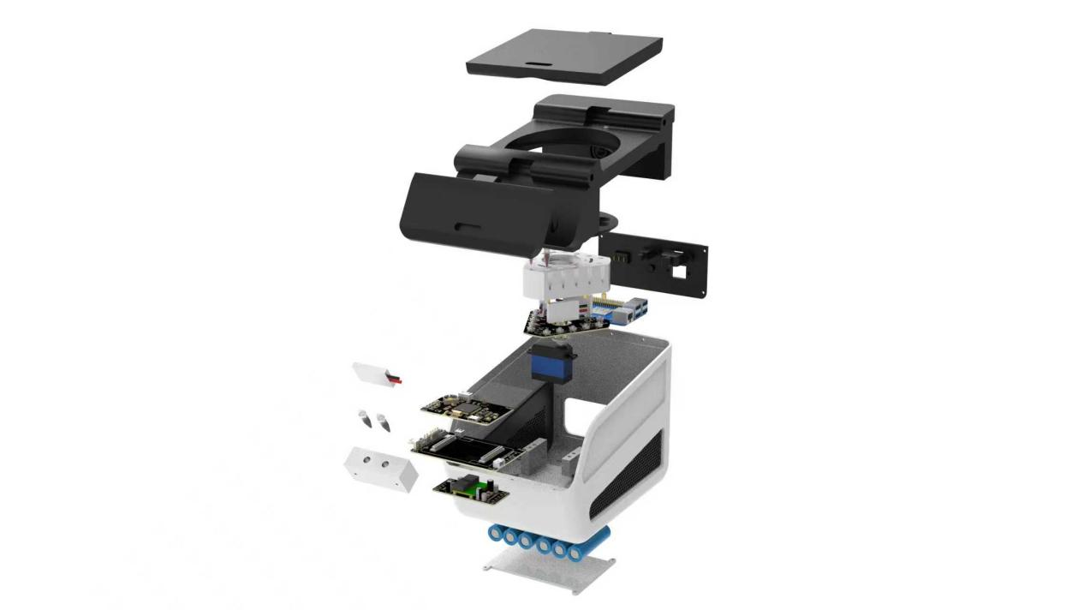
- 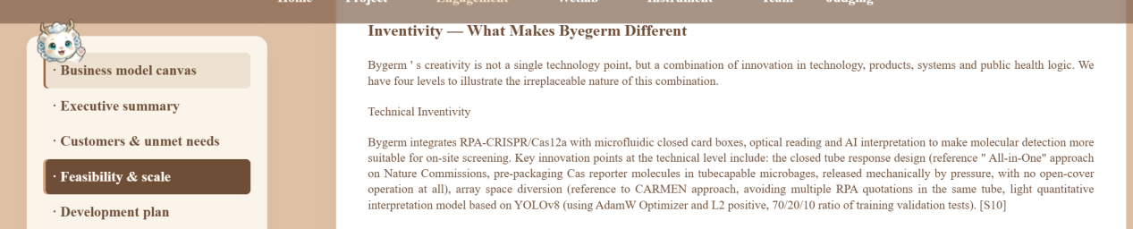
上图最后一段后面插入下图
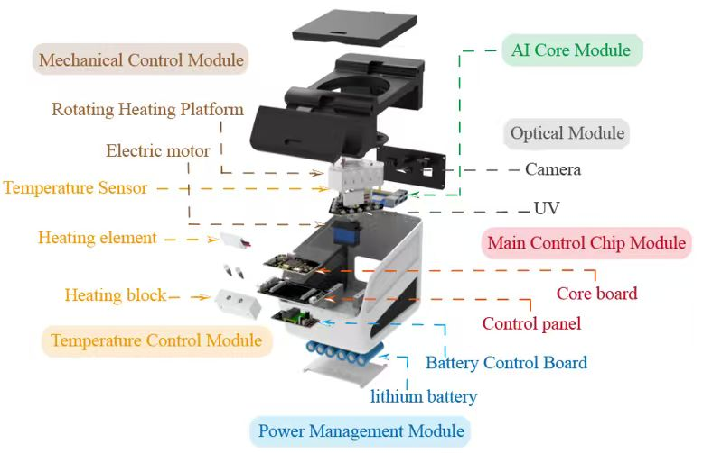
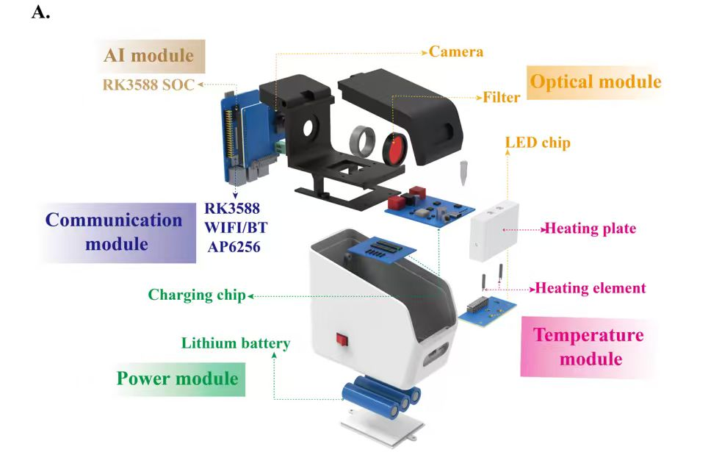
两个图放在一起，拉动展示，可以做成小图，放在上图下一段文字右侧并列展示

