wiki最终修改
- sponsor下面滚动的地方再次高清修复
- 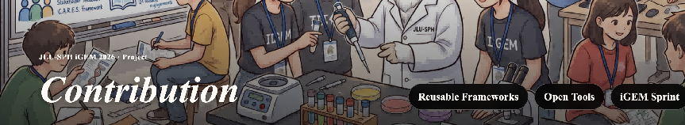 改为iGEM spirit（contribution页面）
- 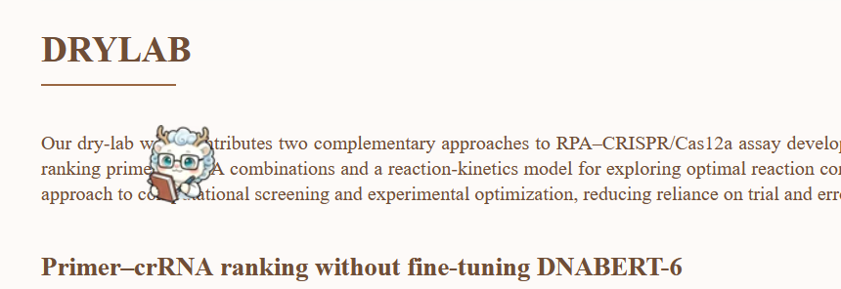
- measurement页面
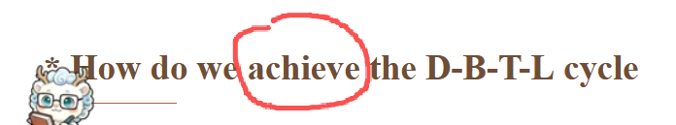
这个achieve改成Implement
- 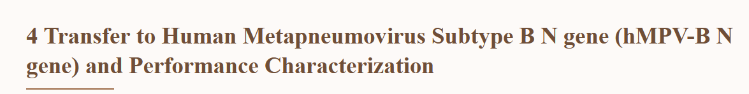修改为 Application to Human Metapneumovirus Subtype B N Gene Detection and Performance Characterization即，将transfer改为application，加上detection这个词（同样为measurement页面）
- 同理，应用于section 5/6/7（5的问题 都改一下）（这个需要特殊注意一下）

- 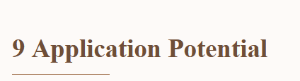这个改成Towards the Future of Global Health
- 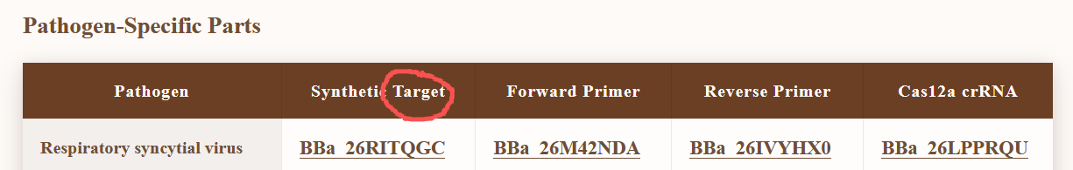
Parts部分，改成synthetic target gene（即后面加一个gene）
- 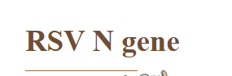Protocol部分，改成Detection of RSV N gene，即，加个detection of，后面的四个gene章节同理修改
- 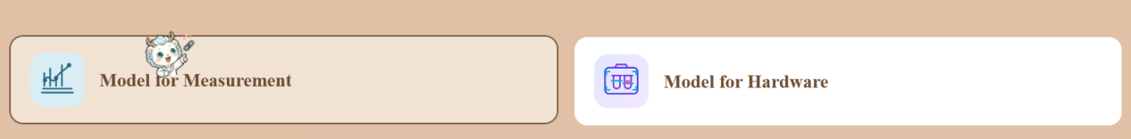
model部分左侧改为 Assay Modeling，右侧改为Instrumentation Modeling
进入这个model界面后，默认出现的界面是Instrumentation Modeling
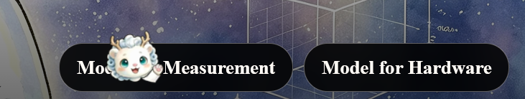
关键词也一并修改成Assay Modeling和Instrumentation Modeling
11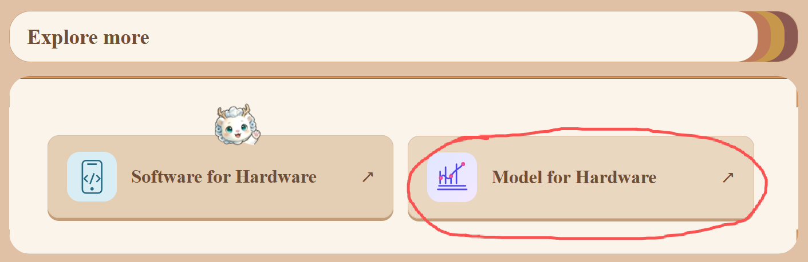
Hardware这部分，对应的链接和题目不随之变动
12ihp后加的summary部分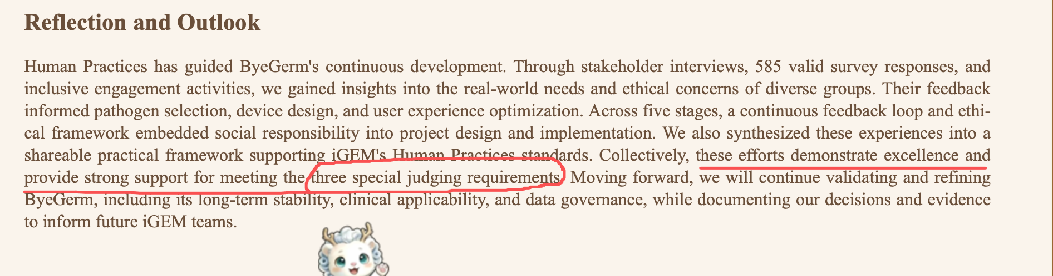画红线的部分改成 Collectively, these efforts exemplify excellence in Integrated Human Practices, demonstrating meaningful and sustained integration of societal needs, stakeholder feedback, and ethical considerations into ByeGerm's development, in strong alignment with the Best Integrated Human Practices Award judging criteria. 划红线的句子改成这个
13 measurement没问题 直接插进去即可
14把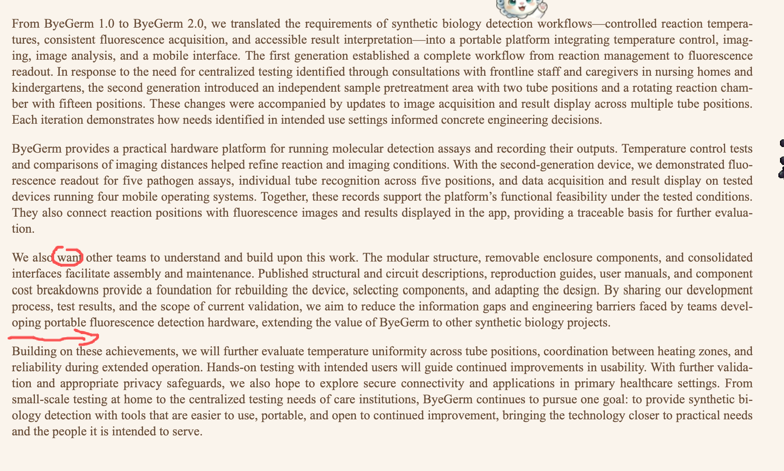
1.把want换成strive to
2.箭头地方插入By providing detailed structural designs, circuit schematics, assembly guides, user manuals, and cost breakdowns, we offer reproducible hardware resources for future iGEM teams, supporting the Bronze Medal Contribution criterion. Guided by stakeholder feedback, we advanced ByeGerm from 1.0 to 2.0 through iterative engineering, introducing independent sample pretreatment and a 15-position rotating reaction chamber, demonstrating the Silver Medal Engineering Success criterion. Meanwhile, experimental validation of five pathogen detection assays, multi-position fluorescence recognition, and compatibility with four mobile operating systems demonstrates the functionality, practical utility, and reproducibility emphasized by the Best Hardware Special Prize. Together, these achievements highlight our commitment to user-informed innovation and accessible synthetic biology, providing strong support for our pursuit of a Gold Medal and the Best Hardware Special Prize.这段话
15 ihp的overview图修改（发群里了）

