Collective Growth: Learning Beyond Boundaries的
Team Bonding & Gamification插入照片：
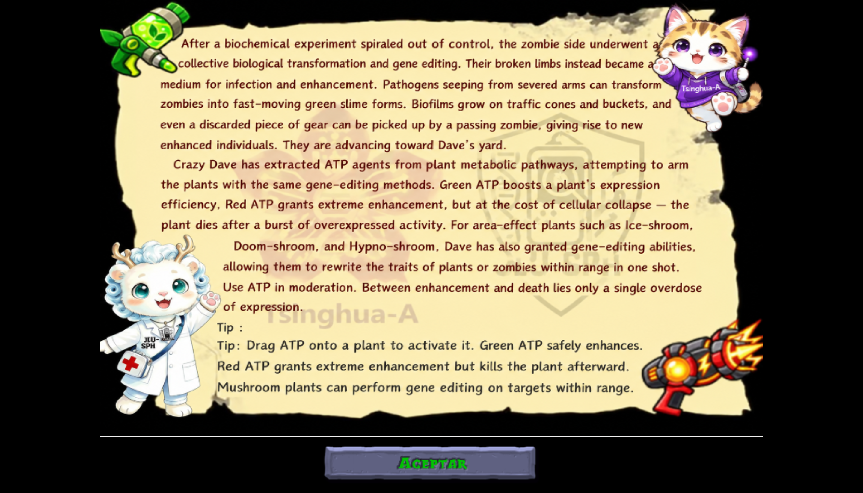

APIc都改成APiC
3.卡片缺少的活动和照片如下：
38 SBti Interactive Public Engagement
SURVEY

Developed the SBti interactive survey to gather public attitudes and tailor synthetic biology communication.
39. Tower-Defense Synthetic Biology Education Game
GAMIFIED ENGAGEMENT
Created an open-source tower-defense game to make synthetic biology mechanisms accessible through play.

4.卡片活动的照片填充到方框里，四周不要留白边，照片与方框完美适配。
5.stage2 public health的pdf插入文件01

6.stage5的A Public Health Perspective — Vice President Ye Wei of Nanjing Second Hospital的Iteration的表改成以下内容：

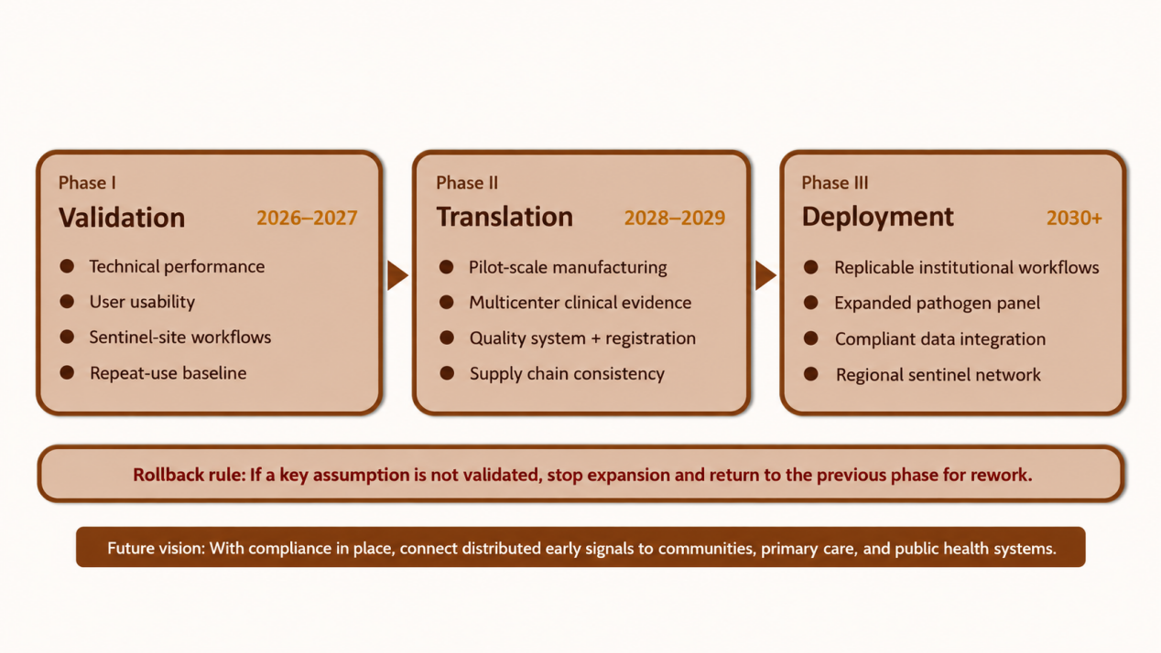
- Card game instructions插入文件
8.把这几张图片替换原stage1的图片，超清不要白边，只要线框内图片，大小适宜。
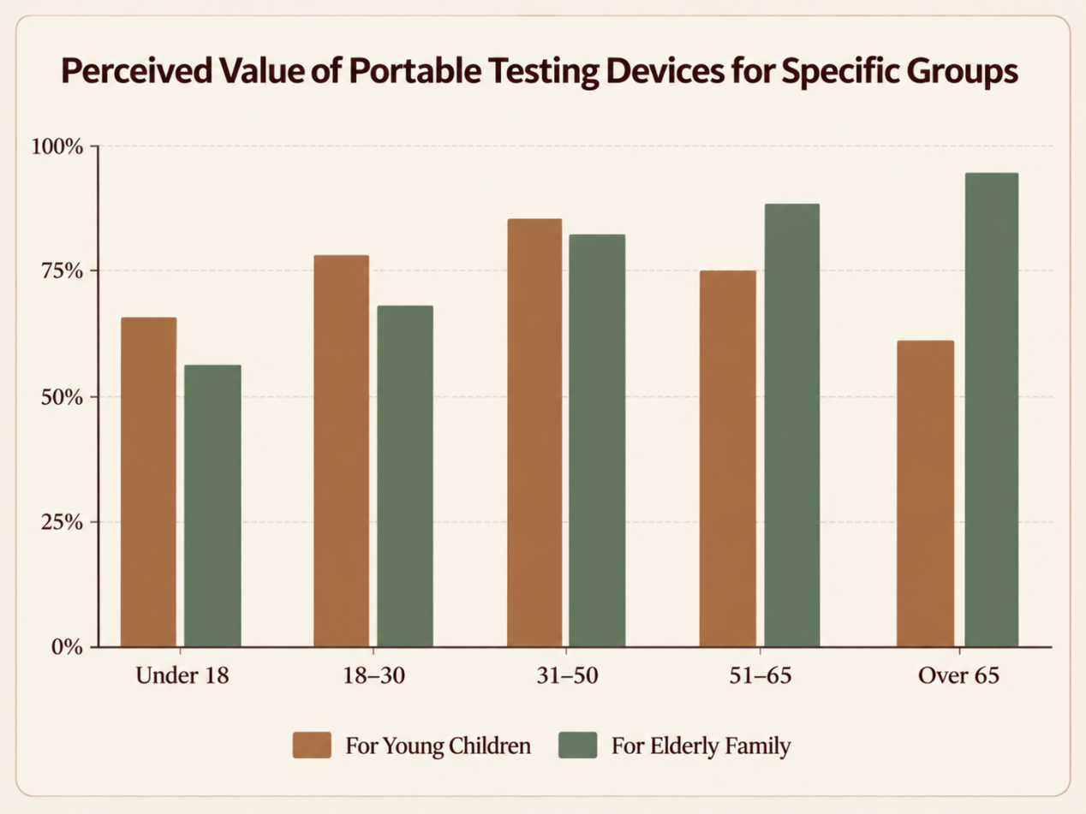
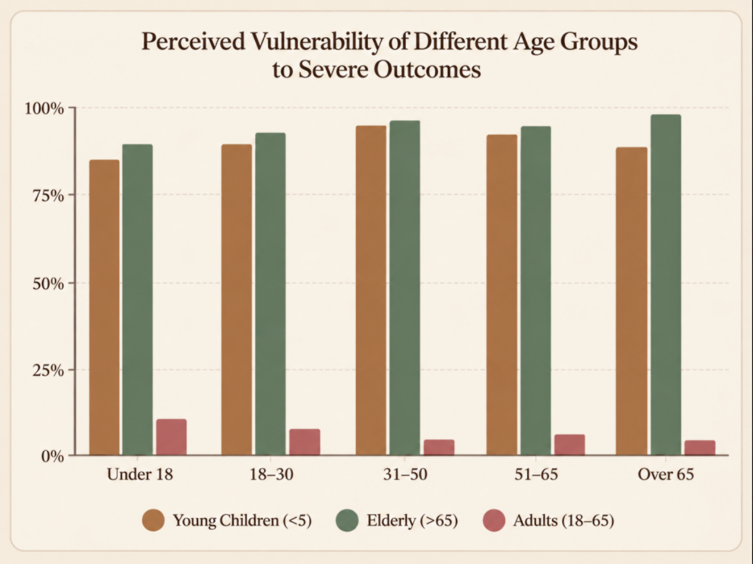
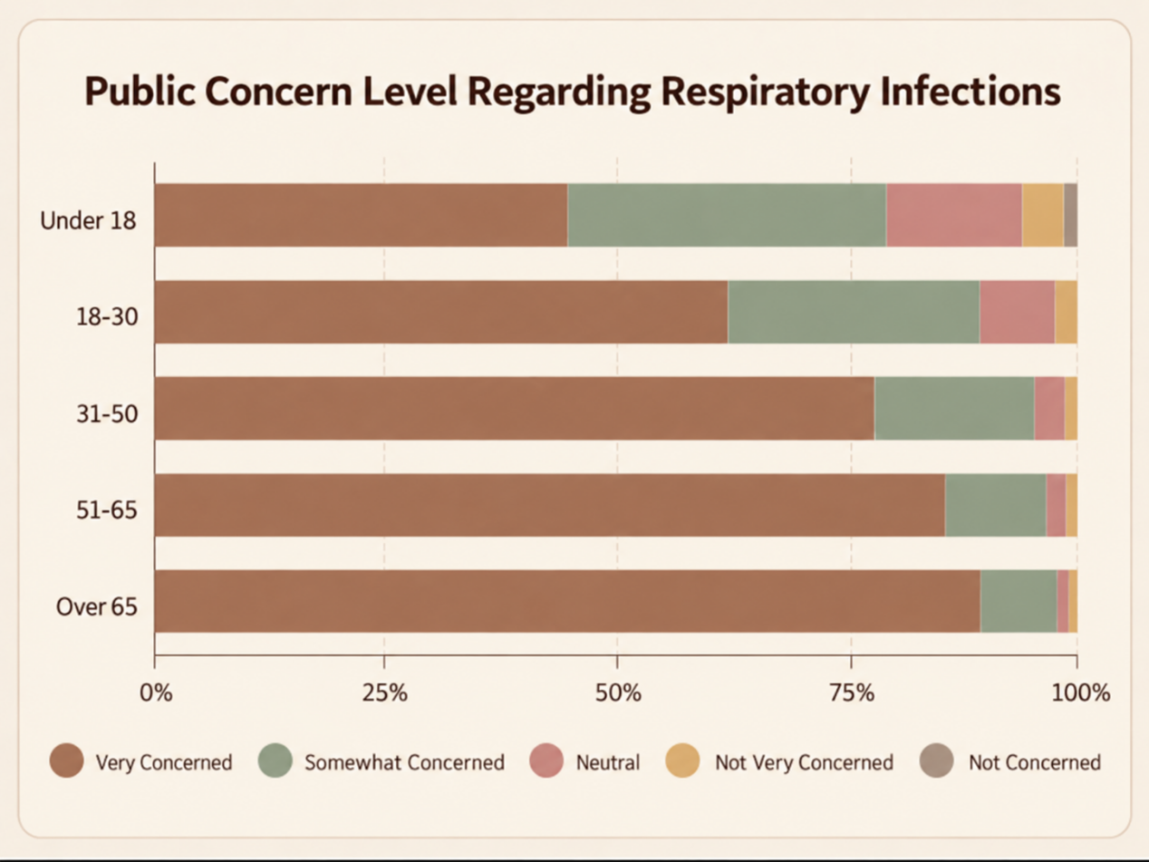
9.关于Dean Li Juan的介绍改成Professor Li Juan, Former Dean of the School of Public Health, Jilin University
10.stage5figure50换成这张照片，图比原来再大一些。