Respiratory infections often present with similar clinical manifestations, although their underlying pathogens may differ. Increasing global mobility further accelerates the spread of respiratory pathogens. Older adults and children may face the dual risks of disease progression while awaiting diagnostic evaluation and cross-infection associated with repeated hospital visits. Rapid testing at the point of need is therefore particularly important in settings such as long-term care facilities and kindergartens.
Against this backdrop, we aim to address the challenges posed by the rapid spread of respiratory pathogens in an increasingly interconnected world and to respond to global public health needs.
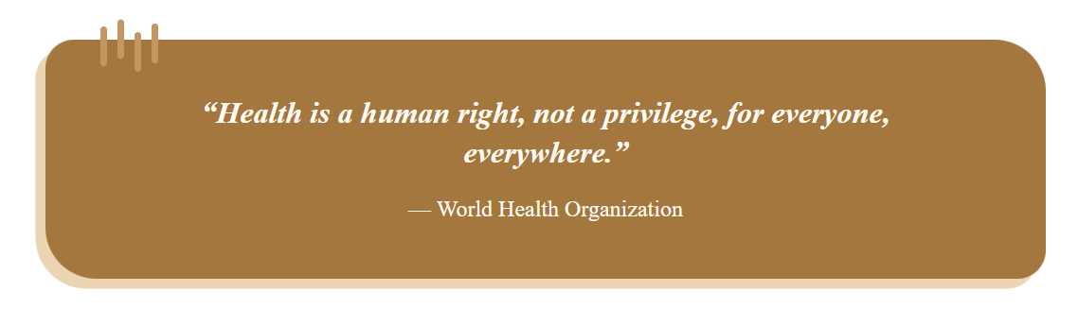
这个原图不变，World Health Organization向右对齐。
To this end, we developed ByeGerm, a portable platform for multiplex detection of respiratory pathogens at the point of need. By detecting multiple pathogens in a single run, providing rapid results, and offering a streamlined operating procedure, the platform aims to advance human well-being through synthetic biology and extend molecular testing beyond centralized laboratories to vulnerable populations and community-level public health service settings.
However, laboratory research alone cannot establish which populations have the most urgent need for testing, which pathogens should be targeted, what requirements should be set for turnaround time and ease of operation, or how a technology can be translated into a usable device. We therefore engaged in sustained dialogue beyond the laboratory with members of the public, patients and their families, staff at long-term care facilities and kindergartens, clinical and public health professionals, and experts in molecular biology, engineering, and computational science.
+ppt图第一页，抠图，只留四个小框和里面的内容
Guided by five interrelated core questions, we organized our Human Practices process into five main stages: LISTEN, DEFINE, BUILD, ENGINEER, and EXTEND. Insights gained at each stage informed subsequent reflection and iterative refinement of the project.
These interactions directly shaped the direction of the project. Needs identified in real-world settings helped us define the target populations and intended applications; epidemiological and clinical perspectives guided the prioritization of detection targets and the establishment of performance requirements; expert recommendations led us to adopt the RPA-CRISPR/Cas12a approach and incorporate DNABERT-assisted optimization; and feedback from frontline users informed further improvements to sample collection, hardware architecture, the results interface, and the operational workflow.
Following each engagement, we applied a four-step reflective cycle to revisit our initial assumptions, translate feedback into design requirements, and evaluate these requirements through experiments, prototype development, and context-specific validation. Human Practices therefore not only informed the project design and helped other teams address the challenges they encountered, but also shaped the criteria used to evaluate our detection platform. In addition to achieving multiplex detection in a single run, rapid turnaround, and ease of operation, ByeGerm must account for safety, accessibility, privacy protection, and the feasibility of long-term implementation. Furthermore, we sought to enhance public understanding through science communication tailored to different audiences and explored pathways to sustainable deployment through entrepreneurial translation. Our long-term objective is for the device to function as a node in a distributed early-warning network, connecting communities, primary healthcare providers, and public health systems.
Building on this process, we adopted a project-wide perspective and linked needs identification, field engagement, problem identification, reflective decision-making, design improvements, and follow-up visits into a continuously iterative feedback loop. In this way, each piece of feedback from Human Practices can be translated into concrete actions that progressively improve ByeGerm, as illustrated in the figure below.
+ppt图第二页
（加图注，抠图，不要白色边框，留一个圆形图片，图片超清）
Our reflections subsequently extended beyond the ByeGerm project itself. As we explored how societal needs shape scientific innovation, we began to consider two broader questions: How can people from different backgrounds gain more equitable access to scientific knowledge and opportunities for participation? How can the knowledge and experience generated by the project create value for wider communities? These questions prompted us to extend Human Practices in two complementary directions. The first, Inclusive Engagement, seeks to remove barriers to participation in scientific activities; the second, Collective Growth, aims to promote collaboration, knowledge sharing, and mutual learning. Taken together, these efforts move Human Practices beyond the refinement of an individual project toward a more inclusive, socially connected, and broadly meaningful approach to scientific innovation.

