AURORA VOGUE
FASHION HOUSE WEBSITE
STUDENT NAME
XXXXXXXXXXXXXXXXXXXX
STUDENT EMAIL
XXXXXXXXXXXXXXXXXXXX
DEPARTMENT
XXXXXXXXXXXXXXXXXXXX
MATRIC NUMBER
XXXXXXXXXXXXXXXXXXXX

Table of Contents
Project Overview 2
Website Features 3
JavaScript Features 3
DOM Structure 3
Website Screenshots 4–6
Source Code & Supporting Files 6
Live Website 6
GitHub Repository 6
Conclusion 6

Project Overview
Aurora Vogue is a responsive, multi-page website for an upcoming fashion house. It presents the brand, showcases clothing and accessories, introduces the leadership team, promotes upcoming events, and provides a structured appointment and inquiry experience.
PURPOSE  Provide a polished digital catalogue and information hub for Aurora Vogue’s products, services and events. | TARGET AUDIENCE  Prospective fashion clients, including students, professionals, wedding parties and event guests. | TECHNOLOGIES  Semantic HTML5, external CSS3, vanilla JavaScript, local image assets and GitHub Pages deployment.

Website Features
PAGE | MAIN FUNCTIONALITY
Home | Introduces the brand through a hero section, featured products, key collection highlights and an appointment call-to-action.
Products | Presents a visual catalogue with categories for couture, formal wear, ready-to-wear, bridal, accessories and footwear.
Events | Highlights the next major fashion event, displays a live countdown and connects event cards to appointment booking.
Board | Introduces the leadership team and allows visitors to open concise profile details for each board member.
Contact / Appointments | Collects client details, service choice, preferred date and message while also displaying studio contact information and opening hours.

JavaScript Features
PAGE | JAVASCRIPT FUNCTIONALITY
All pages | Active-page highlighting, responsive mobile navigation, scroll-reveal animation and automatic footer year.
Home | Typewriter-style motto and animated numerical counters.
Products | Category buttons filter product cards without changing catalogue order.
Events | Countdown timer calculates the remaining days, hours and minutes.
Board | Keyboard-accessible profile modal populated from member data attributes.
Contact | Event-query prefill and client-facing submission confirmation.

DOM Structure
html
├── head → metadata, title, styles.css, deferred script.js
└── body[data-page]
├── header.site-header → navigation and announcement ticker
├── main → page hero and page-specific semantic sections
└── footer.site-footer
Every page follows this semantic HTML5 pattern. Shared header, navigation, main-content and footer regions make the code easier to maintain, while meaningful landmarks, labels and descriptive image text improve navigation and accessibility.

Website Screenshots

Home
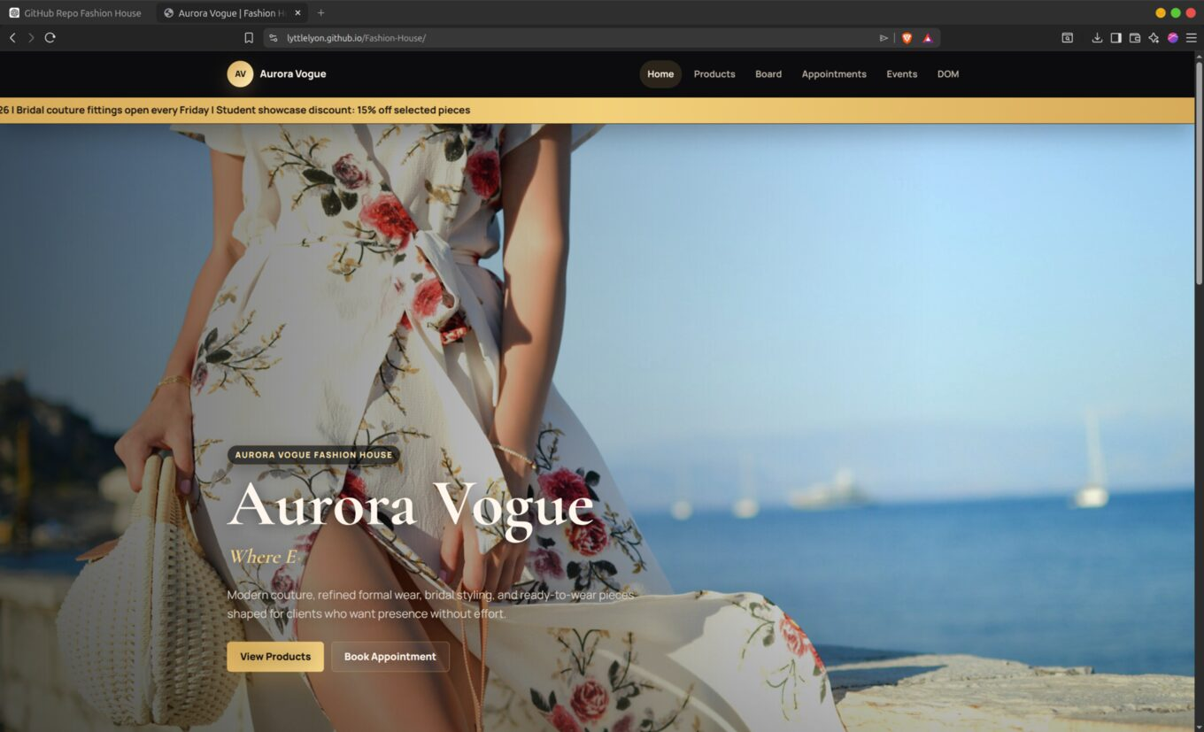
Figure 1. Aurora Vogue homepage with hero branding and primary navigation.

Products
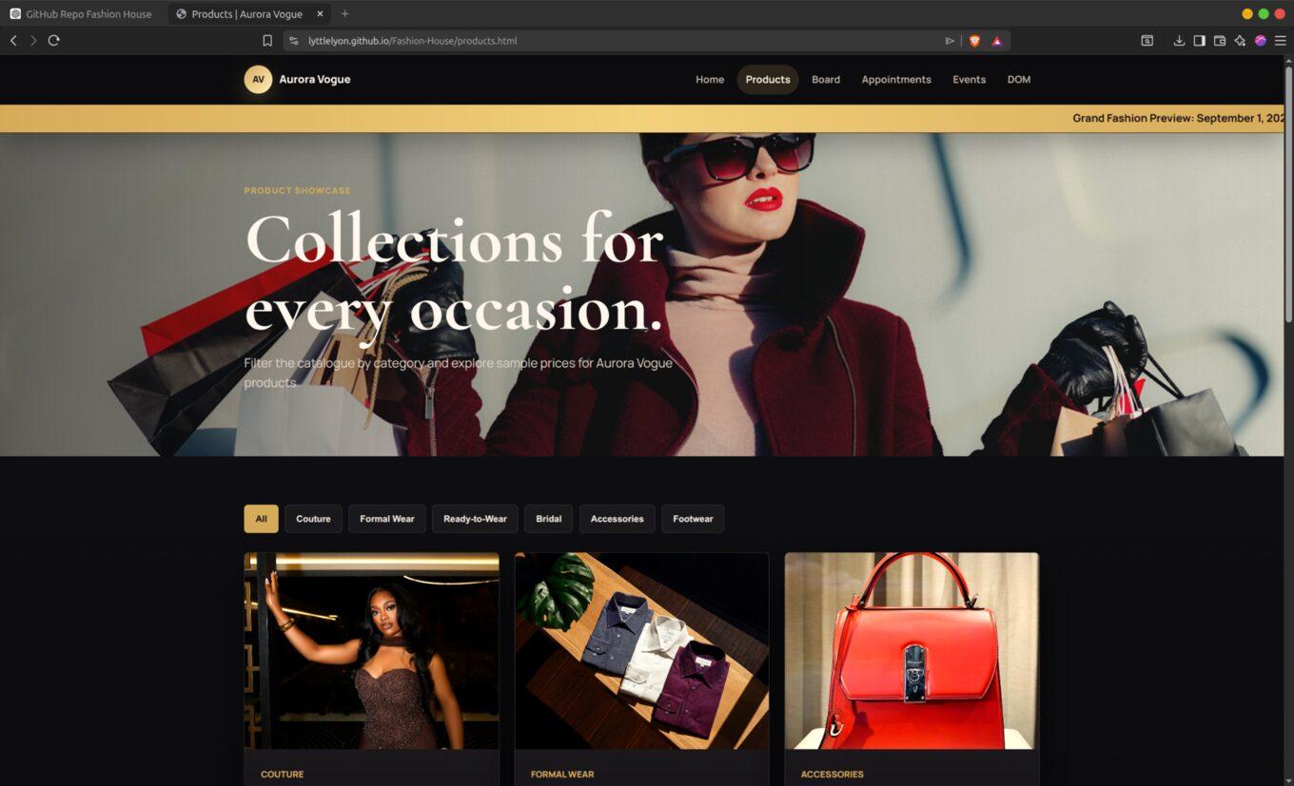
Figure 2. Product catalogue with category filters and visual product cards.

CONTINUED

Website Screenshots

Events
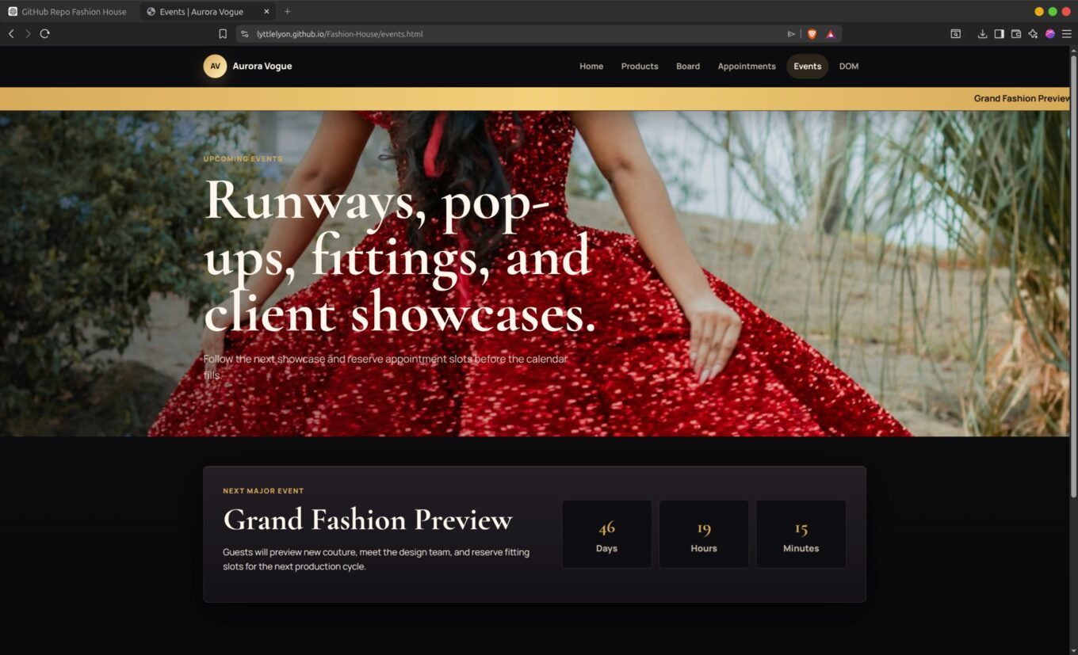
Figure 3. Events page highlighting the Grand Fashion Preview countdown.

Board
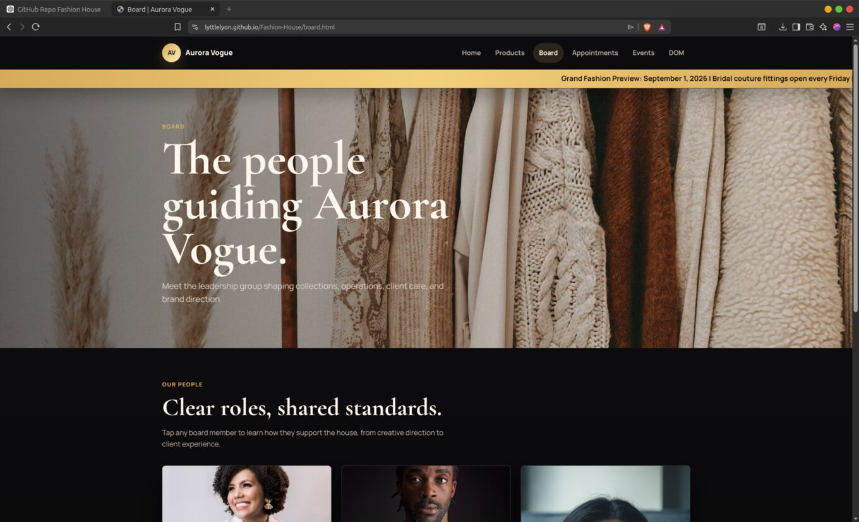
Figure 4. Board page introducing the people guiding the fashion house.

CONTINUED

Website Screenshots

Contact / Appointments
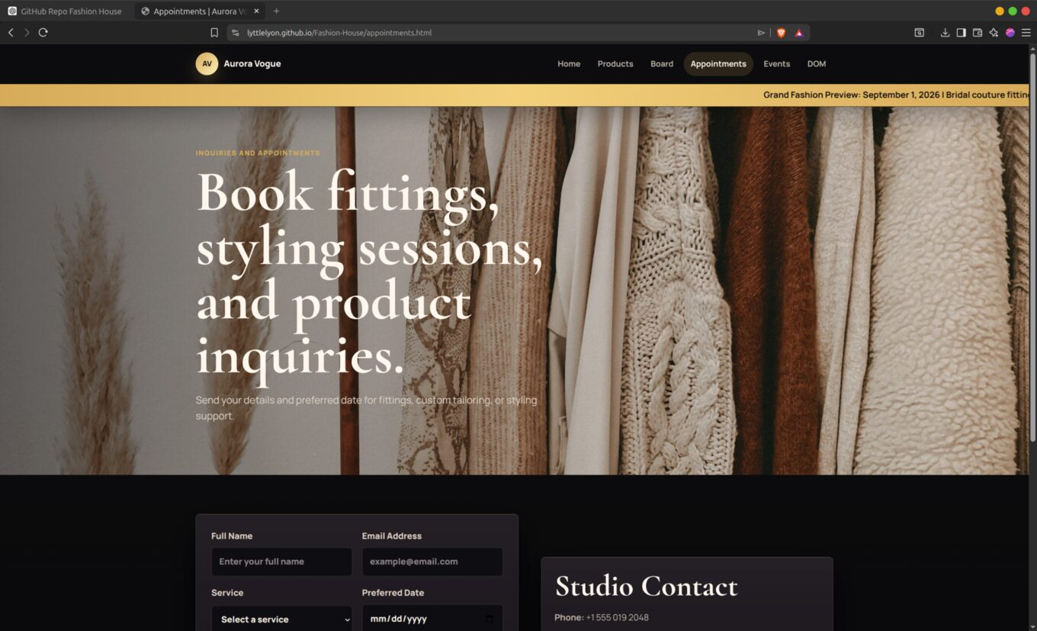
Figure 5. Appointment form and studio contact information.

Source Code & Supporting Files
The complete source code and supporting project files are available in the GitHub repository listed below.

Live Website
https://lyttlelyon.github.io/Fashion-House/

GitHub Repository
https://github.com/lyttlelyon/Fashion-House

Conclusion
Aurora Vogue is a completed, responsive fashion-house website that combines clear navigation, visual product presentation, interactive page features and consistent styling. The final result meets the project’s core multi-page, JavaScript, styling and DOM-documentation requirements in a cohesive user experience.

