Student Course Management System
COS 201 Programming I - Mid-Semester Lab Assessment Report
Full Name | ________________________________________
Email Address | ________________________________________
Department | ________________________________________
Matriculation Number | ________________________________________
System Summary
The Student Course Management System is a Java Swing application that helps a student record and manage semester courses. It stores course code, course title, and unit values, displays all recorded courses in a table, calculates total units, searches courses by code, and saves or loads course records from a text file.
Major Features
• Add Course records validated course details and stores them in the course list.
• View All Courses displays saved course records clearly in the recorded courses table.
• Search Course by Code locates a matching course and shows its details to the user.
• Compute Total Units automatically sums all course units and displays the result.
• Save to File and Load from File preserve course records using courses.txt.
• Exit closes the program and prompts the user to save unsaved changes before leaving.
Error Handling and Recursion
Invalid entries such as empty fields, duplicate course codes, non-numeric units, and failed file operations are handled with validation, exceptions, and clear dialog messages. File loading also skips invalid or duplicate records safely. Recursion is applied in CourseManager.recursiveSearch(), which searches through the course list by checking one course at a time until a match is found or the list ends.

Program Screenshots
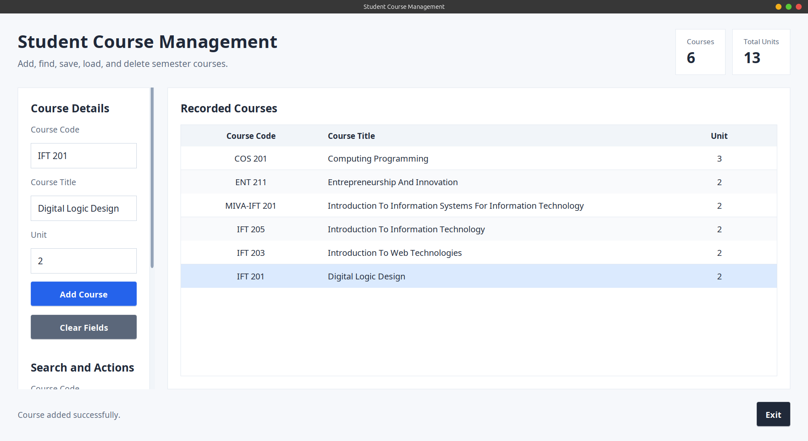  Figure 1: Adding and viewing recorded courses. | 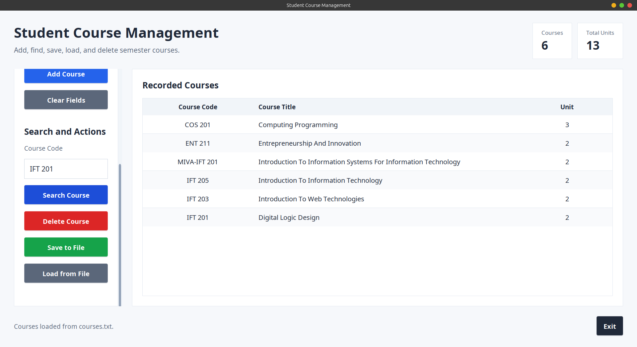  Figure 2: Loading saved courses from file. | 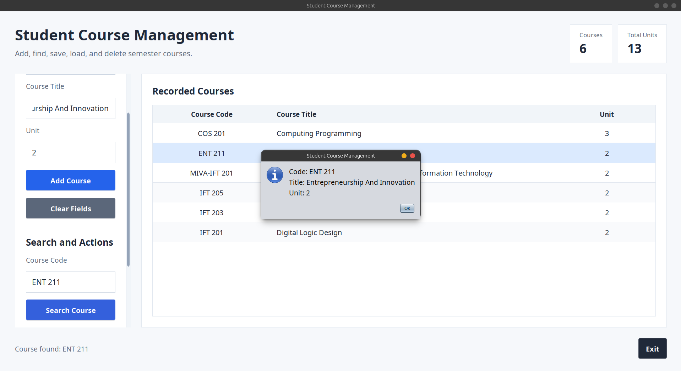  Figure 3: Searching for a course by code.
The screenshots show the working graphical interface, recorded course table, file loading status, and course search result dialog.

