1. What is Boolean? Write down 3 different expression that results a Boolean type (i.e. 5 == 6)

Boolean chỉ có 2 giá trị: true và false

VD: 5==6; 2 ===3; 1<=2

1. What is a flow chart? Draw flow chart for the following code snippet: (you can draw on a paper, take a picture of it)

Flow chart là sơ đồ logic hình học

if name == “Huy be":

    print(“Hand some")

elif name == “Huy big":

    even_more_handsome = True

else:

    webbrowser.open(“<https://www.youtube.com/watch?v=04854XqcfCY>”)

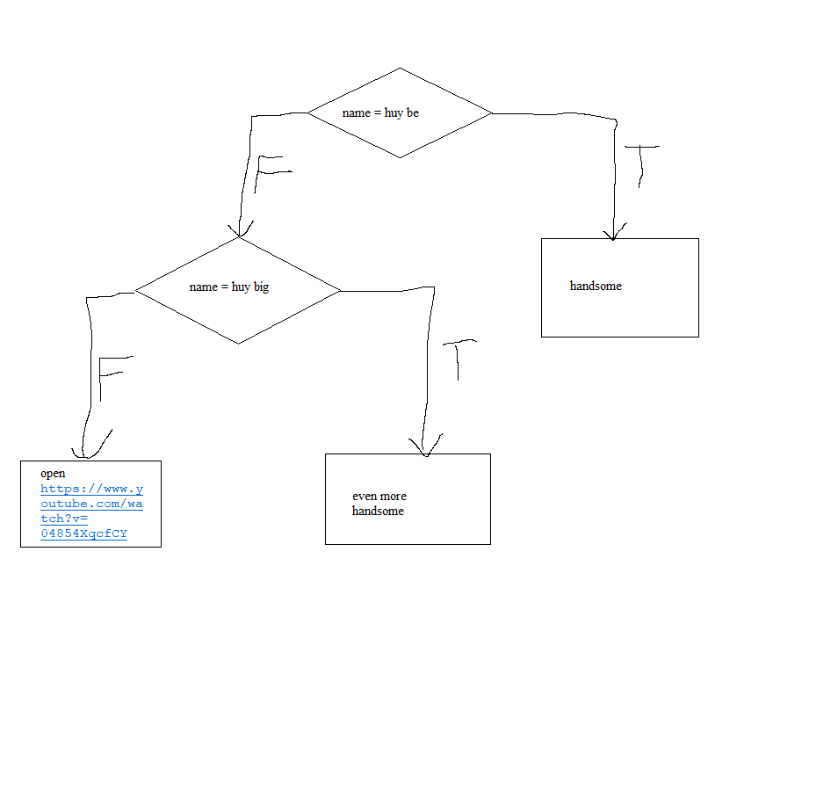

1. What is nested conditionals? Write a piece of code that uses nested conditionals

Là sử dụng cấu trúc if-else trong 1 cấu trúc if-else khác

VD:

if (ammo < 28){

if (ammo < 10){

alert(“RELOAD!!!”);

}

else{

alert(“DON’T RELOAD!!!”);

}

}

else{

alert(“SWEATING PROFUSELY”);

}