# T5-dlrobotics

PPO2:
policy based on discrete space. which leads to bad perfomance in Reacher-v2 environment

SAC & DDPG:
policy based on continuous space. Thus better performance than PPO2.

The results of another laboratory: (Picture from https://awesomeopensource.com/project/medipixel/rl_algorithms)
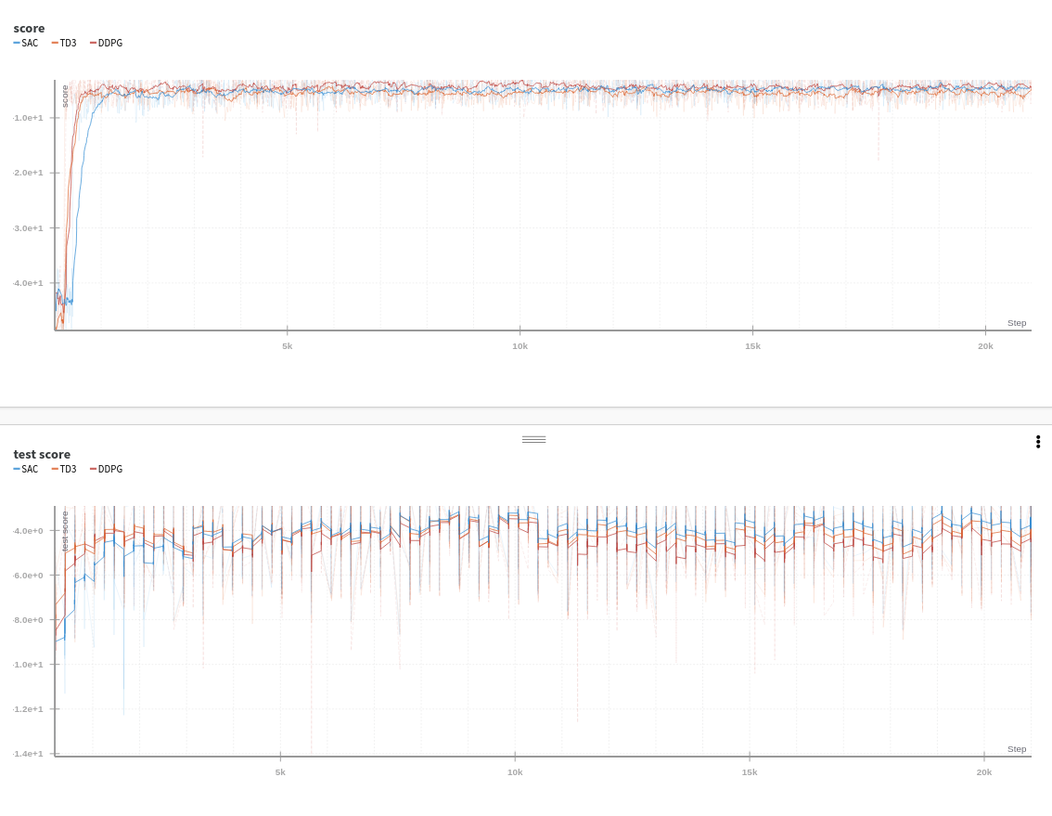
DDPG performance better than SAC, which satisfy the results of Stable Baselines.

Next work:

1. If we extend the step length of prediction, will the performance be better? (eg. agent reaches the ball)
2. Why the loss of DDPG gets bigger when the agent even performance better during the increasing of timesteps?
3. Is istright: PPO2 is episodic policy, while SAC and DDPG are step-based policy.
4. Should we write a policy based on movement primitives? (but movement primitives already got the solution of the weights (s.Picture below), what should the agent learn?)
