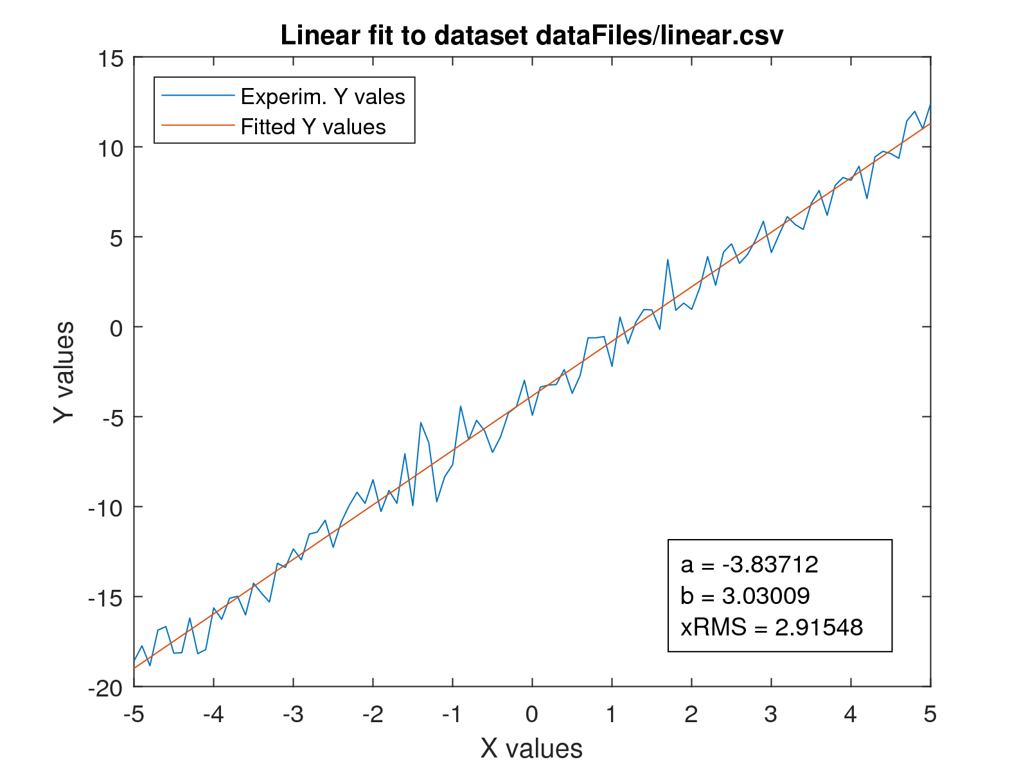

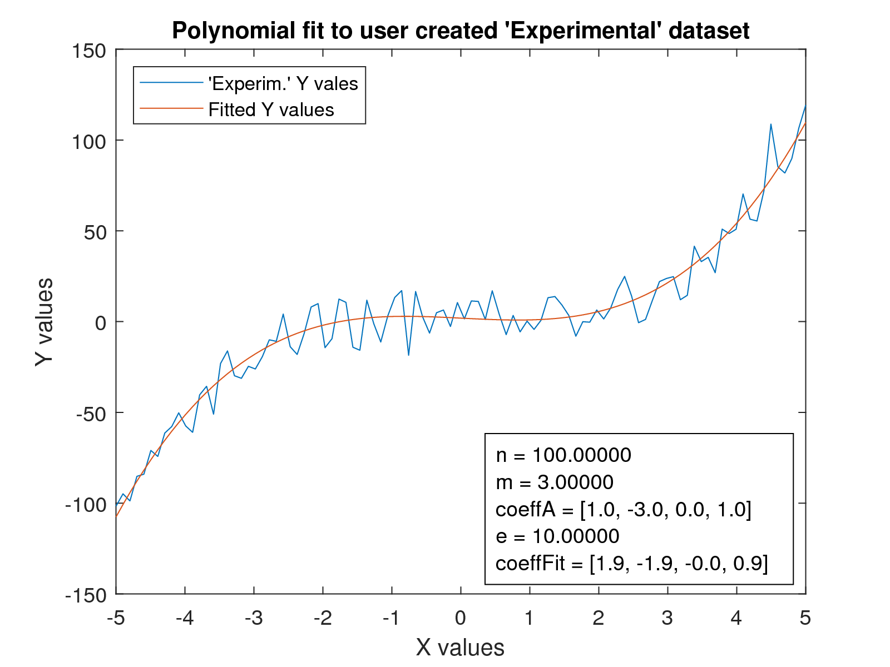

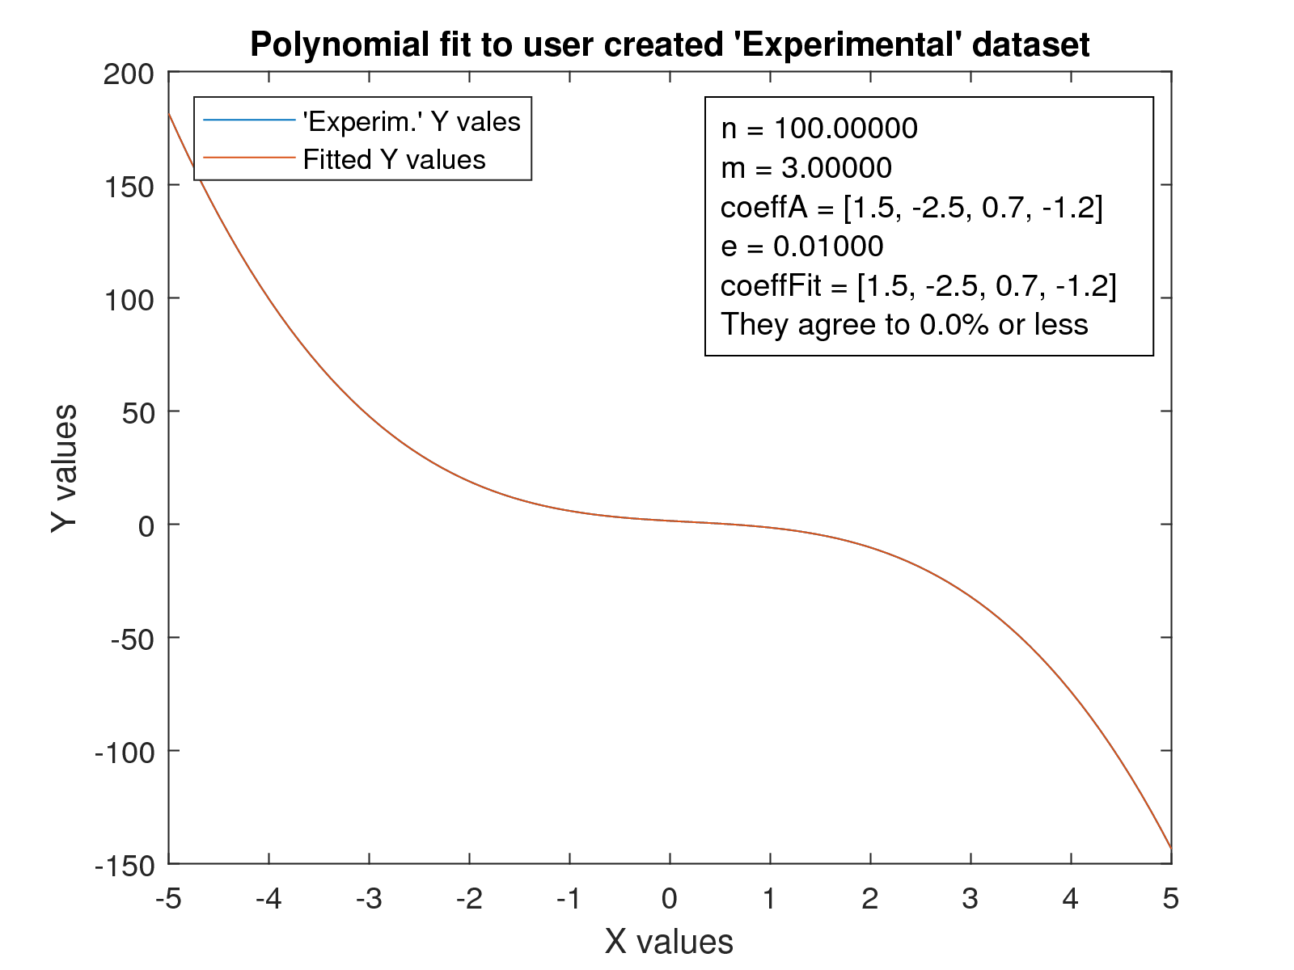

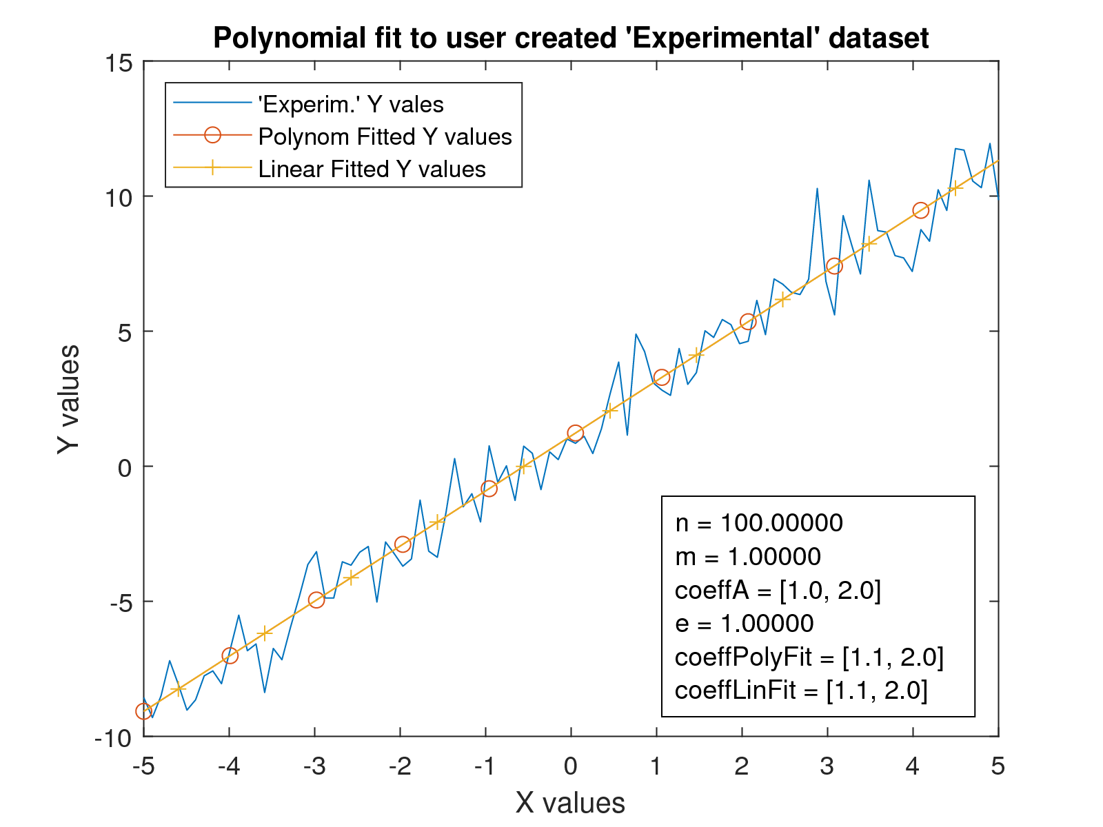

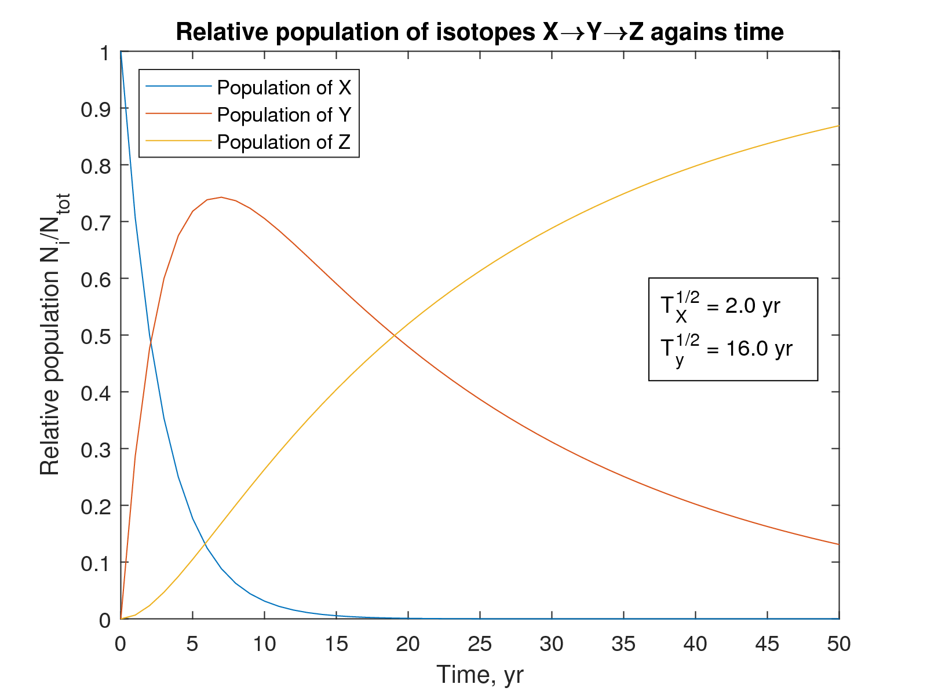

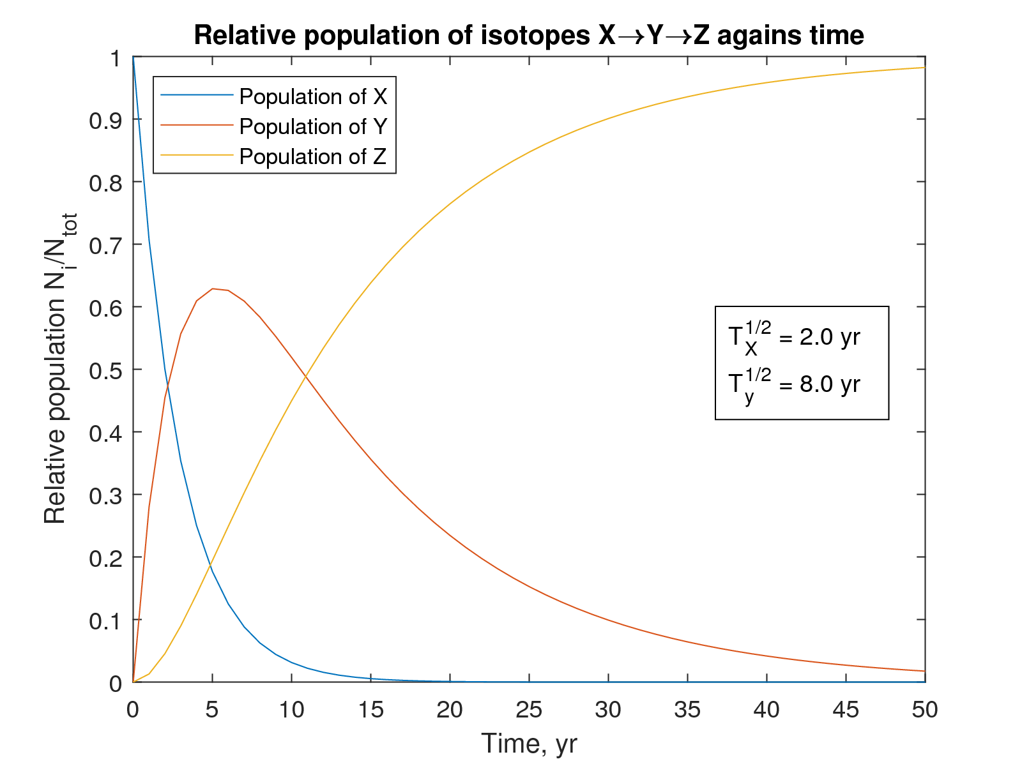

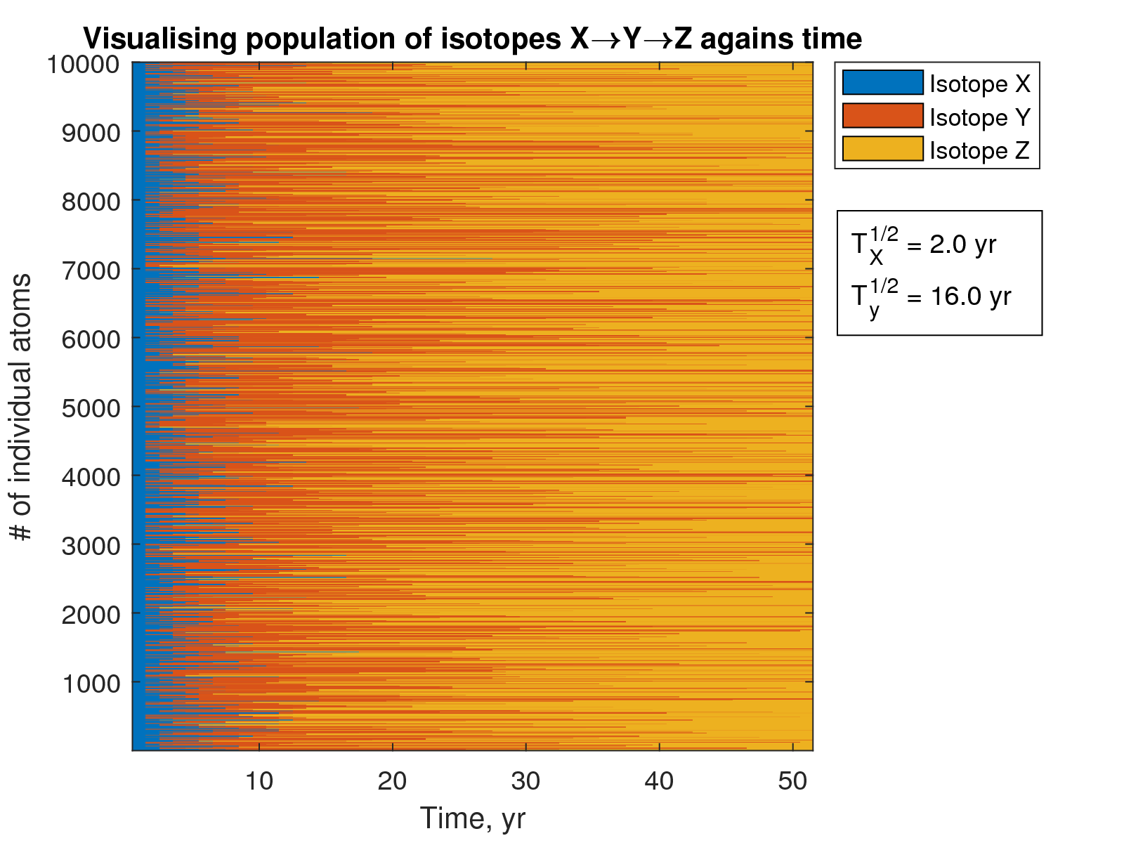

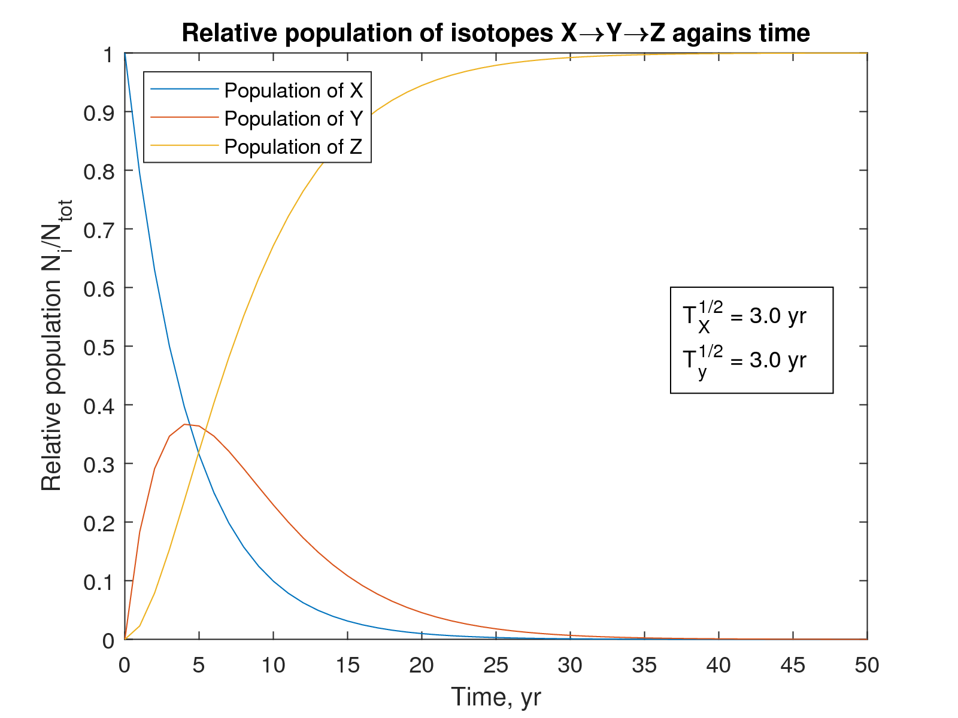

| x| erf| n = 1| n = 10| n = 100|

|---|------------|------------|------------|------------|

|0.2|0.2227025892|0.2227040127|0.2227025894|0.2227025892|

|0.4|0.4283923550|0.4284306410|0.4283923587|0.4283923550|

|0.6|0.6038560908|0.6040666237|0.6038561102|0.6038560908|

|0.8|0.7421009647|0.7426040198|0.7421010113|0.7421009647|

|1.0|0.8427007929|0.8431028300|0.8427008506|0.8427007930|

| Bisection| New-Raph| fzero()|

|------------|------------|------------|

|3.1310197202|3.1310197202|3.1310197202|