**User Guide**

*Using the Readers’ Society Console Application*

Greetings, fellow book worm! This document will teach you how to find the perfect book for any occasion by using our very own console application. Follow these steps, and let our advanced search algorithm take care of the rest:

1. Go to any computer in the Readers’ Society Bookstore in Blagoevgrad. Usually, the application is open, and you can move on to the second step, but if it isn’t, just click on the “book search” icon in the taskbar:

Once you click the icon, a new window should appear on the screen that looks like this: 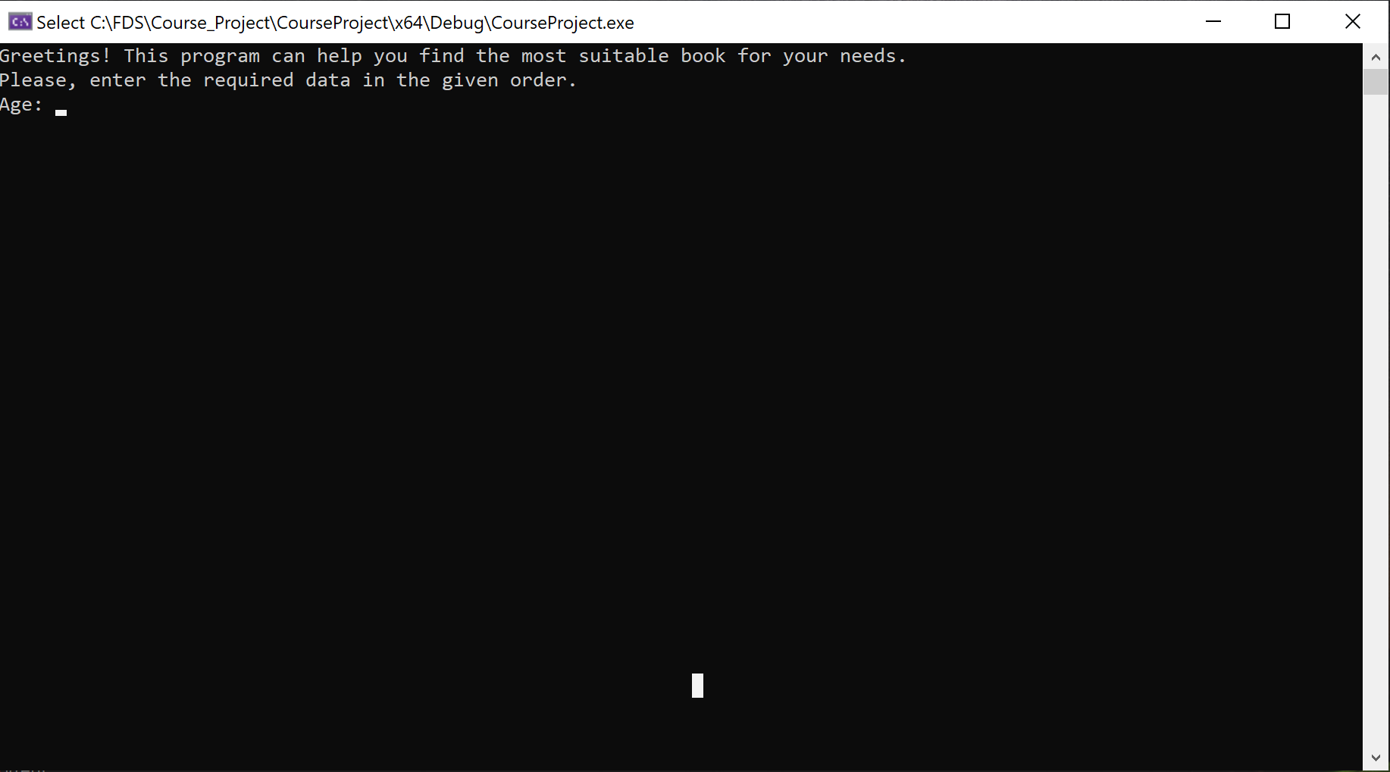

1. You will be asked to enter specific information that will be used to evaluate which books suit you the most. First, you need to type in your age.

Note: If you misspell something or enter the wrong information at the wrong time, the program will keep prompting you until it receives valid input.

1. Enter the maximum price you are willing to pay for a book (in US $).
2. Enter your gender – male, female, or other.
3. Enter the context, or put more simply, the reason you want to buy a book. Choose one answer from these: school, vacation, home, work, gift.
4. Enter a personal interest of yours: sport, science, technology, celebrities, history, mythology. If these categories don’t match any of your interests, then input the category that is closest to your actual interests.

Note: In steps 5-7, the words can start either with an uppercase or lowercase letter. But make sure that there are no uppercase letters in the middle or at the end of a word.

1. The program will output the five most suitable books for you, ranked by their “grade”, which is a quantitative measure of how suitable each book is for your specific preferences. The output should be something of this sort: 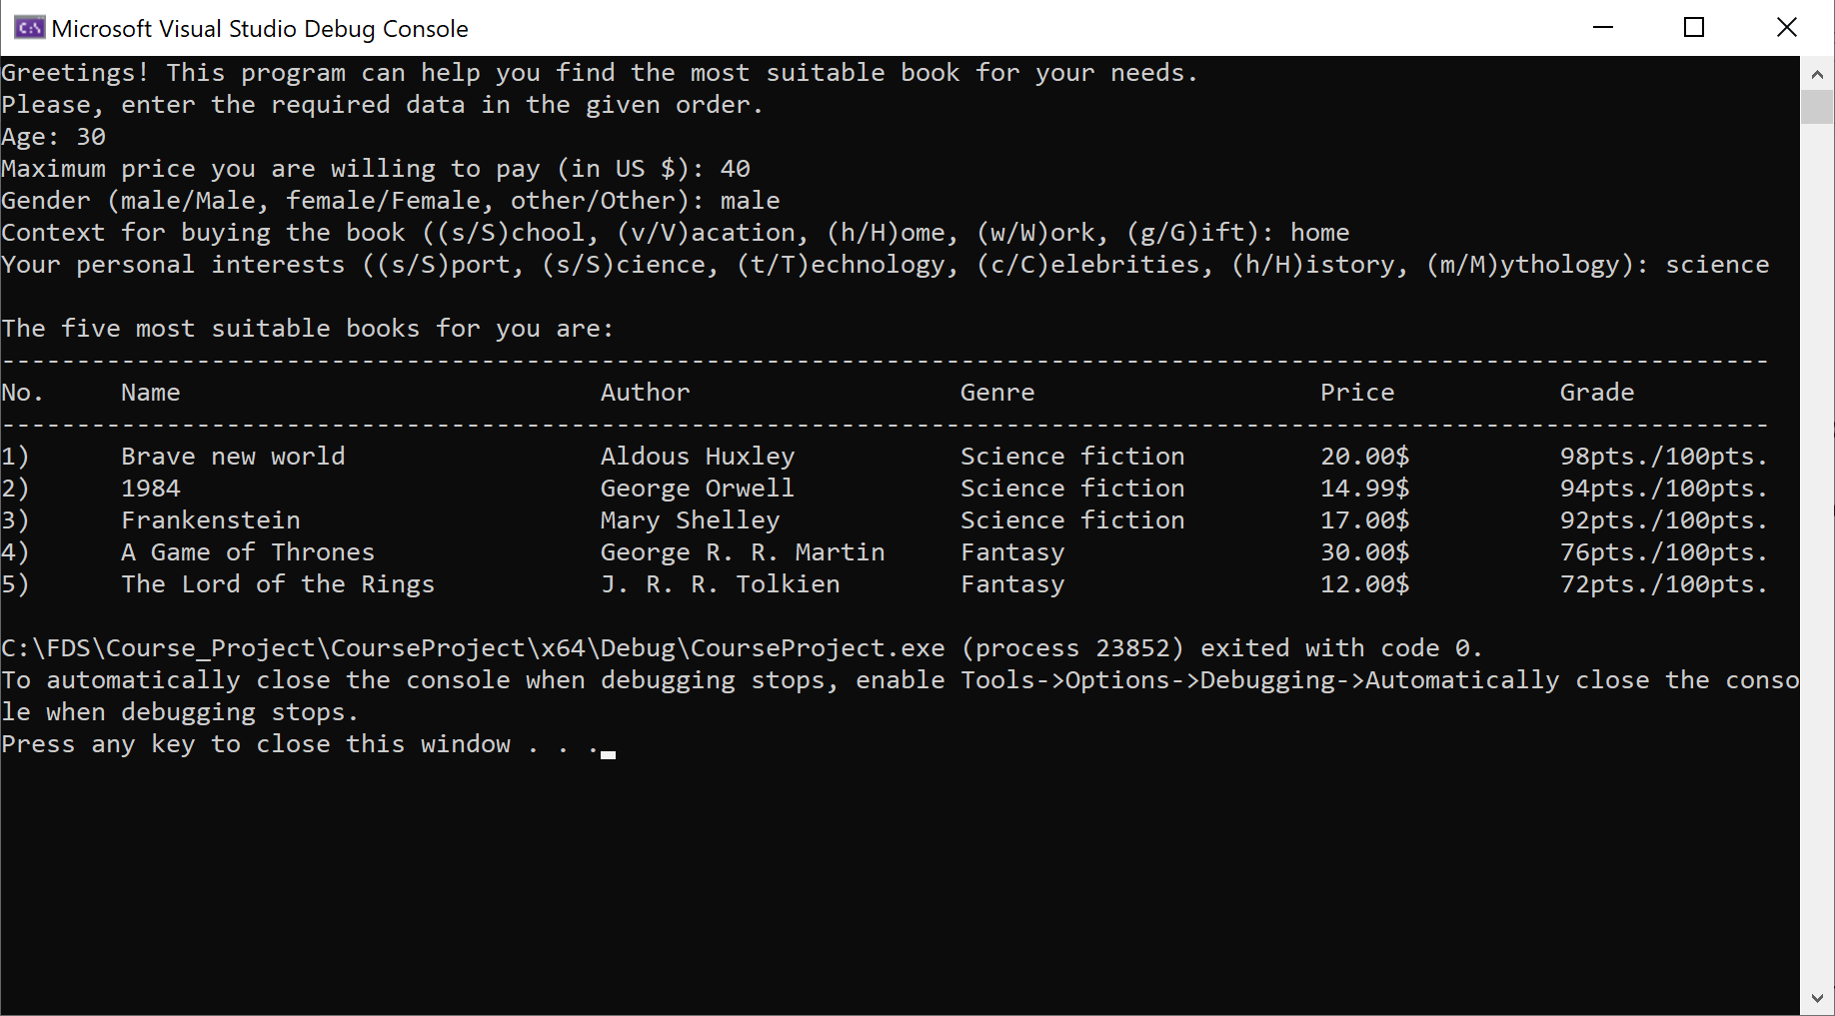

Note: If a bug occurs in the program, please contact a Readers’ Society employee. They will help resolve the issue as fast as possible.

1. Choose which book(s) seem(s) most enticing and head on over to the cashier’s desk to make your purchase.
2. Enjoy!