WORKING DRAFT | 29 July 2025
Renewal decision brief
Foxglove contract renewal review for Gallowspring Associates. Prepared for Damaris Hartnett.
18.57  incidents per 100,000 hours | Revised incident rate - challengedPeriod end: 30 June 2025  Draft basis: latest incidents / earlier exposure  Status: revised working figure

Draft recommendation
Use the revised rate to show a material deterioration and proceed on that basis.

Draft review notes
The draft compares the later incident count with the earlier service-hour total.
The chart and supporting narrative have not yet been reconciled to the authorisation record.
A corrected pack is required for the Friday renewal decision.

WORKING DRAFT | analysis pending review
Aligned incident-rate analysis
The revised view suggests that England and Wales has deteriorated sharply. The comparison below is retained pending final checking.
Jurisdiction | Incidents  10 Jul 2025 | Hours  03 Jul 2025 | Draft rate  per 100,000 hours
England and Wales | 11 | 48,000 | 22.92
Scotland | 2 | 22,000 | 9.09
Overall | 13 | 70,000 | 18.57

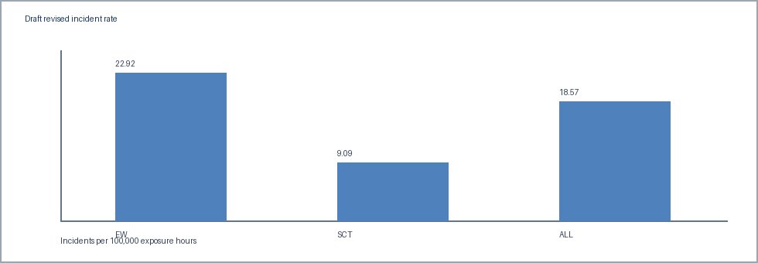
Draft chart: mixed dated values. Unit: incidents per 100,000 exposure hours.
Outstanding point
Confirm whether the compatible overall movement meets the contractual materiality threshold before characterising the change for counsel.

WORKING DRAFT | bridge pending review
Authorized change bridge
The revised total contains several authorised adjustments. Detail is not yet included in this draft.
Change | Count effect | Hours effect | Draft note
Addition |  |  | Pending confirmation
Withdrawal |  |  | Pending confirmation
Reclassification |  |  | Pending confirmation
Exposure correction |  |  | Pending confirmation

Reconciliation frame
Opening compatible baseline: [to be reconciled]
Approved count effects: [to be reconciled]
Approved exposure effects: [to be reconciled]
Closing authorised restatement: [to be reconciled]

Authorised bridge chart frame

WORKING DRAFT | counsel completion
Counsel decision record
Foxglove renewal review. Complete by hand after review of the corrected analysis.
Renewal decision
Decision date
Counsel initials
Conditions / follow-up

Analyst hand-off: the final pack should state the supported rate and factual reconciliation only; counsel records the renewal decision here.

