Howto correct the frequency of the nRF905 module

Author: sp@albatros-tech.eu, Stefan Pielmeier

Date: 2018-11-23

My nRF905 created a EU frequency that was 868.435 or 868.235 MHz.

The frequency error of the TX frequency was therefore 35kHz. That was way too much to achieve:
- beeing received by the OGN tracker
- beeing received by my other SoftRF (based on TTGO, which is 3.5kHz below correct frequency).
- receiving transmissions from other SoftRF

In order to correct the problem, I tried to correct the frequency in Software. However, that is not possible as the nRF905 chip is programmed by “band” and therefore does not allow fine tuning of the channel by smaller frequencies.

Additionally, the crystal on the nRF905 board is not voltage controlled. Therefore, manual tuning was chosen. The nRF905 board implements the crystal as shown in [1], pg. 2:

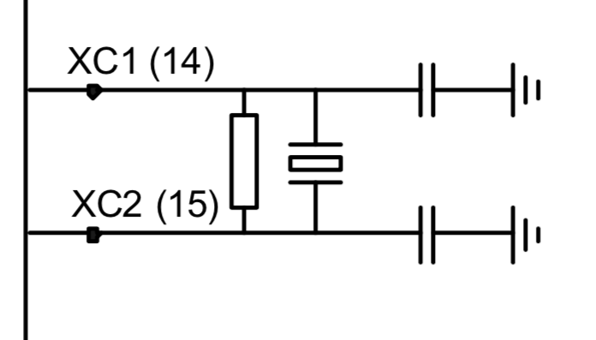

2 additional 4.7pF condesators are added in parallel to the 2 existing ones. Just solder them on top of the existing ones. Take approx. 5pF per 15kHz error in total.

So if your error is +30kHz, just add 2*4.7pF. If your error is +35kHz, add a bit more, etc.

There are limits for what can be achieved. The Crystal might eventually stop to swing as required if tuned too much.

Testing: implement an OGN receiver with a raspberry pi and RTL-SDR. These are frequency corrected by GSM signals (if available in your area) and can show the frequency error quite exactly.

A well calibrated frequency counter can also be connected to the antenna output with a 10dB attenuator to show the TX frequency. As the SoftRF only transmits while having proper GPS position, you need to esure that before measuring.

References:
[1] nRF905 chip datasheet, rev. 1.1, June 2004

