Melbourne city pedestrian traffic

Yiwen Liu

2020/7/21

library("rwalkr")  
start_date=as.Date("2017-07-01")  
ped_walk=melb_walk(from = start_date, to = start_date + 6L)  
library("ggplot2")  
ggplot(data=subset(ped_walk,Sensor == "Melbourne Central")) +  
 geom_line(aes(x = Date_Time, y = Count))

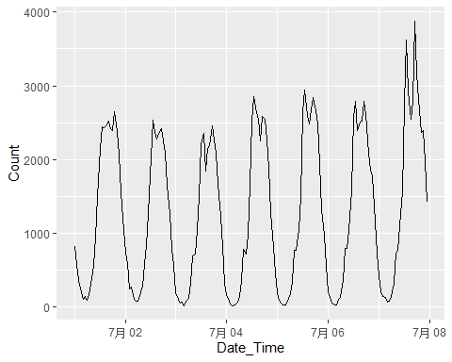

A Small Sample Table.

|  |  |  |  |  |
| --- | --- | --- | --- | --- |
| Sensor | Date_Time | Date | Time | Count |
| Bourke Street Mall (North) | 2017-07-01 | 2017-07-01 | 0 | 280 |
| Bourke Street Mall (South) | 2017-07-01 | 2017-07-01 | 0 | 177 |
| Melbourne Central | 2017-07-01 | 2017-07-01 | 0 | 826 |
| Town Hall (West) | 2017-07-01 | 2017-07-01 | 0 | 682 |
| Princes Bridge | 2017-07-01 | 2017-07-01 | 0 | 0 |

$$s^{2}=\sum_{i=1}^{n}{(}x_{i}−\overline{x})^{2}.$$