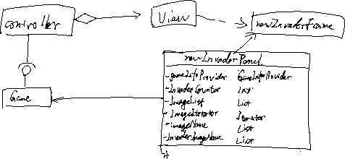



For this assignment, the laser has been fixed really (can shot faster) and the new windows added successfully.

So I think the level should be vi