选择性必修（二）Unit 1 Science and scientists 课堂设计---单元备课
项目 | 内容
课程分析 | 主题语境  课标及课程大概念分析 | 【课程大概念】  1.了解中外科学家的重要贡献及其性格特点和高尚品格,深入理解科学精神的内涵,树立开拓创新、坚忍不拔、艰苦奋斗的观念。  2.了解中国科学技术发展的伟大成就，坚定文化自信。思考科学与生活、科学与艺术、科学与未来发展的关系。  3.分析、提炼、概括科学精神的主要特点，深化对科学及科学研究本质的认识。  4.理解质疑精神的意义,学会批判性地思考,形成自己的观点与看法。  【学科大概念】  1.能够口头叙述自己参与科学探究活动的经历，并描述常见的科学现象；  2.能够结合具体的事例阐释自己对科学精神的内涵和基本要素的理解。  【课标分析】  在以主题意义为引领的课堂上，教师要通过创设与主题意义密切相关的语境，充分挖掘主题所承载的文化信息和发展学生思维品质的关键点，基于对主题意义的探究，已解决问题为目的，整合语言知识和语言技能的学习与发展，将特定主题和学生的生活建立密切关系，鼓励学生学习和运用语言，开展对语言、意义和文化内涵的探究。  在主题探究活动的设计上，要注意激发学生参与活动的兴趣，调动学生已有的基于该主题的经验，帮助学生建构和完善新的知识结构，深化对该主题的理解和认识。  通过一系列具有综合性、关联性特点的语言学习和思维活动，培养学生语言理解和表达的能力，推动学生对主题的深度学习，帮助他们树立正确的世界观、人生观和价值观。
学习  目标 | 单元目标设计 | By the end of the unit, you will be able to:  1. read about people of achievement and their contributions.  2. hear and talk about great people.  3. write an introduction about someone you admire.  4. explore what greatness means and how it is achieved.
单元学时划分  学习阶段 |  | 学习阶段 | 核心任务 | 学时
 |  | Overall Perception | List the significance of science and scientists. | 2 periods
 |  | Exploration & Construction | Explore the importance of the questioning mind. | 4 periods
 |  | Application & Transfer | Write about what makes a great scientist. | 2 periods
 |  | Reconstruction & Extension | Reconstruct and expand the mind map of science and scientists. | 3 periods
单元四大结构 |  | 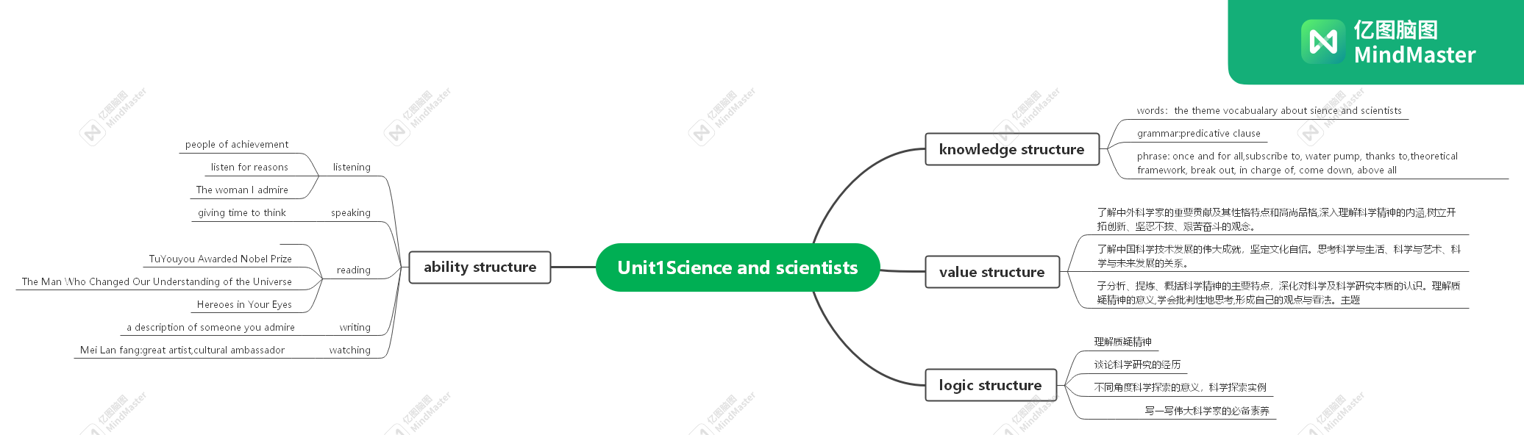
选择性必修（二）Unit 1 Science and scientists
---Write about what makes a great scientist 课堂设计
项目 | 内容
文本分析 | 主题语境 | 本语篇的主题语境是人与社会，主题群是-科学与技术，主题语境内容要求是对社会有突出贡献的人物。
文本分析 | 语篇类型 | 人物传记
文本分析 | 主要内容 | 该部分的活动主题是写一写伟大科学家的必备素养，要求学生通过钱学森和霍金的人物传记，结合自身体验和知识积累写一篇文章，分析伟大科学家的品格和素养，阐述科学精神的内涵。
文本分析 | 文体结构 | 第一篇文章“The Father of China's Aerospace”按照时间顺序概述了钱学森的一生，重点介绍士他面折的求学报国经历，以及他回国后克服困难，在航天科技领域所做的开创性工作，文末还提及他广泛的爱好，以及这些爱好对他开展科学研究的积极影响。第二篇文章“入 Worid of Pure Though”重点讲述了霍金早期成名的经历，突出了他顽强地与疾病作斗争、敢于质疑、坚持梦想、勇于承认错误等可贵品质。
文本分析 | 语言特征 | （1）选取典型事件，用以突出人物的个性和品质，即“借事记人”  （2）在写作策略和技巧上，两个语篇都有效使用了一些衔接词语，如:however、nevertheless,because、in general、besides、furthermore、abgve all等。关注语篇的衔接和连贯是对学生写作能力的较高要求。
其他  分析 | 学情分析 | 本节课面对的学生是昌乐二中高二学生理化生的学生，大多数学生对航天发展了解较少，对钱学森和霍金的事迹了解很少，文本理解对学生而言难度较大。但是大多数学生对科技很感兴趣，，学生英语基础较好，这是本堂课能顺利推进的原因。
其他  分析 | 教学资源及手段分析 | - Adopt task-based teaching method, group discussion and motivational teaching method;  2. Make clear the overall design of this unit and the arrangement of this lesson by using the program design;  3. 271bay;  4. draw the mind map of the structure;  5. Look at the video and some pictures about the achievements of the space.
学习  目标 |  | 1. To learn the life stories of Qian by reading.  2. To summarize the good qualities of Qian as a great scientist .  3. To outline how to write about a great scientist.  4. To write an essay about the scientific spirit
学习阶段 |  | Application & Transfer
课时 |  | 7-8课时
学习任务创造 |  | 学习过程实施 | 学习领导力提升
Step1: lead-in  Step2:read for the structure  Step3: read for important stories  Step4:  Reread paragraph3 and find out what Qian did during the 1930s and in the 1940s.  Step5: go over the mind map and find what other story you can find about Qian  Step6: read Para6 and find the author’s assessment of him.  Step7: go over the mind map and think about a question:why does the author mention so many stories of Qian?  Step7:Discussion ：What qualities are expressed in each of the following events?  Step8: go over the mind map and summarize the writing skills  Step9 : read the following paragraph find the writing skills.  Step10 : read the following paragraph find the writing skills.  Step11:go over the mind map and get the all the skills.  Step12 read a world of pure thought and summaries the qualities of Stephen Hawking referring to the writing skills from Qian xue sen  Step13:Scan the information and find the similarities between Qian wei chang and Qian xue sen.  Step14: writing  Step15: polish the writing according to the version |  | Learn these pillars of the great power by a video and some pictures  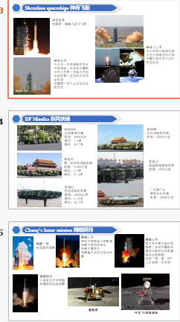  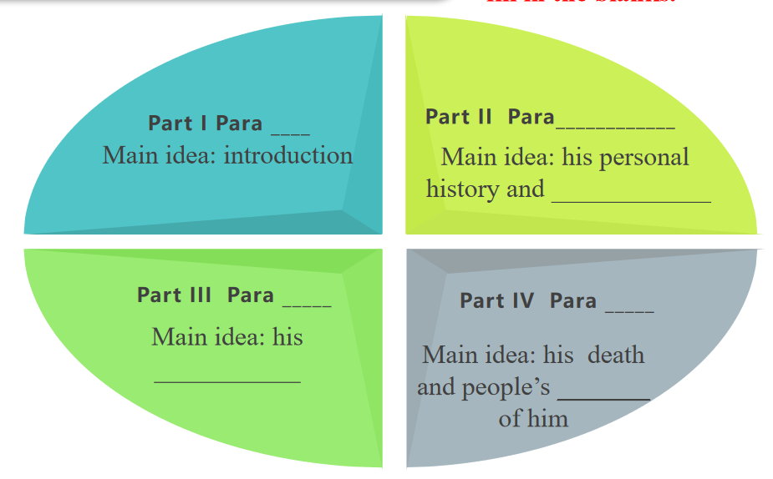  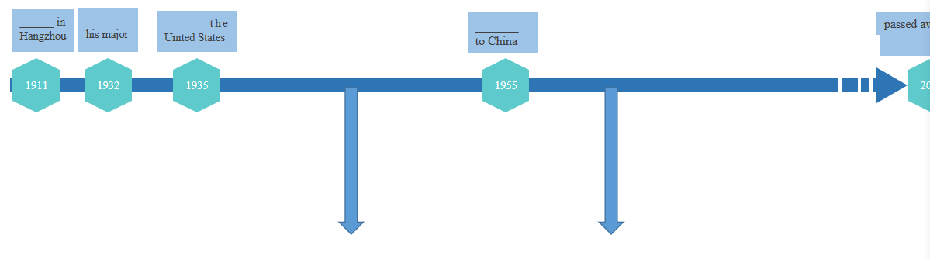  (1) During the 1930s ___________important research into rocket propulsion  (2) In the 1940s he and several people________ the Jet Propulsion Laboratory  2. Reread paragraph4 and find out what Qian did after he returned to China.  He _________ not only developing China's rocket science but also its space and missile programme  - Reread paragraph 5 and find out what accomplishments Qian made.  (1)_____________ of Long March rockets;  (2) Dongfeng_________;  (3)_________________, Dong Fang Hong I  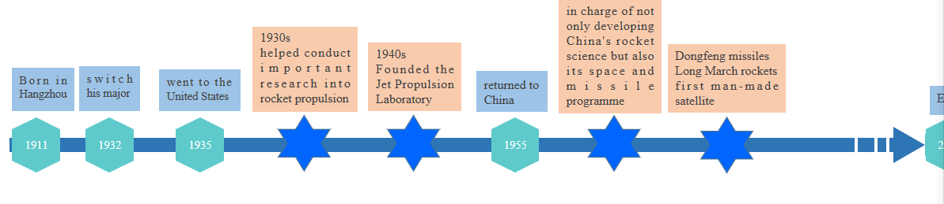  Qian read a lot and was extremely knowledgeable especially in the area of frontier science research. However, what might have made him such an outstanding and creative scientist was probably his strong interest in other things, such as music and drawing. His deep appreciation for art often gave him inspiration in his scientific research.  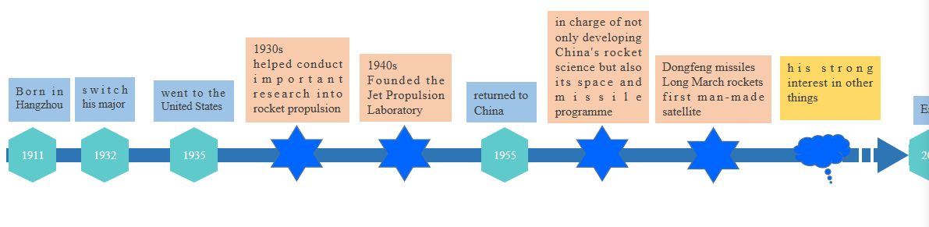  - However, after the Songhu Battle broke out in 1932, Qian made the decision to switch his major to aviation because he realised that China needed its own powerful air force to protect and defend the country.  - Qian went to the United States in 1935 to pursue his graduate studies.  - As a graduate assistant at the California Institute of Technology during the 1930s, Qian helped conduct important research into rocket propulsion.  - in the 1940s, he and several other people founded the Jet Propulsion Laboratory, now one of NASA's leading space-exploration centres .  - 5. After overcoming some difficulties during his final few years in the US, Qian returned to China in 1955.  - He was put in charge of not only developing China's rocket science but also its space and missile programme.At that time, China was poor and its rocket science was undeveloped. No institute or university in China offered rocket science as a major, and there were no talents or experts in this field in China.  7. However, what might have made him such an outstanding and creative scientist was probably his strong interest in other things, such as music and drawing. His deep appreciation for art often gave him inspiration in his scientific research.  8.Under Qian's leadership , China developed the Dongfeng missiles, followed by the first generation of Long March rockets. In 1970, China successfully launched its first man-made satellite(发 Dong Fang Hong I, from a Long March rocket.  (1) patriotism (2) responsibility （3） exploring scientific truth （4） cooperation (5)responsibility (6) firm faith (7) leadership （8）interest and enthusiasm ......  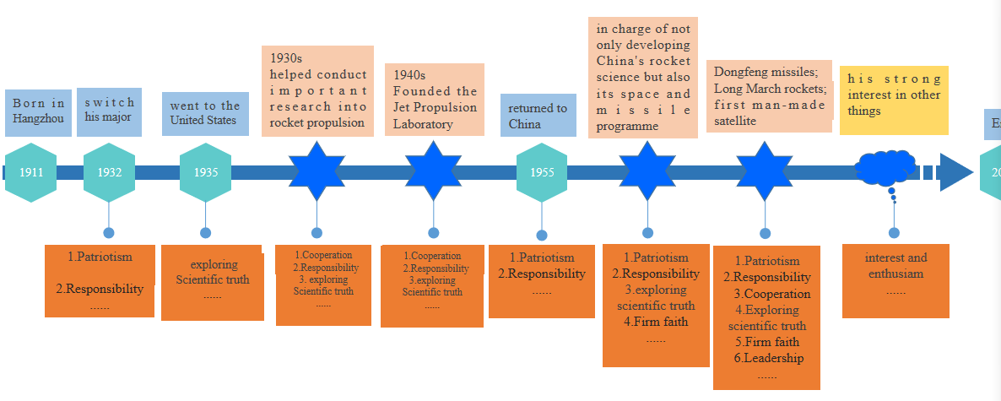  Para 2:  ..... However, after the Songhu Battle broke out in 1932, Qian made the decision to switch his major to aviation because he realised that ....  Para 4：  ...... . At that time, China was poor and its rocket science was undeveloped. No institute or university in China offered rocket science as a major, and there were no talents or experts in this field in China. Nevertheless, Qian did not let .....  Para 5：  ....China successfully launched its first man-made satellite Dong Fang Hong I, from a Long March rocket. Because much of the technology behind the Shenzhou rockets .....  Para 1：Perhaps no other scientist has had a greater impact on China’s aerospace science than Qian Xuesen. Described by the authors of the Story of Qian Xuesen as a man with .......  Para 2:He was put in charge of not only developing China's rocket science but also its space and missile programme. At that time, China was poor and its rocket science was undeveloped. No institute or university in China offered rocket science as a major, and there were no talents or experts in this field in China.  2minutes for students to find the writing skills  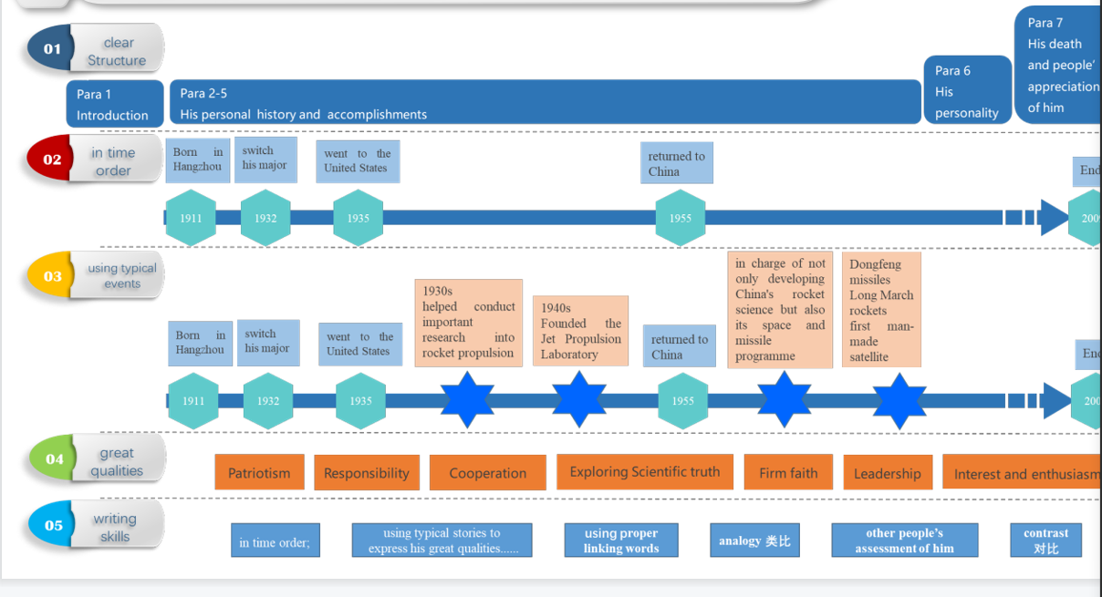  What personality and qualities in Stephen Hawking helped him with his work and made him one of the greatest thinkers of the 20th and 21st centuries?  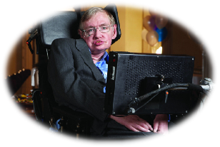  An introduction to Qian Wei chang  Qian Wei chang is a famous Chinese mechanist（中国著名的力学家）, applied mathematician(应用数学家), educator and social activist(教育家和社会活动家). He is one of the founders of modern Chinese mechanics and applied mathematics(中国近代力学、应用数学的奠基人之一),Chinese Academy of Sciences(中国科学院院士), president of Shanghai University(上海大学校长), honorary president of Nanjing University of Aeronautics and Astronautics(南京航空航天大学名誉校长), honorary president of Yaohua Middle School(耀华中学名誉校长).  Finish an essay  1912年10月9日，钱伟长出生在江苏无锡。初中毕业后，祖母和母亲希望他尽快就业。渴望继续学习的钱伟长，就拼命帮家里干活。幸运的是，争取到了读高中的机会。动荡年代，他的小学和初中加起来读了不到五年。上高中的钱伟长经常挑灯夜读。也恰恰是这段经历，练就了钱伟长吃苦耐劳、勇于担当的品质。  1931年9月10日，钱伟长就读清华中文系。“九•一八”事变后，钱伟长决定弃文学理，要科学救国。四年后，他成了清华大学物理系最出色的学生。  1940年去加拿大多伦多大学。钱伟长得到了世界导弹之父--冯•卡门的赏识。1942年，在美国国家喷射推进研究所。他与钱学森共同完成了美国第一枚导弹的设计工作。  1946年8月6日，他只随身带了简单的行李和几本书籍，回到清华。回国后，他负责清华大学、北京大学和燕京大学的应用力学、材料力学、理论力学、弹性力学等课程，担任《清华工程学报》主编，开创了第一个力学专业，出版了中国第一本弹性力学专著。2010年，钱伟长当选为“感动中国”年度人物。  (1)Qian Weichang was born on October 9, 1912 in Wuxi, Jiangsu Province.(2) After junior high school, his grandmother and mother wanted him to get a job as soon as possible. (3)Eager to continue learning, he worked hard to help his family. (4)Luckily, he got the chance to go to high school. (5)During the turbulent years, he spent less than five years in primary and secondary school . (6)During High school Qian often studied night after night. (7)It was this experience that made him equipped with the qualities of bearing hardships and taking responsibilities.  (8)On September 10, 1931, Qian attended the Chinese Department of Tsinghua University.(9)After the September 18th Incident, Qian switched his major and chose to study science to save the country. (10)However, four years later, he became the best student in the physics department of Tsinghua University.  (11)In 1940 he went to the University of Toronto, Canada, where he gained the admiration of von Karman, the father of the world's missiles. (12)In 1942, at the National Jet Propulsion Institute, he worked with Qian xuesen on the design of America's first missile.  (13)On August 6, 1946, he returned to Tsinghua University with only simple luggage and a few books. (14)After returning to China, he was put in charge of the courses of applied mechanics, material mechanics, theoretical mechanics and elasticity at Tsinghua University, Peking University and Yenching University, and served as the chief editor of Tsinghua Engineering Journal, creating the first major in mechanics and publishing the first monograph on elasticity in China.(15) In 2010, Qian was named"Moving China" Person of the Year. | 学生首先观看神州13视频，然后通过图片近期了解航天发展成就。通过视频和图片，激活学生对航天信息的背景，进而引导学生思考who is the founder of all these achievements?然后引导学生转入文本阅读。  Students scan the passage and finish the task. Teacher gives some reading tips。划分结构较难，所以降低难度，让学生填空，快速掌握文本结构。  find the events according to the timeline ,fill in the blanks and pay attention to the events between the two periods  Students find the important events between the two blank periods through the the tasks  本部分是在时间顺序前提下对钱学森重大事件的进一步梳理完善。然学生寻找两个空白时间段到底发生了什么？  Through this tasks students will find all the stories of Qian  学生结合思维导图，思考文本还提到了钱学森的什么事件？  Teacher gives students the advice:find the topic sentences  through this task,teacher guide the students to find  the writing skills.  The task is challenging so  o finish ,students need to summarize the qualities referring to the following chart below. The answer is open but should be reasonable. Students need to pay attention to the underlined words.  学生结合老师提供的参考信息，梳理每一个事件体现了钱学森的什么品质？并给出理由。  Students go over the mind map and find the writing skills.  Answer:in time order;  using typical stories to express his great qualities......  Through this task students can get the following skills:using proper linking words helps focus on the main idea and bring great flow to the passage  Through this task students can get the following skills:analogy 类比  other people’s assessment of him他人评价  contrast 对比  Students will get 6 writing skills.  通过最终构建的思维导图，学生从5个方面梳理写人物传记需要的写作技巧。  根据第一篇文本的写作技巧，学生读二篇文章，总结霍金的优秀品质。  Through this part students will know Qian Wei chang had the similar experience with Qian Xue sen.  学生迅速浏览信息，获取关于钱伟长的主要成就。并且学生依据此信息，发现钱伟长与钱学森的相似之处。  Teacher gives students 15 minutes to finish the passage.  依据范文，学生润色自己的文章。  Students read the version again and again and find the excellen sentences to polish their writing.

