**Unit 2 Morals and virtues**

**------Reading for writing**

# Part I Teaching design

## 1 Text analysis

This reading is a fable A Stone on the Road, which is rich in the educational functions and profound meanings. So students not only should be guided to learn its superficial meaning, but understand its inner meaning. Then students should be asked to write comments about the story, which aims at making them analyzing the story from the outer to the inner, understanding the author’s views correctly and expressing their own feelings and opinions by organizing proper language.

## 2 Learning objectives

1) To get the cause, process and results of the fable by reading

2) To know different people’s emotions and responses

3) To write a review about the story according to the outline

## 3 Curriculum standards

1) Understand the fable and hidden educational senses

2) Can write a review about a fable

3) Can understand common virtues and qualities under different cultures

4) Can summarize common qualities under different cultures

## 4 Student analysis

Students have studied book 1 and book 2; they have the basic knowledge about the vocabulary, grammar and understanding of the texts; but they still need to improve the abilities of the writing.

# Part II Teaching activities

Before reading

## 1 Activity 1 lead in --- small talk

Do you know some fables or stories?  
while reading

## 2 Activity 2 read the fable and answer the questions

***Q1: What was the king's idea for teaching an important lesson to his people?***

He put a huge stone in the middle of a road, and watched to see if anyone would move it.

***Q2: What was the response from most of the people?***

Most of the people just got upset that the stone was in their way.

***Q3: What did the young girl think and do when she saw the coins?***

She thought that the money belonged to someone else and that it should be returned

## 3 Activity3 Summarize how the passage is organized according to the questions above

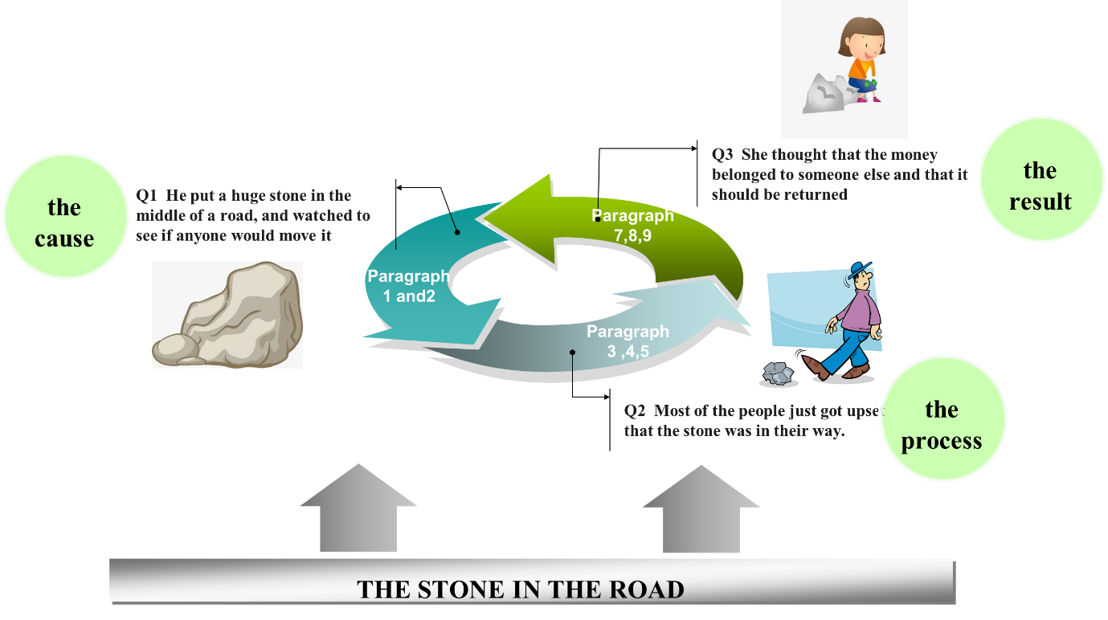

## 4 Activity 4 This story presented different people’s emotions and responses when they came across the same problem. Draw the mind map according to the story.

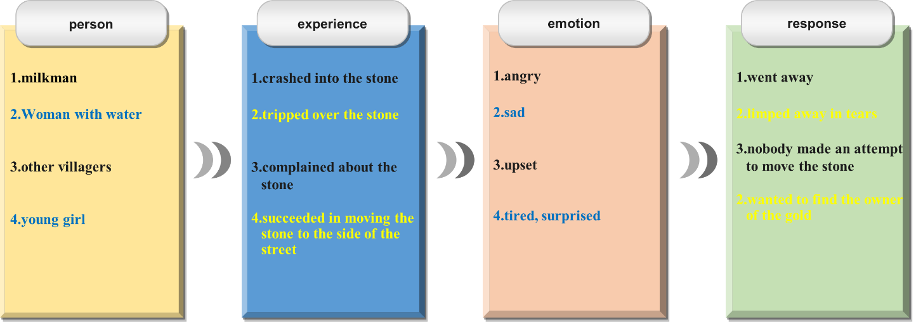

Post reading

## 5 Activity 5 Post reading---Pair work

***Q1: What do you think this fable is trying to tell us?***

***Q2: Was the king wise ? Why or why not ?***

***Q3: Can you list similar things in your life when you felt and acted like the girl or like the other people in the story?***

## 6 Activity 6 Post reading---writing

Write a view of the table. Use the outline below to help you.

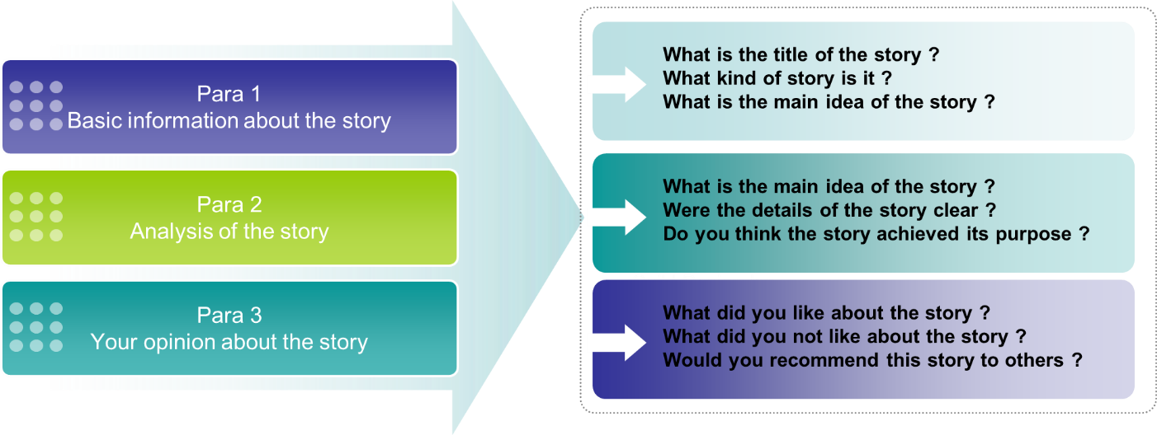

## 7 Activity 7. Exchange drafts with a partner. Use this checklist to help your partner revise his/her draft.

1) Does the writer give a short description of the story ?

2) Does the description include the most important details of the story ?

3) Does the writer give his or her opinion about the character or their actions ?

4) Is the review well-organised ?

5) Does the writer use the -ing form as the adverbial correctly in the writing ?

6) Are there any grammar, spelling, or punctuation errors ?

## 8 Activity8 Each group chooses the best review and upload 271 bay and so the other students can appreciate and analyse them.

## 9 Activity 9 Homework---read and appreciate the following view

The fable is an old fable about a king who thought his people are lazy, so he put a large stone in the middle of the road and hides and waited to see if anyone will try to move it.

The author used this story to impress upon readers with the need to take personal responsibility for problems in the community. The story was quite successful in achieving its purpose, and I liked it because it had a clear moral.

However, while the moral of the story is clear, the actions of the king seemed pointless to me, because none of the characters in the story learnt anything. For this reason, I think there are better stories that can be used to impress upon people with the need for personal responsibility.