Research on Fault Diagnosis of Pitch Sensor Bias for Wind Turbine

Abstract: This paper presents a fault diagnosis method for detecting pitch sensor bias according to the mechanical structure characteristics of wind turbine. The method establishes correspondences between the change of pitch angle and the minute displacement which produced by the force acting on tower of wind turbine. It is based on the change of displacement to diagnosis whether the fault occurs. With regard to the large noise of sensors, we adopt multi-innovation kalman filter to enhance the estimation accuracy and convergence speed. The simulation results show that the multi-innovation kalman filter based method can diagnosis the fault effectively and it is better than common kalman filter.
Key words: wind turbine, sensor, multi-innovation kalman filter

Introduction
Wind energy is playing a more and more important role in world power production [1]. Since most wind farms are located in desert or sea areas where the natural environment is harsh [2], it is common for wind turbines to have faults. Modern wind turbines often adopt fault tolerant control method to maintain normal operation, and fault diagnosis is the premise and necessary condition [3]. Variable pitch system is an important substructure of wind turbines, the pitch fault will affect the power generated when wind velocity is above the rated one.

There have been many fault diagnosis methods for wind turbines. In [4], Watson has studied the rotor fault based on wavelet analysis, which involves monitoring the power output and processing the data to obtain the magnitude of particular frequency components. This method can extract the characteristics of fault, however, wavelet analysis must be calculated off-line, which limits the widespread application. In [5], Guo has studied the current feedback sensor fault, speed sensor fault and constant gain output fault of wind turbine control system. Guo trains the neural networks to analyze fault condition by selecting the appropriate eigenvalue and training samples. But, neural networks algorithm relies on a large amount of training samples, which may not be available in remote areas. Some kind faults of wind turbines do not change system structure, and may affect the system parameters, we can set up the linear model of the turbines, and fault information can be reflected on the parameters’ change. So, the system identification technology can be adopted to fault detection and diagnosis [6].

When the wind velocity is above the rated one, the control objective is to maintain constant generated power [7], which is realized by adjusting the angle of three pitches. The pitch angle sensor is an important part of the closed-loop pitch system, if offset fault happens to pitch angle sensor, the whole pitch system will become unstable. Under the effective wind velocity, there will be a thrust acting on the rotor, which makes the tower sway back and forth [8], and results in a tiny displacement. The value of thrust is dependent on thrust coefficient, and the thrust coefficient is rely on pitch angle and tip-speed ratio, therefore, the pitch angle will influence the thrust. A corresponding relationship can be formed between the pitch angle and the tiny displacement, but the pitch sensor fault will break the relationship. As a consequence, the fault can be detected by monitoring the relationship.

The above method involves a large number of data processing, the kalman filter based on multi-innovation is utilized to filter the value obtained from the pitch angle sensor and tower displacement sensor. The multi-innovation algorithm extends the scalar value [9-11], and the proposed approaches use not only the current data but also the past data, which significantly improve the precision of the estimate and the convergence speed [12]. The tower displacement calculated from pitch angle and the displacement from sensor should be equal when the pitch angle sensor is normal. When there is a deviation between two displacements, we can detect a fault.

The rest of the paper is organized as follows. Section 2 gives wind turbine model for simulation, and presents the fault model for analysis. In Section 3, the fault diagnosis and data processing procedure using multi-innovation kalman filter is given. Section 4 contains a simulation result and followed by the conclusion in Section 5.

Wind turbine model
Aerodynamic model
The wind energy captured from the three blades is transformed to rotational motion of the rotor, the rotor speed is 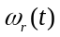.
The captured wind energy is dependent on effective wind speed 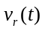, air density and the rotor swept area and power coefficient 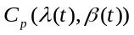. The power coefficient is rely on tip-speed ratio 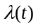 and pitch angle 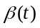. The aerodynamic torque 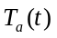 applied to rotor by blade can be obtained from tip-speed ratio and blade radius [13].
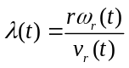 | (1)
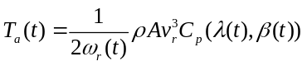 | (2)
Tower model
The wind acting on the rotor of each blade also results in a thrust on the rotor, it can be calculated like [14]:
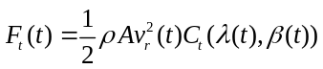 | (3)
The thrust coefficient 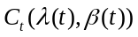 is also dependent on and .
The resulting tower force 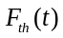 on the tower at hub height, , depends on the azimuth angle of rotor, which is the synthesis of three thrust [8] :
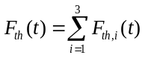 | (4)
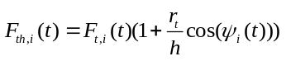 | (5)
Where, 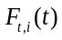 is the thrust from blade , is the distance from the hub to where the thrust acts on the blade. The relationship between 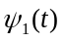, 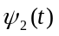, 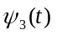 and the location of the blades are illustrated in Fig. 1. As the equation shows, the location of the blades affects the tower force components. This is different from the aerodynamic torque, which is independent of the location of the blades.
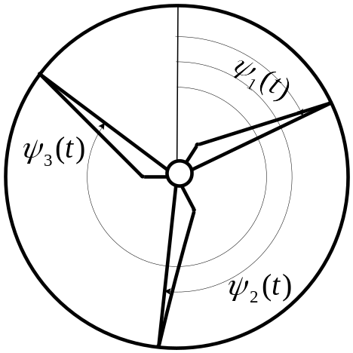
Fig. 1 Position of blades
When under the tower force, the tower will produce a tiny displacement 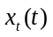, as it is the only measured variable in the tower model, the movement of the tower can be described by a linear displacement of the nacelle. As Fig. 2 shows, the tower model is given as a spring-damper.
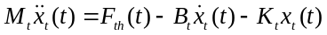 | (6)
Where, 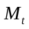 is the top mass of the tower, is the tower damping coefficient, 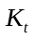 is the tower torsion coefficient.
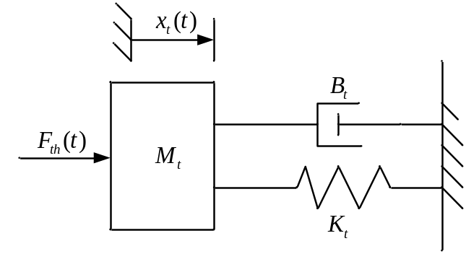
Fig. 2 Tower model
Pitch model
The pitch actuator is modeled as a second order system [15] :
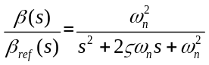 | (7)
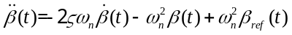 | (8)
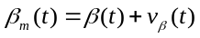 | (9)
Where, 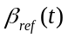 is the reference to the pitch angle, 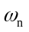 is the natural frequency of the pitch actuator model, is the damping ratio of the pitch actuator model, 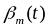 is the value returned from the pitch angle sensor and 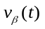 is the measurement noise.
When a offset pitch angle fault happens, the model of the actuator is changed to
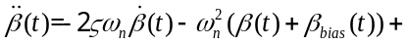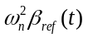 | (10)
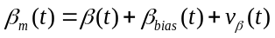 | (11)
Where, 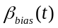 is the offset added to the pitch angle sensor output.

Algorithm of fault diagnosis
Structure of diagnosis system
A fault diagnosis structure is designed for pitch system, which is illustrated in Fig. 3.
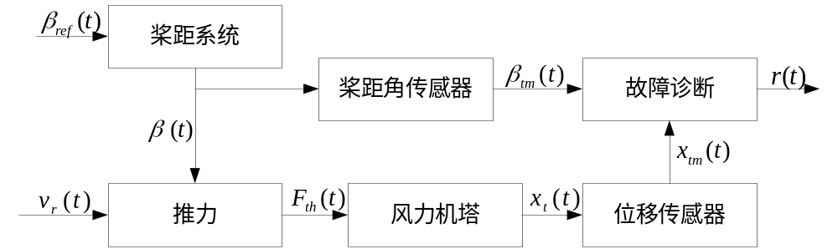
Fig. 3 structure of diagnosis system
From the thrust equation shown in Eq. 3, the thrust on blade 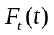 is related to the thrust coefficient 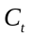, and the coefficient is related to and . The tower force 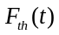 can be deduced from Eq. 4 and Eq. 5. By applying Eq. 6, we can obtain the tiny displacement 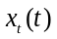 from the tower force . A small offset in pitch angle will result in a small change in thrust coefficient, and the tower force will change correspondingly which makes the displacement vary synchronously. As a result, by monitoring the variation of displacement, the fault can be detected.
To maintain constant wind power output, the closed-loop pitch system work continuously to obtain the pitch angle objective 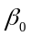. If there is a constant offset output 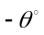 adding to the pitch angle sensor, the sensor output will become 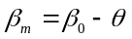. For pitch control system, the value from measurement does not match the control objective , so under the action of pitch actuator, the pitch is adjusted by the actuator to force the sensor output back to objective, that is 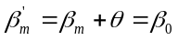. Due to the offset in the sensor output, the real pitch angle is 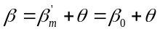. Therefore, we draw the conclusion that the measured displacement 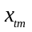 is different from the calculated one which is obtained from . The fault severity can be concluded by comparing the measured and calculated displacement.
As the wind turbines work in a harsh condition, the value returned from the sensor is polluted by a lot of noise and the displacement caused by the sensor offset fault is rather small, it possible for the displacement information be submerged by the noise. It is necessary to filter the sensor output, the kalman filter based on multi-innovation technology is an efficient way to obtain the optimal state estimation, and realize the accurate judgement of the sensor offset fault.

Kalman filter based on multi-innovation
Kalman filter is a kind of recursion method which estimate the optimal system state [16]. The kalman filter consists of two steps: a prediction step and an update step. In the prediction step, the current system state is estimated from the previous sample. In update step, the predicted system state value is corrected by the observation one. When the two steps finish, follows the next cycle.
Innovation is defined as useful information which can improve parameter’s or state’s estimation accuracy [17].
Take the following linear discrete system into consideration:

