# Laboratory work No. 5.

Test design techniques, writing test cases. Functional testing using the "black box" method

**Purpose of the work:** Learn to use test design techniques when writing test scripts.

**Лабораторная работа № 5.**

**Методы тест-дизайна, написание тест-кейсов. Функциональное тестирование методом «черного ящика»**

**Цель работы:** Научиться использовать методы тест-дизайна при написании тестовых сценариев.

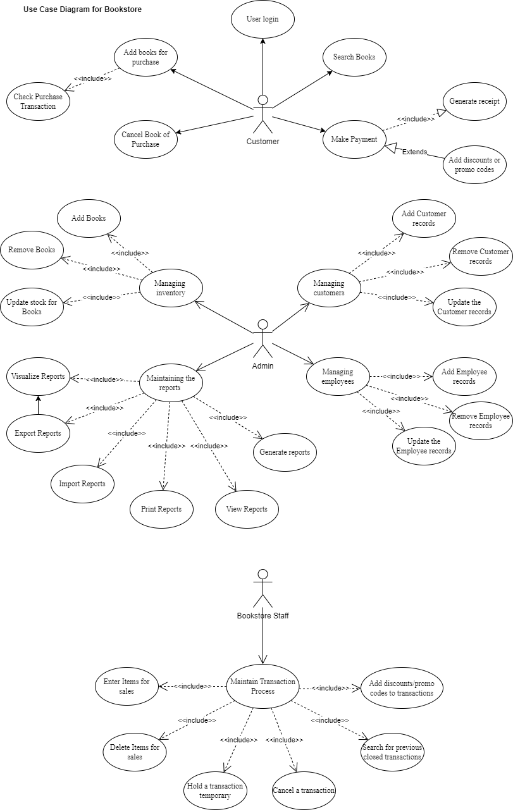

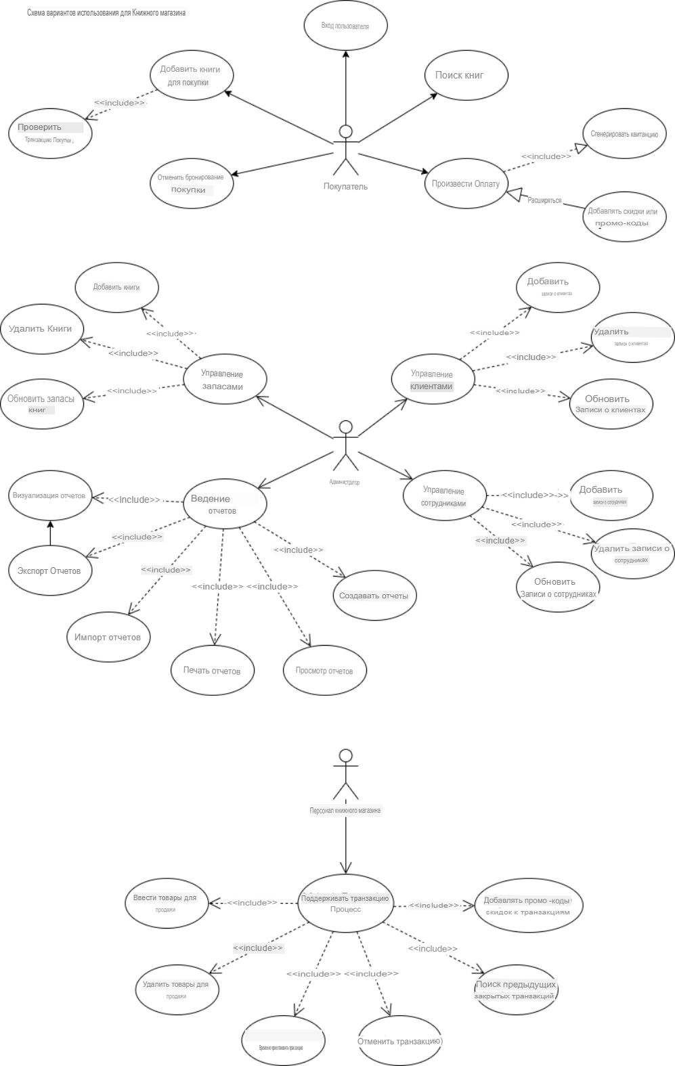

* **Equivalent division(Эквивалентное разделение)**

This is to better understand the test cases.

|  |  |  |  |  |
| --- | --- | --- | --- | --- |
| **Test Case ID** | **Test Case Description** | **Input** | **Expected Output** | **Name/data** |
| TC001 | Add book with valid inputs | ISBN: 9876543212345  Title: “Sample Book”  Price: “$19.99” | Book successfully added to inventory | Uttam/  01.11.2024 |
| TC002 | Add book with invalid ISBN | ISBN: 12345  Title: “Invalid ISBN Book”  Price: “$15.00” | Error message:  “Invalid ISBN” | Li/  02/11/2024 |
| TC003 | Add book with empty title | ISBN: 9876543212345  Title: “ ”(empty)  Price: “$25.00” | Error message:  “Title cannot be empty” | Uttam/  01.11.2024 |
| TC004 | Add book with price $0.00 | ISBN: 9876543212345  Title: “Free Book”  Price: “$0.00” | Error message:  “Price must be greater than $0.00” | Li/  02/11/2024 |
| TC005 | Add book with price $1001 | ISBN: 9876543212345  Title: “Expensive Book”  Price: “$1001.00” | Error message:  “Price cannot exceed $1000” | Uttam/  01.11.2024 |

* **Boundary value analysis(Анализ граничных значений)**

This includes test cases for the boundary values so that any inputs do not go above or below the systemic minimum and maximum values.

|  |  |  |  |  |
| --- | --- | --- | --- | --- |
| **Test Case ID** | **Test Case Description** | **Input(Stock Quantity)** | **Expected Output** | **Name/Data** |
| BV001 | Update Stocks to lower boundary | 0 | Stocks updated successfully | Li/31.10.2024 |
| BV002 | Update Stocks to just above lower boundary | 1 | Stocks updated successfully | Li/31.10.2024 |
| BV003 | Update Stocks to upper boundary | 999 | Stocks updated successfully | Li/31.10.2024 |
| BV004 | Update Stocks to just below upper boundary | 1000 | Stocks updated successfully | Uttam/31.10.2024 |
| BV005 | Attempt to Update Stocks below lower boundary | -1 | Error:  “Invalid Stocks Quantity” | Li/31.10.2024 |
| BV006 | Attempt to Update Stocks above upper boundary | 1001 | Error:  “Invalid Stocks Quantity” | Uttam/30.10.2024 |

* **Cause and effect analysis(Причинно-следственный анализ)**

The decision table ensures the the report generation function behaves correctly under different circumtances.

|  |  |  |  |  |  |  |
| --- | --- | --- | --- | --- | --- | --- |
| **Conditions(INPUTS)** | **1** | **2** | **3** | **4** | **5** | **Name/data** |
| Data range selected | T | T | T | F | F | Uttam/  28.10.2024 |
| Book Category selected | T | T | F | T | F | Li/  29.10.2024 |
| Report Type Chosen | T | F | T | T | F | Uttam/  28.10.2024 |
| **Actions(OUTPUTS)** |  |  |  |  |  | Uttam/  28.10.2024 |
| Report Generated | T | F | T | F | F | Li/  30.10.2024 |
| Error Message Displayed | F | T | F | T | T | Li/  30.10.2024 |

TTT means the report is generated successfully.

TTF means no report is chosen resulting in error.

TFT means no book category is chosen assuming all categories is the default, report is generated successfully

FTT means only book category is chosen, no other important info, resulting in error.

FFF means no selections, resulting in error.

* **Anticipating errors(Предугадывание ошибки)**

The system handles unexpected inputs and handles it with grace.

|  |  |  |  |  |
| --- | --- | --- | --- | --- |
| **Test Case ID** | **Test Case Description** | **Input** | **Expected Output** | **Name/data** |
| AE001 | Search with special characters | “!@#$%” | Error: Invalid search characters | Uttam/  27.10.2024 |
| AE002 | Search with extremely long string | [1000 character string] | Error: Search query too long | Uttam/  27.10.2024 |
| AE003 | Search with SQL injection attempt | “; DROP TABLE BOOKS” | Error: Invalid Search query | Uttam/  27.10.2024 |
| AE004 | Search with empty input | “” (empty string) | Error: Search query cannot be empty | Uttam/  27.10.2024 |
| AE005 | Search with only spaces | “ ” | Error: Invalid Search query | Li/  26.10.2024 |

* **Exhaustive testing(Исчерпывающее тестирование)**

It contains all the possible combinations for the login function.

|  |  |  |  |  |
| --- | --- | --- | --- | --- |
| **Test Case ID** | **Username** | **Password** | **Expected Outcome** | **Name/data** |
| E001 | Valid | Valid | Successful Login | Li/25.10.2024 |
| E002 | Valid | Invalid | Login Failed | Li/24.10.2024 |
| E003 | Invalid | Valid | Login Failed | Li/23.10.2024 |
| E004 | Invalid | Invalid | Login Failed | Uttam/25.10.2024 |