张远进
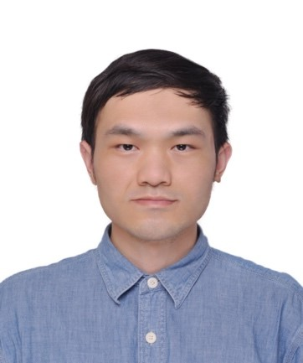
职称：讲师
电话：13517194014
邮箱：ylzhyj@126.com
研究方向：风险与不确定性分析；随机动力学；信号处理；大数据与管理
个人简介
张远进，男，1988年11月生，湖北武汉人，2017年毕业于利物浦大学大学工程学专业，获工学博士学位。现任武汉理工大学安全科学与应急管理学院讲师。
主讲课程
[1] 本科生课程：建设工程力学基础，应急能力评估，地下空间开发与利用，交通运输安全技术，应急管理CAD技能训练
[2] 研究生课程：基础设施健康诊断与韧性评价，系统工程与可靠性

主持科研项目
湖北省自然科学基金青年项目：基于组合型阻尼器的自复位摇摆墙结构动力性能控制研究，2021.10-2023.09。

发表论文情况
[1] Yuanjin Zhang; Fan Kong*; Shujin Li; Rongyue Zhu; Survival probability determination of nonlinear oscillators subject to combined deterministic periodic and non-stationary stochastic loads, Mechanical Systems and Signal Processing, 2023, 199: 110464.
[2] Yuanjin Zhang; Ioannis A. Kougioumtzoglou*; Fan Kong; A Wiener path integral technique for determining the stochastic response of nonlinear oscillators with fractional derivative elements: A constrained variational formulation with free boundaries, Probabilistic Engineering Mechanics, 2023,71:103410.
[3] Yuanjin Zhang; Ioannis A. Kougioumtzoglou*; Fan Kong; Exploiting expansion basis sparsity for efficient stochastic response determination of nonlinear systems via the Wiener path integral technique. Nonlinear Dynamics, 2022, 107: 3669-3682.
[4] Fan Kong; Yixin Zhang; Yuanjin Zhang*; Non-stationary response power spectrum determination of linear/non-linear systems endowed with fractional derivative elements via harmonic wavelet, Mechanical Systems and Signal Processing, 2022, 162:108024.
[5] Fan Kong; Renjie Han; Yuanjin Zhang*; Approximate stochastic response of hysteretic system with fractional element and subjected to combined stochastic and periodic excitation. Nonlinear Dynamics, 2022, 107, 375–390.
[6] Yuanjin Zhang; Shujin Li, Fan Kong*; Survival probability of nonlinear oscillators endowed with fractional derivative element and subjected to evolutionary excitation: A stochastic averaging treatment with path integral concepts, Probabilistic Engineering Mechanics, 2021,66:103156.
[7] Yuanjin Zhang; Liam Comerford*; Ioannis A. Kougioumtzoglou; Michael Beer; Lp-norm minimization for stochastic process power spectrum estimation subject to incomplete data, Mechanical Systems and Signal Processing, 2018, 101: 361-376.
[8] 宋英华,马建,张远进*.非平稳随机地震激励下多层框架-摇摆墙结构的响应分析[J].中国安全科学学报,2024,34(06):48-56.DOI:10.16265/j.cnki.issn1003-3033.2024.06.0987.
[9] 宋英华,何翼龙,张远进*.基于情感分析的网络舆情共振研究[J].中国安全生产科学技术,2024,20(04):186-192.

专利及其他
成先杰; 梁忠华; 张国锦;张远进 ; 一种梁式桥摩擦摆支座快速选型的方法,2020, 中国,ZL201910212915.1 (专利)

