[](https://www.comsol.com/)

2023年5月15日30

Report date

May 19, 2023 8:16:34 AM

Contents

1. Global Definitions

1.1. Parameters

1.2. Geometry Parts

2. 组件 1

2.1. Definitions

2.2. Geometry

2.3. Transport of Concentrated Species

2.4. Brinkman Equations

2.5. Secondary Current Distribution

2.6. Multiphysics

2.7. Mesh

3. 研究 1

3.1. Stationary

3.2. Stationary2

3.3. Stationary3

3.4. Stationary4

4. 结果

4.1. 数据集

4.2. 表格

4.3. Plot Groups

4.4. 组 1

4.5. Plot Groups

1. Global Definitions

|  |  |
| --- | --- |
| Date | May 19, 2023 7:27:15 AM |

Global settings

|  |  |
| --- | --- |
| Name | 2023年5月15日30.mph |
| Path | E:\COMSOL\2023年5月15日30.mph |
| Version | COMSOL Multiphysics 5.6 (Build: 280) |

Used products

|  |
| --- |
| COMSOL Multiphysics |
| CAD Import Module |
| CFD Module |
| Chemical Reaction Engineering Module |
| Corrosion Module |
| Design Module |

Computer information

|  |  |
| --- | --- |
| CPU | AMD Ryzen 7 2700 Eight-Core Processor, 8 cores |
| Operating system | Windows 10 |

* 1. Parameters
     1. Geometric parameters

Geometric parameters

| **Name** | **Expression** | **Value** | **Description** |
| --- | --- | --- | --- |
| a_ch | 0.4[mm] | 4E−4 m | Side length, micrometer |
| a_Ch | 2[mm] | 0.002 m | Side length, millimetre |
| l | 20[mm] | 0.02 m | Reactor length |
| d_GDL | 100[um] | 1E−4 m | Gas diffusion layer thickness |
| d_CL | 50[um] | 5E−5 m | Catalyts layer thickness |
| d_AEM | 30[um] | 3E−5 m | AEM layer thickness |
| S_R | 4[cm^2] | 4E−4 m² | Aera of reactor |

* + 1. Basic setup parameters

Basic setup parameters

| **Name** | **Expression** | **Value** | **Description** |
| --- | --- | --- | --- |
| C0 | 1[M] | 1000 mol/m³ |  |
| E_an | 0[V] | 0 V | AEM potential |
| E_ca | -1.11[V] | −1.11 V | Cathode potential |
| E_COeq | -0.11[V] | −0.11 V | Equilibrium potential, CO |
| E_H2eq | 0[V] | 0 V | Equilibrium potential, H2 |
| E0 | 1[V] | 1 V |  |
| epsilon_CL | 0.5 | 0.5 | Porosity, CL |
| epsilon_GDL | 0.7 | 0.7 | Porosity, GDL |
| k | 1e-12[m^2] | 1E−12 m² | Permeability, estimated value |
| mu_gas | 1e-5[Pa*s] | 1E−5 Pa·s | Gas dynamic viscosity |
| p_H2O | 3357[Pa] | 3357 Pa | Water vapor pressure |
| p0 | 1[atm] | 1.0133E5 Pa |  |
| Qm_CO2 | Q_in*MCO2/V_RT/a_Ch^2*w_CO2 | 0.2374 kg/(m²·s) |  |
| Qm_H2Og | Q_in*MH2O/V_RT/a_Ch^2*w_H2Og | 0.0033279 kg/(m²·s) |  |
| rho_CO2 | MCO2/V_RT | 1.9643 kg/m³ |  |
| rho_in | ((MCO2*w_CO2 + MH2O*w_H2Og))/22.4[L/mol] | 1.9258 kg/m³ |  |
| S_v | l^2*d_CL*a_v | 0.002 m² |  |
| S0 | 1[cm^2] | 1E−4 m² |  |
| sigma_GDL | 222[S/m] | 222 S/m | Electrical conductivity, GDL |
| sigma_m | 25[S/m] | 25 S/m | Electrical conductivity, AEM |
| T | 298.15[K] | 298.15 K | Temperature |
| v_in_ch | Q_in/a_ch/a_ch | 3.125 m/s | Inlet velocity, micrometer |
| v_in_Ch | Q_in/a_Ch/a_Ch | 0.125 m/s | Inlet velocity, millimetre |
| V_RT | 22.4[L/mol] | 0.0224 m³/mol |  |
| w_CO2 | 1 - w_H2Og | 0.96687 |  |
| w_H2Og | p_H2O/p0 | 0.033131 |  |
| M_in | w_CO2*MCO2 + w_H2Og*MH2O | 0.043139 kg/mol |  |
| R_mcl | d_CL*epsilon_CL/(sigma_m*epsilon_CL)/S_R + d_AEM/sigma_m/S_R | 0.008 Ω |  |
| d_SR | (d_AEM + d_CL)/S_R | 0.2 1/m |  |
| sigma_GDL_m | 0.00001[S/m] | 1E−5 S/m | Electrical conductivity, GDL electrolyte |
| P_ref | 1[atm] | 1.0133E5 Pa | Reference pressure |
| Q_in | 30[ml/min] | 5E−7 m³/s | Inlet gas flow |
| a_v | 1e5[1/m] | 1E5 1/m |  |
| Q_V0 | 1[ml/min] | 1.6667E−8 m³/s |  |
| Q_in_num | Q_in/Q_V0 | 30 |  |

* + 1. Gas constant parameters

Gas constant parameters

| **Name** | **Expression** | **Value** | **Description** |
| --- | --- | --- | --- |
| MO2 | 32[g/mol] | 0.032 kg/mol | Molar mass, O2 |
| MN2 | 28[g/mol] | 0.028 kg/mol | Molar mass, N2 |
| MH2O | 18[g/mol] | 0.018 kg/mol | Molar mass, H2O |
| MH2 | 2[g/mol] | 0.002 kg/mol | Molar mass, H2 |
| MCO2 | 44[g/mol] | 0.044 kg/mol | Molar mass，CO2 |
| MCO | 28[g/mol] | 0.028 kg/mol | Molar mass, CO |
| D_eff_H2_H2O | 9.15e-5[m^2/s] | 9.15E−5 m²/s | 307.1K |
| D_eff_H2_O2 | 8.91e-5[m^2/s] | 8.91E−5 m²/s | 316K |
| D_eff_H2_N2 | 7.79e-5[m^2/s] | 7.79E−5 m²/s | 297.2K |
| D_eff_H2_CO | 7.43e-5[m^2/s] | 7.43E−5 m²/s | 295.6K |
| D_eff_H2_CO2 | 6.46e-5[m^2/s] | 6.46E−5 m²/s | 298.2K |
| D_eff_H2O_N2 | 2.93e-5[m^2/s] | 2.93E−5 m²/s | 298.2K |
| D_eff_H2O_O2 | 2.82e-5[m^2/s] | 2.82E−5 m²/s | 308.1K |
| D_eff_N2_O2 | 2.20e-5[m^2/s] | 2.2E−5 m²/s | 293.2K |
| D_eff_H2O_CO | 2.12e-5[m^2/s] | 2.12E−5 m²/s | 295.8K |
| D_eff_H2O_CO2 | 2.02e-5[m^2/s] | 2.02E−5 m²/s | 307.4K |
| D_eff_CO_CO2 | 1.85e-5[m^2/s] | 1.85E−5 m²/s | 315.4K |
| D_eff_N2_CO2 | 1.65e-5[m^2/s] | 1.65E−5 m²/s | 298.2K |
| D_eff_O2_CO2 | 1.56e-5[m^2/s] | 1.56E−5 m²/s | 296K |
| D_eff_CO_N2 | 2.050e-5[m^2/s] | 2.05E−5 m²/s |  |

* + 1. Geometric parameters

Geometric parameters

| **Name** | **Expression** | **Value** | **Description** |
| --- | --- | --- | --- |
| a_ch | 0.4[mm] | 4E−4 m | Side length, micrometer |
| a_Ch | 2[mm] | 0.002 m | Side length, millimetre |
| l | 20[mm] | 0.02 m | Reactor length |
| d_GDL | 100[um] | 1E−4 m | Gas diffusion layer thickness |
| d_CL | 50[um] | 5E−5 m | Catalyts layer thickness |
| d_AEM | 30[um] | 3E−5 m | AEM layer thickness |
| S_R | 4[cm^2] | 4E−4 m² | Aera of reactor |

* + 1. Geometric parameters

Geometric parameters

| **Name** | **Expression** | **Value** | **Description** |
| --- | --- | --- | --- |
| a_ch | 0.4[mm] | 4E−4 m | Side length, micrometer |
| a_Ch | 2[mm] | 0.002 m | Side length, millimetre |
| l | 20[mm] | 0.02 m | Reactor length |
| d_GDL | 100[um] | 1E−4 m | Gas diffusion layer thickness |
| d_CL | 50[um] | 5E−5 m | Catalyts layer thickness |
| d_AEM | 30[um] | 3E−5 m | AEM layer thickness |
| S_R | 4[cm^2] | 4E−4 m² | Aera of reactor |

* + 1. Electrode kinetics

Electrode kinetics

| **Name** | **Expression** | **Value** | **Description** |
| --- | --- | --- | --- |
| Ac_H2 | 1[V]/beta_H2_fitting | −0.26354 V |  |
| Ac_CO | 1[V]/beta_CO_fitting | −0.48312 V |  |
| J0_H2 | J0_H2_fitting/a_v/d_CL | −0.005762 A/m² |  |
| J0_CO | J0_CO_fitting/a_v/d_CL | −1.645 A/m² |  |
| beta_CO_fitting | -4.76604/log(10) | −2.0699 | Fitting,CO |
| beta_H2_fitting | -8.737/log(10) | −3.7944 | Fitting,H2 |
| J0_H2_fitting | -0.002881[mA/cm^2] | −0.02881 A/m² | Current density,JH2 |
| J0_CO_fitting | -0.82252[mA/cm^2] | −8.2252 A/m² | Current density, JCO |
| alpha_CO | -beta_CO_fitting*R_const*T/F_const*log(10) | 0.12245 V |  |
| alpha_H2 | -beta_H2_fitting*R_const*T/F_const*log(10) | 0.22448 V |  |

* 1. Geometry Parts
     1. 蛇形通道（二维），方形回转，矩形横截面

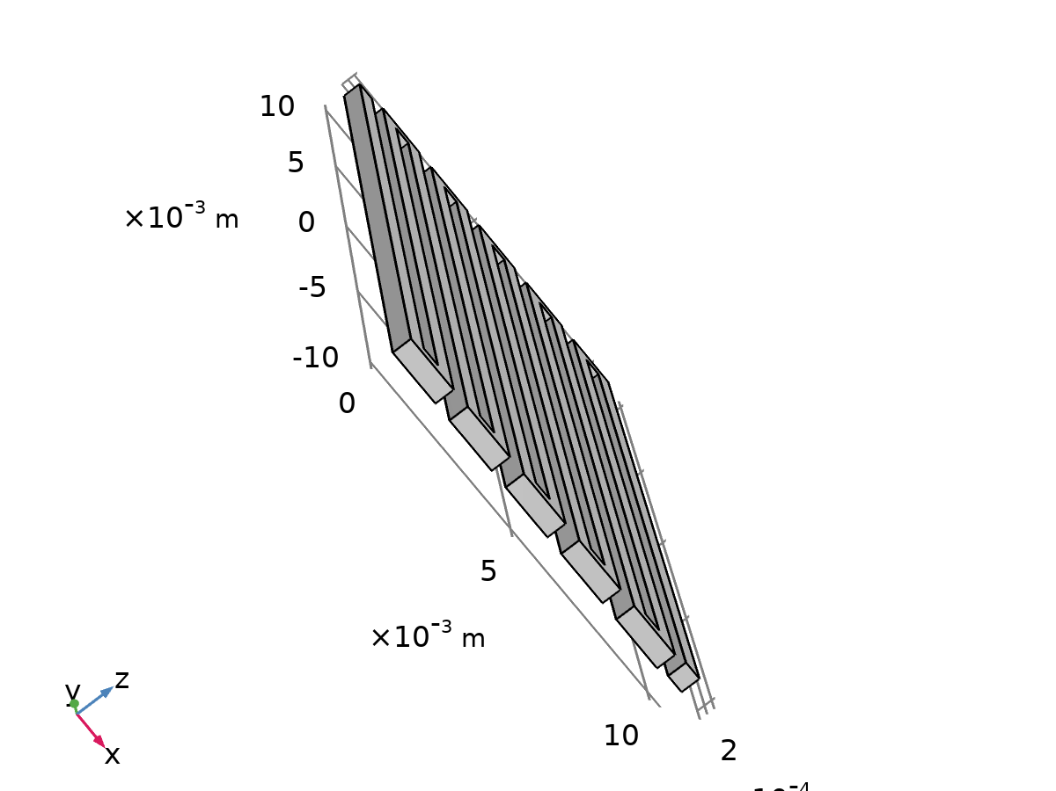

蛇形通道（二维），方形回转，矩形横截面

Units

|  |  |
| --- | --- |
| Length unit | m |
| Angular unit | deg |

1. 组件 1
   1. Geometry

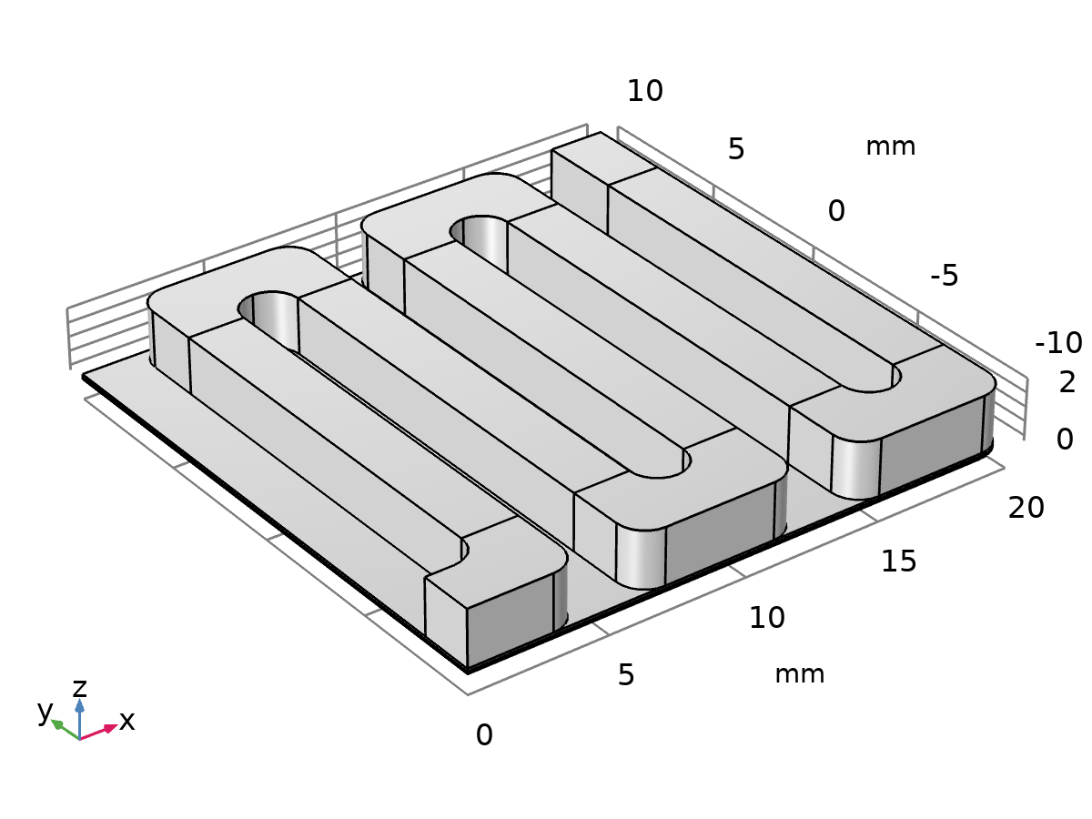

Geometry

Units

|  |  |
| --- | --- |
| Length unit | mm |
| Angular unit | deg |

* 1. Transport of Concentrated Species

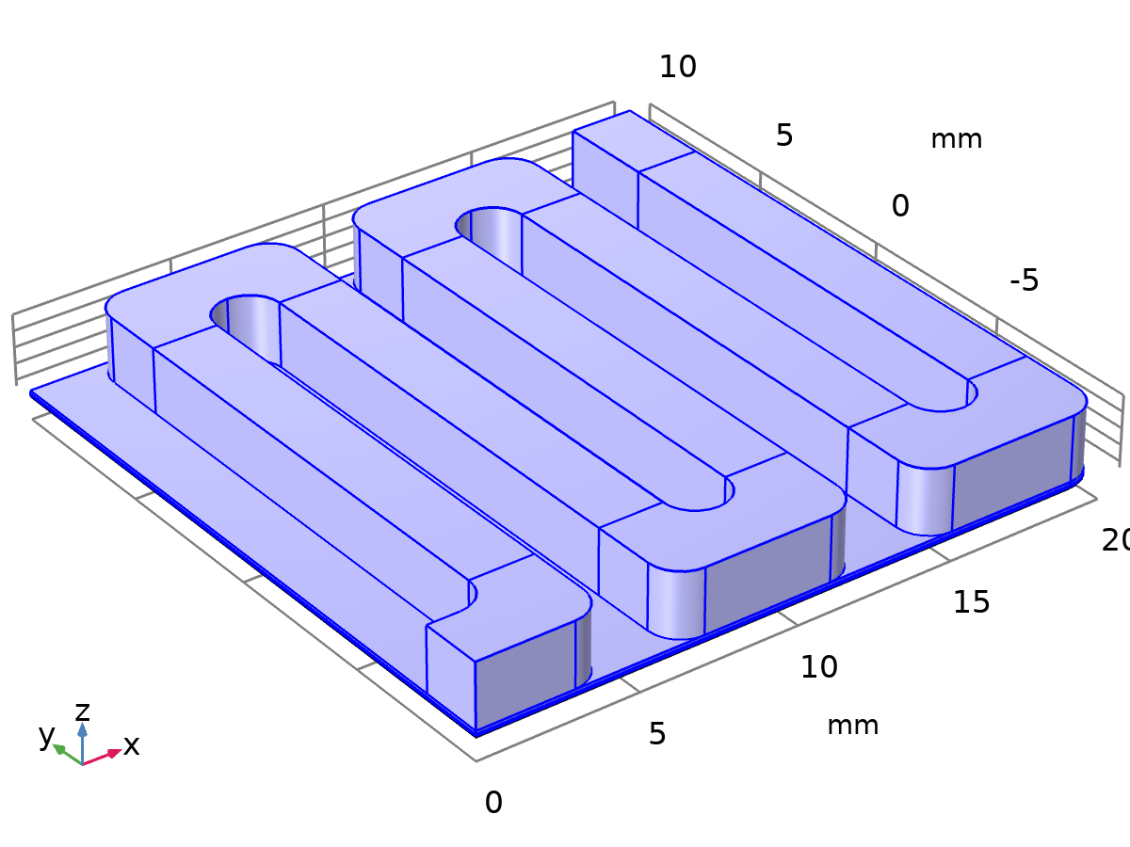

Transport of Concentrated Species

Equations



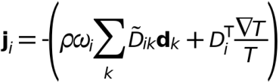

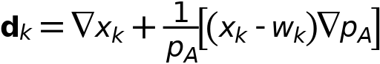

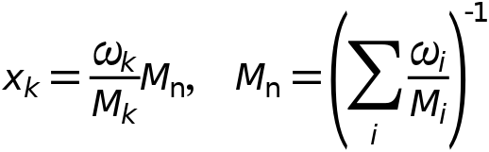

Features

| **Name** | **Level** |
| --- | --- |
| Transport Properties | Domain |
| Initial Values | Domain |
| No Flux | Boundary |
| Porous Media Transport Properties1 | Domain |
| Porous Media Transport Properties2 | Domain |
| Outflow | Boundary |
| Porous Electrode Coupling | Domain |
| Flux | Boundary |

* 1. Brinkman Equations



Brinkman Equations

Equations

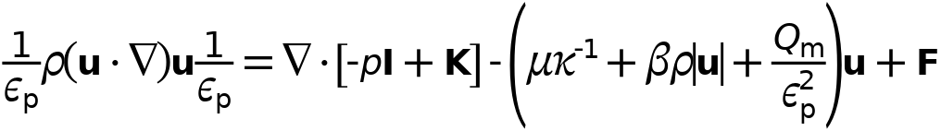



Features

| **Name** | **Level** |
| --- | --- |
| Fluid and Matrix Properties | Domain |
| Initial Values | Domain |
| Wall | Boundary |
| Fluid Properties1 | Domain |
| Fluid and Matri Properties | Domain |
| Inlet | Boundary |
| Outlet | Boundary |
| Wall2 | Boundary |

* 1. Secondary Current Distribution

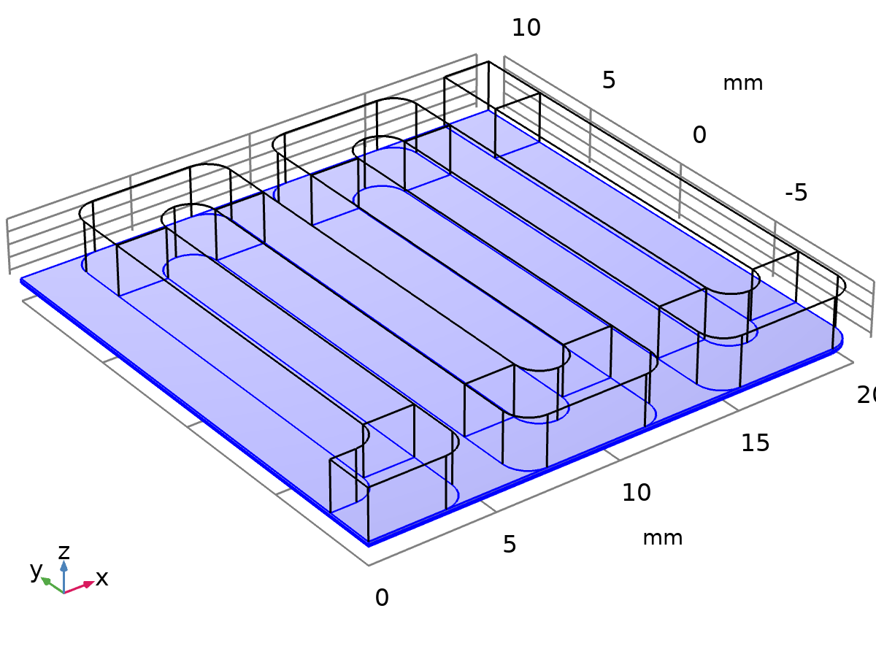

Secondary Current Distribution

Equations







Features

| **Name** | **Level** |
| --- | --- |
| AEM | Domain |
| 绝缘 1 | Boundary |
| Initial Values | Domain |
| GDL | Domain |
| CL | Domain |
| Electric Potential | Boundary |
| Electrolyte Potential | Boundary |

* 1. Multiphysics
     1. Potential Coupling

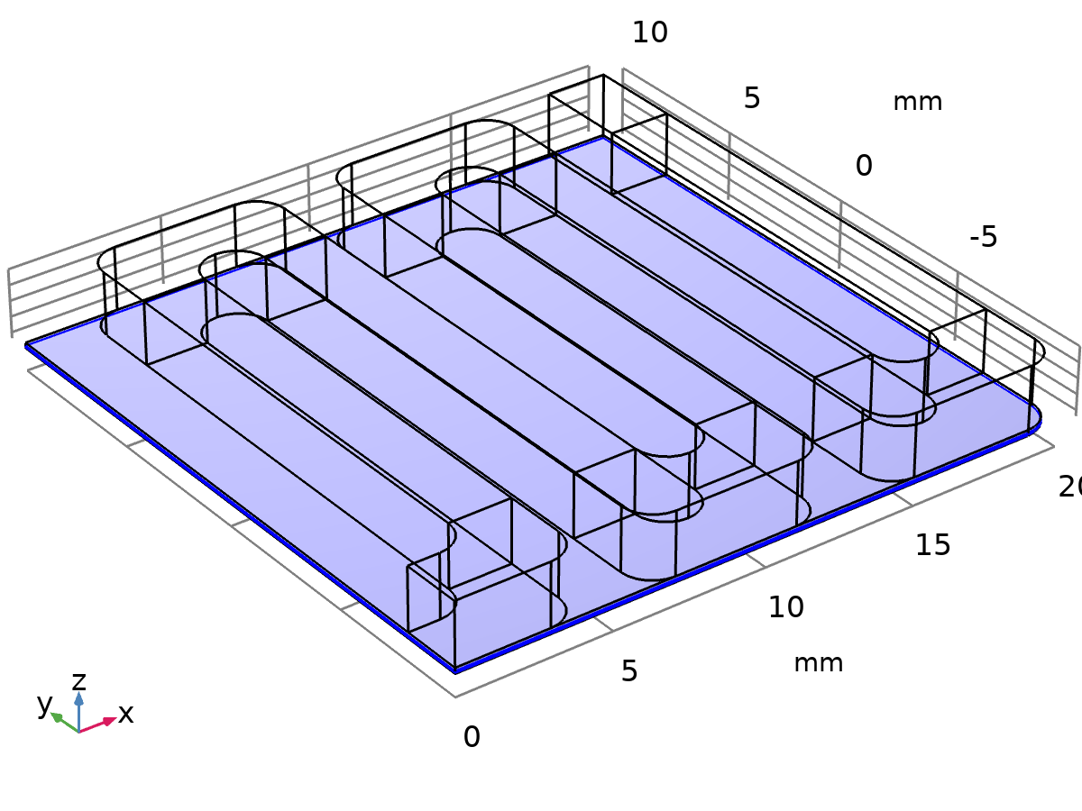

Potential Coupling

* + 1. Reaction Flow



Reaction Flow

Equations



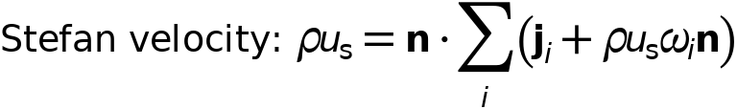

* 1. Mesh

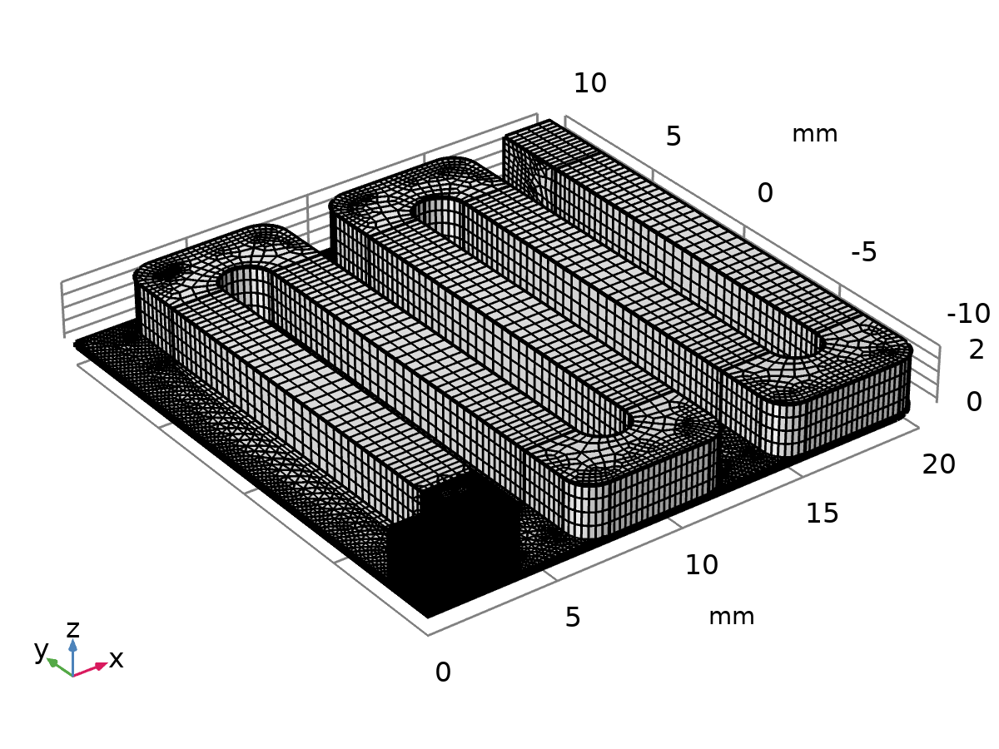

Mesh