A Fully Asynchronous Parallel-Path Hierarchical NoC for Scale-Out High-Fanout Communication

1st Liyan Zhao Weixian College Tsinghua University Beijing, China
zhao-ly24@mails.tsinghua.edu.cn

2nd Jilin Zhang
School of Integrated Circuits Tsinghua University
Beijing, China zhangjil@mail.tsinghua.edu.cn

3rd Hong Chen
School of Integrated Circuits Tsinghua University
Beijing, China hongchen@tsinghua.edu.cn

Abstract—As chip systems scale to many processing elements, accelerators, and memory regions, the on-chip network must sustain longer paths, regional contention, and high-fanout trans- fers. Neuromorphic and other event-driven workloads provide a representative stress case because short sparse events can still address many destinations. This work presents a fully asyn- chronous parallel-path hierarchical NoC combining replicated upper paths with a multi-plane mesh, cross-tier native multicast, and phase-adaptive multi-lane control under two-phase bundled- data handshaking. The architecture increases path diversity and aggregation capacity while preserving multicast sharing across hierarchy levels. Post-synthesis evaluation shows 379.2 Mflit/s/port (10.6 Gb/s/port at 28-bit flits), 58.7% above a flat mesh under 64- node Uniform-Random traffic; native multicast reduces 64-node F16M5 completion latency by 93.8% versus repeated unicast; and the 256-node four-tile network reaches 154.7 Mflit/s/port versus
112.5 Mflit/s/port for a flat mesh, a 37.5% increase.
Index Terms—asynchronous NoC, hierarchical NoC, hardware multicast, multi-lane routing, scale-out interconnects, neuromor- phic computing

- Introduction
As chip systems integrate more processing elements, accel- erators, and memory regions, the on-chip network becomes a primary scale-out constraint. Larger systems increase com- munication distance, contention, and replication traffic at the same time. TrueNorth integrates 4,096 neurosynaptic cores [1], PAICORE connects 1,024 cores through a hierarchical fabric [2], and Hala Point scales 1,152 Loihi 2 processors to 140,544 cores [3], [4]; these systems illustrate the broader growth of on-chip communication demand.
Scale-out creates a direct path and resource problem. As the system grows, packets cross more links and routers, and traffic from many regions converges on shared upper-level resources. Local transfers can remain short, but global transfers need enough independent paths to prevent those shared resources from becoming a throughput bottleneck. The same issue ap- pears in dense streaming and sparse event-driven systems; neuromorphic events provide a clear example because a short event may reach nearby and distant destinations [5]–[7].
Fanout adds a second resource problem. Expanding one- to-many communication into separate unicast packets sends the same data over common links multiple times, increasing injection pressure and queueing. Simply widening one upper router can recover bandwidth but also enlarges its arbitration domain. A scalable NoC must instead preserve short local paths, distribute capacity across the scale-out fabric, and repli- cate multicast data only where paths diverge.
Following the standard interconnection-network model [8], [9], communication latency is
L
T_{comm} = Ht_{r} + Ht_{w} + T_{c} + . (1)
b
where H is hop count, t_{r} and t_{w} are the per-hop router and link delays, respectively, T_{c} is contention delay, and L/b is seri- alization delay. Topology reduces H and supplies path capacity; routing distributes load and shares multicast paths; router microarchitecture reduces local delay and increases service rate. Existing techniques improve individual terms through high- radix or hierarchical connectivity [2], [10], adaptive routing and hardware multicast [11], [12], or wide and asynchronous routers [13]–[15].
These topology and router choices expose different imple- mentation tradeoffs. Regular mesh and torus networks retain simple routers but require more hops as dimensions grow. High-radix and hierarchical structures reduce hop count or preserve locality, while adaptive routing and hardware multi- cast distribute load and share common path segments. Wider datapaths and parallel channels increase service rate, but a hierarchy can concentrate traffic into a few upper-level routers and a wider arbitration domain. Scale-out therefore requires distributed path capacity, in-network replication, and control that safely coordinates parallel physical lanes.
This paper presents a fully asynchronous parallel-path hier- archical NoC for high-fanout communication. Its contributions are:
- Parallel-path hierarchy: replicated intermediate routers connect multiple physical lanes between stages, while independent mesh planes connect tiles. The structure pre- serves short local paths and distributes converging traffic.
- Native hierarchical multicast: one injected transaction remains multicast across the hierarchy and upper meshes, replicating only at routing branches and sharing common path segments.
- Phase-safe parallel-lane control: packet-lifetime path binding preserves two-phase request and acknowledgment state during lane selection and arbitration without local clocks.

- Background and Motivation
- Communication in Large-Scale Systems
Large systems combine local traffic with less frequent global transfers. Address-Event Representation (AER) is one concrete example: an event is a compact address-bearing packet repre- senting one or more neural spikes, and one event may target multiple destination cores [5], [6]. Thus a sparse source can still create high-fanout transfers, routing metadata, and contention [7]. The same distinction appears in accelerator and manycore systems as local streams, regional synchronization, and global reductions. Local traffic therefore needs short paths and low per-hop overhead, while global and high-fanout traffic needs aggregate bisection capacity and efficient replication.

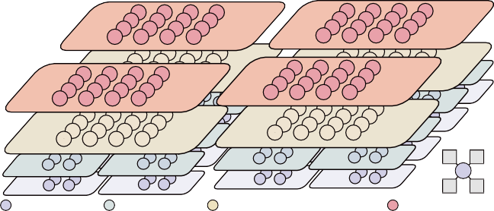
Mesh Router
Mesh Router
RouterRouter L2
Mesh
Router
RouterL1

RouteLr2
Router L1
Router L2
Router Router L1
L2
Router L2
Router L1
RouterRouter L2
L3
Mesh Router
L3
Router
Router
L1
Router L2
Router L1
Router L2
L2
Router
Router
RouteRrouter L1
L2
L3
Router L2
Router
Router L1
L2
L3
Router
Router
Router
Route
Router
Lr1
RouterL1
L2
L2
Router L1
RouterL1 (×16/tree)
Router L1
RouterL2 (×16/tree)
RouteLr1 L2
Router L1
RouteLr1 L2
Router L1
Core
0 1
RouterL3 (×16/tree)
Core (×64/tree)
2 3
MeshRouter (×16/tree)

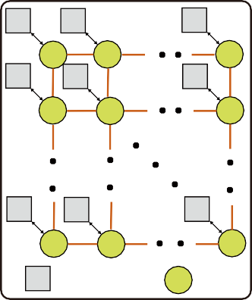
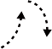

Fig. 1. Basic communication concepts for scalable asynchronous NoCs: (a) PE/router connectivity, (b) four-phase bundled-data transfer, and (c) two-phase bundled-data transfer.
PE PE
PE
(a)
R
R
R
PE
PE
PE
R
R
R
PE
PE
PE
R
R
R
PE Process Element R Router
(b) 4-phase bundled data
data
D1
D2
req ack
(c) 2-phase bundled data
data
D1
D2
req

ack
The interconnect determines whether this traffic can scale. A shared bus is simple, but every transfer passes through one arbitration point and one wire bundle; serialization, electrical fanout, and wire length limit bandwidth as the number of PEs increases. A NoC distributes point-to-point links and routers, so independent transfers can reuse different links concurrently [8], [9]. Fig. 1(a) shows this organization: PEs attach to local routers, which make capacity, locality, and path diversity explicit design dimensions.

- Scale-Out NoC Architectures
Topology, routing, and router microarchitecture then deter- mine complementary parts of communication cost. Meshes are modular but their diameter grows with system size; high-radix and hierarchical networks shorten paths or exploit locality at the cost of wiring and arbitration [2]. Multicast shares common path segments through in-network replication, while bypass, parallel datapaths, and optimized arbitration improve service capacity [6], [7], [9], [13], [16], [17].
Asynchronous signaling supplies the timing discipline for these links. In bundled-data communication, the sender stabi- lizes the data and changes a request; the receiver samples the data and returns an acknowledgment. Fig. 1(b) shows four- phase signaling, in which both control signals return to zero before the next transfer. Fig. 1(c) shows the two-phase variant used here: request and acknowledgment transitions delimit successive transfers without that reset interval. Two-phase links therefore advance on local completion, avoid a network-wide clock, and better tolerate router and wire-delay variation [15], [18], [19]. This reduces per-hop protocol overhead while allow- ing topology and routing to scale independently. It is also the protocol basis for the phase-safe lane binding and PhaseAdapter described in Section III-C; the handshake complements, rather than replaces, path capacity.
Deterministic routing provides predictable paths, whereas adaptive routing uses path diversity to avoid heavily loaded regions. Repeated unicast sends the same multicast data over common links; tree-based branching removes this redundancy, but its benefit remains limited by physical path capacity. Neither router-level optimization nor two-phase signaling can compensate for insufficient end-to-end capacity.
Hierarchical designs are attractive because they confine nearby traffic, but conventional aggregation progressively re- duces the number of upward resources. Increasing the lane count of a single upper router can recover bandwidth, yet its mutual-exclusion and arbitration structures grow with the number of competing paths. Replicating modest-radix routers
Fig. 2. Proposed 256-node organization.

instead provides parallel capacity while keeping each arbitra- tion domain bounded.
- Design Motivation
No single layer resolves scale and fanout together: hierarchy may concentrate traffic, multicast still needs physical capacity, and faster routers do not remove long routes. The proposed design therefore combines distributed parallel connectivity, cross-level multicast, and phase-safe binding of packet branches to physical lanes (Section III).
The resulting objective is a fixed-depth organization that preserves short local routes without progressively collapsing traffic onto a few wide upper-level routers. Multicast should remain a single transaction until a routing decision requires replication, and each branch must retain a stable physical lane for its packet lifetime. In an asynchronous network, that binding must also preserve request and acknowledgment phase state across dynamically selected paths. These requirements jointly motivate the topology, routing, and control mechanisms described next.
- Proposed NoC
- Parallel-Path Hierarchical Topology
Fig. 2 shows four identical 64-core tiles. Within each tile, 64 endpoints feed 16 L1 routers, followed by 16 L2 and 16 L3 routers and 16 mesh routers at the tile boundary. Corresponding mesh routers from the four tiles form 16 independent 2 × 2 planes. The fixed-depth hierarchy keeps local traffic on short
tree paths, while replicated upper paths distribute converg- ing and inter-tile traffic. All four router levels use the c1p4 geometry—one child-side lane and four parent-side lanes per logical direction—so replication raises aggregate path capacity without enlarging an individual arbitration domain.
Fig. 3(a) and (b) expand the two local interconnection stages. Within each quadrant q, the four L1 routers L1(q, i) are fully connected to four replicated L2 routers L2(q, k). Each L1 can therefore select any of four upward L2 paths, while every L2 can receive from all four L1 groups in the quadrant. The second stage regroups routers by k: for each k, the four L2(q, k) routers from different quadrants connect to four L3(j, k) routers. An upward packet first selects k at
L1–L2 and then j at L2–L3, yielding 4 × 4 = 16 physical path combinations. These replicated paths retain the logical
tree hierarchy and its region-based routing semantics while distributing traffic across separate routing elements.
Rather than further extending the hierarchy with increasingly wide upper-level routers, the local tree terminates at L3 and distributes global traffic over multiple mesh planes. Fig. 3(c) shows the L3-to-mesh distribution. Let P_{h} denote the h-th parent lane of an L3 router and L_{k} the k-th local port of
a mesh router, where j, h, k ∈ {0, 1, 2, 3}. The connection is L3(j, k).P_{h} ↔ Mesh(j, h).L_{k}. Consequently, the 16 L3 routers expose 64 tile-boundary links, distributed evenly among

 | 20 | 30 | 21 | 31 |  | 22 | 32 | 23 | 33
 | 00 | 01 | 00 | 01 |  | 10 | 11 | 10 | 11
 | 02 | 03 | 02 | 03 |  | 12 | 13 | 12 | 13
 |  |  |  |  | 0 1
 |  |  |  |  | 2 3
 | 20 | 21 | 20 | 21 |  | 30 | 31 | 30 | 31

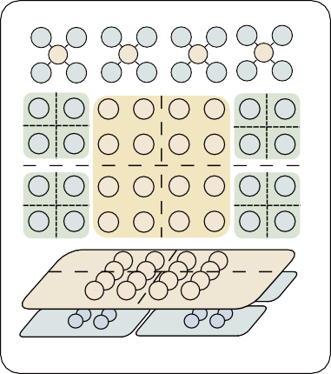
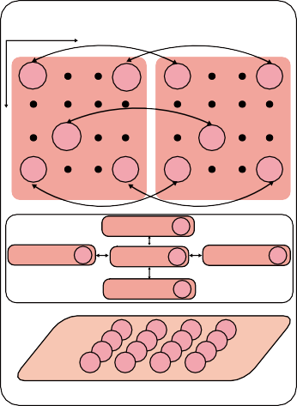
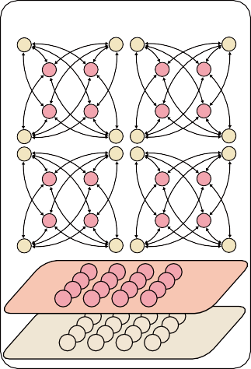
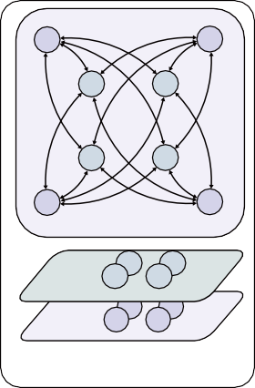
Fig. 3. Inter-level connectivity and upper-mesh planes.
K=0,1,2,3
00 10 01 11 02 12 03 13
K0 K1 K2 K3
22 23 22 23 32 33 32 33
Router L2
Router L1
Router L3
Router L2
Router L2
Level 1 - Level 2 (a) (b) Level 2 - Level 3
Level 3 - Mesh
(c) (d)
Intra - Mesh
X
0,0
3,0 0,0
3,0
Y
x,y
x,y
0,3 3,3
Tree (X,Y)
0,3
Tree (X+1,Y)
3,3
Let (x,y)=(3,1)
Tree(X,Y-1) 3,1
Tree(X+1,Y) 3,1
Tree(X,Y) 3,1
Tree(X+1,Y) 3,1
Tree(X,Y+1) 3,1
Mesh Router

Router L3
Mesh Router

16 mesh routers; each mesh router receives four local L3
TABLE I
28-BIT FLIT FORMAT USED BY THE ROUTING LOGIC.

Head Tail y1 x1 y0 x0 ID

[27] [26] [25:20] [19:14] [13:8] [7:2] [1:0]

capacity bounds rather than throughput predictions; measured performance is evaluated in Section IV.

- Multicast Routing Across Tree and Mesh
A unified rectangular destination representation is used across both routing tiers. Each multicast packet carries R_{d} = [x₀, x₁] × [y₀, y₁], where (x₀, y₀) and (x₁, y₁) denote the two opposite corners of the destination region. At each router v, the routing logic determines a logical output mask D = R (v, R_{d}, d_{in}), where d_{in} is the ingress direction and each bit of D enables one output direction. Physical-lane selection is
handled separately by the multi-lane control in Section III-C, allowing the same multicast packet to traverse the Tree–Mesh hierarchy without destination rewriting or packet regeneration. Table I summarizes the 28-bit flit format used by the routing logic. Bits [27] and [26] identify Head and Tail flits. On a Head flit, the four 6-bit coordinate fields y₁, x₁, y₀, x₀ encode the two opposite corners of the destination rectangle, while the 2-bit packet-ID field does not participate in routing. A unicast is represented as a degenerate rectangle with identical corners, allowing the same header to support both point-to-point and
rectangular multicast traffic.
Routing within Trees: Within the local tree, routing is de- termined by the spatial relation between the destination region and the region represented by each router. Let R_{v} denote the region covered by the current router v, and R^{i} the region

attachments through its four local ports.
Fig. 3(d) shows the intra-mesh step. For a fixed plane
associated with its
v
i-th child. A child direction i is activated

index (j, h), the corresponding Mesh(j, h) router from each tile occupies one coordinate of a 2 × 2 mesh. Links in that plane connect only routers with the same (j, h) index across adjacent tiles. The 256-node configuration therefore contains 16
independent planes and 64 mesh routers in total. This mapping terminates the local tree without introducing another high- radix aggregation point: local communication remains in the fixed-depth hierarchy, while packets that cross tile boundaries continue through one selected upper-mesh plane.
The capacity effect can be expressed with a cut-capacity bound. For a region S containing s nodes in an N -node network
under uniform-random unicast traffic, the average traffic leaving
whenever the destination region overlaps that child region, i.e., R_{d} ∩ R^{i} ̸= ∅. Meanwhile, the parent direction is activated only when R_{d} is not fully contained in R_{v}, allowing the packet to continue upward until reaching the smallest hierarchy level
that covers all destinations. The ingress direction is excluded from the output mask to avoid immediate backtracking. This rule is recursively applied across the three tree levels: L1 resolves destinations at PE level, whereas L2 and L3 operate on progressively larger spatial subregions.
v

Tree routing algorithm
1: D ← ∅
2: for each child direction i do
3: if i ̸= d_{in} and R_{d} ∩ R^{i} ̸= ∅ then
v

S is

Λ_{out} = sλ

N − s N − 1

. (2)
4: D ← D ∪ {i}
5: end if
6: end for
7: if d_{in} ̸= parent and R_{d} ⊈ R_{v} then
8: D ← D ∪ {parent}
9: end if

where λ is the per-node injection rate. If the cut provides c directed lanes of capacity C, the sustainable injection rate is bounded by
cC(N − 1)
λ ≤ . (3)
s(N − s)
10: return D

Routing within Mesh: For inter-tile communication, the destination rectangle is projected onto the upper-mesh coor- dinate space. Let R_{m} = [x_{L}, x_{H} ] × [y_{L}, y_{H} ], where x_{L} =
⌊min ^{(x}0 ,x1 ) ⌋, x_{H} = ⌊max ^{(x}0 ,x1 ) ⌋, and similarly for y_{L}
8 8
and y

For the 64-PE local hierarchy, the 4-PE and 16-PE cuts use (c=4) and c = 16 directed lanes and yield bounds of 1.05C and 1.31C, respectively, both above the endpoint capacity C; hence, neither hierarchical cut becomes the intrinsic bottleneck under this traffic model. At 256 nodes, the 16-plane upper mesh provides a central-bisection bound of 0.498C using 32
directed lanes, twice that of an equal-scale single-plane 16 × 16
mesh with 16 directed lanes (0.249C). These are structural
_{H} . Following prior tree-based multicast routing in 2-D
meshes [20], a packet outside R_{m} is first routed toward the nearest corner using deterministic XY routing. Once the packet enters R_{m}, it is locally delivered and replicated only toward the remaining portions of the destination region according to its ingress direction, as illustrated in Fig. 5. This approach preserves the same destination representation across the Tree– Mesh boundary and avoids regenerating packets for individual destination tiles.

Destination Region
0 | 1
2 | 3

0 |  | 1
2 |  | 3

L2 Region: (0**,0**)
0**
0**

L1 Region: (0*,0*)
0 | 1
2 | 3

Core Region: (0,0)
00
00

0**
0**
0*
0*

0**
0**
0*
0*

Active/Inactive direction

00
01
has consumed the tail and permits that branch to release its path.




The output port module (OPM) merges requests for one physical output. Candidate IPMs present PacketPathEnable_{i}, Req_{i}, and Data_{i}, as shown in Fig. 6. A mutual-exclusion arbiter grants one candidate for the packet lifetime; the granted request latch and data multiplexer drive ReqOut and DataOut toward the downstream channel. AckIn is the downstream acknowledgement. After each output transfer, it is returned only as the selected Ack_{i}, and detection of the transmitted tail generates the matching T ailPass. Thus, the IPM decides which directions participate in a multicast, while each OPM in- dependently arbitrates and forwards one physical output stream. Two arbitration levels are used. In the first level shown in Fig. 7, an asserted PPE allows every available
(c) (d)
（a) (b)
01
01
00
01
0*
0*
01
00
00
00
3
0

1
2
00
00
0**
0**
01
00
0*
0*
00
01
01
01
00
00
01
00

01
01

00
01
00
00
01
00

01
01
0*
0*

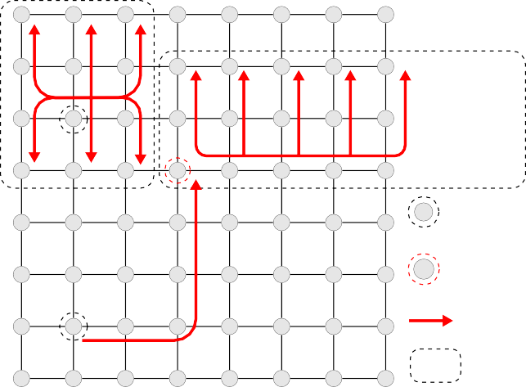
Fig. 4. Representative local-tree multicast routes.
0**
0**

Tree- based multicast XY routing

Source

entry corner

Route
destination region

Fig. 5. Upper-mesh multicast routing.

Mesh routing algorithm 1: D ← ∅; p ← (x, y) 2: if p ∈/ Rm then
3: q ← nearestCorner(p, Rm)
4: D ← {XYNext(p, q)}
5: else
6: if din ̸= local then
7: D ← D ∪ {local}
8: end if
9: W ← (x > x_{L}); E ← (x < x_{H} )
10: N ← (x_{L} ≤ x ≤ x_{H} ) ∧ (y < y_{H} )
11: S ← (x_{L} ≤ x ≤ x_{H} ) ∧ (y > y_{L})
12: if din = W then
13: add E, N, S when their predicates hold
14: else if din = E then
15: add W, N, S when their predicates hold
16: else if din = N then
17: add S; add W, E only at y = y_{H}
18: else if din = S then
19: add N ; add W, E only at y = y_{L}
20: else
21: add every direction whose predicate holds
22: end if
23: end if
24: remove off-grid directions; return D

- Multi-Lane Arbitration and Phase Adaptation
The input port module (IPM) receives a bundled-data channel through ReqIn, DataIn, and the returning AckOut, following the CMR organization in [16]. The incoming flits are stored in the five-entry CMR buffer while the route-computation unit decodes the header in parallel. Its PacketPathEnable outputs identify every required logical direction and remain active for the packet lifetime. Each enabled read interface then advances an independent read pointer and produces a ReqDir/DataDir stream, allowing multicast branches to progress at different rates. The corresponding AckDir acknowledges each trans- ferred flit, whereas T ailPass reports that the selected output
LaneIsEmpty_{i} to set a RequestHold_{i}. These held re- quests enter the exact-width mutex, which produces a one- hot LaneSelect. Feeding the selected bit back to the mutex input prevents the choice from changing when lane availability changes; the selection is released only when PPE falls at packet completion. In the second level, the OPM on that physical lane arbitrates among competing IPMs and retains its winner until the tail passes. Lane choice and output contention are therefore resolved by separate arbitration points.
The Phase Adapter in Fig. 7 preserves two-phase hand- shake state across this dynamic binding. Each physical lane owns an independent OPMReqIn_{i} toggle, while the logical IPM branch owns one IPMAckIn toggle. An IPMReqOut event is translated only to the selected lane. The adapter records when that lane has actually entered the pending state
OPMReqIn_{i} ̸= OPMAckOut_{i}, then accepts completion only from the same selected lane and toggles IPMAckIn.
This ordering keeps lane-selection transients outside the ac- knowledgement event path and prevents a stale lane phase from creating a premature or missing completion.

- Evaluation

- Experiment Setup
All designs use the TSMC 28-nm HPC+ standard-cell library at SS, 0.81 V, and 125 ◦C with CCS models. Timing and performance are obtained from MAXIMUM-SDF gate-level simulation; power and energy use time-based PrimeTime PX analysis. All implementation metrics are post-synthesis results.

- Node-Level Evaluation
Router primitives are evaluated using cXpY notation, where X and Y denote the child-side and parent-side lane counts per logical direction. The fixed offered-load labels M 5, M 20, and M 100 identify repeatable cases; all plotted rates are measured offered or delivered Mflit/s/port.
Table II places the proposed router beside recent asyn- chronous NoCs; differing technologies and latency definitions make the comparison contextual. The Async c1p4 router sus- tains 84.08 Gb/s with a 1.101-ns head-hop latency and 4.581- mW post-synthesis power. Four parent-side lanes increase ser- vice capacity while adding lane-selection and arbitration logic; complete-network effects are evaluated next.

- Network-Level Evaluation
The complete network is evaluated at 64 nodes for topology, control, and multicast ablations, and at 256 nodes for scale-out.

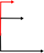
IPM-0
Routing Compute Unit

CellFull[4:0]
CellEmpty0

CellEmpty1

Write Interface Control
Tail[4:0] WritePointer

4 PacketPathEnable
4
OutLane

Req
Ack
LaneSelector & LaneAdaptor
Read Interface Control

4

OutLane OutLane

TailPass
AckDir0 LaneEmpty0 ReqDir0

AckN

Ack1 Ack0

DIR-3
OPM-0

ReqIn AckOut

DataIn

28
D EnQ

Storage
Reg
Reg
Reg
Reg Reg

Forward signal Backward signal

CellEmpty2 CellEmpty3
D En Q
D En Q
Mutex
Q D
ReadPointer0 5
28

XXX0
Q D

DataDir0 PacketPathEnableN
Q D

Q D
Q D

PacketPathEnable1 PacketPathEnable0 LaneEmptyDir0[0]
XXX4
XXX3
XXX2
XXX1

Req0 Req1

ReqN Data0 Data1

DataN

×M

Q D
IsTail

AckIn ReqOut

En
DataOut

×OutLane
×4

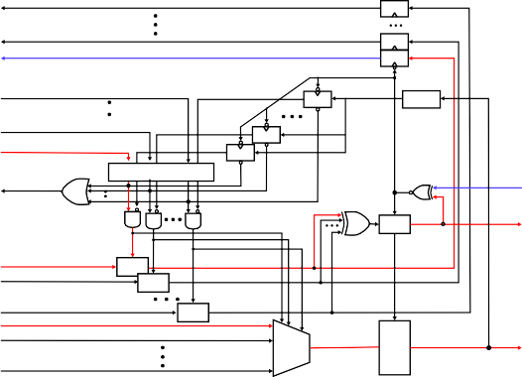
Fig. 6. Multi-lane CMR router interconnection.
D Q
Mux
D En Q

TABLE II
Node-Level Comparison With Representative Asynchronous NoC Routers

Design | Technology | Flit Width | Latency (ns) | Throughputª (Gb/s) | Energy^{b} (pJ/bit) | Area (µm²)
CMR [16] | 45 nm | 128 | 0.693^{c} | – | 0.118e | 54,083
TaBuLA [21] | 40 nm | 32 | 0.980^{d} | 34.24 | 0.120 | 24,866
Zeng et al. [22] | 55 nm | 4 | 1.250^{d} | 4.00 | 0.370 | 22,400
This work (Async c1p4) | 28 nm | 28 | 1.101^{c} | 84.08 | 0.0545 | 12,602
This work (Sync c1p4) | 28 nm | 28 | 1.000^{c} | 69.99 | 0.2254 | 11,374
aLogical throughput. bEnergy per delivered bit from time-based PrimeTime PX power and throughput. cHead-flit/head-hop latency. dReported average forward/flit latency; definitions differ across works. eCMR is derived from 75.4 pJ/(5×128 bits); TaBuLA and Zeng report their values directly.

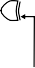
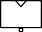
TABLE III
LaneSelector
RequestHold LaneEmpty0[0]

Q D 1
Delay
PacketPathEnable RequestHold LaneEmpty0[1]
LaneSelect[2]
RequestHold LaneEmpty0[2]
RequestHold LaneEmptyN[2]
LaneSelect[N-1]
PackPathEnable
LaneSelect[N-1:0]
PhaseAdapter
OPMAckOut0 OPMAckOut1
OPMAckOut2
IPMAckIn
OPMReqIn0
IPMReqOut
OPMReqIn1

OPMReqIn2
Forward Signal
Backward Signal
OPMAckOutN
OPMReqInN
Toggle

MUTEX
Toggle
Toggle
Toggle
Toggle
64-node Async/Sync results at M 100.

Metric Async Sync
Power (mW) | 64.7 284.3
Energy (pJ/flit) | 13.35 58.66
Mean latency (ns) | 10.33 13.35
Area (normalized) | 1.116 1.000

Fig. 7. Packet-lifetime lane selection and phase adaptation.

  - 64-Node Ablation Study: Fig. 8 compares PROP with an 8×8 Mesh and FAT under Uniform Random, Bit-Complement, and Hotspot10 traffic. Uniform Random selects destinations uniformly, Bit-Complement stresses long paths, and Hotspot10 weights four central nodes by 10%. All designs use identical
28-bit, five-flit traces with exponentially distributed header
arrivals.
Figs. 8(a)–(d) show a later latency knee and useful delivered traffic across all patterns. PROP reaches 379.2 Mflit/s/port (10.6 Gb/s/port) under Uniform Random, 58.7% above Mesh and
2.75× FAT. Its advantage also holds for Bit-Complement and Hotspot10, where PROP reaches 506.4 and 379.4 Mflit/s/port
versus Mesh’s 152.2 and 237.2.
With identical traces, native multicast injects one packet and replicates in network. It reduces completion latency by 94%– 98% across F16M5, F16M20, and F32M5, including 9.24 ns versus 148.60 ns at F16M5 [Fig. 10(a)]. At M 100, Async PROP uses 64.7 mW and 13.35 pJ/flit, compared with 73.5 mW for Mesh and 284.3 mW for Sync PROP; its mean latency is
10.33 ns versus 13.35 ns for Sync, with 11.6% area overhead [Fig. 10(b), Table III].
  - 256-Node Scale-Out Evaluation: The 256-node config- uration connects four 64-node tiles through 16 independent 2 × 2 upper-mesh planes and is compared with a 16 × 16 Mesh. Under global Uniform Random, identical five-flit traces select destinations uniformly from the other 255 nodes. PROP reaches
154.7 Mflit/s/port versus 112.5 Mflit/s/port for Mesh, a 37.5% increase, with a later latency knee [Fig. 9(a)].
For fanout-16 traffic split 8+8 across adjacent tiles, native multicast reduces completion latency by 92% at M 5 and 90%

(a)
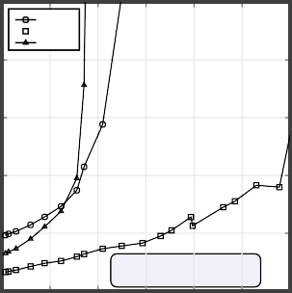
30
Mesh
PROP FAT
Bit Complement

25
Mean flit latency (ns)
(b)
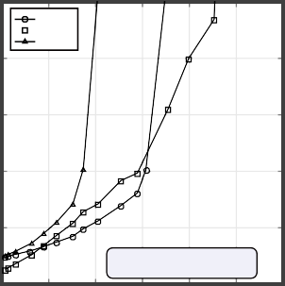
30
Mesh
PROP FAT
Uniform Random

25
Mean flit latency (ns)
(c)
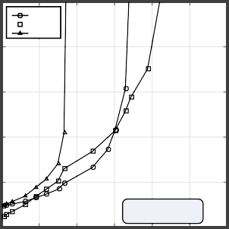
30
Mesh
PROP FAT
Hotspot 10

25
Mean flit latency (ns)

500

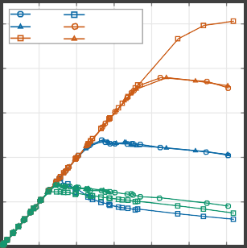
400
Mesh PROP
FAT UR
BC Hotspot10
Delivered throughput (Mflit/s/port)

(d)

20 20 20
300

15 15 15
200

10 10 10

100

5
0 50 100 150 200 250 300
Measured offered throughput (Mflit/s/port)
5
0 50 100 150 200 250 300
Measured offered throughput (Mflit/s/port)
5
0 50 100 150 200 250 300
Measured offered throughput (Mflit/s/port)

0
0 100 200 300 400 500 600
Measured offered throughput (Mflit/s/port)

Fig. 8. 64-node unicast evaluation: mean flit latency for Bit-Complement, Uniform-Random, and Hotspot10 traffic, and delivered throughput across the three patterns.

- 256-node global uniform random latency and throughput
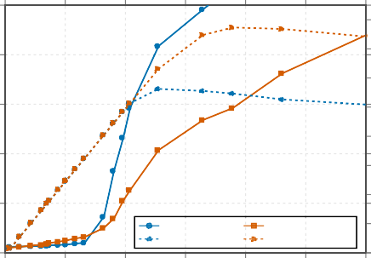
500

Mesh latency PROP latency Mesh throughput PROP throughput
Delivered throughput (Mflit/s/port)
Completion latency (ns)

- 256-node cross-tile multicast (F16)

- 256-node intra tile unicast (M120)

400
Mean flit latency (ns)

300

200

100

0
160

140

120

100

80

60

40

20

0
0 50 100 150 200 250 300
Offered throughput (Mflit/s/port)
400

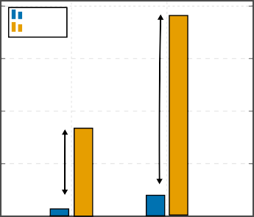
300
Native Repeated
380.0

39.3

13.3
157.6

-92%

-90%

200

100

0

M5 M20
Offered-load case

40

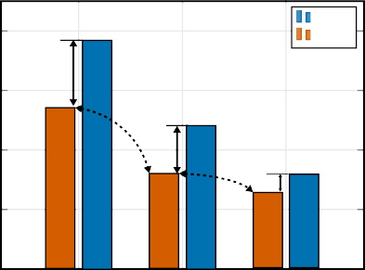
30
24.1

15.9

-20%
12.7

16.2

-33%
27.2
38.7

-30%
Mesh PROP
Mean flit latency (ns)

20

10

0
0.25 0.50 0.75
Intra-tile destination probability

Fig. 9. 256-node evaluation: (a) global Uniform-Random latency and delivered throughput; (b) cross-tile fanout-16 completion latency; (c) locality-dependent mean latency.

400
Mean completion latency (ns)

300

200

100

0

300

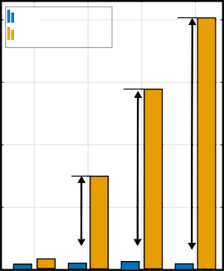
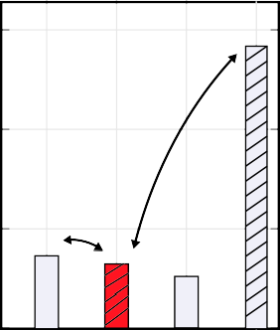
200
Native multicast
Repeated unicast
402.4

-98%
287.7
-95%
148.6

9.5

14.3
-94%

15.6 9.2

8.3
Network power at M100
284.3
51.9

7

64.
73.5
-77%

-12%
Total Power (mW)

100

0
F2M5 F16M5 F16M20 F32M5 Mesh PROP FAT Sync PROP
(a) (b)
topology, multicast, and asynchronous control for high-fanout traffic.

References

- P. A. Merolla, J. V. Arthur, R. Alvarez-Icaza, A. S. Cassidy, J. Sawada,
F. Akopyan, B. L. Jackson, N. Imam, C. Guo, Y. Nakamura et al., “A million spiking-neuron integrated circuit with a scalable communication network and interface,” Science, vol. 345, no. 6197, pp. 668–673, 2014.
- Y. Zhong, Y. Kuang, K. Liu et al., “Paicore: A 1.9-million-neuron 5.181- tsops/w digital neuromorphic processor with unified snn-ann and on-chip learning paradigm,” IEEE Journal of Solid-State Circuits, vol. 60, no. 2,
pp. 651–671, 2025.
- Intel Labs, “Taking neuromorphic computing to the next level with loihi

Fig. 10. 64-node results: (a) native multicast versus repeated-unicast comple- tion latency; (b) total network power at M 100.

at M 20 [Fig. 9(b)]. At M 120, increasing intra-tile locality produces the same trend in both networks, while PROP remains 20%–33% lower in mean latency across the tested probabilities [Fig. 9(c)].

- Conclusion

This paper presented a fully asynchronous hierarchical NoC for scalable high-fanout communication. The design combines a parallel-path fixed-depth hierarchy, native Tree–Mesh multicast, and phase-safe multi-lane control to increase path diversity without a global clock or source-side multicast expansion. Post- synthesis results show 379.2 Mflit/s/port peak throughput in the 64-node network (10.6 Gb/s/port at the 28-bit flit width), 58.7% above a flat mesh, while native multicast reduces fanout- 16 completion latency by 93.8%. A four-lane router reaches
3.00 Gflit/s aggregate throughput, and the 256-node four-tile system reaches 37.5% higher peak throughput than a conven- tional mesh. Together, these measurements support coordinated
2,” Intel Corporation, Tech. Rep., 2021, technology Brief.
- Intel Corporation, “Intel builds world’s largest neuromorphic system to enable more sustainable ai,” Apr. 2024, intel Newsroom, Apr. 17, 2024.
- S. Moradi, N. Qiao, F. Stefanini, and G. Indiveri, “A scalable mul- ticore architecture with heterogeneous memory structures for dynamic neuromorphic asynchronous processors (DYNAPs),” IEEE Transactions on Biomedical Circuits and Systems, vol. 12, no. 1, pp. 106–122, 2018.
- P. Merolla, J. Arthur, R. Alvarez-Icaza, J.-M. Bussat, and K. Boahen, “A multicast tree router for multichip neuromorphic systems,” IEEE Transactions on Circuits and Systems I: Regular Papers, vol. 61, no. 3,
pp. 820–833, 2014.
- Z. Su, A. Bencsik, G. Indiveri, and D. Bertozzi, “An efficient multicast addressing encoding scheme for multi-core neuromorphic processors,” in Proc. IEEE International Symposium on Circuits and Systems (ISCAS), 2025.
- W. J. Dally and B. Towles, Principles and Practices of Interconnection Networks. San Francisco, CA, USA: Morgan Kaufmann, 2004.
- T. Krishna, C.-H. O. Chen, W. C. Kwon, and L.-S. Peh, “Breaking the on-chip latency barrier using SMART,” in Proc. 19th IEEE International Symposium on High Performance Computer Architecture (HPCA), 2013,
pp. 378–389.
- J. Kim, J. Balfour, and W. J. Dally, “Flattened butterfly topology for on- chip networks,” IEEE Computer Architecture Letters, vol. 6, no. 2, pp. 37–40, 2007.
- X. Xiang, W. Shi, S. Ghose, L. Peng, O. Mutlu, and N.-F. Tzeng, “Carpool: A bufferless on-chip network supporting adaptive multicast and hotspot alleviation,” in Proc. International Conference on Supercomputing (ICS), 2017.

- N. Enright Jerger, L.-S. Peh, and M. H. Lipasti, “Virtual circuit tree multicasting: A case for on-chip hardware multicast support,” in Proc. 35th Annual International Symposium on Computer Architecture (ISCA), 2008, pp. 229–240.
- T. Fischer, M. Rogenmoser, T. Benz, F. K. Gu¨rkaynak, and L. Benini, “Floonoc: A 645-gb/s/link 0.15-pj/b/hop open-source noc with wide physical links and end-to-end axi4 parallel multistream support,” IEEE Transactions on Very Large Scale Integration (VLSI) Systems, vol. 33, no. 4, pp. 1094–1107, 2025.
- S. Liu, M. Roediger, and A. Karanth, “Monet: A mixture-of-experts accelerator with a multicast-optimized two-tier network-on-chip,” in Proc. Design, Automation and Test in Europe Conference (DATE), 2026.
- C. Zhang, Y. Hu, and Y. Kang, “A reusable methodology for high- performance interconnects using a standard-cell based asynchronous noc router,” in Proc. Design, Automation and Test in Europe Conference (DATE), 2026, pp. 1–7.
- K. Bhardwaj and S. M. Nowick, “A continuous-time replication strategy for efficient multicast in asynchronous nocs,” IEEE Transactions on Very Large Scale Integration (VLSI) Systems, vol. 27, no. 2, pp. 350–363, 2019.
- S. Rasheed, P. V. Gratz, S. Shakkottai, and J. Hu, “Storm: A simple traffic-optimized router microarchitecture for networks-on-chip,” in Proc. 8th IEEE/ACM International Symposium on Networks-on-Chip (NOCS), 2014, pp. 176–177.
- A. Ghiribaldi, D. Bertozzi, and S. M. Nowick, “A transition-signaling bundled data noc switch architecture for cost-effective gals multicore systems,” in Proc. Design, Automation and Test in Europe Conference (DATE), 2013, pp. 332–337.
- W. Jiang, D. Bertozzi, G. Miorandi, S. M. Nowick, W. Burleson, and
G. Sadowski, “An asynchronous noc router in a 14nm finfet library: Comparison to an industrial synchronous counterpart,” in Proc. Design, Automation and Test in Europe Conference (DATE), 2017, pp. 732–733.
- L. Wang, Y. Jin, H. Kim, and E. J. Kim, “Recursive partitioning multicast: A bandwidth-efficient routing for networks-on-chip,” in Proc. International Symposium on Networks-on-Chip (NOCS), 2009, pp. 64–73.
- D. Bertozzi, G. Miorandi, A. Ghiribaldi, W. Burleson, G. Sadowski,
K. Bhardwaj, W. Jiang, and S. M. Nowick, “Cost-effective and flexible asynchronous interconnect technology for gals systems,” IEEE Micro, vol. 41, no. 1, pp. 69–81, 2021.
- Q. Zeng, J. Wang, J. Cong, and D. Shang, “A lightweight and high- throughput asynchronous message bus for communication in multi-core heterogeneous systems,” IEEE Access, vol. 12, pp. 48 555–48 568, 2024.

