A Fully Asynchronous Parallel-Path Hierarchical NoC for Scalable High-Fanout On-Chip Communication
Anonymous Authors

Abstract—As manycore processors, AI accelerators, and other large SoCs grow, their on-chip networks must carry traffic across longer distances and increasingly shared links. This scaling creates two related problems: global traffic competes for a small number
Following the standard interconnection-network model [8], [9], communication latency is
L

of upper-level links, while one-to-many transfers send repeated copies of the same data through those links. The network therefore
T_{comm} = Ht_{r} + Ht_{w} + T_{c} +
. (1)
b

needs more parallel paths and intra-network replication, while avoid- ing unnecessary copies at the source. We address this problem with a fully asynchronous hierarchical NoC. Each 64-node tile contains a three-level local tree, while independent 2 × 2 upper-mesh planes connect the tile boundaries. At each tree level, multiple routers provide several independent request/data paths, called lanes, between adjacent levels. Native multicast keeps one packet while destinations share a path and creates copies only when paths diverge. A phase-safe controller selects one lane for each packet branch and preserves the two-phase request/acknowledge protocol during the selection. Post-synthesis evaluation shows that PROP reaches 379.2 Mflit/s per NoC node in the 64-node network, 58.7% above a flat mesh. Native multicast reduces F16M5 completion latency by 93.8% relative to repeated unicast. In the 256-node four-tile network, PROP reaches 154.7 Mflit/s per node, 37.5% above the flat-mesh baseline.
Index Terms—asynchronous NoC, hierarchical NoC, hardware multicast, multi-lane routing, scale-out interconnects, neuromor- phic computing

- Introduction
Modern manycore processors, AI accelerators, and other large SoCs integrate hundreds or thousands of processing elements and memory blocks. Within these chips, the on- chip network determines how efficiently data moves between compute regions. As the number of endpoints grows, packets traverse more routers, traffic from many regions converges on shared links, and one-to-many transfers increase replication traffic. TrueNorth integrates 4,096 neurosynaptic cores [1], PAICORE connects 1,024 cores through a hierarchical fabric [2], and Hala Point scales 1,152 Loihi 2 processors to 140,544 cores [3], [4]; these systems illustrate how communication becomes a limiting factor as on-chip systems scale.
Scale-out creates a path-capacity problem. Local traffic can remain within one tile, but traffic between distant regions must share a smaller set of upper-level links. As the number of endpoints increases, these shared links can become congested even when local routers are lightly loaded. A scalable NoC therefore needs several independent links between levels so that traffic can be distributed across multiple paths. The same issue appears in dense streaming and sparse event-driven systems; neuromorphic events provide a clear example because a short event may reach nearby and distant destinations [5]–[7].
Fanout creates a second problem. Sending one-to-many traf- fic as separate unicast packets repeats the same flit on common links, increasing injection and queueing pressure. Widening one upper-level router can provide more capacity, but it also makes that router handle more competing requests and increases its control cost. The proposed design uses several parallel routers and keeps a multicast packet shared until its destination paths diverge.
where H is hop count, t_{r} and t_{w} are the per-hop router and link delays, respectively, T_{c} is contention delay, and L/b is seri- alization delay. Topology reduces H and supplies path capacity; routing distributes load and shares multicast paths; router microarchitecture reduces local delay and increases service rate. Existing techniques improve individual terms through high- radix or hierarchical connectivity [2], [10], adaptive routing and hardware multicast [11], [12], or wide and asynchronous routers [13]–[15].
These topology and router choices expose different imple- mentation tradeoffs. Regular mesh and torus networks retain simple routers but require more hops as dimensions grow. High- radix and hierarchical structures reduce hop count or preserve locality, while adaptive routing and hardware multicast dis- tribute load and share common path segments. Wider datapaths and parallel channels increase service rate, but a hierarchy can concentrate traffic in a few upper-level routers and make them congested. Scale-out therefore requires distributed path capac- ity, in-network replication, and control that safely coordinates parallel physical lanes.
This paper presents a fully asynchronous parallel-path hier- archical NoC for high-fanout communication. Its contributions are:
- Parallel-path hierarchy: multiple intermediate routers connect several physical lanes between stages, while inde- pendent mesh planes connect tiles. The structure preserves short local paths and distributes converging traffic.
- Native hierarchical multicast: one injected transaction remains multicast across the hierarchy and upper meshes, replicating only at routing branches and sharing common path segments.
- Phase-safe parallel-lane control: packet-lifetime path binding preserves two-phase request and acknowledgment state during lane selection and arbitration without local clocks.
- Background and Motivation
- Communication in Large-Scale Systems
Large systems combine local traffic with less frequent global transfers. Address-Event Representation (AER) is one concrete example: an event is a compact address-bearing packet repre- senting one or more neural spikes, and one event may target multiple destination cores [5], [6]. Thus a sparse source can still create high-fanout transfers, routing metadata, and contention [7]. The same distinction appears in accelerator and manycore systems as local streams, regional synchronization, and global reductions. Local traffic therefore needs short paths and low

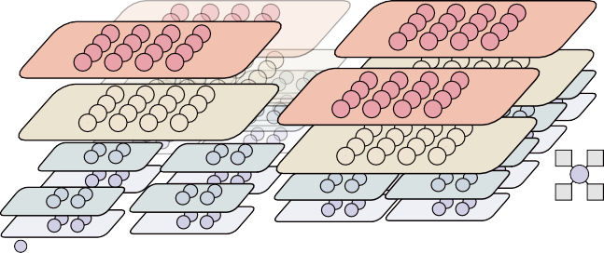
Mesh Router
Mesh Router
Mesh Router
Router
Router L3
Router L2
Router L1
Router
L2
Router L1
L2
Router L1
Router L2
Router Router L1
L2
Router L1
Router
RouterL2
RouterL2
L3
L3
Router RouterL1
Mesh
Router
Router
Router L1
L2
Router
Router L2
Router Router L1
L2
Router L2
Router L1
Router L1
Router
L3 L2
Router RouterL1
Router L2
Router L1
L2
Router L1
Router RouterL1
L2
Router Router L1
L2
Router L1
Core
0 1

2 3
RouterL1 (×16/tree)
RouterL2 (×16/tree)
RouterL3 (×16/tree)
Core (×64/tree) MeshRouter (×16/tree)

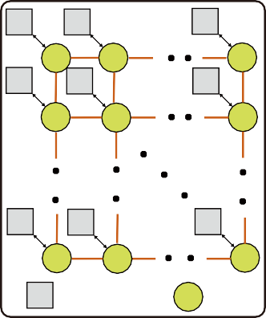
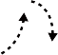

Fig. 1. Basic communication concepts for scalable asynchronous NoCs: (a) PE/router connectivity, (b) four-phase bundled-data transfer, and (c) two-phase bundled-data transfer.
PE PE
PE
(a)
R
R
R
PE
PE
PE
R
R
R
PE
PE
PE
R
R
R
PE Process Element R Router
(b) 4-phase bundled data
data
D1
D2
req ack
(c) 2-phase bundled data
data
D1
D2
req

ack
per-hop overhead, while global and high-fanout traffic needs aggregate bisection capacity and efficient replication.
The interconnect determines whether this traffic can scale. A shared bus is simple, but every transfer passes through one arbitration point and one wire bundle; serialization, electrical fanout, and wire length limit bandwidth as the number of PEs increases. A NoC distributes point-to-point links and routers, so independent transfers can reuse different links concurrently [8], [9]. Fig. 1(a) shows this organization: PEs attach to local routers, which make capacity, locality, and path diversity explicit design dimensions.
- Scale-Out NoC Architectures
Topology, routing, and router microarchitecture then deter- mine complementary parts of communication cost. Meshes are modular but their diameter grows with system size; high-radix and hierarchical networks shorten paths or exploit locality at the cost of wiring and arbitration [2]. Multicast shares common path segments through in-network replication, while bypass, parallel datapaths, and optimized arbitration improve service capacity [6], [7], [9], [13], [16], [17].
Asynchronous signaling supplies the timing discipline for these links. In bundled-data communication, the sender stabi- lizes the data and changes a request; the receiver samples the data and returns an acknowledgment. Fig. 1(b) shows four- phase signaling, in which both control signals return to zero before the next transfer. Fig. 1(c) shows the two-phase variant used here: request and acknowledgment transitions delimit successive transfers without that reset interval. Two-phase links therefore advance on local completion, avoid a network-wide clock, and better tolerate router and wire-delay variation [15], [18], [19]. This reduces per-hop protocol overhead while allow- ing topology and routing to scale independently. It is also the protocol basis for the phase-safe lane binding and PhaseAdapter described in Section III-C; the handshake complements, rather than replaces, path capacity.
Deterministic routing provides predictable paths, whereas adaptive routing uses path diversity to avoid heavily loaded regions. Repeated unicast sends the same multicast data over common links; tree-based branching removes this redundancy, but its benefit remains limited by physical path capacity. Neither router-level optimization nor two-phase signaling can compensate for insufficient end-to-end capacity.
Hierarchical designs are attractive because they confine nearby traffic, but conventional aggregation progressively re- duces the number of upward resources. Increasing the lane count of a single upper router can recover bandwidth, yet its arbitration structures must handle more competing paths.
Fig. 2. Proposed 256-node organization.

The proposed design spreads the upward links across several routers. Each router handles a limited number of competing requests, while the combined structure still provides multiple paths through the hierarchy.
- Design Motivation
No single layer resolves scale and fanout together: hierarchy may concentrate traffic, multicast still needs physical capacity, and faster routers do not remove long routes. The proposed design therefore combines distributed parallel connectivity, cross-level multicast, and phase-safe binding of packet branches to physical lanes (Section III).
The resulting objective is a fixed-depth organization that preserves short local routes without progressively collapsing traffic onto a few wide upper-level routers. Multicast should remain a single transaction until a routing decision requires replication, and each branch must retain a stable physical lane for its packet lifetime. In an asynchronous network, that binding must also preserve request and acknowledgment phase state across dynamically selected paths. These requirements jointly motivate the topology, routing, and control mechanisms described next.
- Proposed NoC
- Parallel-Path Hierarchical Topology
Fig. 2 shows four identical 64-core tiles. Within each tile, 64 endpoints feed 16 L1 routers, followed by 16 L2 and 16 L3 routers and 16 mesh routers at the tile boundary. Corresponding mesh routers from the four tiles form 16 independent 2 × 2 planes. The fixed-depth hierarchy keeps local traffic on short
tree paths, while replicated upper paths distribute converg- ing and inter-tile traffic. All four router levels use the c1p4 geometry—one child-side lane and four parent-side lanes per logical direction—so replication raises aggregate path capacity without concentrating all requests in one wider router.
Fig. 3(a) and (b) expand the two local interconnection stages. Within each quadrant q, the four L1 routers L1(q, i) are fully connected to four replicated L2 routers L2(q, k). Each L1 can therefore select any of four upward L2 paths, while every L2 can receive from all four L1 groups in the quadrant. The second stage regroups routers by k: for each k, the four L2(q, k) routers from different quadrants connect to four L3(j, k) routers. An upward packet first selects k at
L1–L2 and then j at L2–L3, yielding 4 × 4 = 16 physical path combinations. These replicated paths retain the logical
tree hierarchy and its region-based routing semantics while distributing traffic across separate routing elements.
Rather than further extending the hierarchy with increasingly wide upper-level routers, the local tree terminates at L3 and distributes global traffic over multiple mesh planes. Fig. 3(c) shows the L3-to-mesh distribution. Let P_{h} denote the h-th
parent lane of an L3 router and L_{k} the k-th local attachment of a mesh router, where j, h, k ∈ {0, 1, 2, 3}. The connection

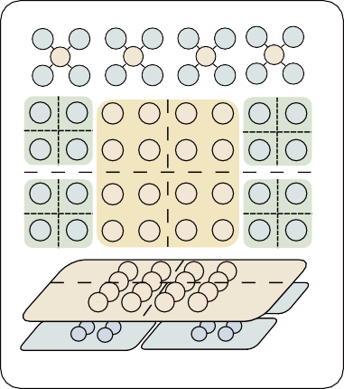
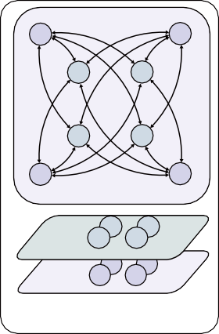
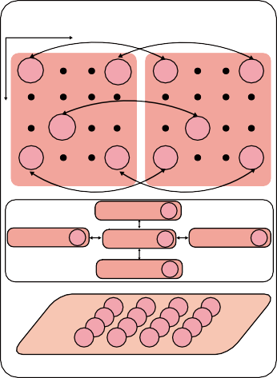
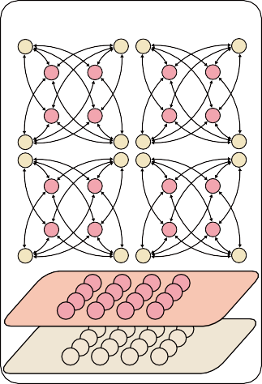
TABLE I
K=0,1,2,3
00 10
K0
01 11 02 12
K1
K2
03 13
K3
Router L1
Router L3
Router L2
Router L2
Level 1 - Level 2 (a) (b) Level 2 - Level 3
Level 3 - Mesh
(c) (d)
Intra - Mesh
X
0,0
3,0 0,0
3,0
Y
x,y
x,y
0,3 3,3
Tree (X,Y)
0,3
Tree (X+1,Y)
3,3
Let (x,y)=(3,1)
Tree(X,Y-1) 3,1
Tree(X+1,Y) 3,1
Tree(X,Y) 3,1
Tree(X+1,Y) 3,1
Tree(X,Y+1) 3,1
Mesh Router

Router L3
Mesh Router
28-BIT FLIT FORMAT USED BY THE ROUTING LOGIC.
 | 20 | 30 | 21 | 31 |  | 22 | 32 | 23 | 33
 | 00 | 01 | 00 | 01 |  | 10 | 11 | 10 | 11
 | 02 | 03 | 02 | 03 |  | 12 | 13 | 12 | 13
 |  |  |  |  | 0 1
 |  |  |  |  | 2 3
 | 20 | 21 | 20 | 21 |  | 30 | 31 | 30 | 31
 | 22 | 23 | 22 | 23 |  | 32 | 33 | 32 | 33
Router
L2

Head Tail y1 x1 y0 x0 ID

[27] [26] [25:20] [19:14] [13:8] [7:2] [1:0]

directed lanes, twice that of an equal-scale single-plane 16 × 16 mesh with 16 directed lanes (0.249C). These are structural capacity bounds rather than throughput predictions; measured
performance is evaluated in Section IV.

Fig. 3. Inter-level connectivity and upper-mesh planes.

is L3(j, k).P_{h} ↔ Mesh(j, h).L_{k}. Consequently, the 16 L3 routers expose 64 tile-boundary links, distributed evenly among
16 mesh routers; each mesh router receives four local L3
- Multicast Routing Across Tree and Mesh
A unified rectangular destination representation is used across both routing tiers. Each multicast packet carries R_{d} = [x₀, x₁] × [y₀, y₁], where (x₀, y₀) and (x₁, y₁) denote the two opposite corners of the destination region. At each router v, the routing logic determines a logical output mask D = R (v, R_{d}, d_{in}), where d_{in} is the ingress direction and each bit of D enables one output direction. Physical-lane selection is
handled separately by the multi-lane control in Section III-C, allowing the same multicast packet to traverse the Tree–Mesh hierarchy without destination rewriting or packet regeneration. Table I summarizes the 28-bit flit format used by the routing logic. Bits [27] and [26] identify Head and Tail flits. On a Head flit, the four 6-bit coordinate fields y₁, x₁, y₀, x₀ encode the two opposite corners of the destination rectangle, while the 2-bit packet-ID field does not participate in routing. A unicast is represented as a degenerate rectangle with identical corners, allowing the same header to support both point-to-point and
rectangular multicast traffic.
Routing within Trees: Within the local tree, routing is de- termined by the spatial relation between the destination region and the region represented by each router. Let R_{v} denote the region covered by the current router v, and R^{i} the region

attachments through its four local interfaces.
Fig. 3(d) shows the intra-mesh step. For a fixed plane
associated with its
v
i-th child. A child direction i is activated

index (j, h), the corresponding Mesh(j, h) router from each tile occupies one coordinate of a 2 × 2 mesh. Links in that plane connect only routers with the same (j, h) index across
adjacent tiles. The 256-node configuration therefore contains 16 independent planes and 64 mesh routers in total. This mapping terminates the local tree without introducing another high- radix aggregation point: local communication remains in the fixed-depth hierarchy, while packets that cross tile boundaries continue through one selected upper-mesh plane.
The capacity effect can be expressed with a cut-capacity
bound. For a region S containing s nodes in an N -node network under uniform-random unicast traffic, the average traffic leaving
whenever the destination region overlaps that child region, i.e., R_{d} ∩ R^{i} ̸= ∅. Meanwhile, the parent direction is activated only when R_{d} is not fully contained in R_{v}, allowing the packet
to continue upward until reaching the smallest hierarchy level that covers all destinations. The ingress direction is excluded from the output mask to avoid immediate backtracking. This rule is recursively applied across the three tree levels: L1 resolves destinations at PE level, whereas L2 and L3 operate on progressively larger spatial subregions.
v

Tree routing algorithm
1: D ← ∅
2: for each child direction i do
3: if i ̸= d_{in} and R_{d} ∩ R^{i} ̸= ∅ then
v

S is

Λ_{out} = sλ

N − s N − 1

. (2)
4: D ← D ∪ {i}
5: end if
6: end for
7: if d_{in} ̸= parent and R_{d} ⊈ R_{v} then
8: D ← D ∪ {parent}
9: end if

where λ is the per-node injection rate. If the cut provides c directed lanes of capacity C, the sustainable injection rate is bounded by
cC(N − 1)
λ ≤ . (3)
s(N − s)
10: return D

Routing within Mesh: For inter-tile communication, the destination rectangle is projected onto the upper-mesh coor- dinate space. Let R_{m} = [x_{L}, x_{H} ] × [y_{L}, y_{H} ], where x_{L} =
⌊min ^{(x}0 ,x1 ) ⌋, x_{H} = ⌊max ^{(x}0 ,x1 ) ⌋, and similarly for y_{L}
8 8
and y

For the 64-PE local hierarchy, the 4-PE and 16-PE cuts use (c=4) and c = 16 directed lanes and yield bounds of 1.05C and 1.31C, respectively, both above the endpoint capacity C; hence, neither hierarchical cut becomes the intrinsic bottleneck under this traffic model. At 256 nodes, the 16-plane upper mesh provides a central-bisection bound of 0.498C using 32
_{H} . Following prior tree-based multicast routing in 2-D
meshes [20], a packet outside R_{m} is first routed toward the nearest corner using deterministic XY routing. Once the packet enters R_{m}, it is locally delivered and replicated only toward the remaining portions of the destination region according to its ingress direction, as illustrated in Fig. 5. This approach preserves the same destination representation across the Tree–





Destination Region
0**
0**
00
00
01
00
0*
0*
00
01
01
01
0 | 1
2 | 3

0 |  | 1
2 |  | 3

L2 Region: (0**,0**)
0**
0**

L1 Region: (0*,0*)

Active/InactiveCore Region: (0,0)
0 | 1
2 | 3

destination tiles.

Mesh routing algorithm 1: D ← ∅; p ← (x, y) 2: if p ∈/ Rm then
3: q ← nearestCorner(p, Rm)
3
2

1
0
0**
0**
00
00
01
00
0*
0*
00
01
01
01
（a) (b)
(c) (d)
00
00
0**
0**
01
00
0*
0*
00
01
01
01
4: D ← {XYNext(p, q)}
5: else
6: if din ̸= local then
7: D ← D ∪ {local}
8: end if
00
00
0**
0**
01
00
0*
0*
00
01
01
01
9: W ← (x > x_{L}); E ← (x < x_{H} )
10: N ← (x_{L} ≤ x ≤ x_{H} ) ∧ (y < y_{H} )
11: S ← (x_{L} ≤ x ≤ x_{H} ) ∧ (y > y_{L})
12: if din = W then
13: add E, N, S when their predicates hold
14: else if din = E then
15: add W, N, S when their predicates hold
16: else if din = N then
17: add S; add W, E only at y = y_{H}
18: else if din = S then
0*
0*
00
00
direction

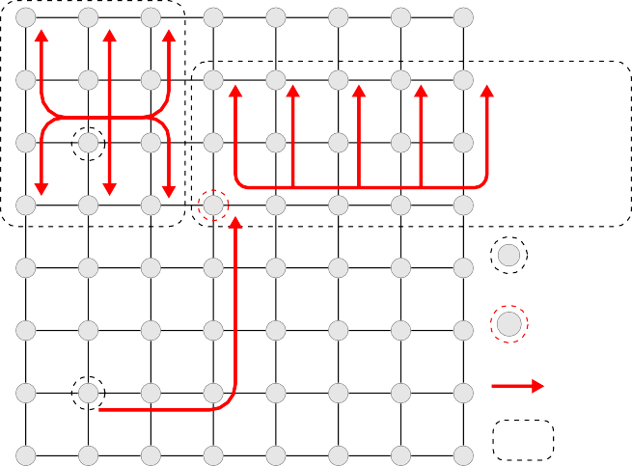
Fig. 4. Local-tree multicast examples for four destination regions. In (a), the destination lies entirely in core region (0, 0), so the packet is sent only to that core. In (b), the destination requires an upward transfer beyond the current L1 region. In (c), the destination covers core regions (0, 0) and (0, 1), so both child directions are enabled. In (d), the destination spans multiple L1 regions, so the packet is sent upward before being replicated at the next level.

Tree- based multicast
19: add N ; add W, E only at y = y_{L}
20: else
21: add every direction whose predicate holds
22: end if
23: end if
24: remove off-grid directions; return D

- Multi-Lane Arbitration and Phase Adaptation
The input interface module (IPM) receives a bundled- data channel through ReqIn, DataIn, and the returning AckOut, following the CMR organization in [16]. The in- coming flits are stored in the five-entry CMR buffer while

(b)
XY routing
(a)

Source

entry corner

Route

destination region
the route-computation unit decodes the header in parallel. Its PacketPathEnable outputs identify every required logical direction and remain active for the packet lifetime. Each en- abled read interface then advances an independent read pointer and produces a ReqDir/DataDir stream, allowing multicast branches to progress at different rates. The corresponding AckDir acknowledges each transferred flit, whereas T ailPass reports that the selected output has consumed the tail and permits that branch to release its path.
The output interface module (OPM) merges requests for one physical output. Candidate IPMs present PacketPathEnable_{i},

Fig. 5. Upper-mesh multicast examples for two source locations. In (a), the
source lies inside the destination region, so the packet is forwarded within that region and branches along the required mesh directions. In (b), the source lies outside the destination region, so the packet first reaches the region through the shared route and then branches inside it. The dashed box marks the destination region and the red arrows show the transmission path.

Mesh boundary and avoids regenerating packets for individual
Req_{i}, and Data_{i}, as shown in Fig. 6. A mutual-exclusion arbiter grants one candidate for the packet lifetime; the granted request latch and data multiplexer drive ReqOut and DataOut toward the downstream channel. AckIn is the downstream acknowledgement. After each output transfer, it is returned only as the selected Ack_{i}, and detection of the transmitted tail generates the matching T ailPass.

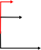
IPM-0
Routing Compute Unit

4 PacketPathEnable
4
Q D

Q D
Q D

OutLane

TailPass AckDir0

AckN
DIR-3
OPM-0

CellFull[4:0]

Write Interface Control
Tail[4:0] WritePointer
Read
Interface
4 Control
Req Ack
LaneSelector OutLane &
LaneAdaptor OutLane
LaneEmpty0 ReqDir0
Ack1 Ack0

ReqIn AckOut
CellEmpty0

CellEmpty1

CellEmpty2 CellEmpty3
Mutex
Q D
ReadPointer0 5
28

Lane-Aware Read Interface0
Q D

DataDir0 PacketPathEnableN

PacketPathEnable1 PacketPathEnable0
D En Q
D En Q
D EnQ

Q D
IsTail

AckIn

DataIn
D Q
Mux
D En Q

28

Storage
Reg
Reg
Reg
Reg Reg

Forward signal Backward signal
Lane-Aware Read Interface1

Lane-Aware Read Interface3

Lane-Aware Read Interface3
×M
LaneEmptyDir0[0]

Req0 Req1

ReqN Data0 Data1

DataN

ReqOut

En
DataOut

×OutLane
×4

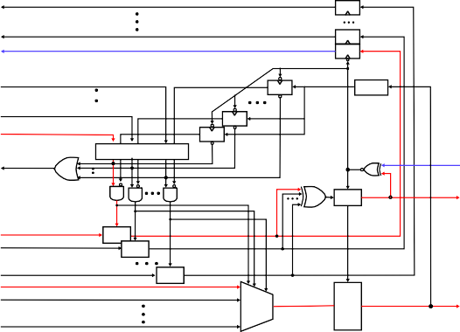
Fig. 6. Internal interconnection of the multi-lane CMR router. The input interface computes the route mask and issues requests for eligible outputs. The output interface arbitrates among these requests, binds each packet branch to one physical lane, and forwards the data through the selected child or parent path. The phase adapter preserves the request and acknowledge phase relationship across the selected lane.

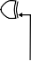
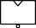
winner until the tail passes. Lane choice and output contention are therefore resolved by separate arbitration points.
LaneSelector
RequestHold LaneEmpty0[0]

Q D 1
Delay

PacketPathEnable
LaneEmpty0[1]
LaneEmpty0[2]
LaneSelect[2]
RequestHold LaneEmptyN[2]
LaneSelect[N-1]
PackPathEnable
LaneSelect[N-1:0]
PhaseAdapter
OPMAckOut0 OPMAckOut1
OPMAckOut2
IPMAckIn
OPMReqIn0
IPMReqOut
OPMReqIn1

OPMReqIn2
Forward Signal
Backward Signal
OPMAckOutN
OPMReqInN
Toggle

MUTEX
RequestHold
RequestHold
Toggle
Toggle
Toggle
Toggle
The Phase Adapter in Fig. 7 preserves two-phase hand- shake state across this dynamic binding. Each physical lane owns an independent OPMReqIn_{i} toggle, while the logical IPM branch owns one IPMAckIn toggle. An IPMReqOut event is translated only to the selected lane. The adapter records when that lane has actually entered the pending state
OPMReqIn_{i} ̸= OPMAckOut_{i}, then accepts completion only from the same selected lane and toggles IPMAckIn.
This ordering keeps lane-selection transients outside the ac- knowledgement event path and prevents a stale lane phase from creating a premature or missing completion.
- Evaluation

Fig. 7. Packet-lifetime lane selection and phase adaptation.
Thus, the IPM decides which directions participate in a mul- ticast, while each OPM independently arbitrates and forwards one physical output stream.
Two arbitration levels are used. In the first level shown in Fig. 7, an asserted PPE allows every available LaneIsEmpty_{i} to set a RequestHold_{i}. These held re- quests enter the exact-width mutex, which produces a one- hot LaneSelect. Feeding the selected bit back to the mutex input prevents the choice from changing when lane availability changes; the selection is released only when PPE falls at packet completion. In the second level, the OPM on that physical lane arbitrates among competing IPMs and retains its
- Experiment Setup
All designs use the TSMC 28-nm HPC+ standard-cell li- brary. Timing and performance are obtained from MAXIMUM- SDF gate-level simulation; power and energy use time-based PrimeTime PX analysis. All implementation metrics are post- synthesis results.
- Node-Level Evaluation
Router primitives are evaluated using cXpY notation, where X and Y denote the child-side and parent-side lane counts per logical direction. For network-level experiments, each case uses five-flit packets. At each source, packet headers are generated with exponentially distributed inter-arrival times. The five flits belonging to one packet are presented as a packet burst, while asynchronous handshakes and router arbitration determine their actual progress through the network. The load labels M 5, M 20, and M 100 denote nominal mean injection rates of 5, 20, and 100 Mflit/s per NoC node, respectively. Since packet arrivals are sampled from an exponential distribution, the measured injection rate of a finite trace can differ slightly from its nominal M value.

TABLE II
Node-Level Comparison With Representative Asynchronous NoC Routers

Design | Technology | Flit Width | Latency (ns) | Throughputª (Gb/s) | Energy^{b} (pJ/bit) | Area (µm²)
CMR [16] | 45 nm | 128 | 0.693^{c} | – | 0.118e | 54,083
[21] | 40 nm | 32 | 0.980^{d} | 34.24 | 0.120 | 24,866
[22] | 55 nm | 4 | 1.250^{d} | 4.00 | 0.370 | 22,400
This work (Async c1p4) | 28 nm | 28 | 1.101^{c} | 84.08 | 0.0545 | 12,602
This work (Sync c1p4) | 28 nm | 28 | 1.000^{c} | 69.99 | 0.2254 | 11,374
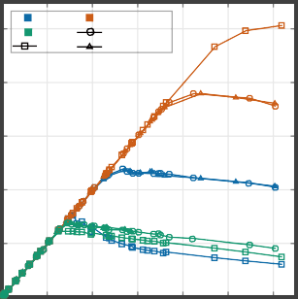
aLogical throughput. bEnergy per bit from time-based PrimeTime PX power and throughput. cHead-flit/head-hop latency. dReported average forward/flit latency. eCMR is derived from 75.4 pJ/(5×128 bits); TaBuLA and Zeng report their values directly.
Mesh PROP
FAT UR
BC Hotspot10

(a)
30
Mesh PROP FAT
Bit Complement

25
Mean flit latency (ns)

(b)
30
Mesh PROP FAT
Uniform Random

25
Mean flit latency (ns)

(c)
30
Mesh PROP FAT
Hotspot 10

25
Mean flit latency (ns)

500

400
Delivered throughput (Mflit/s/port)

(d)

20 20 20
300

15 15 15
200

10 10 10

100

5
0 50 100 150 200 250 300
Injection rate (Mflit/s/node)
5
0 50 100 150 200 250 300
Injection rate (Mflit/s/node)
5
0 50 100 150 200 250 300
Injection rate (Mflit/s/node)

0
0 100 200 300 400 500 600
Injection rate (Mflit/s/node)

Fig. 8. 64-node unicast evaluation: (a) Bit-Complement mean flit latency, (b) Uniform-Random mean flit latency, (c) Hotspot10 mean flit latency, and (d) throughput versus injection rate for the three patterns.

- 256-node global uniform random latency and throughput
500

Mesh latency PROP latency Mesh throughput PROP throughput
Delivered throughput (Mflit/s/node)
Completion latency (ns)
- 256-node cross-tile multicast (F16)
- 256-node intra tile unicast (M120)

400
Mean flit latency (ns)

300

200

100

0
160

140

120

100

80

60

40

20

0
0 50 100 150 200 250 300
Injection rate (Mflits/s/node)
400

300
380.0

39.3

13.3
157.6

-92%

-90%
Native Repeated

200

100

0

M5 M20
Offered-load case

40

30
24.1

15.9

-20%
12.7

16.2

-33%
27.2
38.7

-30%
Mesh PROP
Higher locality introduces
lower latency
Mean flit latency (ns)

20

10

0
0.25 0.50 0.75
Intra-tile destination probability

Fig. 9. 256-node scale-out evaluation: (a) global Uniform-Random latency and throughput, (b) cross-tile fanout-16 completion latency, and (c) locality-dependent mean latency.

Table II compares the proposed router with representative
Native multicast
Repeated unicast
402.4

-98%

287.7
-95%
148.6

9.5

14.3
-94%

15.6 9.2

8.3
Netw |  | ork pow |  |  | er at M1 |  |  | 00
284 |  | .3
 |  |  |  |  | -12% |  |  | -77%
 |  |  | 73.5 |  | 64. |  |  | 7

asynchronous NoCs. The Async c1p4 router sustains 84.08 Gb/s with a 1.101-ns head-hop latency and 4.581-mW post- synthesis power. Four parent-side lanes increase service capac- ity while adding lane-selection and arbitration logic; complete- network effects are evaluated next.
Mean completion latency (ns)
- Network-Level Evaluation
The complete network is evaluated at 64 nodes for topology, control, and multicast ablations, and at 256 nodes for scale-out.
  - 64-Node Ablation Study: The 64-node comparison in-
cludes three topologies. Mesh is a flat 8 × 8 two-dimensional
400

300

200

100

0

F2M5 F16M5 F16M20 F32M5
300

200
Total Power (mW)

100

0

Sync PROP Mesh PROP

mesh in which each endpoint is attached to one mesh router. FAT is the conventional fat-tree baseline, with progressively wider connectivity toward the root. PROP is the topology proposed in this work: 64 endpoints are organized into 16 L1 routers, 16 L2 routers, 16 L3 routers, and parallel boundary mesh routers. The tree levels use multiple parent-side lanes to distribute traffic across independent paths, while the boundary mesh provides the inter-region connection.
The three unicast patterns exercise different destination dis- tributions. Uniform-Random selects one destination uniformly from the other 63 nodes. Bit-Complement sends each source to the node obtained by complementing its 6-bit node address. Hotspot10 selects from the other 63 nodes while assigning a
1.10 weight to the four central nodes and a 1.00 weight to every other node. Mesh, FAT, and PROP use the same seed, packet length, and generated source-destination trace for each case.
Panels (a)–(d) of Fig. 8 show the latency and throughput curves for all three traffic patterns. Under Uniform-Random traffic, PROP reaches 379.2 Mflit/s per NoC node, which is 58.7% higher than Mesh and 2.75× the FAT result. The same ordering appears for Bit-Complement and Hotspot10 traffic,
where PROP reaches 506.4 and 379.4 Mflit/s per NoC node, compared with 152.2 and 237.2 for Mesh.
With identical traces, native multicast injects one packet and replicates in network. It reduces completion latency by 94%– 98% across F16M5, F16M20, and F32M5, including 9.24 ns versus 148.60 ns at F16M5, as shown in Fig. 10(a). At M 100, Async PROP uses 64.7 mW and 13.35 pJ/flit, compared with
73.5 mW for Mesh and 284.3 mW for Sync PROP; its mean latency is 10.33 ns versus 13.35 ns for Sync, with 11.6% area overhead (Fig. 10(b); Table III).
  - 256-Node Scale-Out Evaluation: The 256-node config- uration connects four 64-node tiles through 16 independent 2 × 2 upper-mesh planes and is compared with a 16 × 16 Mesh. Under global Uniform Random, identical five-flit traces select
destinations uniformly from the other 255 nodes. PROP reaches
154.7 Mflit/s per NoC node versus 112.5 Mflit/s per NoC node
(a) (b)

Fig. 10. 64-node results: (a) native multicast versus repeated-unicast comple- tion latency; (b) total network power at M 100.

TABLE III
64-node Async/Sync results at M 100.

Metric | Async Sync
Power (mW) | 64.7 284.3
Energy (pJ/flit) | 13.35 58.66
Mean latency (ns) | 10.33 13.35
Area (normalized) | 1.116 1.000

for Mesh, a 37.5% increase, with a later latency knee, with the latency knee shown in Fig. 9(a).
For fanout-16 traffic split 8+8 across adjacent tiles, native multicast reduces completion latency by 92% at M 5 and 90% at M 20 (Fig. 9(b)). At M 120, increasing intra-tile locality produces the same trend in both networks, while PROP remains 20%–33% lower in mean latency across the tested probabilities (Fig. 9(c)).

- Conclusion

This paper presented a fully asynchronous hierarchical NoC for scalable high-fanout communication. The design com- bines a parallel-path fixed-depth hierarchy, native Tree–Mesh multicast, and phase-safe multi-lane control to increase path diversity without a global clock or source-side multicast ex- pansion. Post-synthesis results show 379.2 Mflit/s per NoC node peak throughput in the 64-node network (10.6 Gb/s per NoC node at the 28-bit flit width), 58.7% above a flat mesh, while native multicast reduces fanout-16 completion latency by 93.8%. A four-lane router reaches 3.00 Gflit/s aggregate throughput, and the 256-node four-tile system reaches 37.5% higher peak throughput than a conventional mesh. Together, these measurements support coordinated topology, multicast, and asynchronous control for high-fanout traffic.

References
- P. A. Merolla, J. V. Arthur, R. Alvarez-Icaza, A. S. Cassidy, J. Sawada,
F. Akopyan, B. L. Jackson, N. Imam, C. Guo, Y. Nakamura et al., “A million spiking-neuron integrated circuit with a scalable communication network and interface,” Science, vol. 345, no. 6197, pp. 668–673, 2014.
- Y. Zhong, Y. Kuang, K. Liu et al., “Paicore: A 1.9-million-neuron 5.181- tsops/w digital neuromorphic processor with unified snn-ann and on-chip learning paradigm,” IEEE Journal of Solid-State Circuits, vol. 60, no. 2,
pp. 651–671, 2025.
- Intel Labs, “Taking neuromorphic computing to the next level with loihi 2,” Intel Corporation, Tech. Rep., 2021, technology Brief.
- Intel Corporation, “Intel builds world’s largest neuromorphic system to enable more sustainable ai,” Apr. 2024, intel Newsroom, Apr. 17, 2024.
- S. Moradi, N. Qiao, F. Stefanini, and G. Indiveri, “A scalable mul- ticore architecture with heterogeneous memory structures for dynamic neuromorphic asynchronous processors (DYNAPs),” IEEE Transactions on Biomedical Circuits and Systems, vol. 12, no. 1, pp. 106–122, 2018.
- P. Merolla, J. Arthur, R. Alvarez-Icaza, J.-M. Bussat, and K. Boahen, “A multicast tree router for multichip neuromorphic systems,” IEEE Transactions on Circuits and Systems I: Regular Papers, vol. 61, no. 3,
pp. 820–833, 2014.
- Z. Su, A. Bencsik, G. Indiveri, and D. Bertozzi, “An efficient multicast addressing encoding scheme for multi-core neuromorphic processors,” in Proc. IEEE International Symposium on Circuits and Systems (ISCAS), 2025.
- W. J. Dally and B. Towles, Principles and Practices of Interconnection Networks. San Francisco, CA, USA: Morgan Kaufmann, 2004.
- T. Krishna, C.-H. O. Chen, W. C. Kwon, and L.-S. Peh, “Breaking the on-chip latency barrier using SMART,” in Proc. 19th IEEE International Symposium on High Performance Computer Architecture (HPCA), 2013,
pp. 378–389.
- J. Kim, J. Balfour, and W. J. Dally, “Flattened butterfly topology for on- chip networks,” IEEE Computer Architecture Letters, vol. 6, no. 2, pp. 37–40, 2007.
- X. Xiang, W. Shi, S. Ghose, L. Peng, O. Mutlu, and N.-F. Tzeng, “Carpool: A bufferless on-chip network supporting adaptive multicast and hotspot alleviation,” in Proc. International Conference on Supercomputing (ICS), 2017.
- N. Enright Jerger, L.-S. Peh, and M. H. Lipasti, “Virtual circuit tree multicasting: A case for on-chip hardware multicast support,” in Proc. 35th Annual International Symposium on Computer Architecture (ISCA), 2008, pp. 229–240.
- T. Fischer, M. Rogenmoser, T. Benz, F. K. Gu¨rkaynak, and L. Benini, “Floonoc: A 645-gb/s/link 0.15-pj/b/hop open-source noc with wide physical links and end-to-end axi4 parallel multistream support,” IEEE Transactions on Very Large Scale Integration (VLSI) Systems, vol. 33, no. 4, pp. 1094–1107, 2025.
- S. Liu, M. Roediger, and A. Karanth, “Monet: A mixture-of-experts accelerator with a multicast-optimized two-tier network-on-chip,” in Proc. Design, Automation and Test in Europe Conference (DATE), 2026.
- C. Zhang, Y. Hu, and Y. Kang, “A reusable methodology for high- performance interconnects using a standard-cell based asynchronous noc router,” in Proc. Design, Automation and Test in Europe Conference (DATE), 2026, pp. 1–7.
- K. Bhardwaj and S. M. Nowick, “A continuous-time replication strategy for efficient multicast in asynchronous nocs,” IEEE Transactions on Very Large Scale Integration (VLSI) Systems, vol. 27, no. 2, pp. 350–363, 2019.
- S. Rasheed, P. V. Gratz, S. Shakkottai, and J. Hu, “Storm: A simple traffic-optimized router microarchitecture for networks-on-chip,” in Proc. 8th IEEE/ACM International Symposium on Networks-on-Chip (NOCS), 2014, pp. 176–177.
- A. Ghiribaldi, D. Bertozzi, and S. M. Nowick, “A transition-signaling bundled data noc switch architecture for cost-effective gals multicore systems,” in Proc. Design, Automation and Test in Europe Conference (DATE), 2013, pp. 332–337.
- W. Jiang, D. Bertozzi, G. Miorandi, S. M. Nowick, W. Burleson, and
G. Sadowski, “An asynchronous noc router in a 14nm finfet library: Comparison to an industrial synchronous counterpart,” in Proc. Design, Automation and Test in Europe Conference (DATE), 2017, pp. 732–733.
- L. Wang, Y. Jin, H. Kim, and E. J. Kim, “Recursive partitioning multicast: A bandwidth-efficient routing for networks-on-chip,” in Proc. International Symposium on Networks-on-Chip (NOCS), 2009, pp. 64–73.
- D. Bertozzi, G. Miorandi, A. Ghiribaldi, W. Burleson, G. Sadowski,
K. Bhardwaj, W. Jiang, and S. M. Nowick, “Cost-effective and flexible asynchronous interconnect technology for gals systems,” IEEE Micro, vol. 41, no. 1, pp. 69–81, 2021.
- Q. Zeng, J. Wang, J. Cong, and D. Shang, “A lightweight and high- throughput asynchronous message bus for communication in multi-core heterogeneous systems,” IEEE Access, vol. 12, pp. 48 555–48 568, 2024.

