CHAMP: A Scalable Click-Based Asynchronous NoC with Parallel-Router Hierarchy and Native Multicast

Abstract—
Keywords—

Introduction
Modern computing platforms are evolving toward increasingly large-scale and highly parallel architectures, including many-core processors, GPUs, wafer-scale accelerators, and neuromorphic systems. As illustrated in Fig. 1(a), representative platforms have substantially expanded their computing resources and processing capabilities, alongside rising chip-to-chip bandwidth. These trends place growing demands on data movement and communication among processing elements, making the on-chip interconnect a critical factor in overall system performance. Consequently, networks-on-chip (NoCs) must provide low-latency, high-throughput, and energy-efficient communication while remaining scalable to larger systems.
To identify the fundamental bottlenecks of scalable on-chip communication, packet latency can be conceptually decomposed as
$T_{comm}≈HT_{r}+T_{c}$ (1)
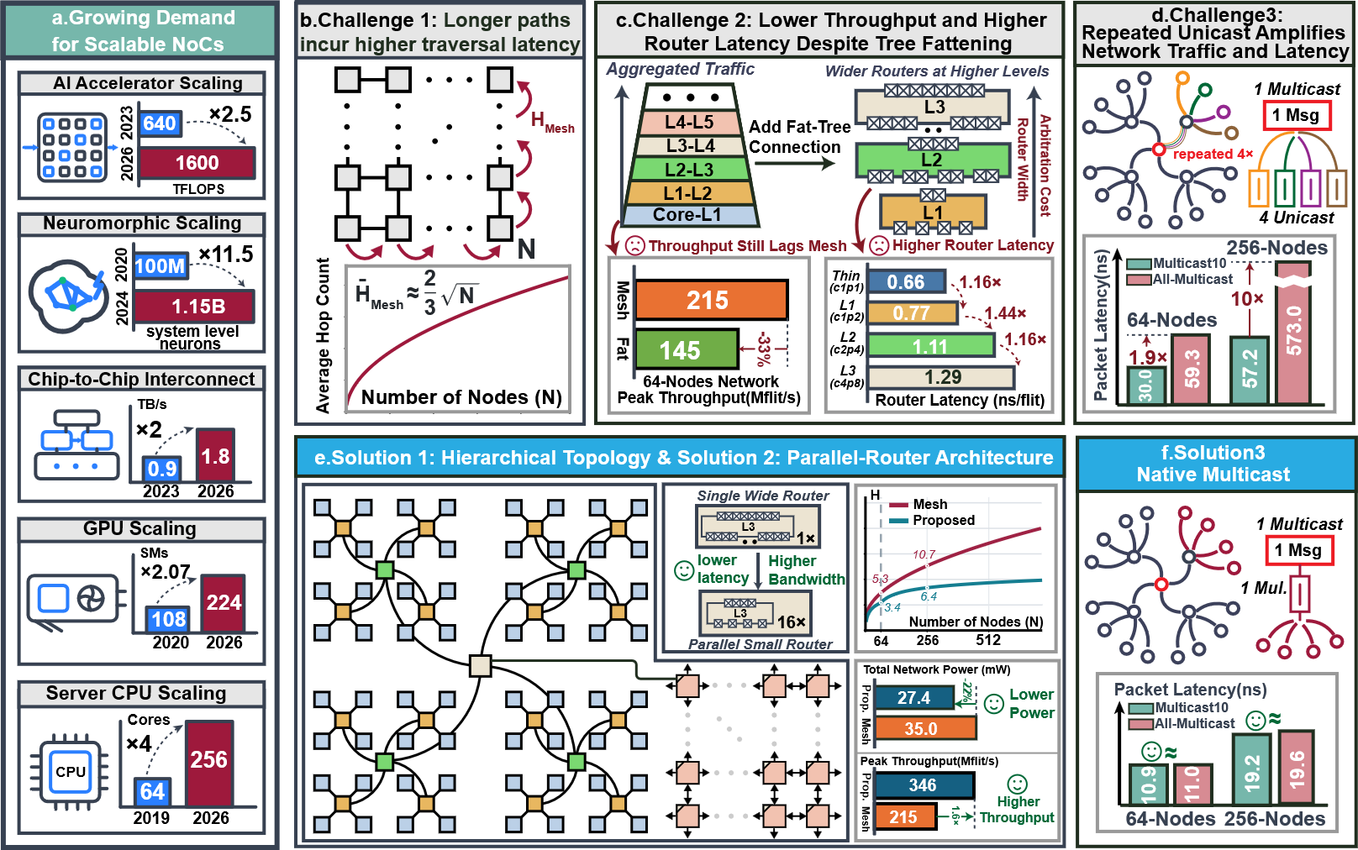
where $H$ denotes the number of routing hops, $T_{r}$ the effective per-hop router-and-link delay, and $T_{c}$ the delay caused by contention and queuing. This simplified model treats packet serialization as a common offset under a fixed packet and channel configuration. It highlights three coupled design factors: network topology determines routing paths and resource distribution; router microarchitecture affects both per-hop delay and contention through arbitration, buffering, and parallel transmission capacity; and traffic patterns further influence resource utilization and queuing. Therefore, optimizing these factors jointly is essential for scalable, low-latency communication.
Prior NoC studies have pursued scalability through network topology, router microarchitecture, and multicast routing. Regular meshes provide simple connectivity but incur increasing hop counts at scale, motivating hierarchical and link-augmented topologies [5], [20]–[23]. These approaches involve distinct tradeoffs: long-range links consume additional wiring resources, while conventional fat-tree scaling increases upper-level router width and arbitration complexity [1], [31]. The resulting per-hop delay can erode the latency savings of reduced hop counts, while increased link capacity does not necessarily translate into higher delivered throughput. At the microarchitectural level, two-phase bundled-data switches, replicated-switch designs, Click-based controllers, and continuous-time replication have improved asynchronous forwarding and multicast buffering [3], [24]–[26]. However, distributing bandwidth across dynamically selected physical lanes requires careful coordination of packet-level arbitration and two-phase handshake states. Meanwhile, existing multicast schemes, including destination bitmaps, subtree broadcasting, and hybrid path/tree routing, enable in-network replication [27]–[30], [34]. These approaches exhibit different tradeoffs among destination-encoding overhead, replication selectivity, and network traffic [39]. In particular, efficient region-oriented multicast requires compact addressing and selective branching across network levels, while the absence of native replication can amplify traffic through repeated unicast. Together, these considerations motivate the co-design of hierarchical connectivity, parallel-router resources, and region-aware multicast routing.
These observations reveal three key challenges in scaling asynchronous NoCs, as illustrated in Fig. 1(b)-(f):
Despite these advances, existing NoC architectures face three key challenges, as illustrated in Fig.1(b)-(f). First, flat 2-D meshes incur increasing communication distances as the network scales: the analytical average hop count grows from 5.3 at 64 nodes to 10.7 at 256 nodes. Second, fat-tree architectures widen upper-level routers to increase bisection bandwidth, but the resulting router complexity and arbitration overhead limit the benefits of link fattening. In the evaluated 64-node unicast benchmark, the fat-tree achieves a peak delivered-copy throughput of 145 Mflit/s/port, 33% lower than the mesh's 215 Mflit/s/port. Third, without native multicast support, repeated unicast generates separate packets for individual destinations, amplifying network traffic and contention. Under the evaluated All-Multicast workloads, average packet latency increases from 11.0 to 59.3 ns at 64 nodes and from 19.6 to 573.0 ns at 256 nodes when repeated unicast replaces native multicast. These challenges motivate an architecture that reduces communication distance, scales bandwidth without excessively widening routers, and supports efficient in-network multicast.
To address these challenges, we propose CHAMP (Click-based Hierarchical Asynchronous Multicast with Parallel Routers), a scalable asynchronous NoC architecture featuring the following three key contributions:
R1: Hierarchical Tree–Mesh Topology. We propose a hierarchical interconnect that combines local quadtrees with a global mesh, allowing local communication to remain within lower tree levels while supporting long-distance communication through the upper mesh. Compared with a flat mesh, the analytical average hop count decreases from 5.3 to 3.4 at 64 nodes (35.8%) and from 10.7 to 6.4 at 256 nodes (40.2%), reducing the hop-dependent component of communication latency as the network scales.
R2: Parallel-Router Architecture. Instead of concentrating bandwidth in increasingly wide routers, CHAMP distributes physical paths across multiple lightweight asynchronous routers and employs dynamic lane allocation to scale aggregate bandwidth. In the evaluated 64-node unicast scan, CHAMP achieves a peak delivered-copy throughput of 346 Mflit/s/port, compared with 215 Mflit/s/port for the mesh, representing a 1.61× increase.
R3: Native Region-Aware Multicast. CHAMP supports native multicast through region-aware destination encoding and selective in-network replication, avoiding the repeated source injection required by unicast emulation. Under the evaluated All-Multicast workloads, CHAMP reduces mean offer-to-tail latency from 59.3 to 11.0 ns at 64 nodes (5.4× lower) and from 573.0 to 19.6 ns at 256 nodes (29.2× lower) compared with repeated unicast

Background

