

Software Engineering 4 year

Distributed System

Lecture: Distributed system

Subject: Rest Application and Client

Student: LYU ZHENG A00248564

**Main GUI**

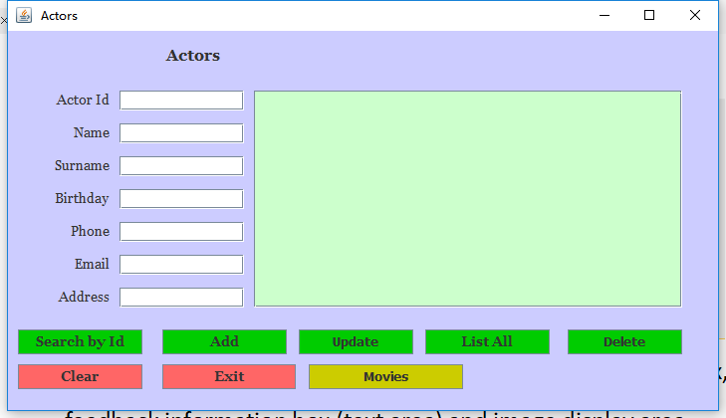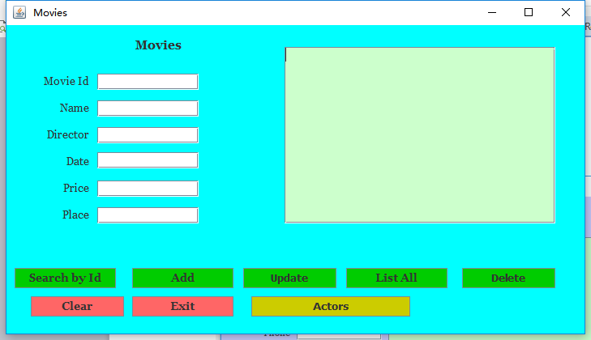

There are two interface for my project, Movies and Actors, both of them have functions like search, add, update, delete and list all results. And the two interface can switch by the button Actors and Movies. The text area on the right will print the result after any operation, and clear button will clean all the contents in the text fields and text area.

SQL:

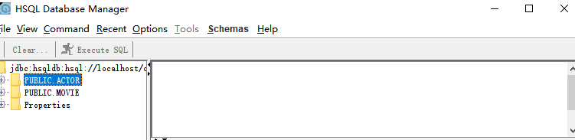

I have two tables on database, ACTOR and MOVIE.

**Function:**

1. Add

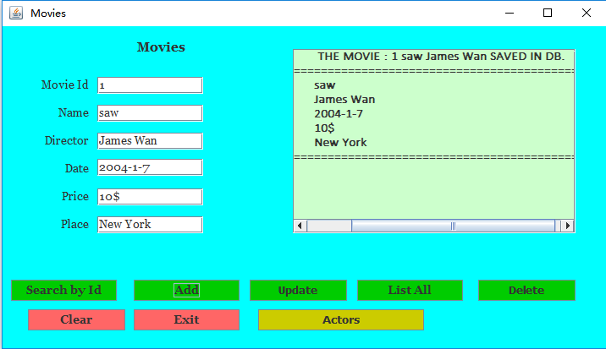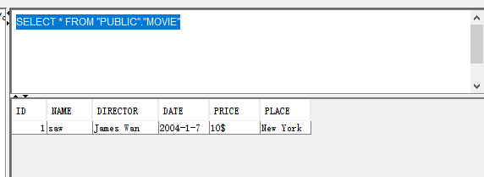

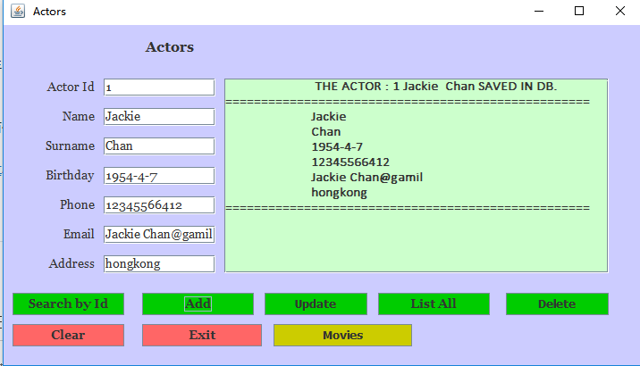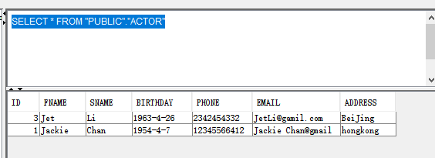

This function will add new data in database, we could input all the details in the blanks and click the button “add”, the result will be shown on the text area.

1. Search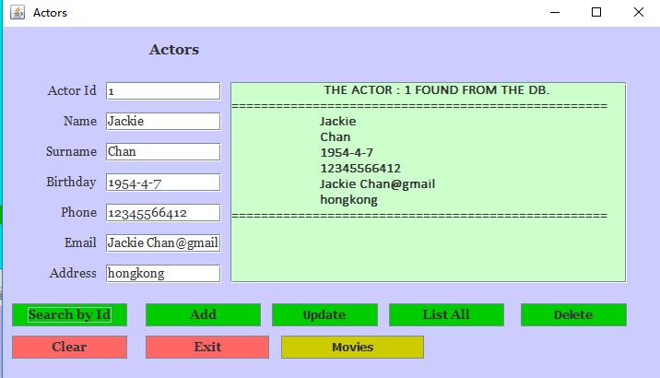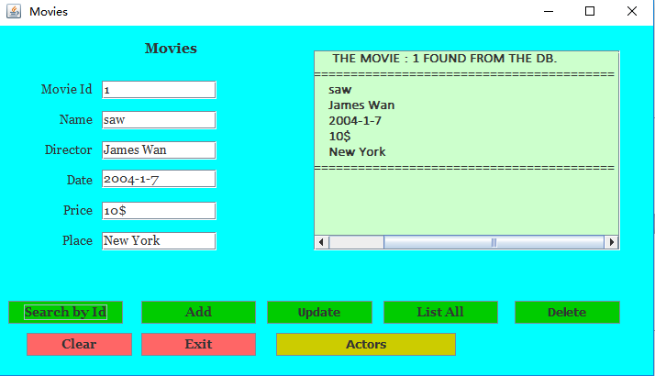

The function will search the data in database by ID. We should only input the id number, and click the button “search by Id”. The result will be print on both text area and each text field on the left.

1. Update

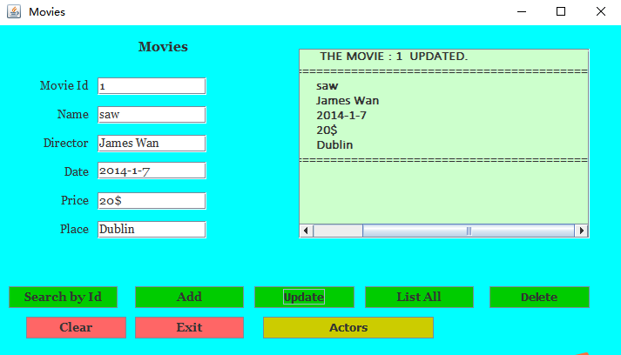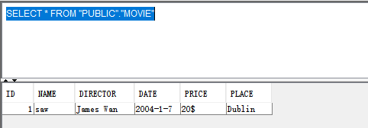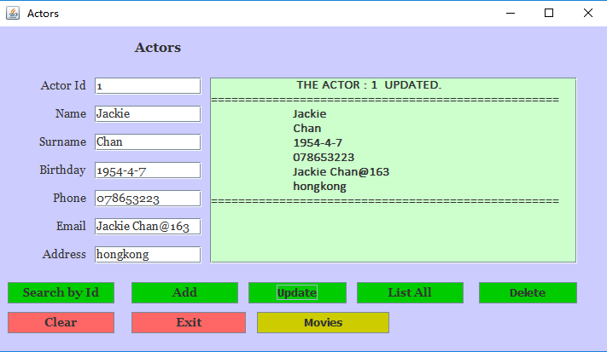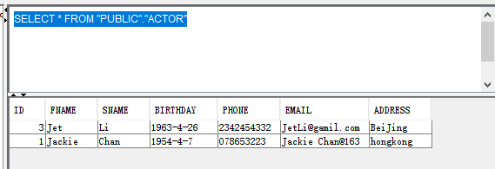

If we want to use update, we could use search by id to show the information right now, and modify any details on the text field. Then we click the button ”Update”, the modify will be saved in database.

1. List All

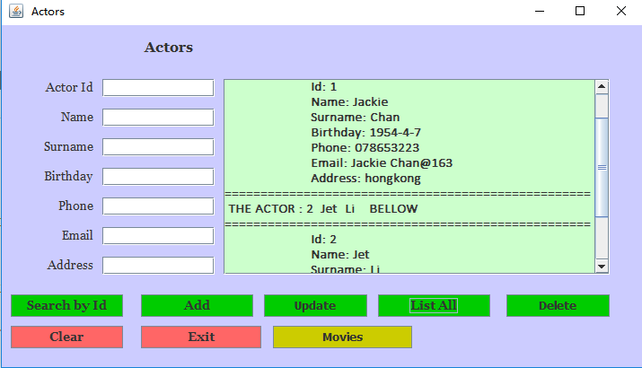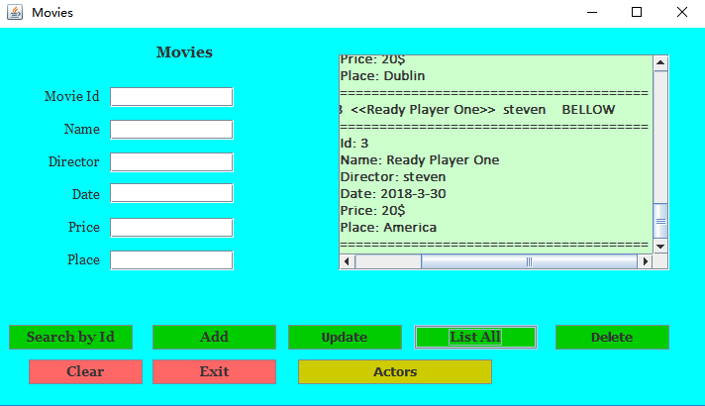

This function will print all data from database. Just click the button “list all” and it will show all the information on the text area.

1. Delete

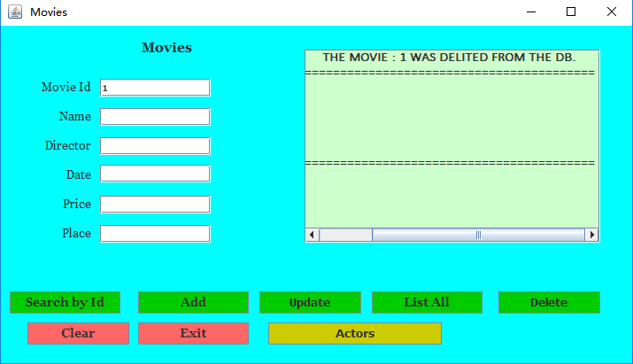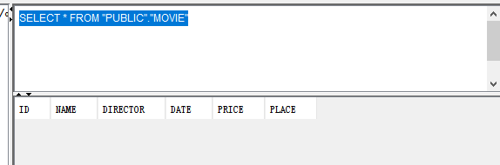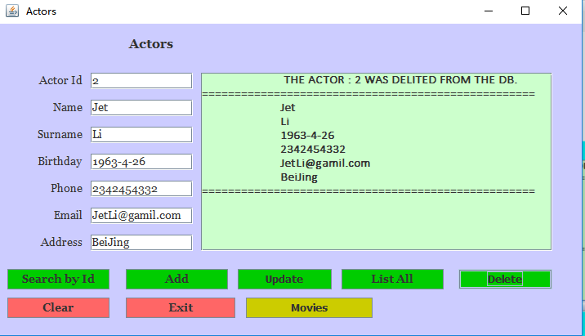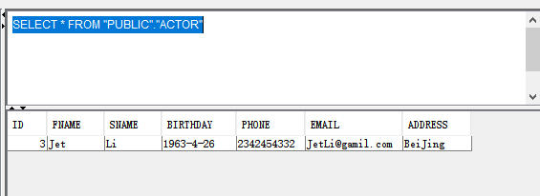

If you want to delete any data, we can input the ID of that data we want to delete, and click the button “delete”. The information in database will be deleted after that. The information is deleted by ID.