dtc算法评估报告

## 相关性分析热力图

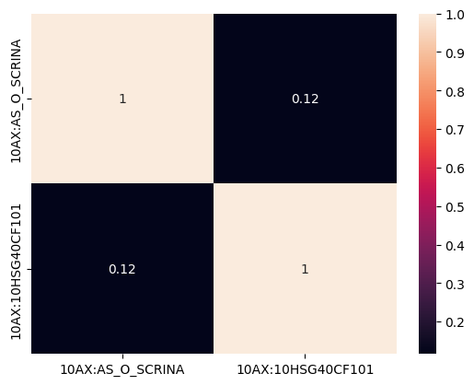

## 评估指标

|  |  |  |  |  |
| --- | --- | --- | --- | --- |
| 评估指标 | precision | recall | f1-score | support |
| 0 | 0.9772735881216621 | 0.9671264712497188 | 0.9721735526291 | 26678 |
| 1 | 0.9677632788090424 | 0.9777183600713012 | 0.9727153492324458 | 26928 |
| accuracy | 0.9724471141290154 |  |  |  |
| macro avg | 0.9725184334653523 | 0.97242241566051 | 0.9724444509307729 | 53606 |
| weighted avg | 0.9724962570547998 | 0.9724471141290154 | 0.9724457143075482 | 53606 |

## ROC曲线

