dtc算法评估报告

## 相关性分析热力图

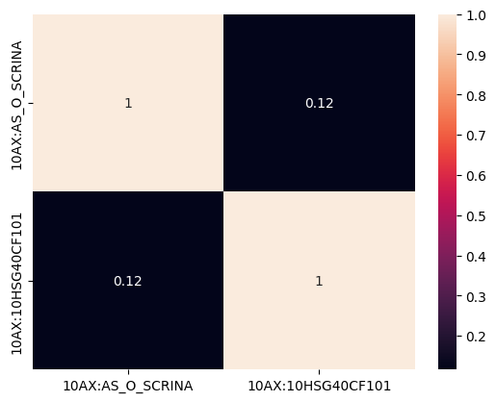

## 评估指标

|  |  |  |  |  |
| --- | --- | --- | --- | --- |
| 评估指标 | precision | recall | f1-score | support |
| 0 | 0.9697354655507398 | 0.9737009941849559 | 0.9717141840918025 | 26655 |
| 1 | 0.9738842113106326 | 0.9699454565693295 | 0.9719108434182887 | 26951 |
| accuracy | 0.9718128567697646 |  |  |  |
| macro avg | 0.9718098384306861 | 0.9718232253771427 | 0.9718125137550456 | 53606 |
| weighted avg | 0.9718212926405222 | 0.9718128567697646 | 0.9718130567088255 | 53606 |

## ROC曲线

