The following is the progress of my latest project:

**Features:**

1. Get two frame form video1.avi. You can input the number of the first frame and it will automatically store this frame and the next frame.
2. Using SIFT algorithm (or SURF) to find the key-points in both of the frame, and then do the match job.
3. Show the picture of the first frame with key-points on it. And then show the match result.

**Need to be done:**

1. The key point is too much so there must be a filter or standard nerve image to help me to find the nerves.
2. About how to measure the movements of the nerve, I noticed that all the key-points class in SIFT has a location so if I can find out some of the nicely matched key-points, I think I can know the movement of the nerve. Together with the information about the camera. The actual length of the movement can be done.

**Screen-shot:**

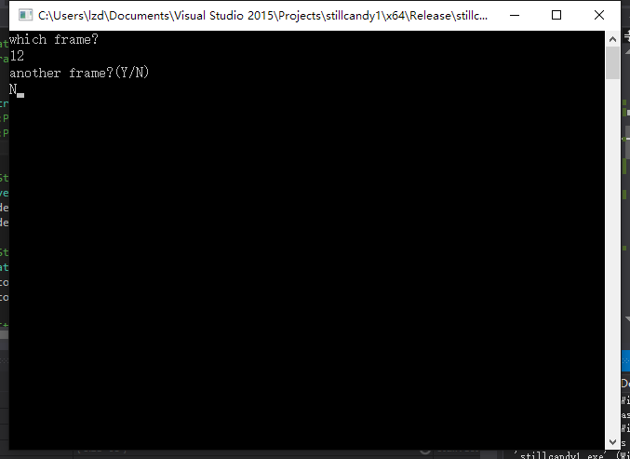

The basic menu of the program. You can enter the number of the frame first and then have a chance to regret. (it only detect ‘Y’, so it’s OK if you enter something else)

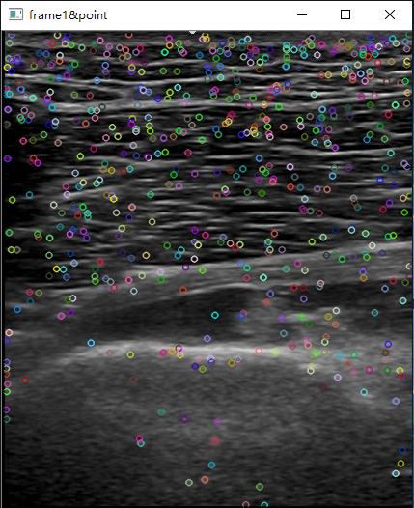

This is the result of the SIFT. The key-points are in a mess☹

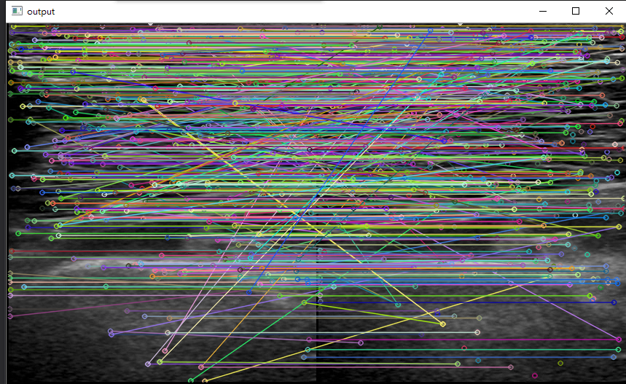This is the match result of the two frame, I tried to reduce the amount of the key-points and make the image clearer. The result is quite satisfying. Although there are some mistake point but most of them are nicely matched.

**How to test it yourself:**

1. This version of OpenCV (3.1.0) is not contain the SIFT class because it’s considered not stable. So we have to install something called **opencv_contrib** first. If you think the step is not clear enough, I can do it for you in the next meeting☺.
2. Put the things in folder **‘need’** in to your computer near OpenCV
3. Install the cmake-3.4.3-win32-x86.exe in the folder and open it, You will see as the following picture The red box must be filled with the directory path of OpenCV source, and the green box must be filled with the directory path of designated build folder.

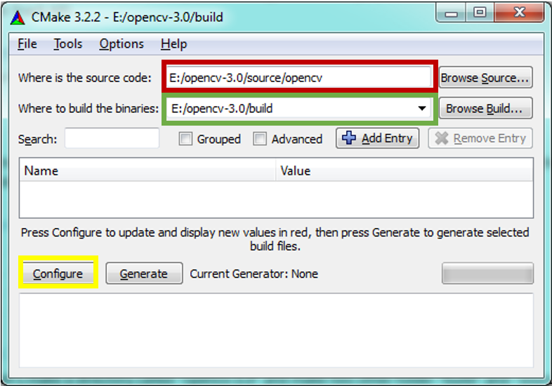

1. Then click **configure** and follow the instruction until the content said **configuring done!**
2. Next, we need to specify the extra modules path which is **opencv_contrib /module**s as depicted in figure below:

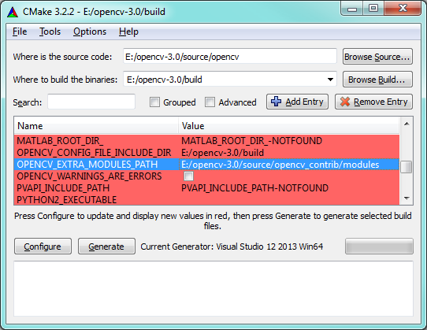

1. Then click the **configure** button again and wait until it’s done. Now you will find a solution file in you OpenCV/build folder called ‘**OpenCV.sln**’ (not the opencv_contrib one).
2. Use the VS2015 to open the **OpenCV.sln** file and buid the INSTALL program in release mode.

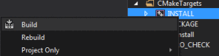

1. Then in the path of OpenCV.sln, there will be a new **install** folder. It is now your new OpenCV (the content is very like the previous openCV folder with **bin, include,x64,etc**). Then you can just modified the project we built together before by changing the lib path into what’s in the install folder, adding more ‘.dll' file, and add it in the link. This will make your project be able to use the build-in SIFT class.
2. Now you can paste my code into your project and put the three video in the right path and test the program.