《软件测试》

实验报告八 ——JUnit测试方法

姓 名： 李志豪 学 号： 2018138102
院 系： 计算机与信息学院 专 业：计算机科学与技术
实 验 室： 实验日期： 2021/4/29
总评成绩： 审阅教师： 杨青

一、实验目的
1、学习在一定规模实际项目中综合测试方法
2、学习研读开源代码的技术
3、熟悉项目构建工具gradle
4、熟悉静态代码分析工具

二、实验环境
IntelliJ IDEA、Junit5、Gradle5.X

实验要求
1、从https://github.com/SERG-Delft/jpacman 仓库克隆代码到自己仓库，导入到自己使用的IDE中
2、运行冒烟测试smoketest，在src/default-test/java/nl.tudelft.jpacman/下；
3、项目有两个测试文件目录，default-test (src/default-test)包含一些已经给出的测试用例样例，test (src/test)目录作为作业编写检查的目录
4、修改标题：在PacManUI类（nl.tudelft.tudelft.jpacman.ui 包），在构造函数的第一行，即 super("JPacman");修改为super("JPacman ");
5、完成题目1和题目2

四、实验步骤与内容

一、实验内容

题目1
Open the board.DirectionTest. Just to get you started, create additional test methods in DirectionTest for e.g., the south, east, and west directions. Run the tests, and ensure they pass.

题目2
Take a look at the OccupantTest class. It tests whether Units correctly (de)occupy squares. We left three test methods empty there for you. Your goal is to implement these tests.
- The noStartSquare() test asserts that a unit has no square to start with, i.e., a unit “has no square” at the beginning. 2.The testOccupy() veriﬁes that the unit indeed has the target square as its base after occupation. In other words, if a unit is occupied by a(ny) basic square, then one should contain the other.
- Finally, the testReoccupy() veriﬁes that the unit indeed has the target square as its base after double occupation. What happens if the unit is reoccupied by another square?

实验步骤

克隆项目
在本地文件夹中运行git，输入git clone https://github.com/SERG-Delft/jpacman Jpcman

运行冒烟测试smoketest
测试在src/default-test/java/nl.tudelft.jpacman/下的测试类LauncherSmokeTest
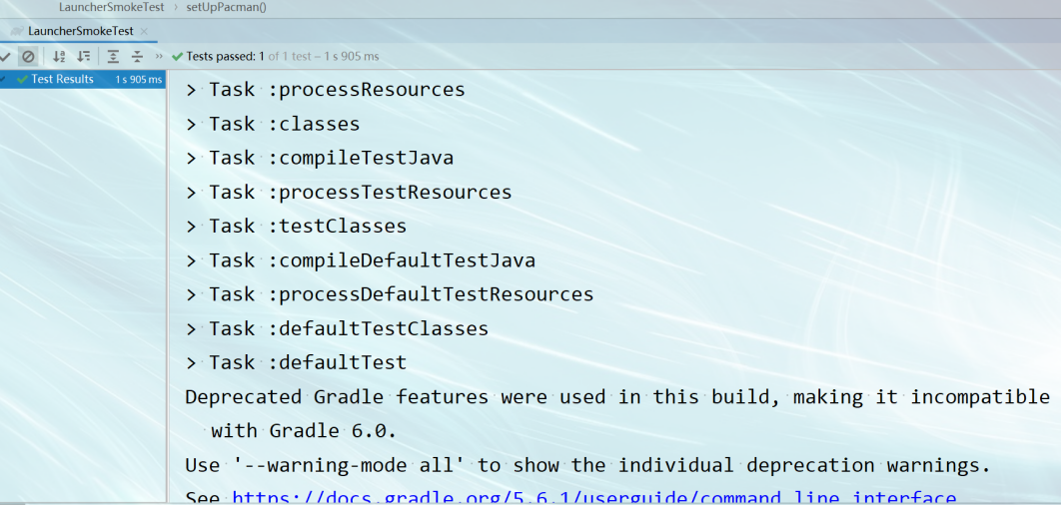

完成题目一
在src/test/java/nl/tudelft/jpacman/board/路径下的DirectionTest.java类里面添加三个方法
/**
* Do we get the correct delta when moving west?
*/
@Test
void testWest() {
Direction west = Direction.valueOf("WEST");
assertThat(west.getDeltaX()).isEqualTo(-1);
}
/**
* Do we get the correct delta when moving east?
*/
@Test
void testEast() {
Direction east = Direction.valueOf("EAST");
assertThat(east.getDeltaX()).isEqualTo(1);
}
/**
* Do we get the correct delta when moving south?
*/
@Test
void testSouth() {
Direction south = Direction.valueOf("SOUTH");
assertThat(south.getDeltaY()).isEqualTo(1);
}

测试上面的代码
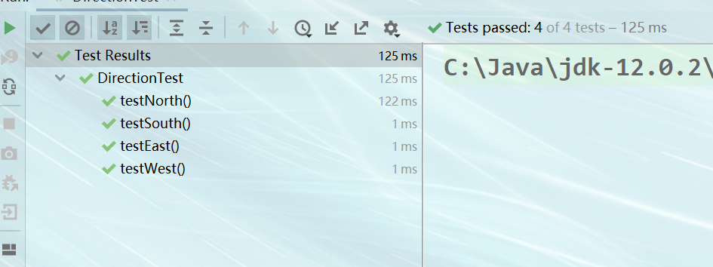

完成题目二
在src/test/java/nl/tudelft/jpacman/board/路径下的OccupantTest.java类里面添加三个方法
/**
* Asserts that a unit has no square to start with.
*/
@Test
void noStartSquare() {
org.junit.jupiter.api.Assertions.assertThrows(
AssertionError.class,
() -> unit.getSquare());
}
/**
* Tests that the unit indeed has the target square as its base after
* occupation.
*/
@Test
void testOccupy() {
BasicSquare basicSquare = new BasicSquare();
unit.occupy(basicSquare);
Assertions.assertThat(unit.getSquare()).isNotEqualTo(null);
}
/**
* Test that the unit indeed has the target square as its base after
* double occupation.
*/
@Test
void testReoccupy() {
BasicSquare basicSquare = new BasicSquare();
unit.occupy(basicSquare);
unit.occupy(basicSquare);
Assertions.assertThat(basicSquare).isEqualTo(basicSquare);
}

测试上面的代码
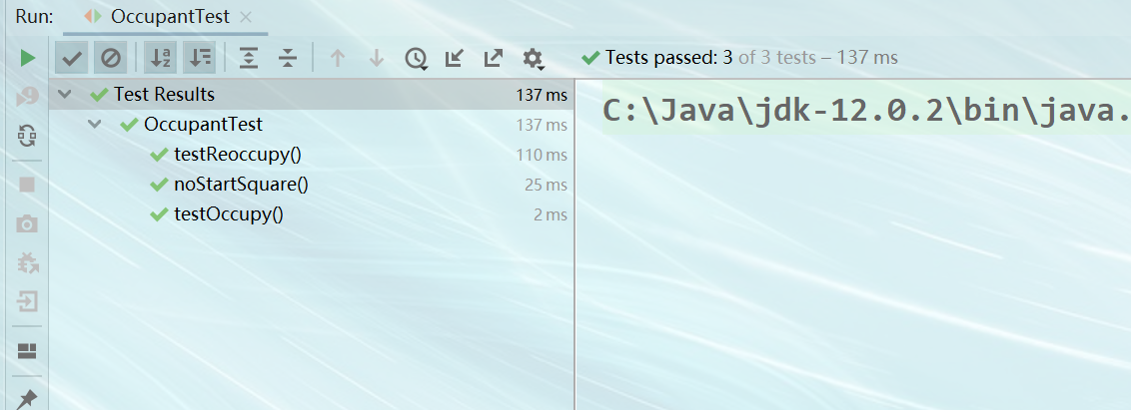

五、结论分析与体会
通过这次实验，我明白了Junit的优点，可以直观的判断数据的正确与否，避免了后面的数据出错，从而方便了程序员进行修改的麻烦性，而我在这次实验中也学到了此插件的方便性，练习了基本的编程能力，学习JUnit自动测试框架，掌握非参数化和参数化测试方法。

六、仓库地址
https://github.com/lzh-yi/SoftwareTest.git

