《软件测试》

实验报告七 ——JUnit测试方法

姓 名： 李志豪 学 号： 2018138102
院 系： 计算机与信息学院 专 业：计算机科学与技术
实 验 室： 实验日期： 2021/4/29
总评成绩： 审阅教师： 杨青

一、实验目的：
1、了解Gradle部署工具，编写gradle静态检查任务staticAnalysys；
2、配置代码规范检查工具checkstyle、pmd和spotbugs

二、实验环境：
IntelliJ IDEA、Gradle 5.X

实验要求：

一、实验前提：
1、gradle安装和配置
2、checkstyle 插件
3、pmd插件
4、spotbugs插件

二、实验要求：
1、参考上述实验步骤构建gradle工程
2、把自己编写的实验四代码放入gradle工程中，执行静态代码检查，并根据检查结果修复；
3、把gradle工程上传到gitee自己的仓库；
4、编写实验报告并把gradle工程和生成的报告打包提交到雨课堂。

四、实验步骤与内容

一、下载gradle
去官网下载gradle对应版本的包。本实验下载的是Gradle5.6.2。下载过程参见官网。下载完并配置环境变量后在cmd输入gradle -v出现下面输出则gradle安装成功：
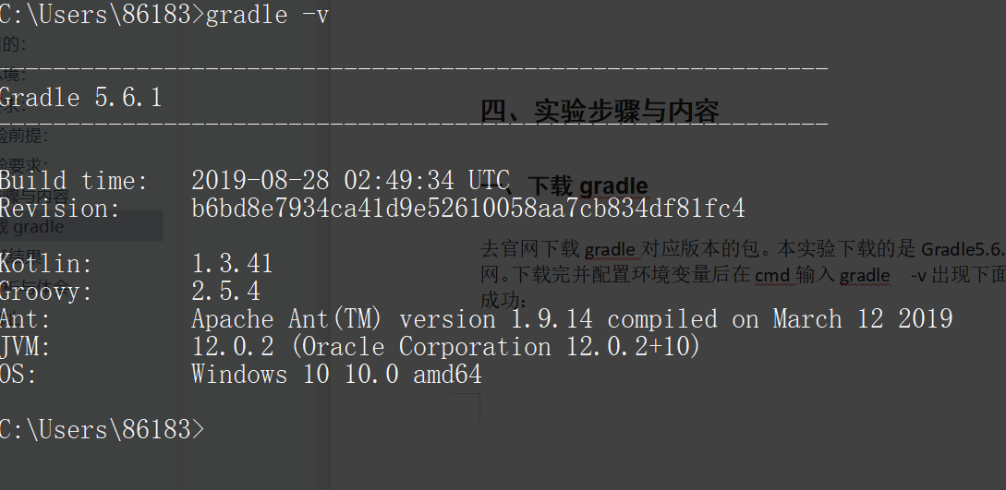

在IDEA中配置gradle
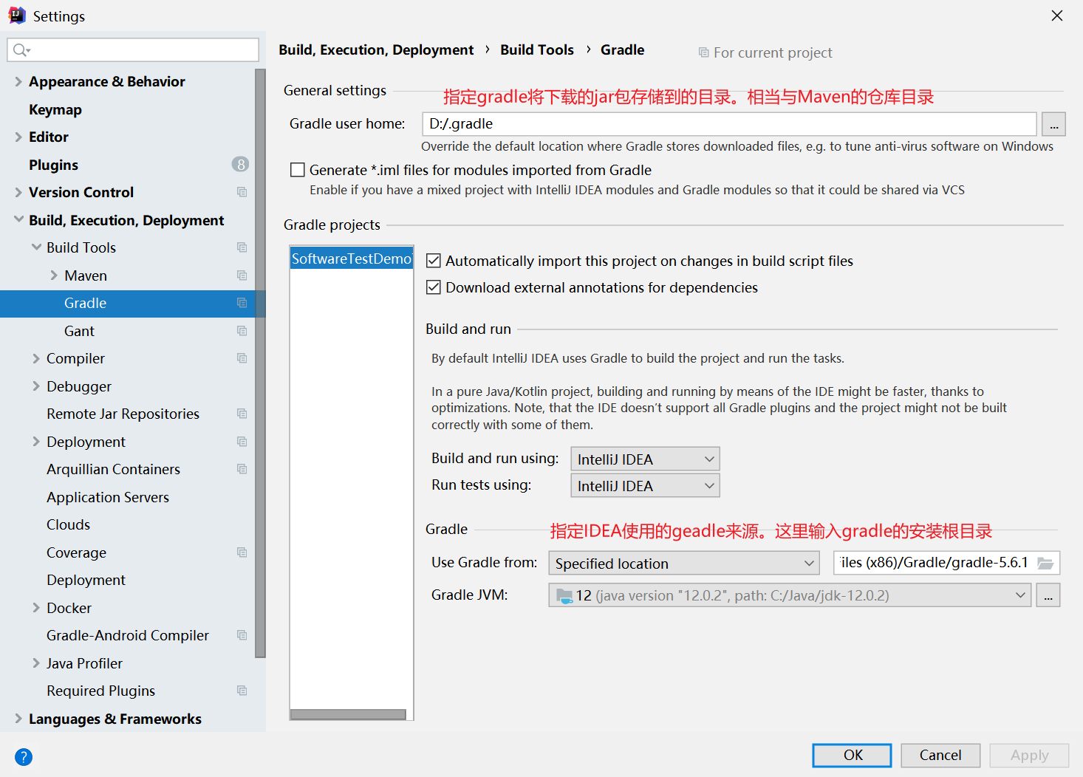

创建gradle工程
在IDEA中创建gradle的java工程。

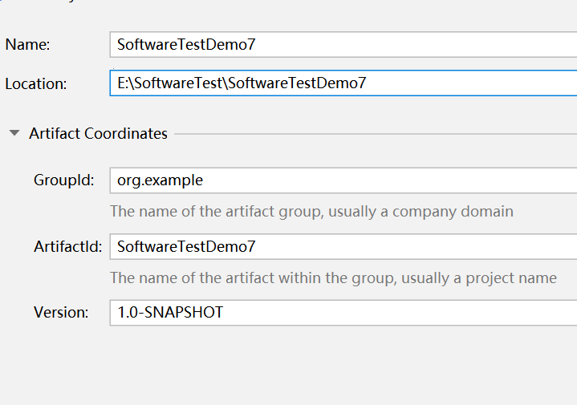
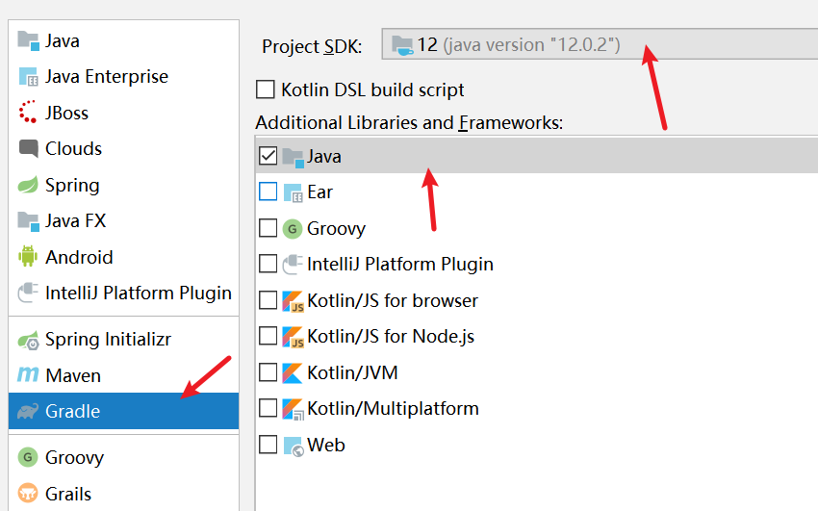

编辑build.gradle文件
plugins {
id 'java'
// Apply the application plugin to add support for building a CLI application.
id 'application'
id 'checkstyle'
id 'pmd'
id 'com.github.spotbugs' version '4.0.5'
}
group 'org.example'
version '1.0-SNAPSHOT'
sourceCompatibility = 1.8
repositories {
// Use jcenter for resolving dependencies.
// You can declare any Maven/Ivy/file repository here.
maven{ url 'http://maven.aliyun.com/nexus/content/groups/public/'}
}
dependencies {
// https://mvnrepository.com/artifact/org.junit.jupiter/junit-jupiter-params
testImplementation group: 'org.junit.jupiter', name: 'junit-jupiter-params', version: '5.7.0'
// https://mvnrepository.com/artifact/org.junit.jupiter/junit-jupiter-api
testImplementation group: 'org.junit.jupiter', name: 'junit-jupiter-api', version: '5.7.0'
}
sourceSets {
mainClassName = 'com.cn.lzh.mai.Main'
}
tasks.withType(JavaCompile) {
options.encoding = 'UTF-8'
}
tasks.withType(Javadoc) {
options.encoding = 'UTF-8'
}
// 配置 checkstyle
checkstyle {
toolVersion '6.11.1'
showViolations true
}
check.dependsOn 'checkstyle'
task checkstyle(type: Checkstyle) {
configFile file(
"${project.rootDir}/config/checkstyle/checkstyle.xml"
) // Where my checkstyle config is...
configProperties.checkstyleSuppressionsPath = file(
"${project.rootDir}/config/checkstyle/suppressions.xml"
).absolutePath // Where is my suppressions file for checkstyle is...
source 'src'
include '**/*.java'
exclude '**/gen/**'
classpath = files()
}
// 配置pmd
task pmd(type: Pmd) {
ruleSetFiles = files("${project.rootDir}/config/pmd/pmd-ruleset.xml")
ignoreFailures = false
ruleSets = []
source 'src'
include '**/*.java'
exclude '**/gen/**'
reports {
xml.enabled = false
html.enabled = true
xml {
destination file("$project.buildDir/reports/pmd/pmd.xml")
}
html {
destination file("$project.buildDir/reports/pmd/pmd.html")
}
}
}

引入checkstyle、pmd、spotbugs
根据上面的配置文件里面的配置，引入pmd-ruleset.xml、checkstyle.xml和suppressions.xml
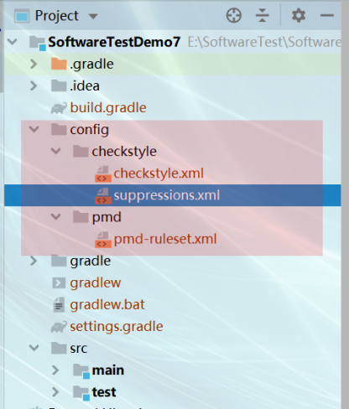

checkstyle.xml
<?xml version="1.0"?>
<!DOCTYPE module PUBLIC
"-//Puppy Crawl//DTD Check Configuration 1.3//EN"
"http://www.puppycrawl.com/dtds/configuration_1_3.dtd">
<!--
Checkstyle configuration that checks the Google coding conventions from Google Java Style
that can be found at https://google.github.io/styleguide/javaguide.html.
Checkstyle is very configurable. Be sure to read the documentation at
http://checkstyle.sf.net (or in your downloaded distribution).
To completely disable a check, just comment it out or delete it from the file.
Authors: Max Vetrenko, Ruslan Diachenko, Roman Ivanov.
-->
<module name="Checker">
<property name="charset" value="UTF-8"/>
<property name="severity" value="warning"/>
<!--<property name="fileExtensions" value="java, properties, xml"/>-->
<!-- Checks for whitespace -->
<!-- See http://checkstyle.sf.net/config_whitespace.html -->
<module name="FileTabCharacter">
<property name="eachLine" value="true"/>
</module>
<module name="TreeWalker">
<module name="OuterTypeFilename"/>
<module name="IllegalTokenText">
<property name="tokens" value="STRING_LITERAL, CHAR_LITERAL"/>
<property name="format"
value="\\u00(08|09|0(a|A)|0(c|C)|0(d|D)|22|27|5(C|c))|\\(0(10|11|12|14|15|42|47)|134)"/>
<property name="message" value="Avoid using corresponding octal or Unicode escape."/>
</module>
<module name="AvoidEscapedUnicodeCharacters">
<property name="allowEscapesForControlCharacters" value="true"/>
<property name="allowByTailComment" value="true"/>
<property name="allowNonPrintableEscapes" value="true"/>
</module>
<!--单行最大长度,google100,修改-->
<module name="LineLength">
<property name="max" value="200"/>
<property name="ignorePattern"
value="^package.*|^import.*|a href|href|http://|https://|ftp://"/>
</module>
<module name="AvoidStarImport"/><!--import要指明到类 不能包含*-->
<module name="OneTopLevelClass"/>
<module name="NoLineWrap"/>
<module name="EmptyBlock">
<property name="option" value="TEXT"/>
<property name="tokens"
value="LITERAL_TRY, LITERAL_FINALLY, LITERAL_IF, LITERAL_ELSE, LITERAL_SWITCH,LITERAL_WHILE,LITERAL_FOR,LITERAL_CASE"/>
</module>
<module name="NeedBraces"/>
<!--option: 定义左大括号'{'显示位置，eol在同一行显示，nl在下一行显示
maxLineLength: 大括号'{'所在行行最多容纳的字符数
tokens: 该属性适用的类型，例：CLASS_DEF,INTERFACE_DEF,METHOD_DEF,CTOR_DEF -->
<module name="LeftCurly">
<property name="maxLineLength" value="100"/>
</module>
<module name="RightCurly"/>
<module name="RightCurly">
<property name="option" value="alone"/>
<property name="tokens"
value="CLASS_DEF, METHOD_DEF, CTOR_DEF, LITERAL_FOR, LITERAL_WHILE, LITERAL_DO, STATIC_INIT, INSTANCE_INIT"/>
</module>
<!--检查空格 方法体前括号,比较操作符两边空格等-->
<module name="WhitespaceAround">
<property name="allowEmptyConstructors" value="true"/>
<property name="allowEmptyMethods" value="true"/>
<property name="allowEmptyTypes" value="true"/>
<property name="allowEmptyLoops" value="true"/>
<message key="ws.notFollowed"
value="WhitespaceAround: ''{0}'' is not followed by whitespace. Empty blocks may only be represented as '{}' when not part of a multi-block statement (4.1.3)"/>
<message key="ws.notPreceded"
value="WhitespaceAround: ''{0}'' is not preceded with whitespace."/>
</module>
<module name="OneStatementPerLine"/>
<!--一行声明一个变量-->
<module name="MultipleVariableDeclarations"/>
<module name="ArrayTypeStyle"/>
<!--default clause-->
<module name="MissingSwitchDefault"/>
<!--case break-->
<module name="FallThrough"/>
<!--Long型常量后缀-->
<module name="UpperEll"/>
<module name="ModifierOrder"/>
<!--空行规则-->
<module name="EmptyLineSeparator">
<property name="allowNoEmptyLineBetweenFields" value="true"/>
</module>
<module name="SeparatorWrap">
<property name="tokens" value="DOT"/>
<property name="option" value="nl"/>
</module>
<module name="SeparatorWrap">
<property name="tokens" value="COMMA"/>
<property name="option" value="EOL"/>
</module>
<module name="PackageName">
<property name="format" value="^[a-z]+(\.[a-z][a-z0-9]*)*$"/>
<message key="name.invalidPattern"
value="Package name ''{0}'' must match pattern ''{1}''."/>
</module>
<module name="TypeName">
<message key="name.invalidPattern"
value="Type name ''{0}'' must match pattern ''{1}''."/>
</module>
<!--成员变量命名规则--><!--修改-->
<module name="MemberName">
<property name="format" value="^m[A-Z][a-zA-Z0-9]*$"/>
<message key="name.invalidPattern"
value="Member name ''{0}'' must match pattern ''{1}''."/>
</module>
<!--参数命名规则--><!--修改-->
<module name="ParameterName">
<property name="format" value="^[a-z][a-zA-Z0-9]*$"/>
<message key="name.invalidPattern"
value="Parameter name ''{0}'' must match pattern ''{1}''."/>
</module>
<!--unused start-->
<!--<module name="CatchParameterName">-->
<!--<property name="format" value="^[a-z][a-z0-9][a-zA-Z0-9]*$"/>-->
<!--<message key="name.invalidPattern"-->
<!--value="Catch parameter name ''{0}'' must match pattern ''{1}''."/>-->
<!--</module>-->
<!--unused end-->
<module name="LocalVariableName">
<property name="tokens" value="VARIABLE_DEF"/>
<property name="format" value="^[a-z][a-zA-Z0-9]*$"/>
<property name="allowOneCharVarInForLoop" value="true"/>
<message key="name.invalidPattern"
value="Local variable name ''{0}'' must match pattern ''{1}''."/>
</module>
<module name="ClassTypeParameterName">
<property name="format" value="(^[A-Z][0-9]?)$|([A-Z][a-zA-Z0-9]*[T]$)"/>
<message key="name.invalidPattern"
value="Class type name ''{0}'' must match pattern ''{1}''."/>
</module>
<module name="MethodTypeParameterName">
<property name="format" value="(^[A-Z][0-9]?)$|([A-Z][a-zA-Z0-9]*[T]$)"/>
<message key="name.invalidPattern"
value="Method type name ''{0}'' must match pattern ''{1}''."/>
</module>
<module name="InterfaceTypeParameterName">
<property name="format" value="(^[A-Z][0-9]?)$|([A-Z][a-zA-Z0-9]*[T]$)"/>
<message key="name.invalidPattern"
value="Interface type name ''{0}'' must match pattern ''{1}''."/>
</module>
<!--不能定义finalize方法-->
<module name="NoFinalizer"/>
<!--泛型表示中的空格规则-->
<module name="GenericWhitespace">
<message key="ws.followed"
value="GenericWhitespace ''{0}'' is followed by whitespace."/>
<message key="ws.preceded"
value="GenericWhitespace ''{0}'' is preceded with whitespace."/>
<message key="ws.illegalFollow"
value="GenericWhitespace ''{0}'' should followed by whitespace."/>
<message key="ws.notPreceded"
value="GenericWhitespace ''{0}'' is not preceded with whitespace."/>
</module>
<!--缩进规则-->
<module name="Indentation">
<property name="basicOffset" value="2"/>
<property name="braceAdjustment" value="0"/>
<property name="caseIndent" value="2"/>
<property name="throwsIndent" value="2"/>
<property name="arrayInitIndent" value="2"/>
<property name="lineWrappingIndentation" value="2"/>
</module>
<!--名称中缩写,驼峰规则-->
<module name="AbbreviationAsWordInName">
<property name="ignoreFinal" value="false"/>
<property name="allowedAbbreviationLength" value="1"/>
</module>
<!--重载方法不能被其他方法间隔开-->
<module name="OverloadMethodsDeclarationOrder"/>
<!--局部变量声明与使用的间隔,默认3行-->
<module name="VariableDeclarationUsageDistance"/>
<!--import规则与android studio IDE 不一致,采用IDE规则-->
<!--<module name="CustomImportOrder">-->
<!--<property name="specialImportsRegExp" value="com.google"/>-->
<!--<property name="sortImportsInGroupAlphabetically" value="true"/>-->
<!--<property name="customImportOrderRules"-->
<!--value="STATIC###SPECIAL_IMPORTS###THIRD_PARTY_PACKAGE###STANDARD_JAVA_PACKAGE"/>-->
<!--</module>-->
<module name="MethodParamPad"/>
<module name="OperatorWrap">
<property name="option" value="NL"/>
<property name="tokens"
value="BAND, BOR, BSR, BXOR, DIV, EQUAL, GE, GT, LAND, LE, LITERAL_INSTANCEOF, LOR, LT, MINUS, MOD, NOT_EQUAL, PLUS, QUESTION, SL, SR, STAR "/>
</module>
<module name="AnnotationLocation">
<property name="tokens"
value="CLASS_DEF, INTERFACE_DEF, ENUM_DEF, METHOD_DEF, CTOR_DEF"/>
</module>
<module name="AnnotationLocation">
<property name="tokens" value="VARIABLE_DEF"/>
<property name="allowSamelineMultipleAnnotations" value="true"/>
</module>
<!--@注释 @param, @return, @throws, @deprecated -->
<module name="NonEmptyAtclauseDescription"/>
<module name="JavadocTagContinuationIndentation"/>
<!--unused start-->
<!--注释文档规则,@return 不能包含的文字,第一句注释结尾标点-->
<!--<module name="SummaryJavadoc">-->
<!--<property name="forbiddenSummaryFragments"-->
<!--value="^@return the *|^This method returns |^A [{]@code [a-zA-Z0-9]+[}]( is a )"/>-->
<!--</module>-->
<!--unused end-->
<module name="JavadocParagraph"/>
<module name="AtclauseOrder">
<property name="tagOrder" value="@param, @return, @throws, @deprecated"/>
<property name="target"
value="CLASS_DEF, INTERFACE_DEF, ENUM_DEF, METHOD_DEF, CTOR_DEF, VARIABLE_DEF"/>
</module>
<!--方法注释 修改 可以不添加方法注释-->
<module name="JavadocMethod">
<property name="scope" value="public"/>
<property name="allowMissingParamTags" value="true"/>
<property name="allowMissingThrowsTags" value="true"/>
<property name="allowMissingReturnTag" value="true"/>
<property name="minLineCount" value="2"/>
<property name="allowedAnnotations" value="Override, Test"/>
<property name="allowThrowsTagsForSubclasses" value="true"/>
<property name="allowMissingJavadoc" value="true" />
</module>
<module name="MethodName">
<property name="format" value="^[a-z][a-z0-9][a-zA-Z0-9_]*$"/>
<message key="name.invalidPattern"
value="Method name ''{0}'' must match pattern ''{1}''."/>
</module>
<!--these unused start-->
<!--<module name="SingleLineJavadoc">-->
<!--<property name="ignoreInlineTags" value="false"/>-->
<!--</module>-->
<!--<module name="EmptyCatchBlock">-->
<!--<property name="exceptionVariableName" value="expected"/>-->
<!--</module>-->
<!--<module name="CommentsIndentation"/>-->
<!--these unused end-->
<!--嵌套深度-->
<module name="NestedForDepth"/>
<module name="NestedTryDepth"/>
<module name="NestedIfDepth">
<property name="max" value="3"/>
</module>
<!--<module name="MethodLength">-->
<!--<property name="max" value="20"/>-->
<!--<property name="countEmpty" value="false"/>-->
<!--</module>-->
<module name="SimplifyBooleanExpression"/>
<module name="StaticVariableName" >
<property name="format" value="^s[A-Z][a-zA-Z0-9]*$"/>
</module>
<!--<module name="TodoComment"/>-->
</module>
</module>

suppressions.xml
<?xml version="1.0"?>
<!DOCTYPE suppressions PUBLIC
"-//Puppy Crawl//DTD Suppressions 1.1//EN"
"http://www.puppycrawl.com/dtds/suppressions_1_1.dtd">
<suppressions>
<suppress checks="IllegalTokenText"
files="CommonUtil.java"/>
<suppress checks="AvoidEscapedUnicodeCharacters"
files="CommonUtil.java"/>
<suppress checks="MethodName"
files="CommonUtil.java"/>
</suppressions>

pmd-ruleset.xml

<?xml version="1.0" encoding="UTF-8" standalone="no" ?>
<ruleset name="PMD.rul" xmlns="http://pmd.sourceforge.net/ruleset/2.0.0"
xmlns:xsi="http://www.w3.org/2001/XMLSchema-instance"
xsi:schemaLocation="http://pmd.sourceforge.net/ruleset/2.0.0 http://pmd.sourceforge.net/ruleset_2_0_0.xsd">
<description>This ruleset was created from PMD.rul</description>
<rule ref="rulesets/java/basic.xml">
<exclude name="AvoidBranchingStatementAsLastInLoop"/>
</rule>
<rule ref="rulesets/java/braces.xml"/>
<rule ref="rulesets/java/strings.xml">
<!-- TODO: This warns about annotations, apparently fixed in a later version. -->
<exclude name="AvoidDuplicateLiterals"/>
</rule>
<rule ref="rulesets/java/unusedcode.xml"/>
<rule ref="rulesets/java/design.xml">
<exclude name="ConfusingTernary"/>
<exclude name="EmptyMethodInAbstractClassShouldBeAbstract"/>
<exclude name="AvoidSynchronizedAtMethodLevel"/>
<!-- This check breaks on double checked locking which is safe in Java 6/7 -->
<exclude name="NonThreadSafeSingleton"/>
<!-- This check breaks the builder pattern, I didn't find the solution-->
<exclude name="AccessorClassGeneration"/>
<!-- TODO: Fix these -->
<exclude name="AvoidReassigningParameters"/>
<exclude name="GodClass"/>
</rule>
<rule ref="rulesets/java/design.xml/AvoidDeeplyNestedIfStmts">
<properties>
<property name="problemDepth" value="5"/>
</properties>
</rule>
<rule message="Commented blocks are ok" ref="rulesets/java/empty.xml/EmptyCatchBlock">
<properties>
<property name="allowCommentedBlocks" value="true"/>
</properties>
</rule>
</ruleset>

六、实验四代码放入gradle工程中，执行静态代码检查，并根据检查结果修复

七、测试结果
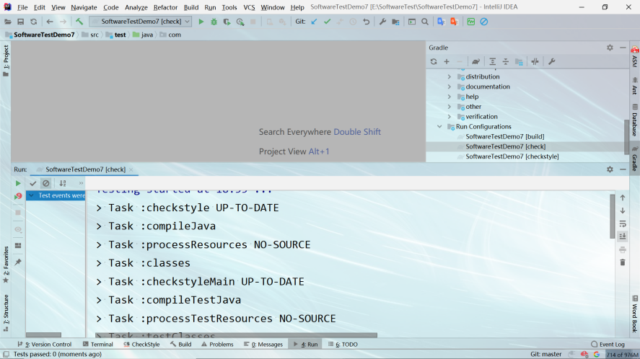

五、结论分析与体会
通过这次实验，我明白了gradle的优点，可以直观的判断数据的正确与否，避免了后面的数据出错，从而方便了程序员进行修改的麻烦性，而我在这次实验中也学到了此插件的方便性，练习了基本的编程能力，学习JUnit自动测试框架，掌握非参数化和参数化测试方法。

六、仓库地址
https://github.com/lzh-yi/SoftwareTest.git

