**HW1**

**Problem 1**

1. **(Please refer to the attached R code)**

|  |  |  |  |  |  |  |  |
| --- | --- | --- | --- | --- | --- | --- | --- |
|  | -3 | -2 | -1 | 0 | 1 | 2 | 3 |
| Item |  |  |  |  |  |  |  |
| 1 | .000 | .000 | .002 | .045 | .500 | .955 | .998 |
| 2 | .008 | .027 | .085 | .233 | .500 | .767 | .915 |
| 3 | .250 | .250 | .252 | .284 | .625 | .966 | .998 |
| 4 | .205 | .236 | .412 | .788 | .964 | .995 | .999 |
| 5 | .001 | .006 | .045 | .265 | .735 | .955 | .994 |
| 6 | .165 | .239 | .369 | .550 | .731 | .861 | .935 |

**ICCs**

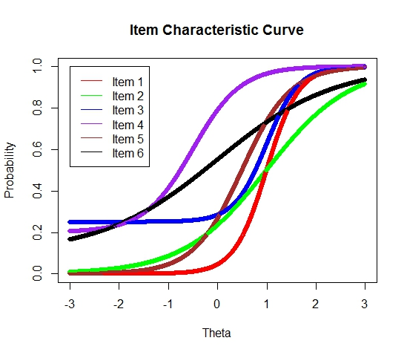

Item 4, whose b parameter is the smallest of all (b=-0.5) is the easiest item.

Item 6, whose a parameter is the smallest of all (a=0.5) is the least discriminating item.

According to the ICCs in (a), an examinees with = 0 has the highest probability of answering item 4 correctly. P (wrong) =1-.788=.212

**Problem 2**

1. Item 4 is the easiest at = -1
2. Item 1 is the hardest at  = 0
3. Items 5 and 6 are equally difficult at = -1
4. Item 2 is the most discriminating at = 2

**Problem 3**

1. P3(=-1) = 0.5
2. Item 2 is the least discriminating.
3. In Figure 2.3, the lower asymptotes of all items are 0, because all 4 items have only 2 parameters (no c parameter), while in Figure 2.4, not all items have lower asymptotes equal to 0, because some items have all 3 parameters (a, b, and c).

**Problem 4**

The 3-PL model: 

When = b, we get:



**Problem 5**

**ICCs (Please refer to the attached R code)**

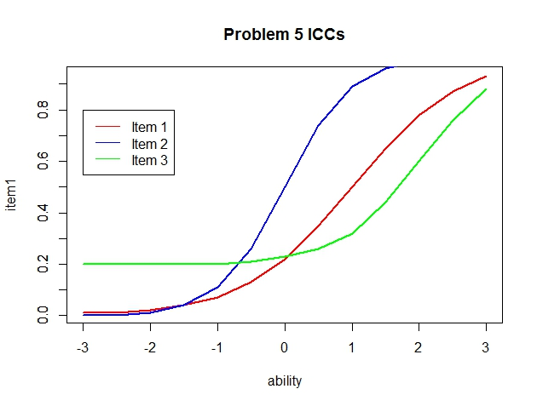

1. According to the plot, for item 1, b=1.0, and for item 2, b=0.
2. P = (1+c)/2 = (1+0.2)/2 = 0.6 when =b, and according to the plot, b = 2.
3. Name this point on the curve M (b, p). Find another point N (,) on the same curve. The slope of MN is given by: Now move N closer to M, and we have N (), and the sloe of MN is given by: Repeat this procedure, which mean to move N along the curve closer and closer to M, and by observing the trend of the s, figure out the limit of s when  approaches b, and this limit is the slope of the ICC at, which is the a parameter. However in this problem, an interval of theta of 0.5 is the best we can get, and what we are getting here is an underestimation of the real slope:

**Item 1: a= (0.5-0.35)/ (1-0.5) = 0.15/0.5 = 0.3**

**Item 2: a= (0.5-0.26)/ 0.5 = 0.48**

**Item 3: a= (0.6-0.44)/ (2-1.5) = 0.32**

As a matter of fact, the a parameter is not equal to the slope of the point on the curve where, because if we take the derivative of P () for  , what we get is not a, but instead we will get a function of a:

, where, and when we plug in, m will become 1, and therefore the slope will look like:, which is not equal to a.

**Problem 6**

|  |  |  |  |  |
| --- | --- | --- | --- | --- |
| Item 1 |  | Item 2 | |  |
|  | Incorrect | Correct |  |
| Incorrect | 8 | 20 | 28 |
| Correct | 8 | 4 | 12 |
|  |  | 16 | 24 | 40 |



According to the  value, we can reject the null hypothesis, and therefore the assumption of local independence is violated in this case.