**HW 2**

**Problem 1**



The assumption of local independence must be made in order to determine the likelihood function.

1. (Please refer to the attached R code)

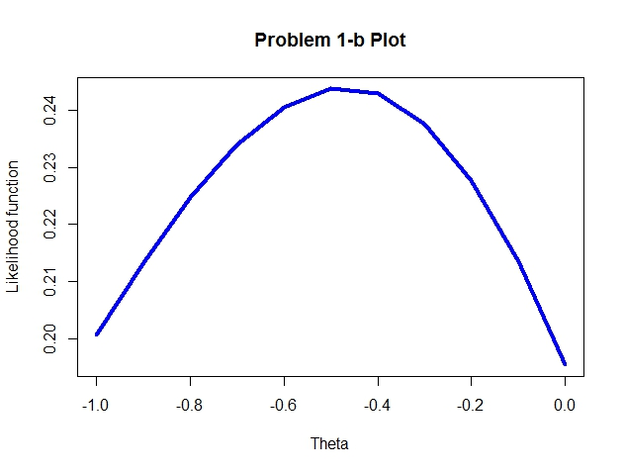

According to the plot above, the maximum likelihood estimate of θ is approximately -0.46.

**Problem 2**

Items information at theta=1.5:



According to the results shown below, test information at theta=1.5 is 5.199, and standard error of MLE is 0.439.

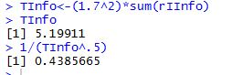

Therefore, the 95% CI for the true theta is 1.5 ± 1.96*0.439，which is equal to (0.640, 2.360).

**Problem 3**

1. L(x1,x2,x3|1,2,3)=Q1*Q2*P3

=

The assumption that has been made here is that responses of examinees are independent of each other.

1. **(Please refer to the attached R code)**



Using the data shown above, the likelihood function of b ranging from 0 to 1 in increments of 0.1 is plotted as:

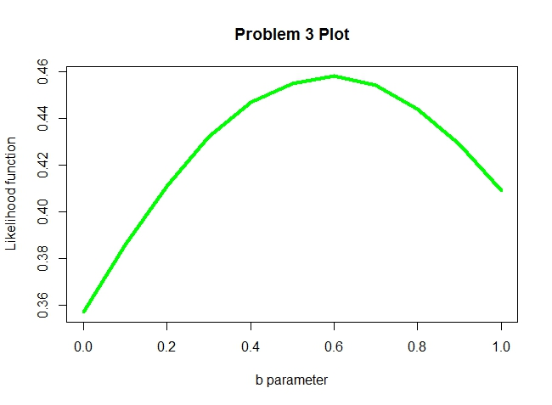

**According to the plot above, we can observe that the MLE of b is equal to 0.6.**

**Problem 4**

1. 



1. **(Please refer to the attached R code)**

According to problem 3, the MLE of b is equal to 0.6, and three examinees have theta values -1, 0, and 1, respectively.

s are shown below:



Therefore, test information and SE of the MLE can be obtained via the formulas in (a)

