**CH 4**

**Problem 1**

1. Observed proportion correct:
2. = -2, p = 4/20 = .20
3. = -1, p = 5/20 = .25
4. = 0, p = 8/20 = .40
5. = 1, p = 15/20 = .75
6. = 2, p = 18/20 = .90
7. As shown below,

= -2, p = .25

= -1, p = .27

= 0, p = .38

= 1, p = .72

= 2, p = .95



1. As shown below, Q1 = 1.48, and DF = 5-3 = 2.

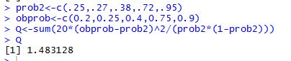

1. = 5.99, which is larger than Q1 = 1.48, indicating that the 3-PL model is a good fit for the data.

**Problem 2**

1. As shown below, for 1-PL, Q1 = 38.52

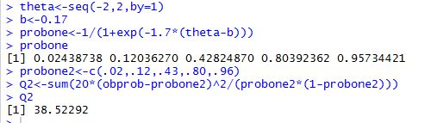

1. As shown below, for 2-PL, Q1 = 2.67

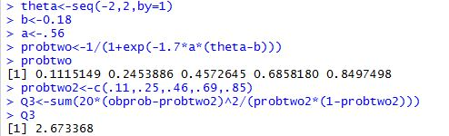

1. = 5.99, indicating that the 1-PL model does not fit well the data, while the 2-PL model fits the data.
2. Since both 2-PL and 3-PL models fit the data well, we can choose the 2-PL model because it’s simpler.