**HW 3 Simulation**

1. **Write the function for simulating item responses (R code shown below)**

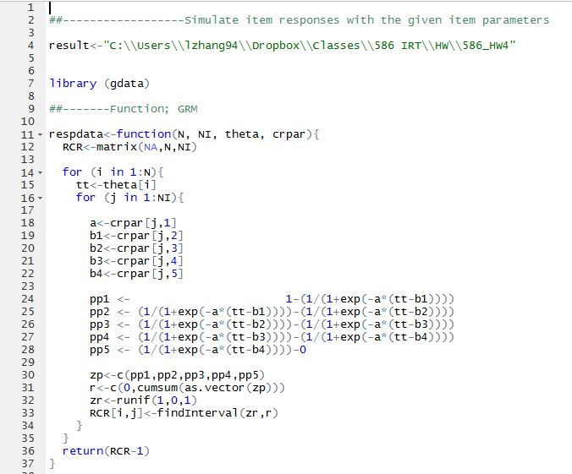

1. **Plug in the item parameters, No. of examinees, No. of items, and examinees’ true abilities. Output the simulated item responses to target folder.**

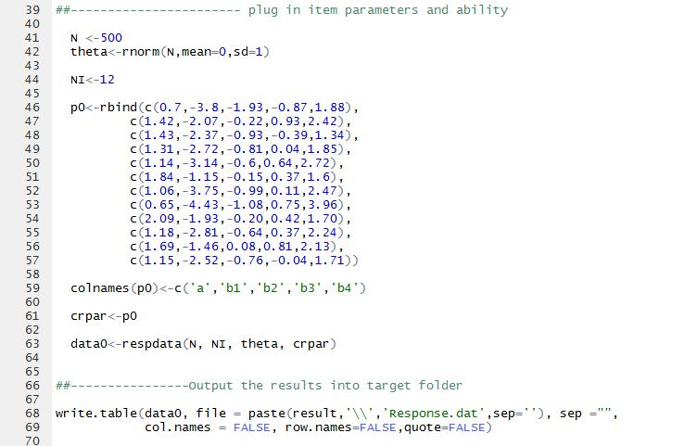

1. **After obtaining the item responses, we put them in MULTILOG to get estimated thetas.**

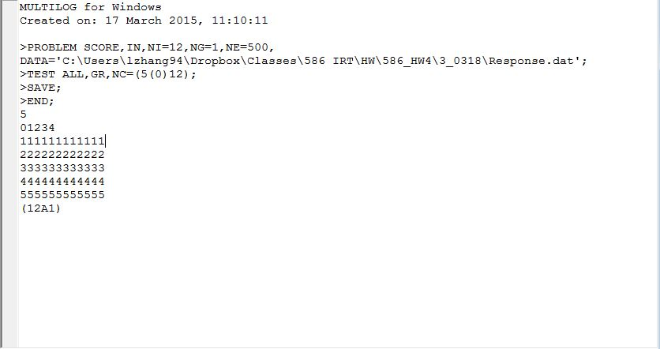

1. **After obtaining estimated thetas from MULTILOG, we put both the true thetas and the estimated ones in R, and plot to figure out the relationship between the two.**

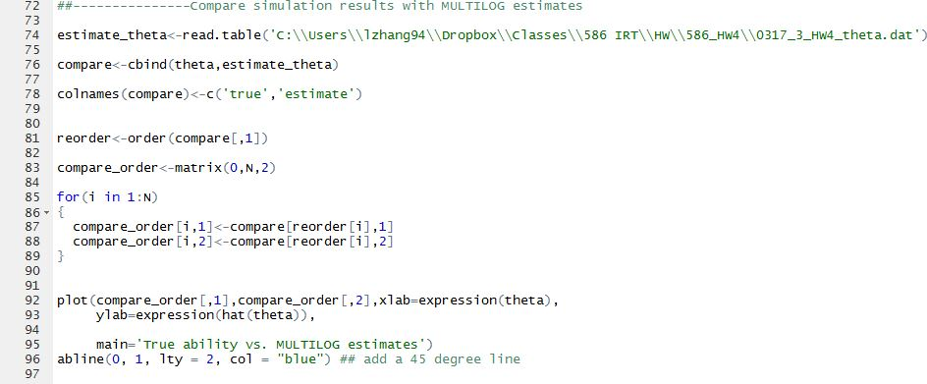

1. **As the plot shown below, we can see that examinees with low abilities have their theta values overestimated, while examinees with relatively high abilities have their theta values underestimated. However, generally speaking, the estimates from MULTILOG are satisfying.**

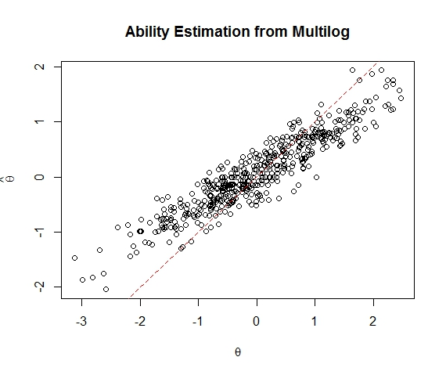

1. **Then I obtained estimated item parameters from MULTILOG, using the same simulated item responses. The MULTILOG syntax is as below:**

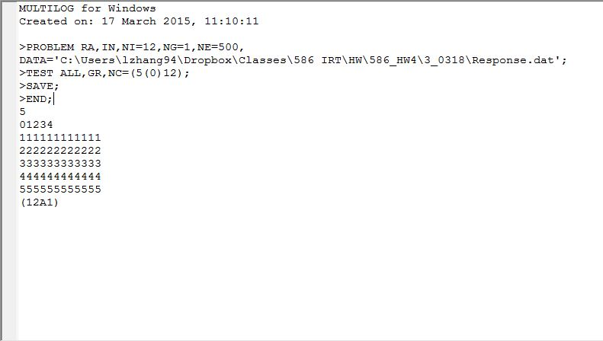

1. **And compared estimated item parameters with the true item parameters given in the HW, also by plots.**

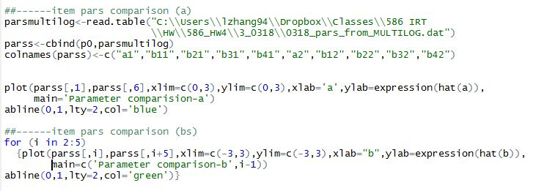

1. **Plots**

**According to the plots below, we can say that item parameter estimates given by MULTILOG are pretty reliable, in that all the points are lying closely to the 45 degree line. I’m not sure if it’s an accident, but it seems to me that MULTILOG is slightly better at estimating b parameters than a parameters.**

