**Chapter 9**

**Problem 1**

To ensure that the item parameters are on a common scale, we need to standardize the b parameter estimates, which means we need to set mean = 0 and SD = 1 for the b parameters.

**Problem 2**

Abilities of examinees who took both tests should be the same, but in practice, the two sets of ability estimates should be linearly related because of standardization, and the relationship should be:

,

where  stands for the ability of common examinees based on Test Y, and  stands for ability of common examinees based no Test X.

Via mean and Sigma method, the scaling constants can be obtained using mean and standard deviation of common examinees’ abilities for Test X and Test Y via the equations below:

,

Where  and  are the standard deviations of common examinees’ abilities for Test X and Y, respectively.  and  are the mean abilities of common examines for Test X and Y, respectively.

Once  and  are obtained, we can map examinees’ abilities, b-parameters, and a-parameters of Test X onto Test Y via the equations below:



**Problem 3**

1. Using the R code below, we obtain the scaling the constant, and the results are as below:



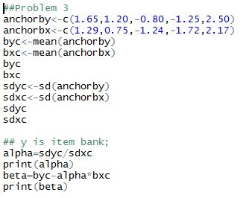

1. Using the R code below, we can obtain the b values of the common items in experimental test after they are mapped onto item bank.

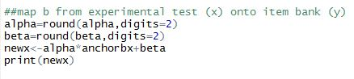

The b values are:

2PL:



3PL:



1. The plot for 2PL:

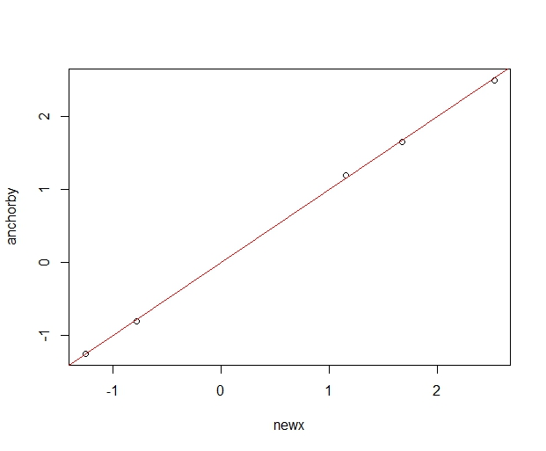

The plot for 1PL:

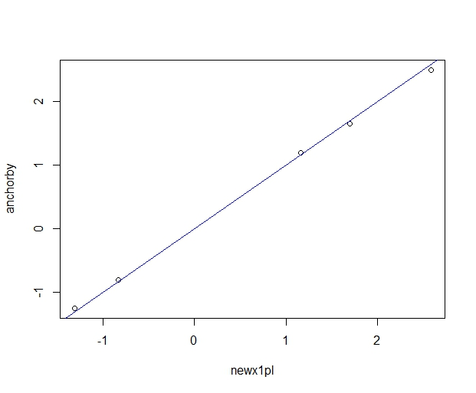

According to the 2 plots above (45 degree lines), b values of the common items based on 2PL model are slightly closer to the values in the item bank, compared with 1PL model.

Also, according to the plot below, we can tell that b values of the common items are pretty similar for 1PL model and 2PL model.

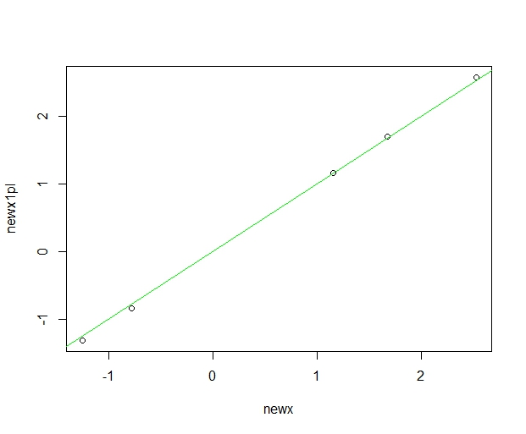

1. Using the “Mean and Sigma method”, we can obtain the scaling constants below:





Therefore, scaled item difficulty and discrimination values are:

