**Lab #8&9 Questions: Name: ___Rui Guo_________**

1. Give the text for the DL file ‘alba’ below.

dl n=4, format=FM

labels:

A,B,C,D

data:

0 1 1 0

1 0 0 1

0 0 0 0

0 0 1 0

2a. Write out the matrix, ‘alba 2’.

1 2 3 4

A B C D

1 A 1 0 0 1

2 B 0 1 2 0

3 C 0 0 0 0

4 D 0 0 0 0

2b. By *how many* paths of length 2 can person 3 *get advice from* person 4?

0

3. By *how many* paths of length 3 can person 1 *get advice from* person 3?

2

4. Draw the paths between the four actors (using dots and arrows), as instructed in Step 5. Is your drawing compatible with the number of ‘length 2’ paths shown in ‘alba2’?

Yes

1

2 3

4

**Part B) Cognitive Maps**

5. Print out the pooled network from Step 4. W hat does this network represent (*describe in detail*)?

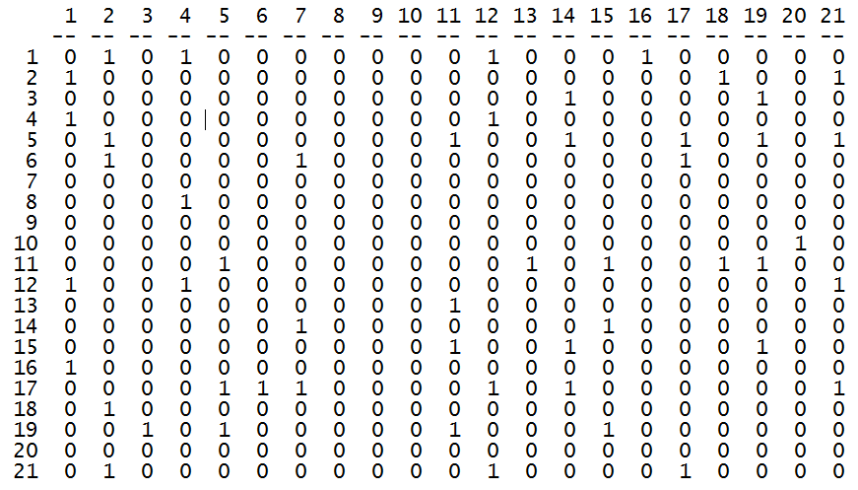

This matrix represents an existing friendship only when both parties agree the friendship exits.

6. What are the QAP Pearson Correlation estimates of the pooled friendship matrix with the cognitive friendship maps of Actor #20 and Actor #5, respectively?

Actor #20: 0.085 (*p* = .137)

Actor #5: 0.504 (*p* < .001)

7. Print out the sociograms (i.e., network diagrams) for the pooled matrix, Actor #20’s matrix, and Actor #5’s matrix. [Also bring these diagrams to class.]

**Pooled:**

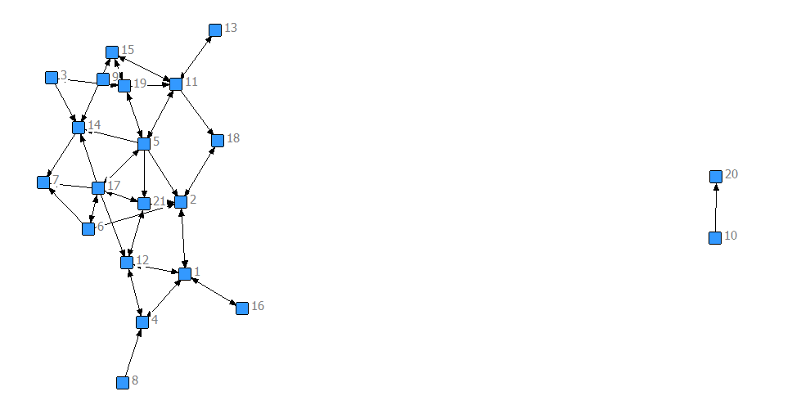

**Actor #20:**

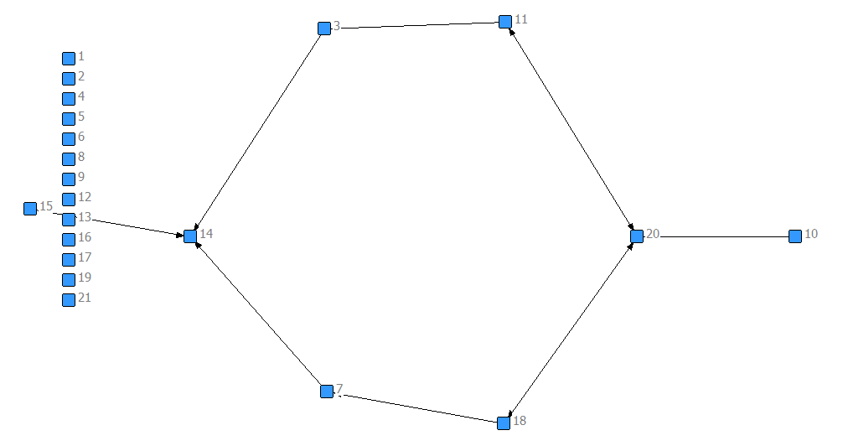

**Actor #5:**

