**Lab #8&9 Questions: Name: _____Liwen Liu_________**

**1. Give the text for the DL file ‘alba’ below.**

dl n=4, format=FM

labels:

A,B,C,D

data:

0 1 1 0

1 0 0 1

0 0 0 0

0 0 1 0

**2a. Write out the matrix, ‘alba 2’.**

1 2 3 4

A B C D

- - - -

1 A 1 0 0 1

2 B 0 1 2 0

3 C 0 0 0 0

4 D 0 0 0 0

**2b. By *how many* paths of length 2 can person 3 *get advice from* person 4?**

0

**3. By *how many* paths of length 3 can person 1 *get advice from* person 3?**

2

**4. Draw the paths between the four actors (using dots and arrows), as instructed in Step 5. Is your drawing compatible with the number of ‘length 2’ paths shown in ‘alba2’?**

1 2

3 4

Yes

**Part B) Cognitive Maps**

**5. Print out the pooled network from Step 4. What does this network represent (*describe in detail*)?**

1 2 3 4 5 6 7 8 9 10 11 12 13 14 15 16 17 18 19 20 21

-- -- -- -- -- -- -- -- -- -- -- -- -- -- -- -- -- -- -- -- --

1 0 1 0 1 0 0 0 0 0 0 0 1 0 0 0 1 0 0 0 0 0

2 1 0 0 0 0 0 0 0 0 0 0 0 0 0 0 0 0 1 0 0 1

3 0 0 0 0 0 0 0 0 0 0 0 0 0 1 0 0 0 0 1 0 0

4 1 0 0 0 0 0 0 0 0 0 0 1 0 0 0 0 0 0 0 0 0

5 0 1 0 0 0 0 0 0 0 0 1 0 0 1 0 0 1 0 1 0 1

6 0 1 0 0 0 0 1 0 0 0 0 0 0 0 0 0 1 0 0 0 0

7 0 0 0 0 0 0 0 0 0 0 0 0 0 0 0 0 0 0 0 0 0

8 0 0 0 1 0 0 0 0 0 0 0 0 0 0 0 0 0 0 0 0 0

9 0 0 0 0 0 0 0 0 0 0 0 0 0 0 0 0 0 0 0 0 0

10 0 0 0 0 0 0 0 0 0 0 0 0 0 0 0 0 0 0 0 1 0

11 0 0 0 0 1 0 0 0 0 0 0 0 1 0 1 0 0 1 1 0 0

12 1 0 0 1 0 0 0 0 0 0 0 0 0 0 0 0 0 0 0 0 1

13 0 0 0 0 0 0 0 0 0 0 1 0 0 0 0 0 0 0 0 0 0

14 0 0 0 0 0 0 1 0 0 0 0 0 0 0 1 0 0 0 0 0 0

15 0 0 0 0 0 0 0 0 0 0 1 0 0 1 0 0 0 0 1 0 0

16 1 0 0 0 0 0 0 0 0 0 0 0 0 0 0 0 0 0 0 0 0

17 0 0 0 0 1 1 1 0 0 0 0 1 0 1 0 0 0 0 0 0 1

18 0 1 0 0 0 0 0 0 0 0 0 0 0 0 0 0 0 0 0 0 0

19 0 0 1 0 1 0 0 0 0 0 1 0 0 0 1 0 0 0 0 0 0

20 0 0 0 0 0 0 0 0 0 0 0 0 0 0 0 0 0 0 0 0 0

21 0 1 0 0 0 0 0 0 0 0 0 1 0 0 0 0 1 0 0 0 0

The matrix is constructed with a connection between i and j if both i and j agree that such a connection exists.

**6. What are the QAP Pearson Correlation estimates of the pooled friendship matrix with the cognitive friendship maps of Actor #20 and Actor #5, respectively?**

0.085 (*p* = .137); 0.504 (*p* < .001)

**7. Print out the sociograms (i.e., network diagrams) for the pooled matrix, Actor #20’s matrix, and Actor #5’s matrix. [Also bring these diagrams to class.]**

**Pooled**

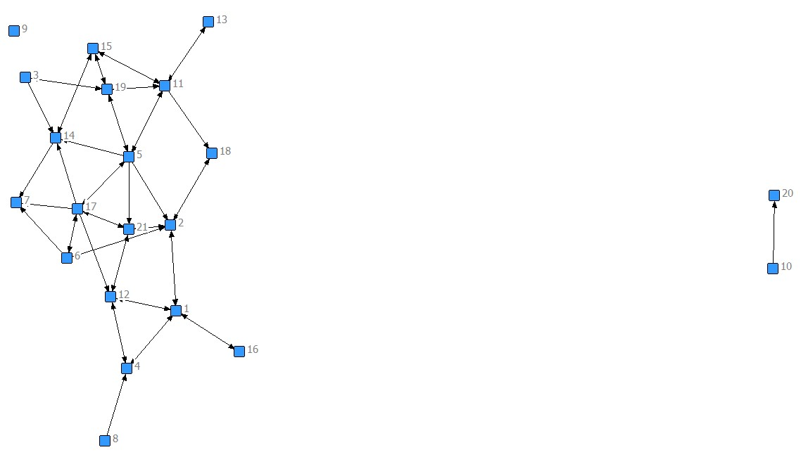

**Actor #20**

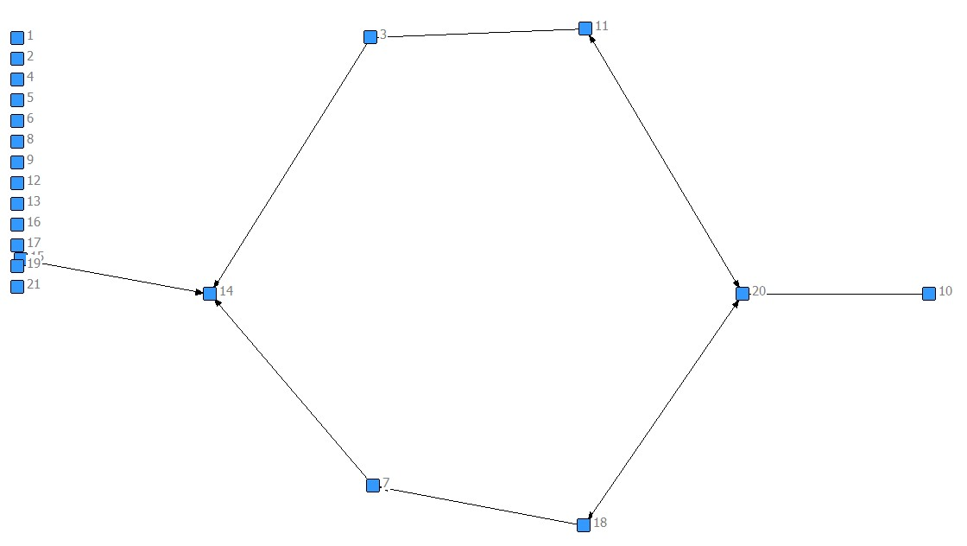

**Actor #5**

