**ingEpsy587**

The data used for this final project is provided by Dr Carolyn Anderson.

1. Exploratory Analysis:
   1. The frequency table for peer by gender indicates that every peer group is very homogeneous in terms of gender, only two exceptions for all the peer groups in the data. In retrospection, this can explain why gender can be dropped from the final model. The information from gender is explained or included in the random intercept, so gender can be dropped if there is a random intercept in the model. Only 10 groups are presented below for demonstration purpose.

| **Table of peer by gender** | | | |
| --- | --- | --- | --- |
| **peer(Peer group)** | **gender** | | |
| **female** | **male** | **Total** |
| **1** | |  | | --- | | 9 | | |  | | --- | | 0 | | |  | | --- | | 9 | |
| **2** | |  | | --- | | 5 | | |  | | --- | | 0 | | |  | | --- | | 5 | |
| **3** | |  | | --- | | 3 | | |  | | --- | | 0 | | |  | | --- | | 3 | |
| **4** | |  | | --- | | 3 | | |  | | --- | | 0 | | |  | | --- | | 3 | |
| **5** | |  | | --- | | 0 | | |  | | --- | | 1 | | |  | | --- | | 1 | |
| **6** | |  | | --- | | 5 | | |  | | --- | | 0 | | |  | | --- | | 5 | |
| **7** | |  | | --- | | 3 | | |  | | --- | | 0 | | |  | | --- | | 3 | |
| **8** | |  | | --- | | 8 | | |  | | --- | | 0 | | |  | | --- | | 8 | |
| **9** | |  | | --- | | 10 | | |  | | --- | | 0 | | |  | | --- | | 10 | |
| **10** | |  | | --- | | 3 | | |  | | --- | | 0 | | |  | | --- | | 3 | |

* 1. Analysis of empathy: 32 peer groups are randomly selected from the data and 3 kinds of plots are fitted to explore the relationship between empathy and bully. The basic message from the plots is that there is a negative relationship between these two variables and there is also a location effect which indicates a possible random intercept.

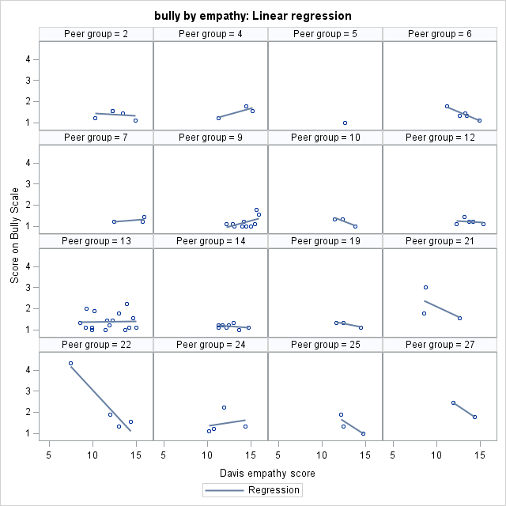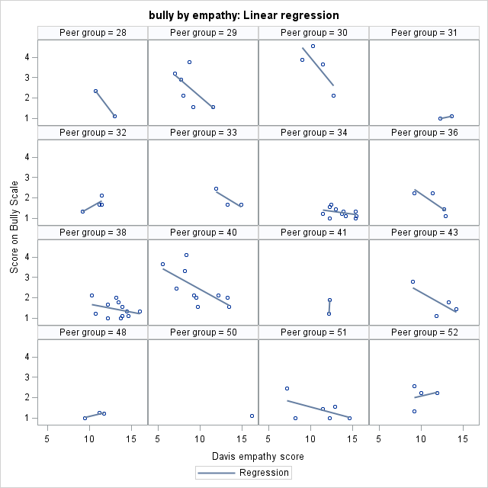

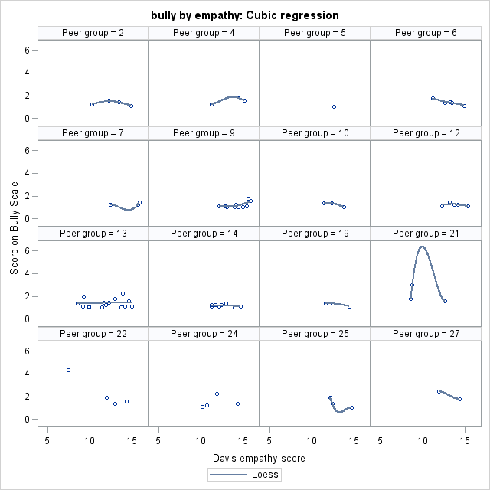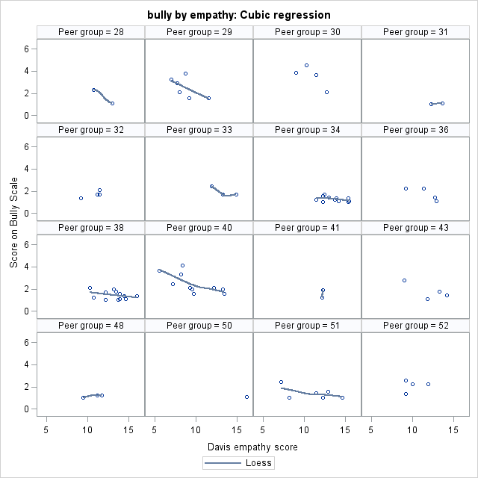

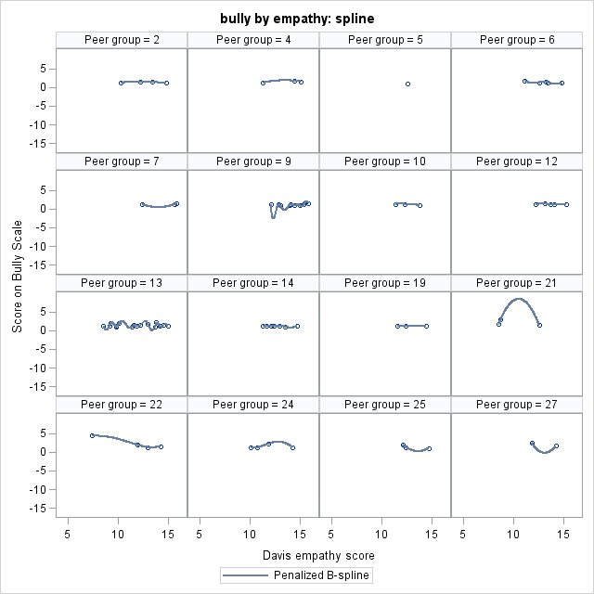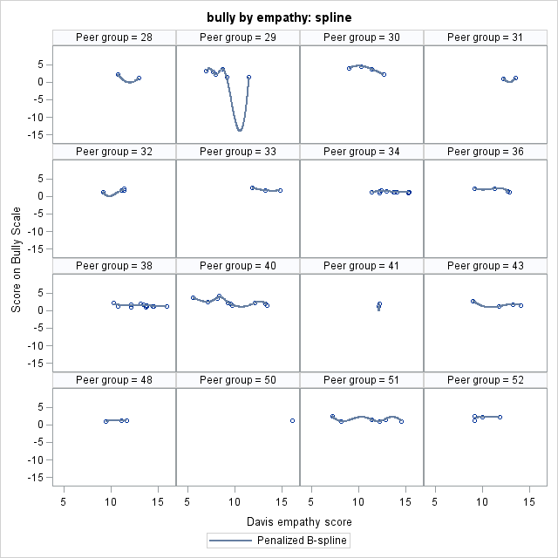

Plots for empathy by overall mean bully are produced. The negative relation is confirmed.

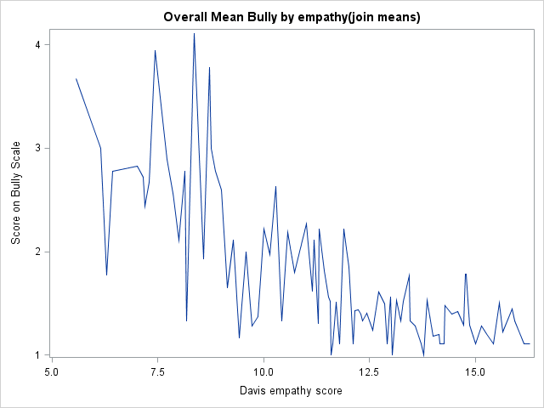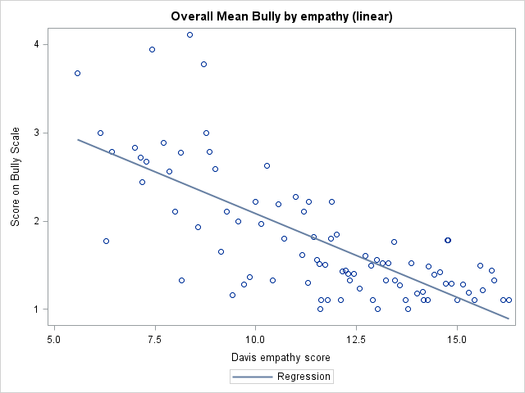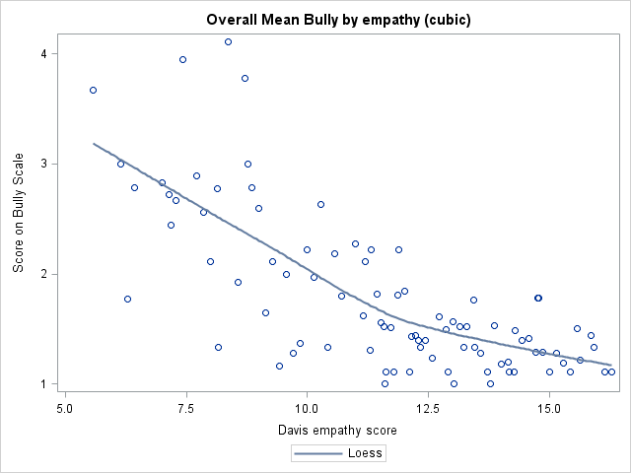

The plots for regression of each peer group for all the groups are also presented here. The plots can provide another piece of evidence to the message from above plots: negative relation and random intercept. The two plots also indicate there might be a random slope effect.

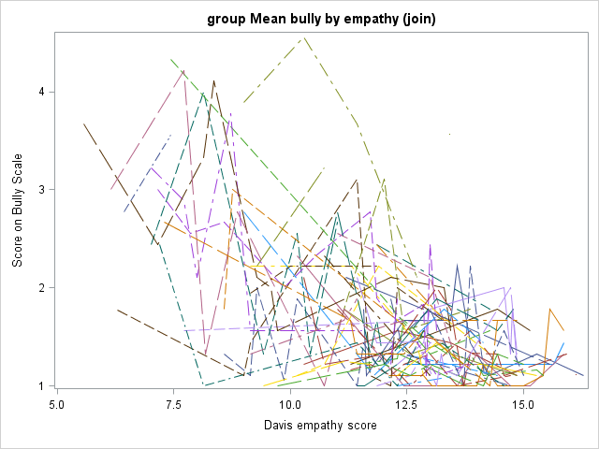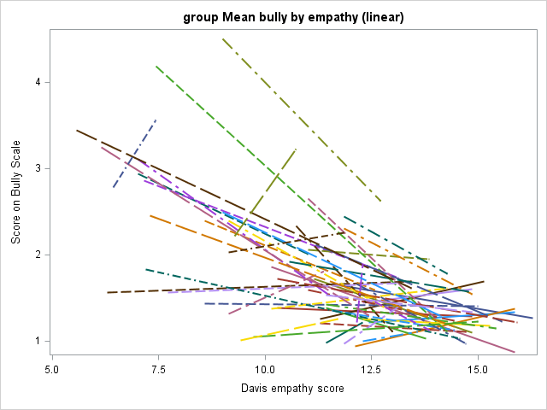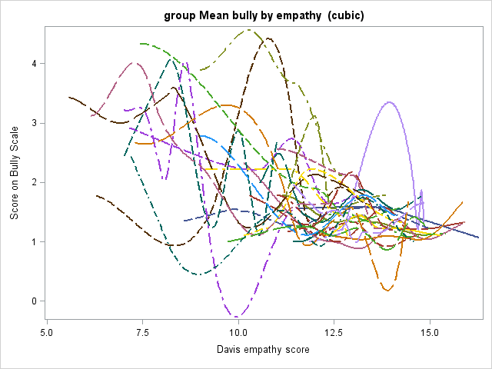

* 1. A similar Analysis of fight and bully. 32 peer groups are randomly selected from the data and 3 kinds of plots are fitted to explore the relationship between fight and bully. The basic message from the plots is that there is a positive relationship between these two variables and there is also a location effect which indicates a possible random intercept.

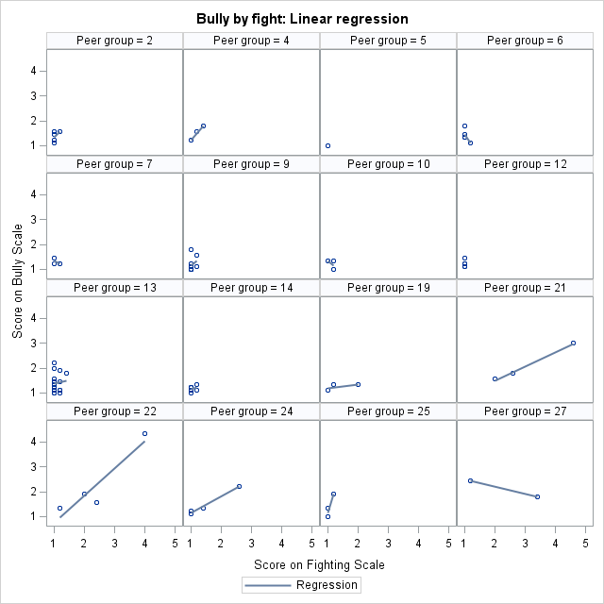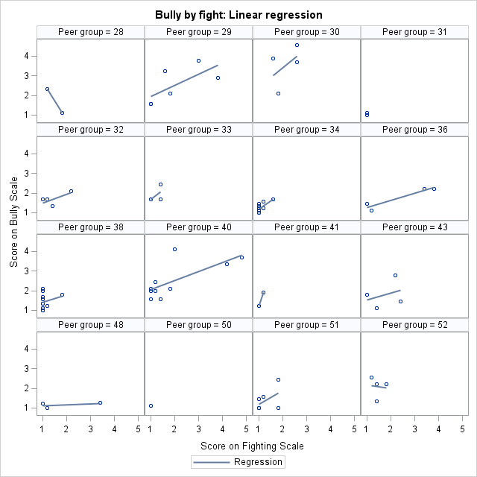

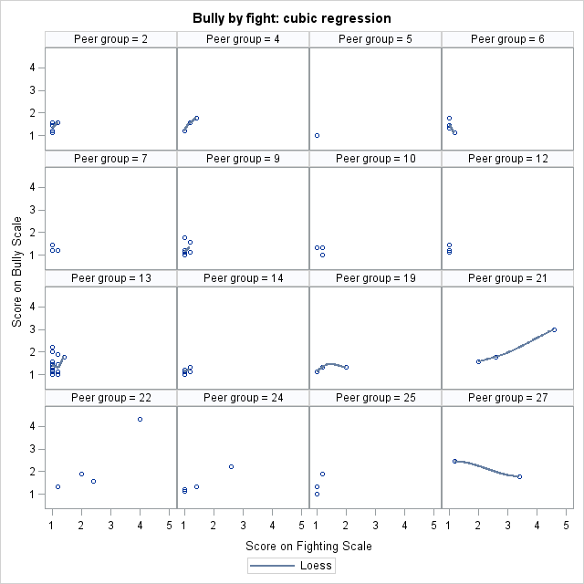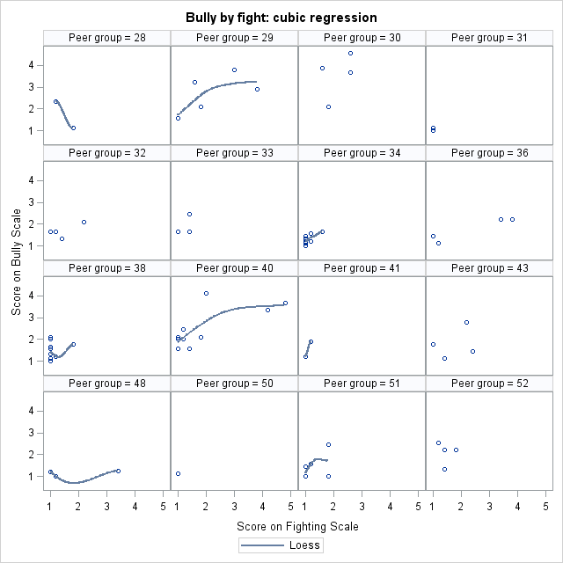

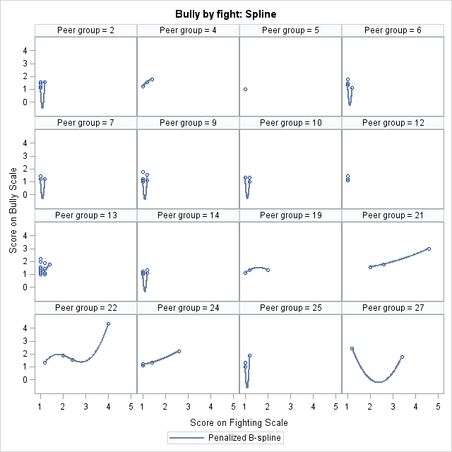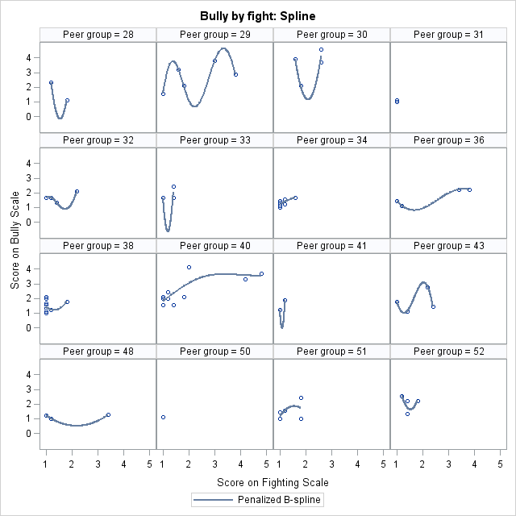

Plots for fight by overall mean bully are produced. The positive relation is confirmed.

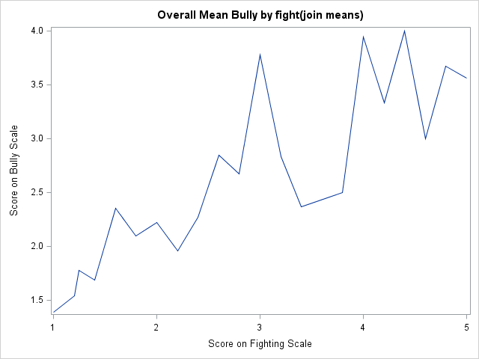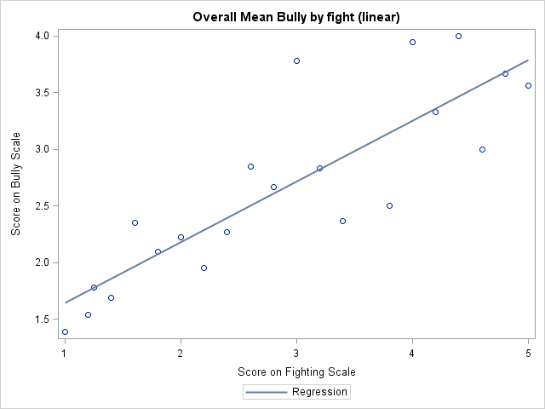

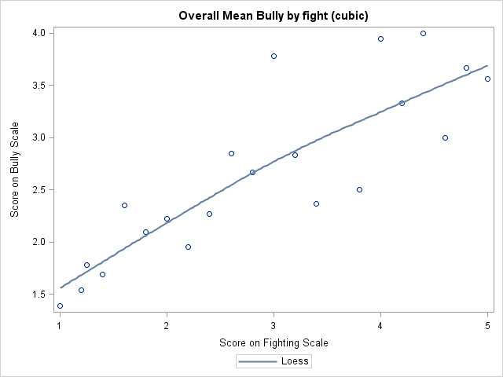

The plots for regression of each peer group for all the groups are also presented here. The plots can provide another piece of evidence to the message from above plots: positive relation and random intercept. The two plots also indicate there might be a random slope effect.

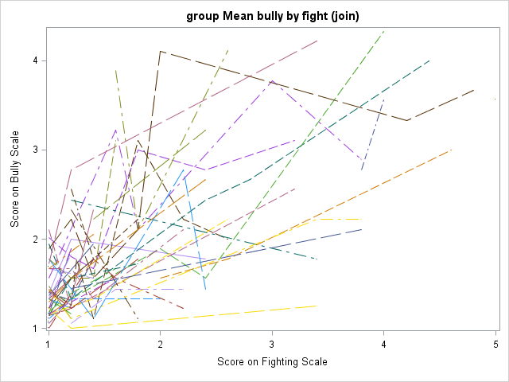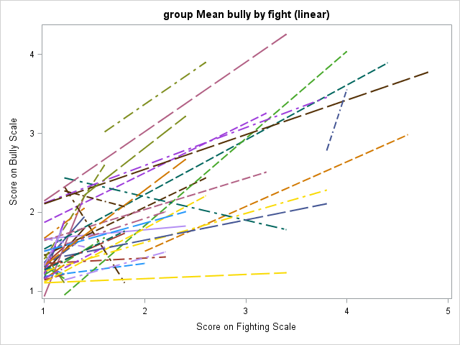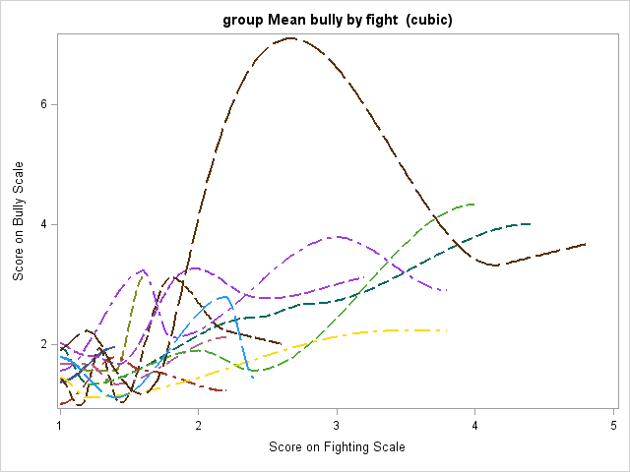

* 1. Analysis of gender: the plots below imply that a gender by empathy interaction is apparent and a gender by fight interaction is possible.

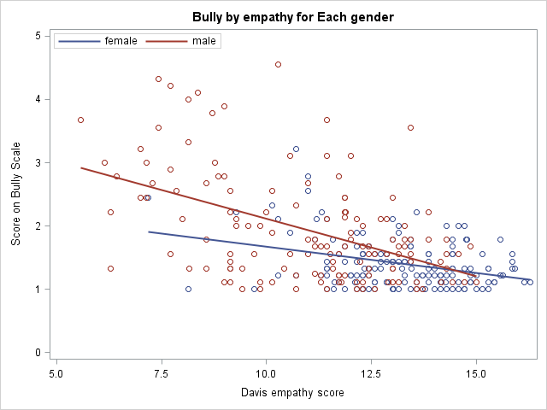

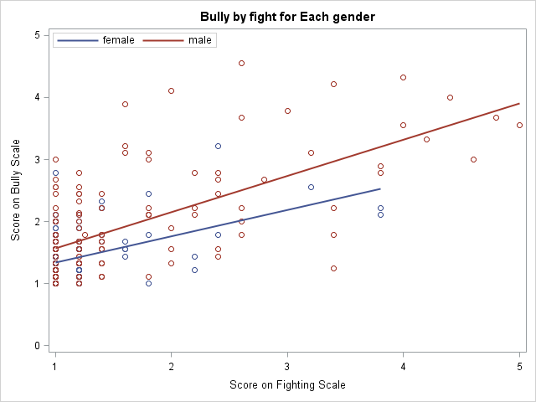

From the exploratory analysis, I can summarize as the following:

* Gender: main effect and interaction with fight and empathy
* Fight: random slope is possible
* Empathy: random slope is possible
* An random intercept is possible
  1. Determine the random slopes.

In order to determine whether the random slope models for fight and empathy are feasible or not, I build three random slope models. All of the models include the variable gender, group-centered fight, group-centered empathy and interaction between gender and group-centered empathy at level 1 and group mean empathy and fight as the explanatory variable for the random intercept at the level 2. The difference for the three models is that the first model has random slope for both fight and empathy, the second for fight only and the third for empathy only. But the SAS program for the first and third cannot converge. This means only random slope for fight is possible for the data.

So by now, the model is

* Gender: main effect and interaction with fight and empathy
* Fight: random slope is possible
* Empathy: no random slope.
* An random intercept is possible

1. Model comparisons: 6 different models are built to compare the estimates and fit statistics.

M 0: empty model

Model 1: fixed effect-gender, grpCempathy, grpCfight, gender*grpCempathy, grpCfight,

grpMempathy, grpMfight

Random intercept

Random slope for fight.

This is the full model obtained from the exploratory analysis.

Model 2: model 1 with gender*grpCempathy removed; (determine whether the interaction term can be dropped or not)

Model 3: model 2 with grpMfight for the random slope removed; (whether the grpMfight can be dropped or not)

Model 4: Model 3 with grpMempathy for random intercept removed; (whether the grpMempathy can be dropped)

Model 5: random intercept (whether a random intercept only model is feasible)

Model 6: model 3 with gender removed (whether the variable gender can be dropped)

|  |  |  |  |  |  |  |  |  |  |  |  |
| --- | --- | --- | --- | --- | --- | --- | --- | --- | --- | --- | --- |
|  |  | Fixed effect | | | Random effects | | | | Fit statistics | | |
|  | #  of  par(s) |  |  |  | between | | within | |  |  |  |
| model |  | ’s | SE |  | SE |  | SE | -2loglike | AIC | BIC |
| M 0 | 3 | intercept | 1.6874 | 0.0722 | 0.2046 | 0.0571 | 0.3051 | 0.02827 | 556.2 | 562.2 | 568.1 |
| M1 | 13 | grpCempathy | -0.0934 | 0.02003 | 0.06614 | 0.02118 | 0.1630 | 0.01557 | 363.0 | 389.0 | 414.8 |
| grpCfight | 0.5967 | 0.2371 | 0.03174 | 0.01777 |  |  |  |  |  |
| grpCempathy*gender | 0.04165 | 0.03192 | 0.02864 | 0.02292 |  |  |  |  |  |
| grpCfight*gender | -0.0226 | 0.128 |  |  |  |  |  |  |  |
| grpMfight | 0.4952 | 0.08317 |  |  |  |  |  |  |  |
| grpMempathy | -0.1003 | 0.03617 |  |  |  |  |  |  |  |
| grpCfight*grpMfight | -0.0638 | 0.1196 |  |  |  |  |  |  |  |
| grpCempathy | -0.0934 | 0.02003 |  |  |  |  |  |  |  |
| grpCfight | 0.5967 | 0.2371 |  |  |  |  |  |  |  |
| M 2 | 11 | intercept | 2.1665 | 0.4749 | 0.06532 | 0.02105 | 0.1639 | 0.01568 | 364.8 | 386.8 | 408.6 |
| gender(f) | -0.0541 | 0.09975 | 0.03452 | 0.01810 |  |  |  |  |  |
| grpCempathy | -0.0766 | 0.01555 | 0.03324 | 0.02455 |  |  |  |  |  |
| grpCfight | 0.5603 | 0.2329 |  |  |  |  |  |  |  |
| grpMfight | 0.4987 | 0.08238 |  |  |  |  |  |  |  |
| grpMempathy | -0.0987 | 0.03575 |  |  |  |  |  |  |  |
| grpCfight*  grpMfight | -0.0462 | 0.1216 |  |  |  |  |  |  |  |
| M 3 | 10 | Intercept | 2.1532 | 0.4724 | 0.06548 | 0.02108 | 0.1638 | 0.01566 | 364.9 | 384.9 | 404.8 |
| gender(f) | -0.0537 | 0.0996 | 0.03615 | 0.01768 |  |  |  |  |  |
| grpCempathy | -0.0766 | 0.01555 | 0.03482 | 0.02454 |  |  |  |  |  |
| grpCfight | 0.4746 | 0.06069 |  |  |  |  |  |  |  |
| grpMfight | 0.5043 | 0.08085 |  |  |  |  |  |  |  |
| grpMempathy | -0.0983 | 0.03565 |  |  |  |  |  |  |  |
| M 4 | 9 | Intercept | 0.8992 | 0.1499 | 0.08223 | 0.02432 | 0.1634 | 0.02432 | 371.9 | 389.9 | 407.8 |
| gender(f) | -0.1753 | 0.09254 | 0.03972 | 0.01822 |  |  |  |  |  |
| grpCempathy | -0.0744 | 0.01551 | 0.03425 | 0.02355 |  |  |  |  |  |
| grpCfight | 0.4572 | 0.05988 |  |  |  |  |  |  |  |
| grpMfight | 0.5885 | 0.07937 |  |  |  |  |  |  |  |
| M 5 | 8 | Intercept | 2.3105 | 0.4899 | 0.05967 | 0.02054 | 0.1765 | 0.01630 | 372.6 | 388.6 | 404.5 |
| gender(f) | -0.0495 | 0.1018 |  |  |  |  |  |  |  |
| grpCempathy | -0.0778 | 0.01591 |  |  |  |  |  |  |  |
| grpCfight | 0.4736 | 0.0465 |  |  |  |  |  |  |  |
| grpMfight | 0.486 | 0.08327 |  |  |  |  |  |  |  |
| grpMempathy | -0.109 | 0.03682 |  |  |  |  |  |  |  |
| M 6 | 9 | Intercept | 2.2267 | 0.4525 | 0.06615 | 0.02121 | 0.1638 | 0.01566 | 365.2 | **383.2** | **401.1** |
| grpCempathy | -0.0775 | 0.01546 | **0.03591** | **0.01759** |  |  |  |  |  |
| grpCfight | 0.4746 | 0.06051 | 0.03425 | 0.02427 |  |  |  |  |  |
| grpMfight | 0.5104 | 0.08036 |  |  |  |  |  |  |  |
| grpMempathy | -0.1074 | 0.03137 |  |  |  |  |  |  |  |

* 1. The empty model and ICC:

ICC= 0.2046/(0.2046+0.3051)=0.40

The ICC is about 0.40 which means that the correlation among kids in a peer group is very high and implies that it is necessary to consider a hierarchical linear model for the data.

* 1. Comparison of M 1 to M 6:

M1 vs M2: whether the interaction term2 can be removed or not

LR= 364.8-363=1.8 with 2 degrees of freedom, so there is no significant difference the two models, i.e., the interaction term can be removed.

M2 vs M3: whether the random slope explanatory variable grpMfight can be dropped

LR = 364.9-364.8=0.1, so there is no difference and grpMfight can be dropped

M3 vs M4: whether the random intercept explanatory variable grpMempathy can be dropped

LR = 371.9-364.9= 7 with 1 degrees of freedom, so there is a difference and grpMemapthy cannot be dropped.

M3 vs M5: whether random intercept only model is feasible.

LR= 372.6-364.9= 7.7

Mixture of p-values from χ1 and χ2 is (0.005+0.02)/2=0.013, so there is a difference and intercept only model is not feasible.

M3 vs M6: whether gender can be dropped or not

LR = 365.2 – 364.9 =0.3, so there is no difference between the two models and gender can be removed.

From the AIC and BIC indexes, M6 is the best model.

I also want to fit a random slope model for empathy base on M6, i.e., I only replace the random slope for empathy and the SAS program cannot converge, so I have not missed any possible models by only taking the model with random slope for fight.

**In conclusion, the final model is M 6 which takes group-centered fight and empathy as main effect and includes an random intercept model (group mean fight and empathy are explanatory variables) and an random slope for fight .**

1. Model Diagnostics.
   1. Normality of the random effects.

EBLUPs of random intercept and random slope with normal distribution overlaid in plot. They are approximately normal, so the normality assumption is possible.

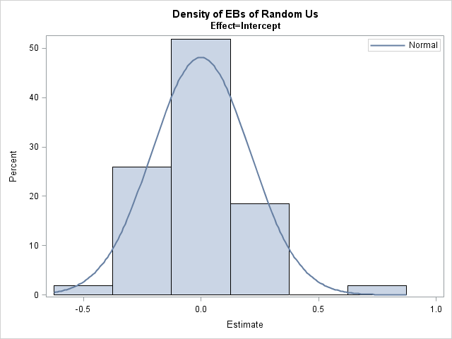

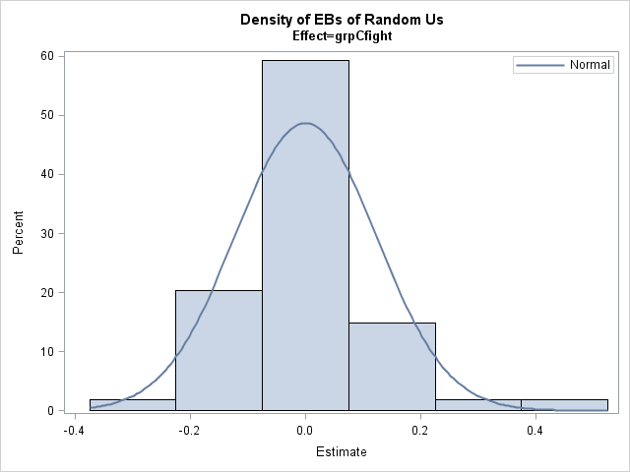

* 1. Bully

Plots of studentized marginal and conditional residuals and predictions are presented. The histograms indicate that the residuals might be normal, but the Q-Q plots show that it might not be normal and residual-vs-predicted mean plots shows that there residual for the smaller values of bully are more clustered than those of bigger values.

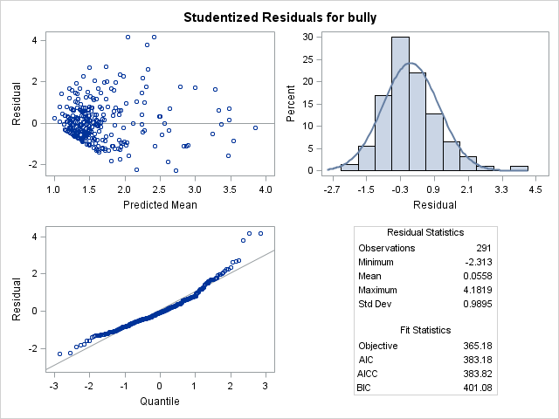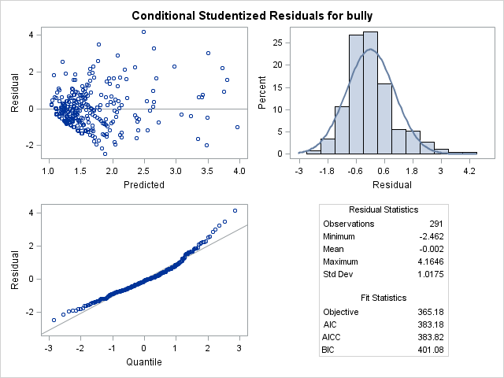

* 1. Plots of Influence Diagnostic:This is the effect of dropping one student. There are some students who have big influence on the model.

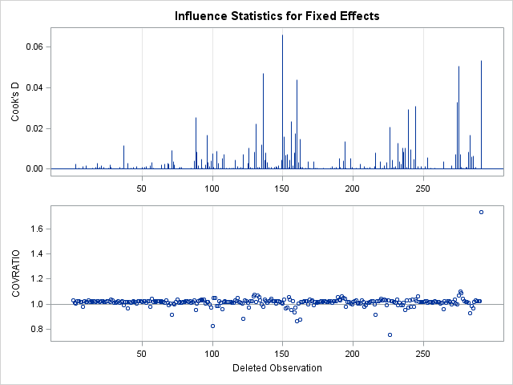

* 1. Plots of Influence Diagnostic: There are some influential peer groups and students within the group. From the plots, it seems that deleting one peer have bigger influence on fixed effects than on random effects and among random effect, it has a bigger influence on the random slope effect.

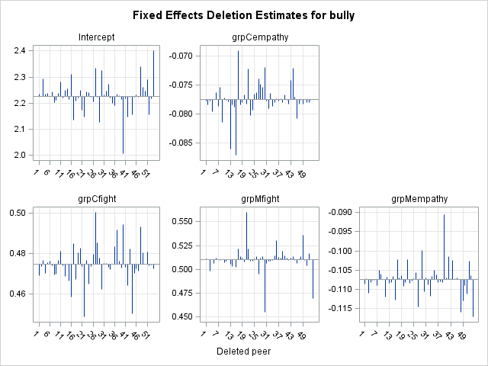 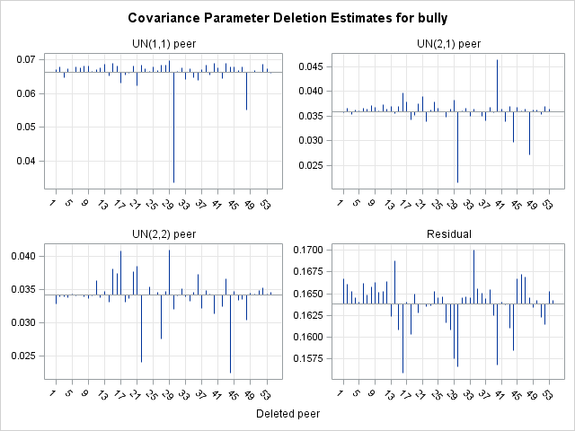

* 1. Plots of influence diagnostics for peer group: the plots confirm the summary made in d.

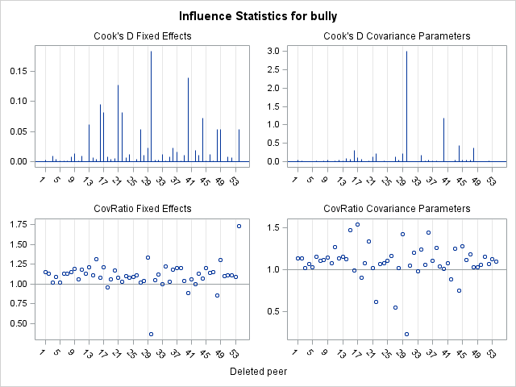

* 1. Plots of influence diagnostics: likelihood distance (effect on criteria when delete peer group). Two peer groups have a big influence on the criteria.

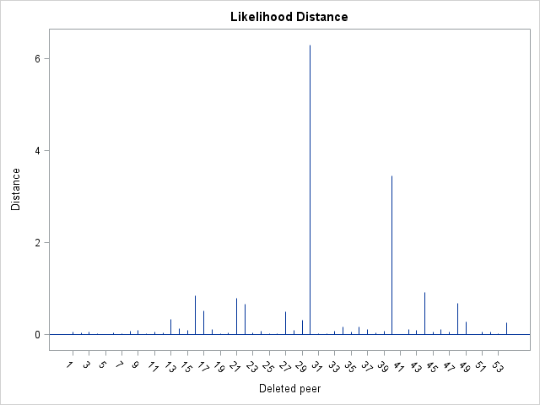

* 1. Distribution of each school.

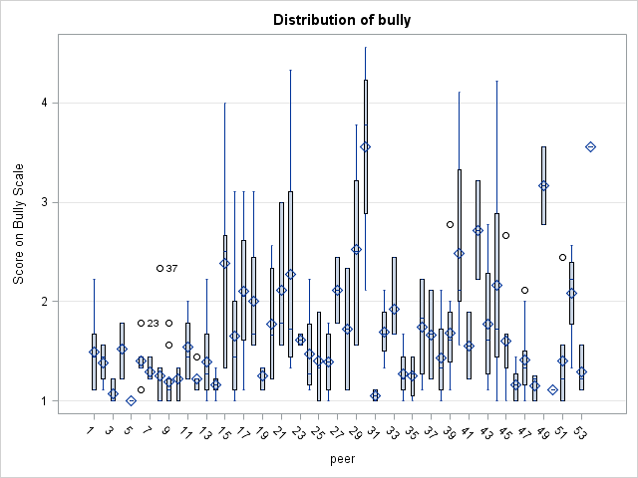 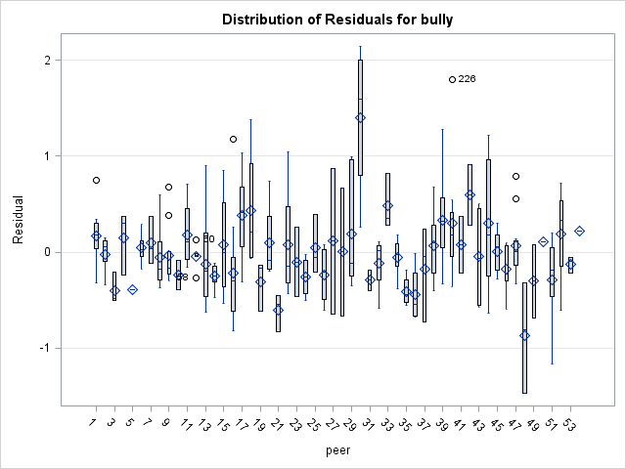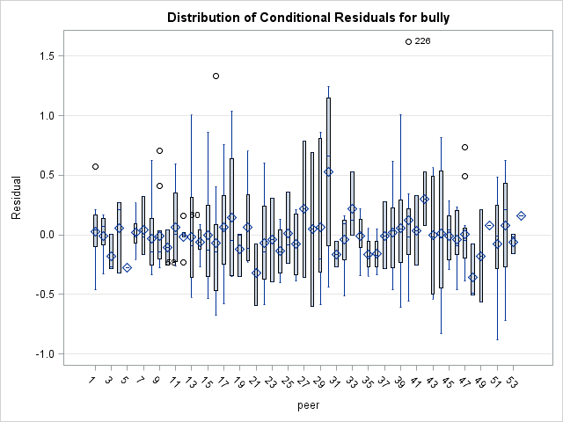

**Summary of the model dianogstics:**

* **The normality of the random effects is possible, but not guaranteed;**
* **The residual of the marginal distribution might not be normal, especially at the lower and higher ends;**
* **There are some inflential peer groups and students. In general, they have a bigger influence on the estimation of the fixed effects and the random slope effect.**

1. Interpretation. The final model is



| **Solution for Fixed Effects** | | | | | |
| --- | --- | --- | --- | --- | --- |
| **Effect** | **Estimate** | **Standard Error** | **DF** | **t Value** | **Pr > |t|** |
| **Intercept** | 2.2267 | 0.4525 | 64.3 | 4.92 | <.0001 |
| **grpCempathy** | -0.07751 | 0.01546 | 233 | -5.01 | <.0001 |
| **grpCfight** | 0.4746 | 0.06051 | 23.8 | 7.84 | <.0001 |
| **grpMfight** | 0.5104 | 0.08036 | 97 | 6.35 | <.0001 |
| **grpMempathy** | -0.1074 | 0.03137 | 59.1 | -3.43 | 0.0011 |
| **Covariance Parameter Estimates** | | | | | |
| **Cov Parm** | **Subject** | **Estimate** | **Standard Error** | **Z Value** | **Pr Z** |
| **UN(1,1)** | **peer** | 0.06615 | 0.02121 | 3.12 | 0.0009 |
| **UN(2,1)** | **peer** | 0.03591 | 0.01759 | 2.04 | 0.0412 |
| **UN(2,2)** | **peer** | 0.03425 | 0.02427 | 1.41 | 0.0791 |
| **Residual** |  | 0.1638 | 0.01566 | 10.46 | <.0001 |

Interpretation:

1 increase in empathy score compared to one’s peer group mean empathy score, one’s bully score will decrease 0.07751.

There is a difference in the intercept. From

Beta0j =

High group fight score is associated with high bully, more specifically, if there is 1 score increase in group mean fight score, there is 0.5104 increases in bully score.

Low group empathy score is also associated with high bully, more specifically, if there is 1 score decrease in group mean empathy score, there is 0.1074 increases in bully score.

There is a random slope effect for group-centered fight score. The intercept for the random slope effect is significant, more specifically, 1 increase in fight score compared to one’s peer group mean empathy score, one’s bully score will increase 0.4746.

Question 1: From the interpretation above, we can infer that there is no difference in bully scores base on the gender groups. But the bully scores do differ in terms of empathy and fight score. More specifically, if there is 1 increase in empathy score compared to one’s peer group mean empathy score, one’s bully score will decrease 0.07751. if there is 1 increase in fight score compared to one’s peer group mean empathy score, one’s bully score will increase 0.4746.

Question 2: there is a peer group effect which is associated with the random intercept effect from the model. High group fight score is associated with high bully, more specifically, if there is 1 score increase in group mean fight score, there is 0.5104 increases in bully score. Low group empathy score is also associated with high bully, more specifically, if there is 1 score decrease in group mean empathy score, there is 0.1074 increases in bully score.