1. Define which items to be reversely coded based on
2. Single item fit
3. Fit plots
4. Wei’s FLs
5. Results:
6. Reverse decisions on most items are consistent across samples, and criteria
7. **A_cop_3: Others might take advantage of me if I choose to cooperate**

**Wei’s FL: 0.099 --- positive**

**US and CHN data: may indicate reverse**

**US:**

**CHN:**

1. **A_cop_8: I don't like to do a project on my own**

**Wei’s FL: .108**

**US (reverse? Not?):**

**CHN (reverse?):**

1. **A_cop_13: I don't argue with others even if I don't agree with them**

**Wei’s FL: .307 (no reverse)**

**US (not sure):**

**CHN (reverse?)**

1. **A_cop_10: I am comfortable counting on other people to get things done**

**Wei’s FL: .047**

**US (no need to reverse):**

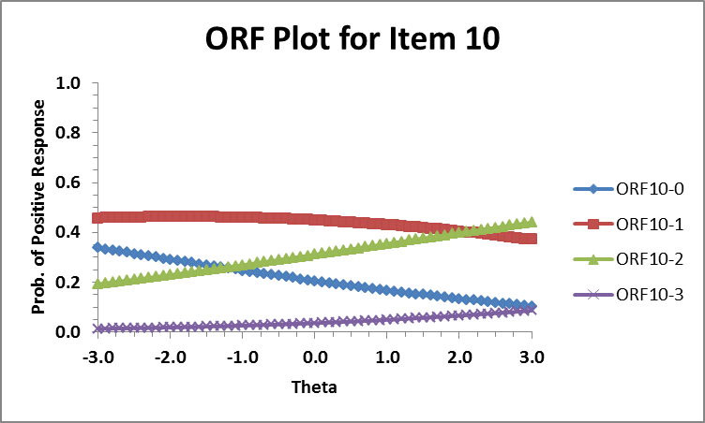

**CHN (probably should reverse):**

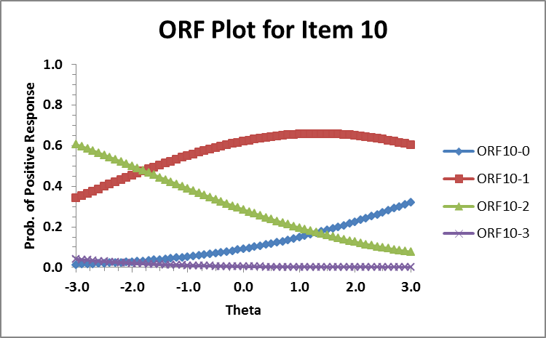

1. **N_web_2: I sometimes find myself thinking negative thought**

**Wei’s FL: -.598 (should reverse)**

**US (probably should reverse)**

**CHN (not sure):**

1. **N_web_17: I am positive, but negative thoughts can conquer me sometimes**

**Wei’s FL: -.06**

**US:**

**CHN:**

1. **O_cur_1: I am open to new concepts but only if they are not hard to understand**

**Wei’s FL: -.481 (should reverse)**

**US (probably should reverse; plots should be read reversely)**

**CHN (no need to reverse):**

1. **O_cur_13: I am as curious as anybody else I know**

**Wei’s FL: .073**

**US (should reverse?? plots should be read reversely)**

**CHN (can’t tell):**

1. **O_cur_19: I like to experience new things, but find myself limited by my obligations**

**Wei’s FL: -.055**

**US: (plots should be read reversely; reverse?)**

**CHN: (no reverse?)**

1. **E_soc_11: I don't mind talking to people, but I enjoy being alone too**

**Wei’s FL: -.355 (should reverse)**

**US (should even be kept in the scale?)**

**CHN (not sure):**

1. **E_soc_15: I don't talk a lot, but I enjoy being with my friends**

**Wei’s FL: -.548 (should reverse)**

**US (can’t tell):**

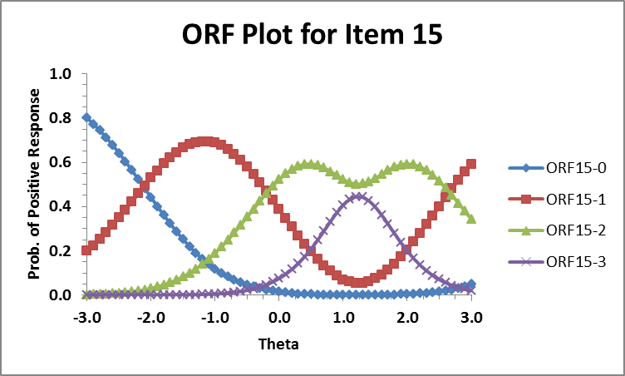

**CHN (can’t tell):**

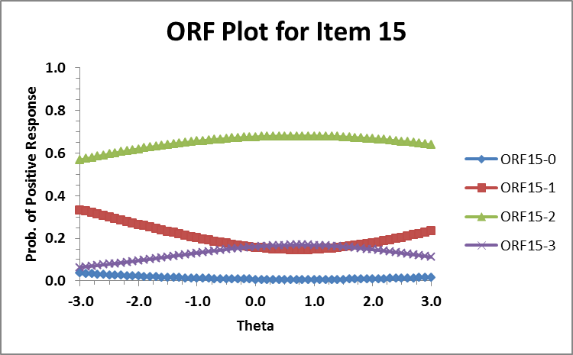

1. **E_soc_19: I am not a talkative person, but if I have to, I usually know what to say**

**Wei’s FL: -.529 (should reverse)**

**US (can’t tell)**

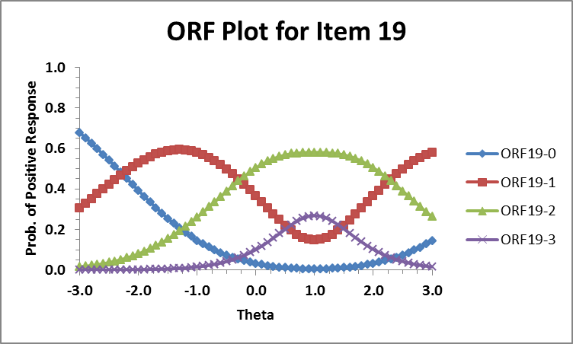

**CHN (can’t tell):**

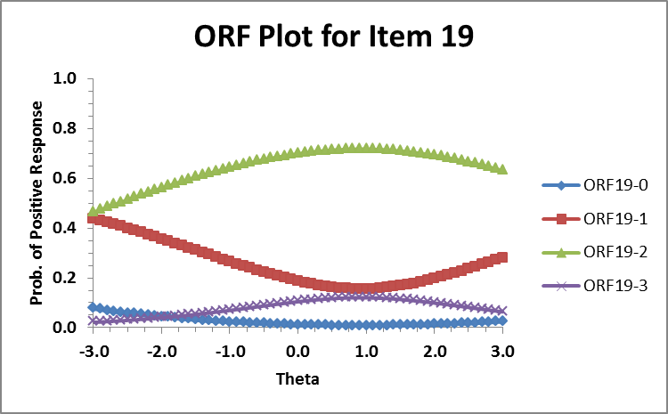

1. Why the theta axes for some facets are reversed (both samples on E and US sample on O).

High theta = low trait level.

1. Programs that run DIF for GGUM?