- Figures
- Math by Science
Figure 1 (a)
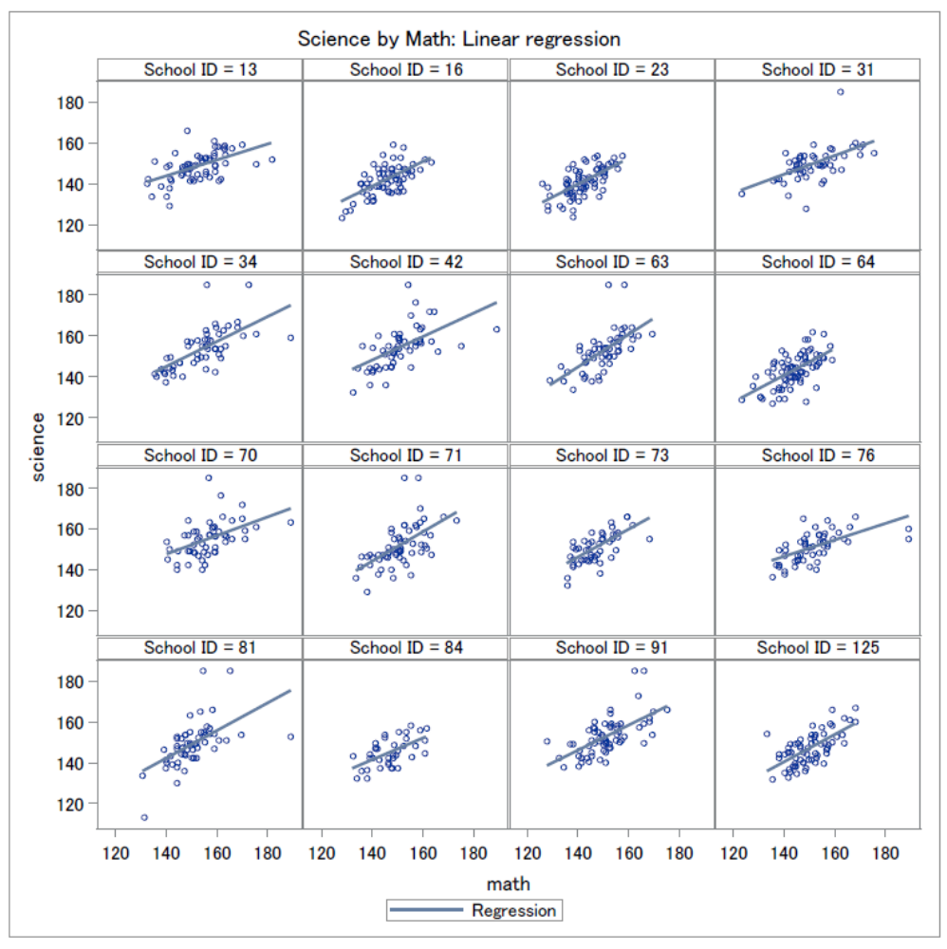

Figure 1 (b)
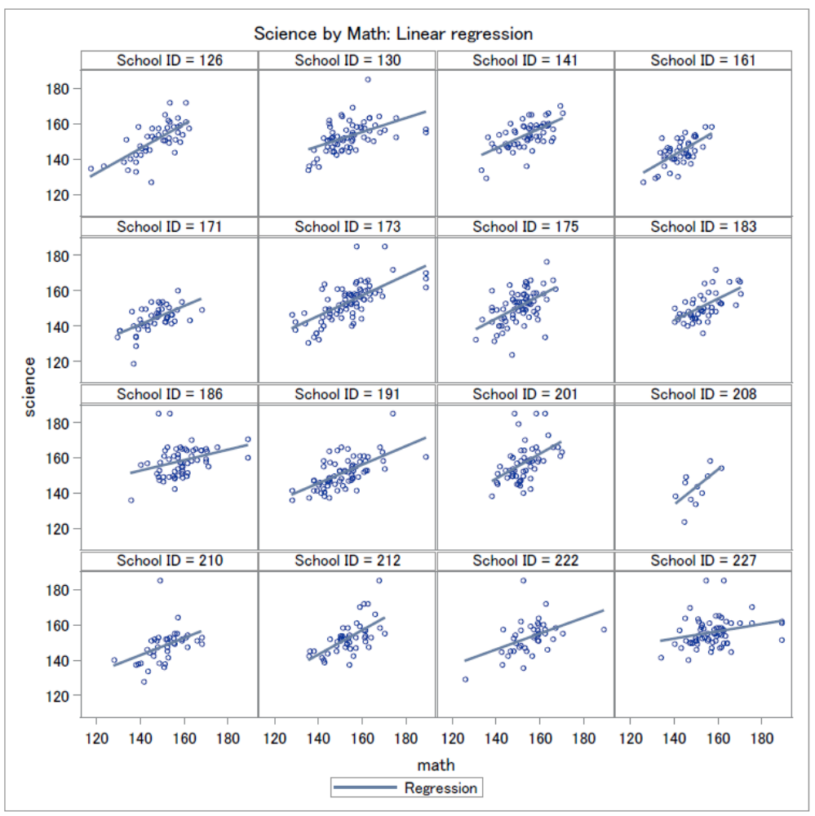
32 schools are randomly selected from the large sample, and above are the linear regression for “Science by Math’. We can tell from the panels that a positive relationship exists between the two variables, and different slopes and levels can be obesreved.

Figure 2 (a)
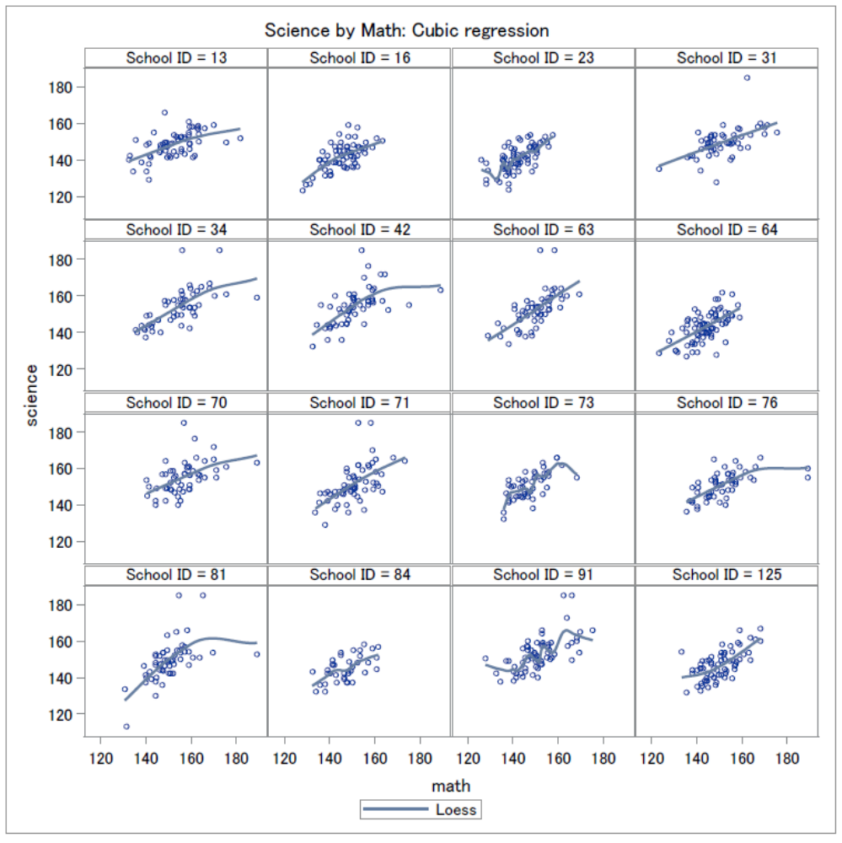

Figure 2 (b)
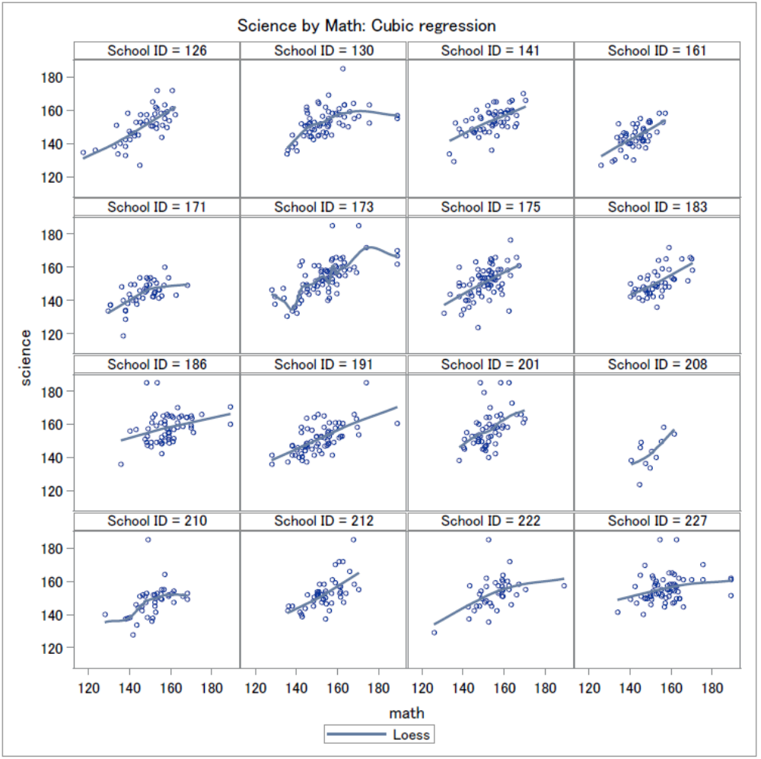
Above are cubic regressions (loess). A positive relationship can be observed, and many graphs look very linear.

Figure 3 (a)
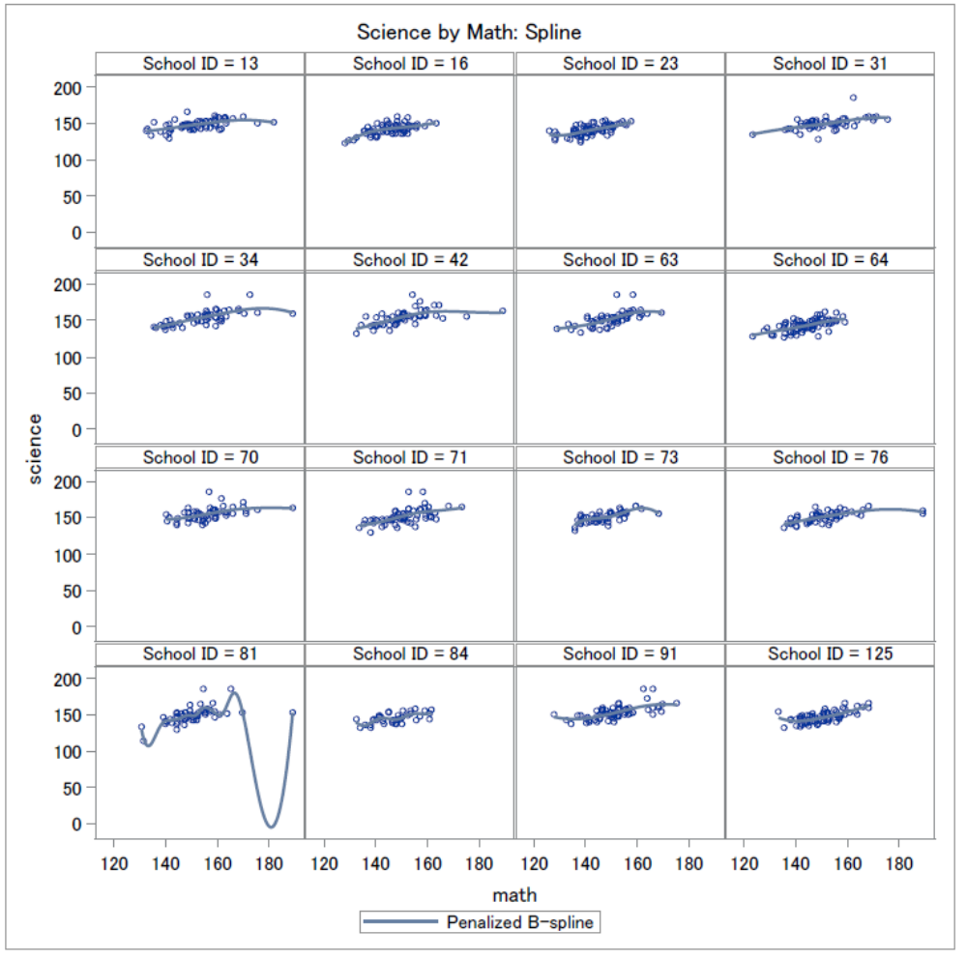

Figure 3 (b)
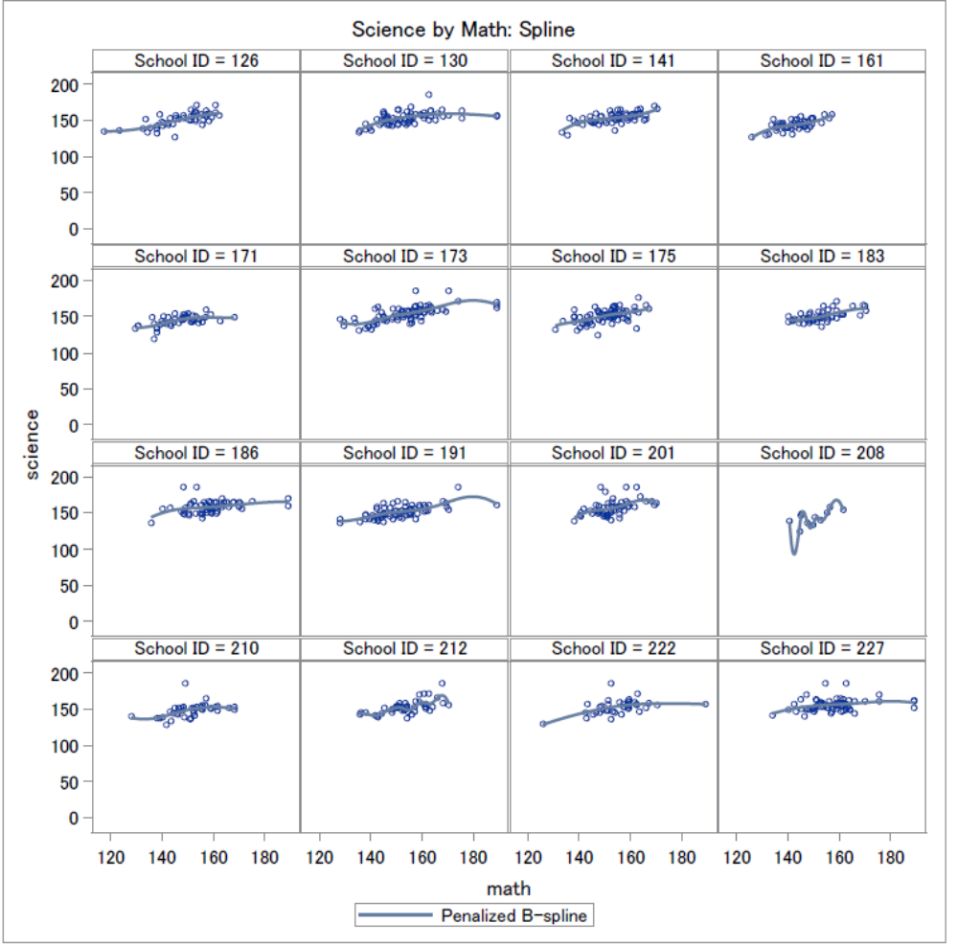
Cubic regression (penalized b-spline). Like Figure 2, we can observe a positive relationship between science and math, and many of the graphs look linear.

- Hours TV by Science
Figure 4(a)
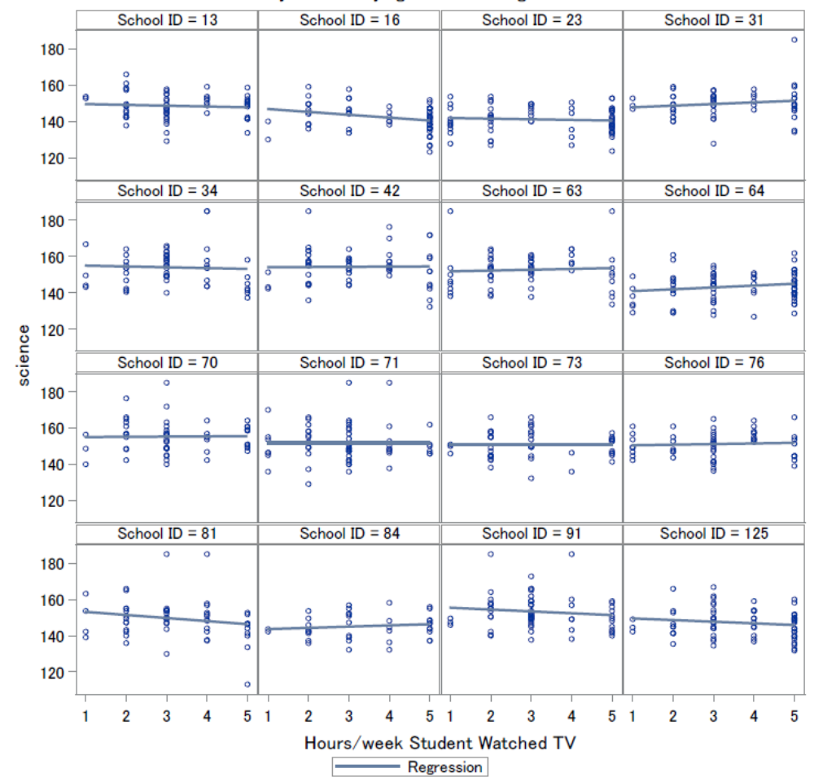

Figure 4(b)
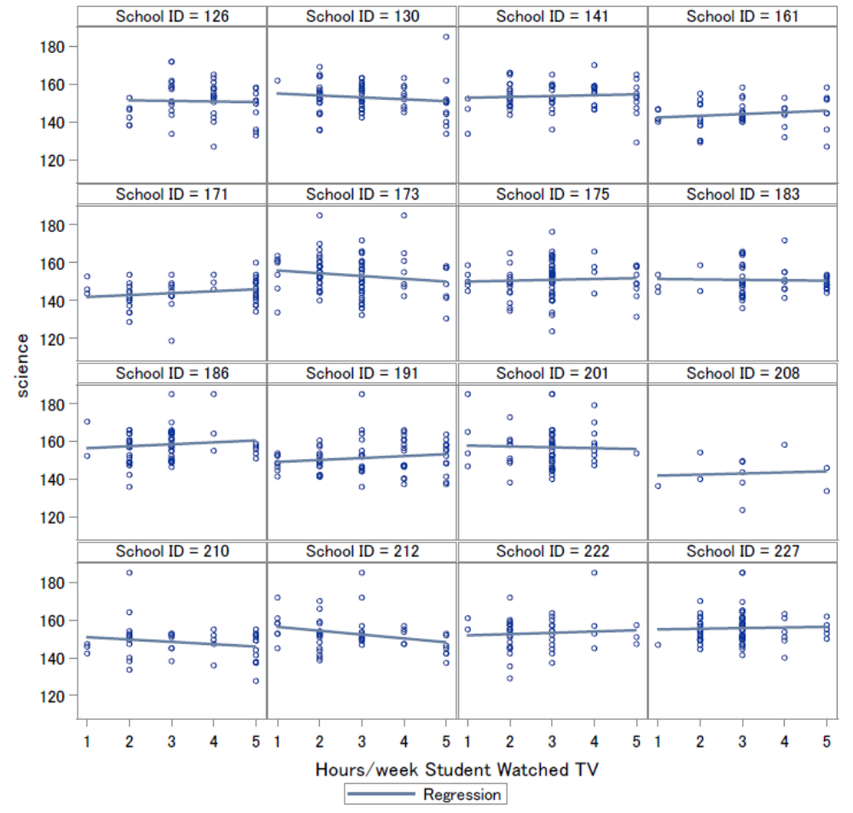
Regression lines are very flat, but can still tell that some have different slopes as well as different levels.

Figure 5(a)
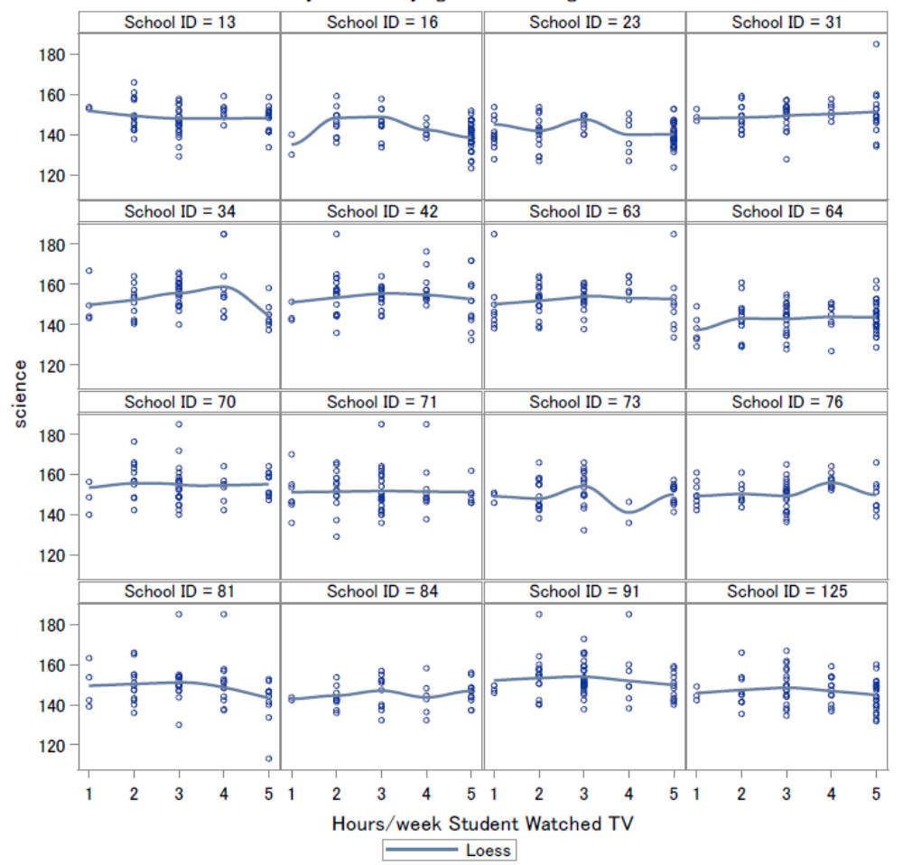

Figure 5(b)
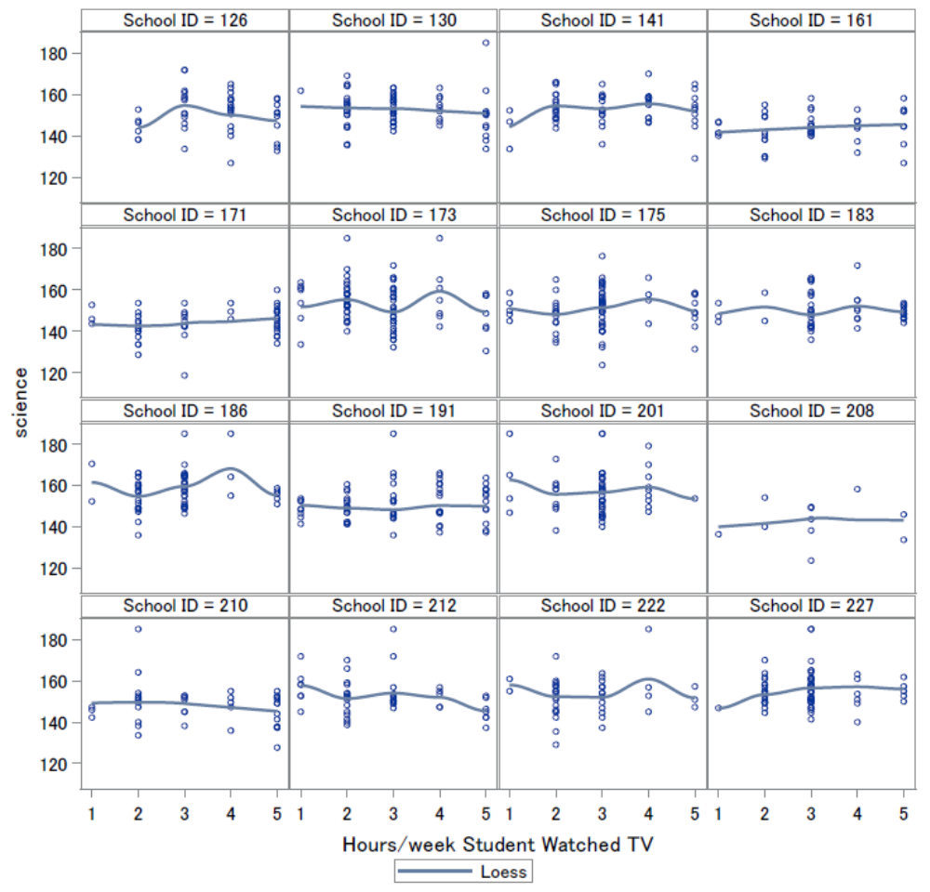
Some lines are flat, but some are not. We can still tell that they have different slopes and there are different levels.

Figure 6(a)
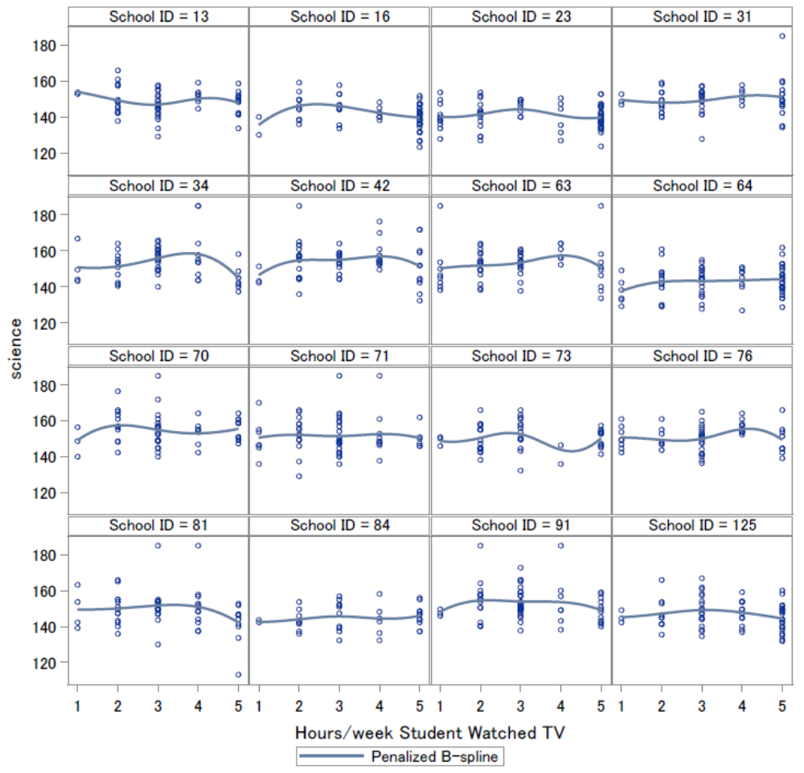

Figure 6(b)
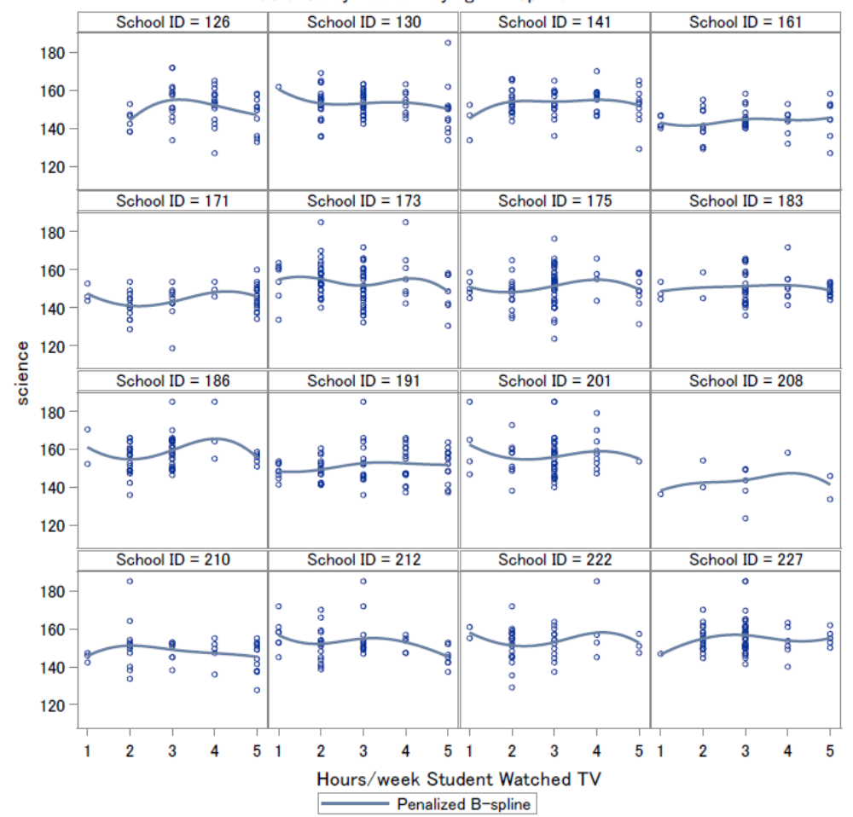
Lines are roughly flat and there are different levels. We can sort of tell that there’s a downward quadratic shape.

Figure 7
Overall mean science by hours TV. We can observe a quadratic relationship between science score and hours spent watching TV, which indicates that hours TV should be considered categorical.
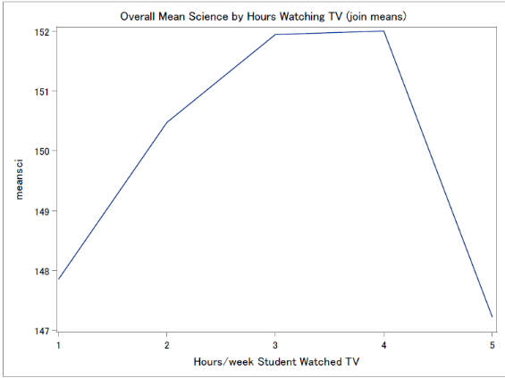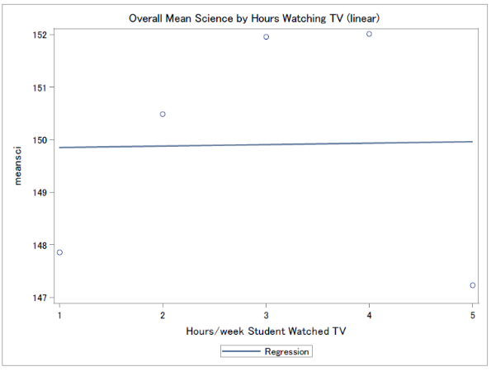

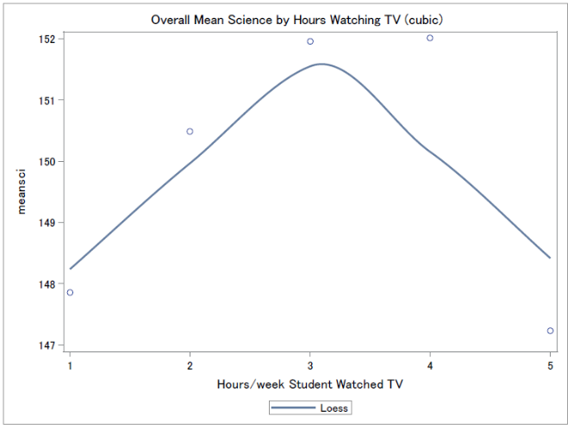

Figure 8
Mean science score by hours TV for each school (join, linear regression, and cubic). A quadratic relationship can be observed.
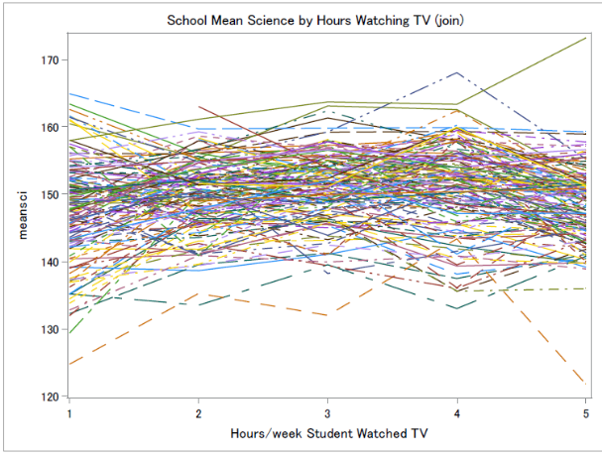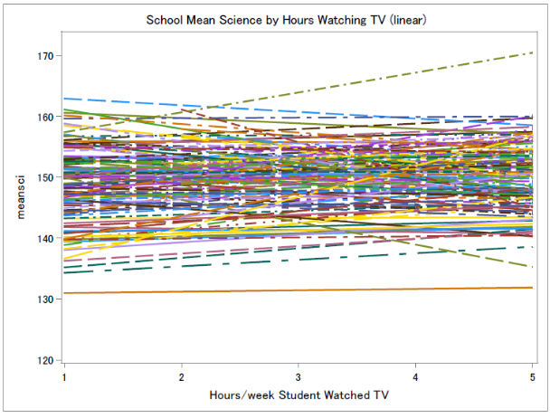

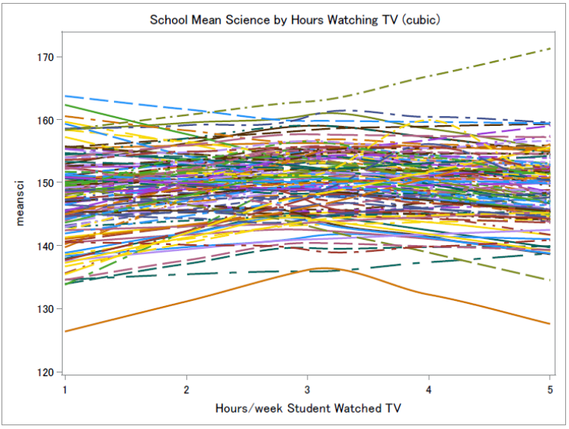

- Hours computer games by Science
Figure 9(a)

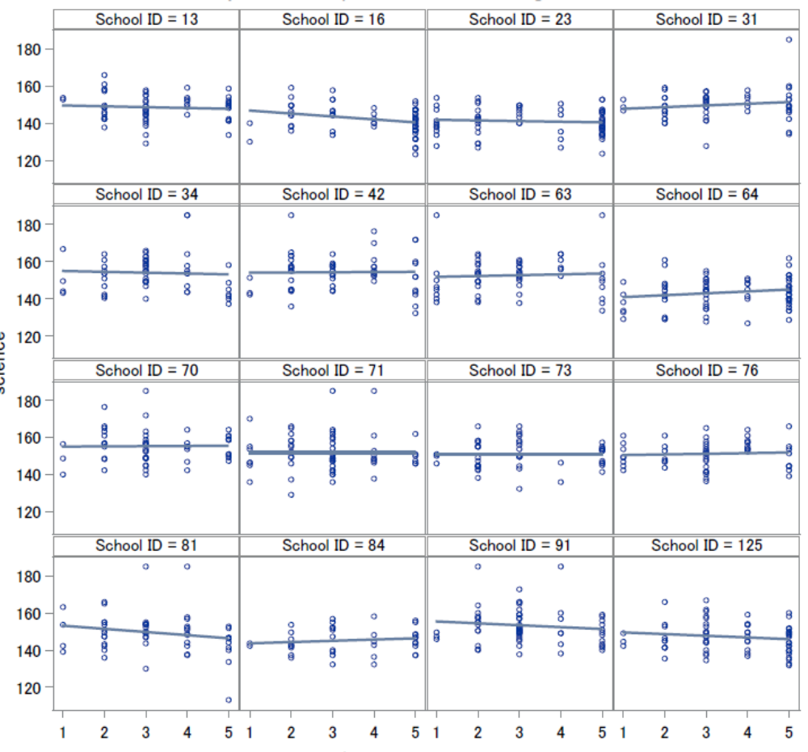

Figure 9(b)
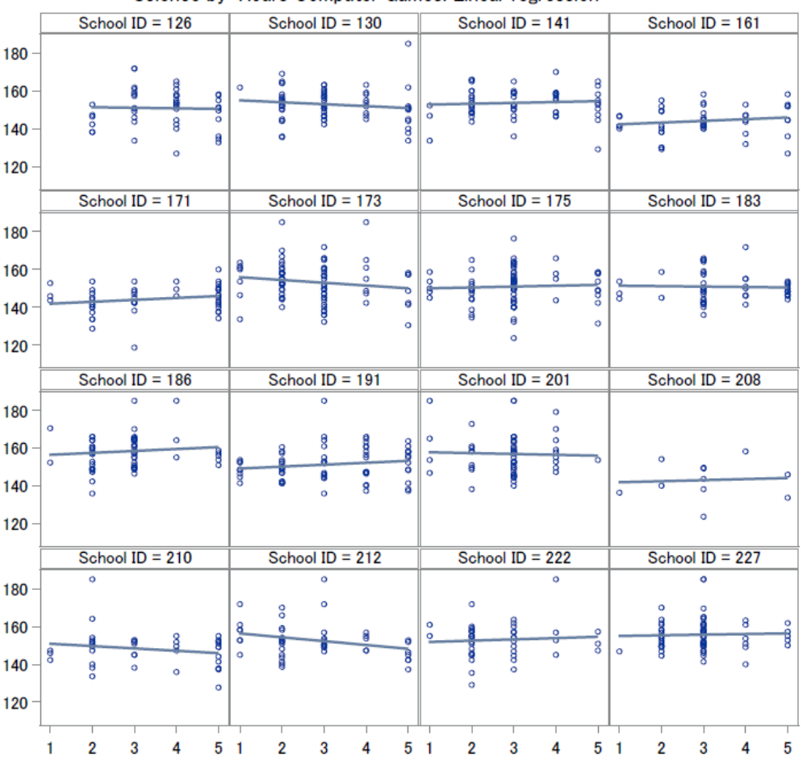
Linear regression lines are quite flat, and some have different slopes. Different levels can be observed.

Figure 10(a)
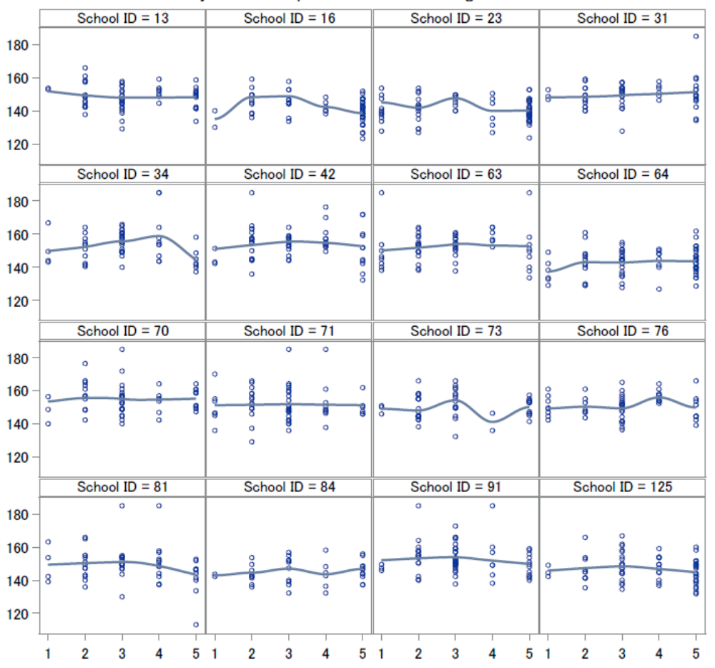

Figure 10(b)
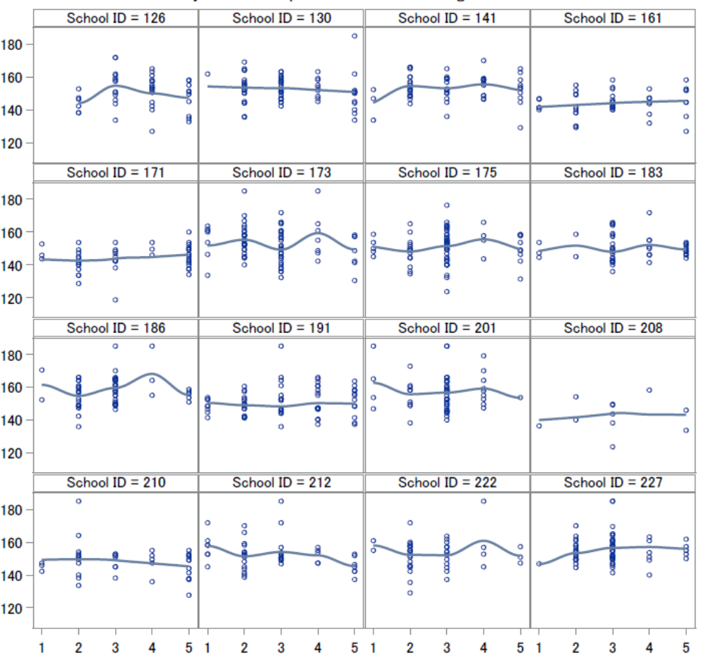
Cubic regression lines (LOESS): some are flat, but can still tell different levels.

Figure 11(a)
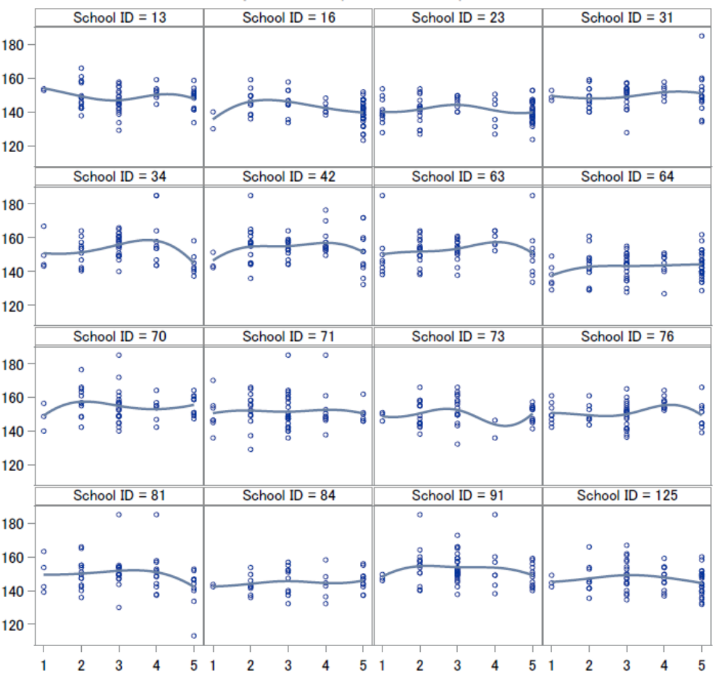

Figure 11(b)
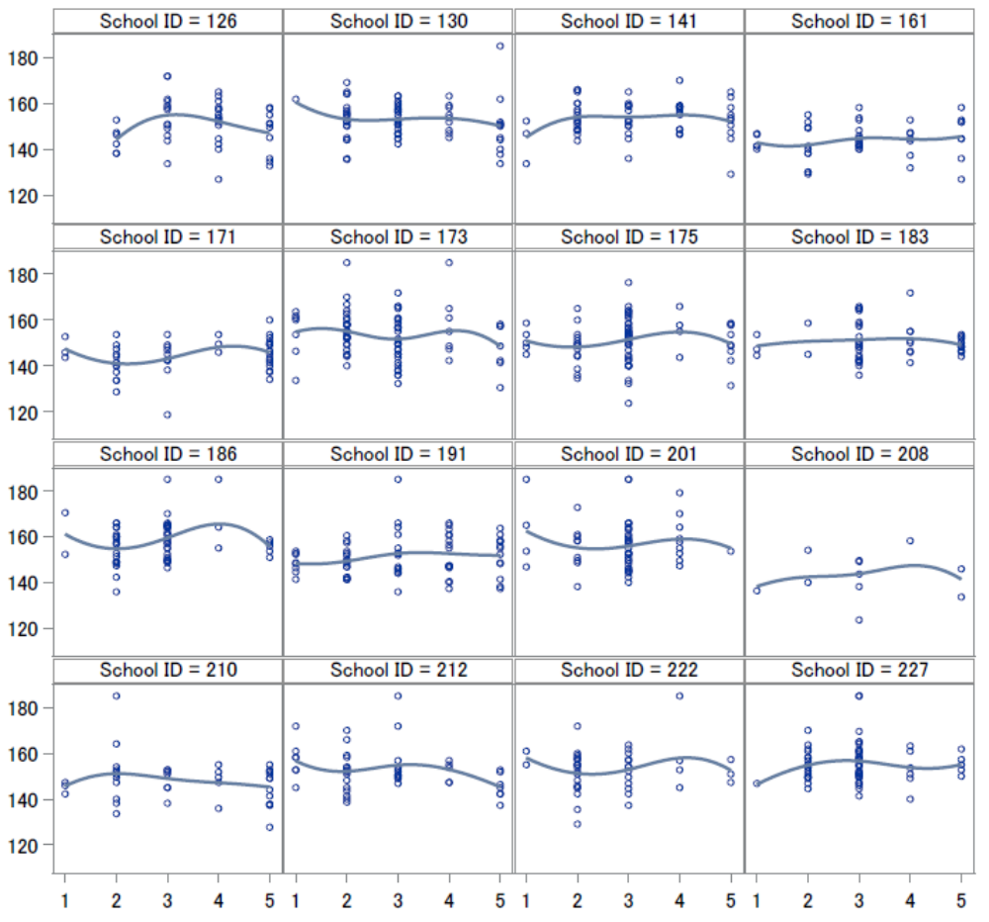
Cubic regression (penalized b-spline) lines are flat, too, but can tell different levels exist.

Figure 12
Overall mean science scores by hours computer games (join, linear, and loess). We can tell from the graphs below that when a large amount time is spent on computer games, there tends to be a big drop in science score.

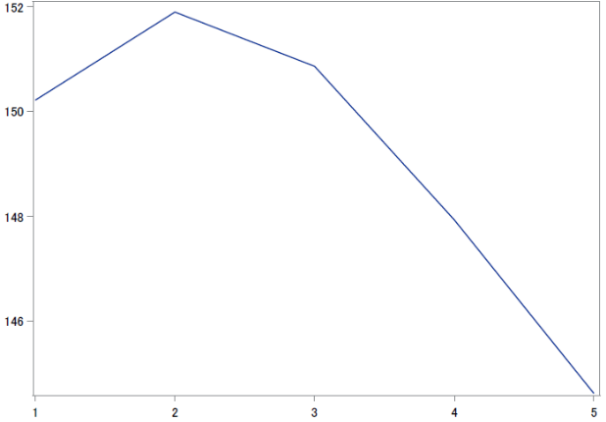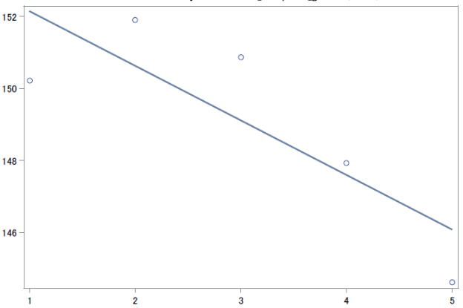
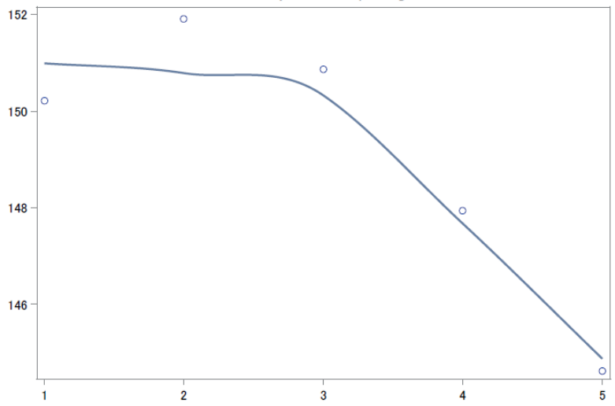

Figure 13
Mean science scores by hours computer games for each school (join, linear, and cubic). On the overall level, variability among schools is very large. Cubic regression lines are kind of flat.
