- Figures
- Math by Science
Figure 1 (a)
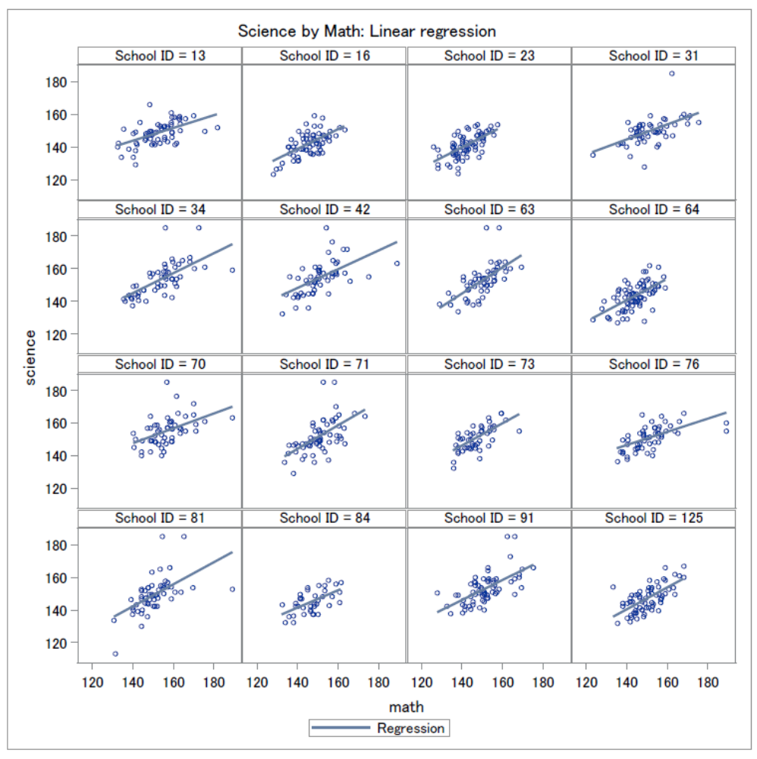

Figure 1 (b)
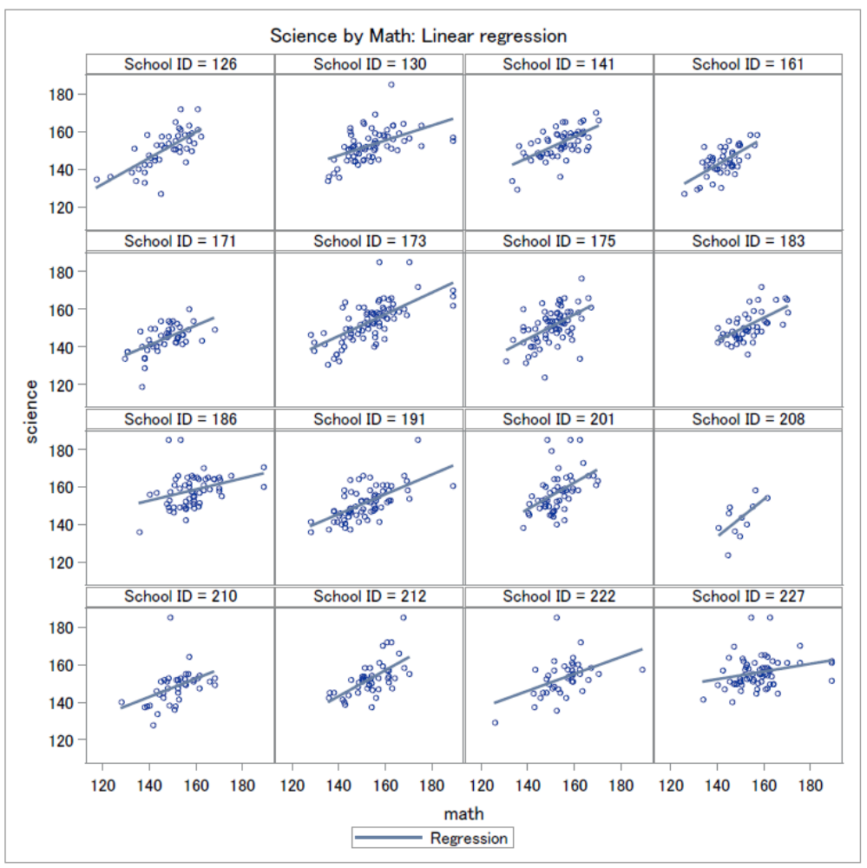
32 schools are randomly selected from the large sample, and above are the linear regression for “Science by Math’. We can tell from the panels that a positive relationship exists between the two variables, and different slopes and levels can be obesreved.

Figure 2 (a)
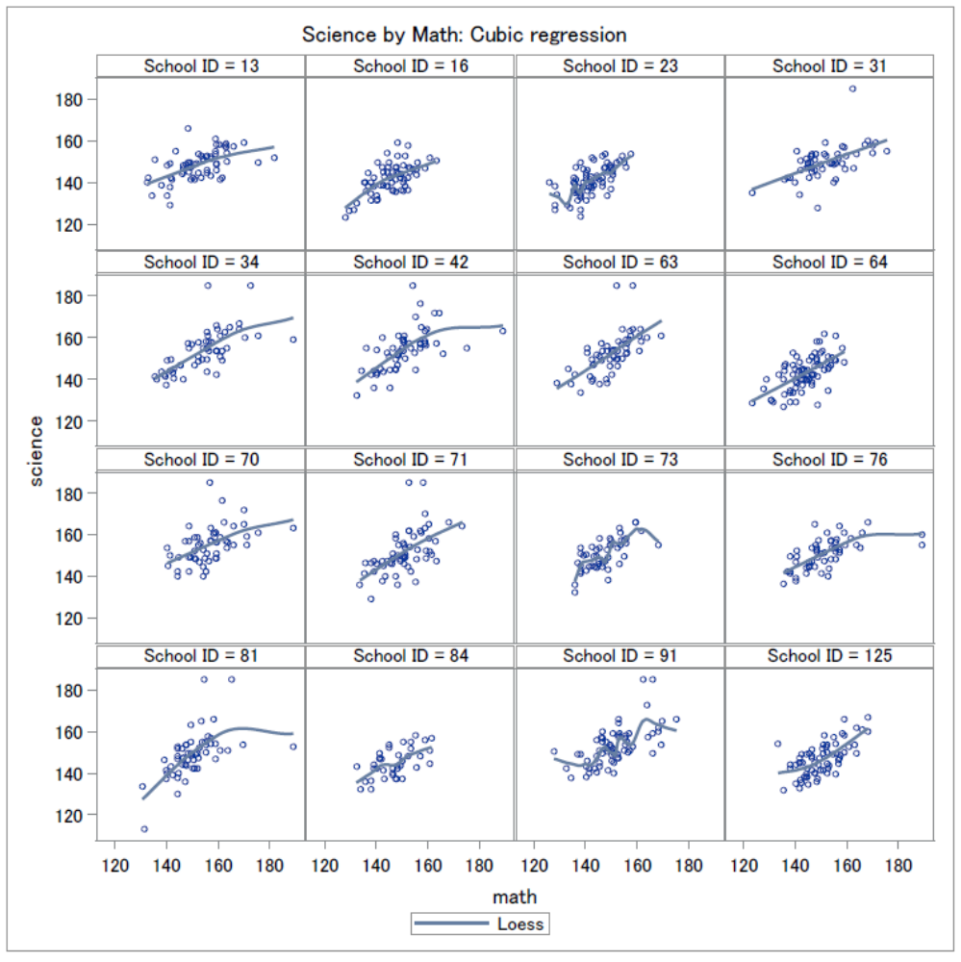

Figure 2 (b)
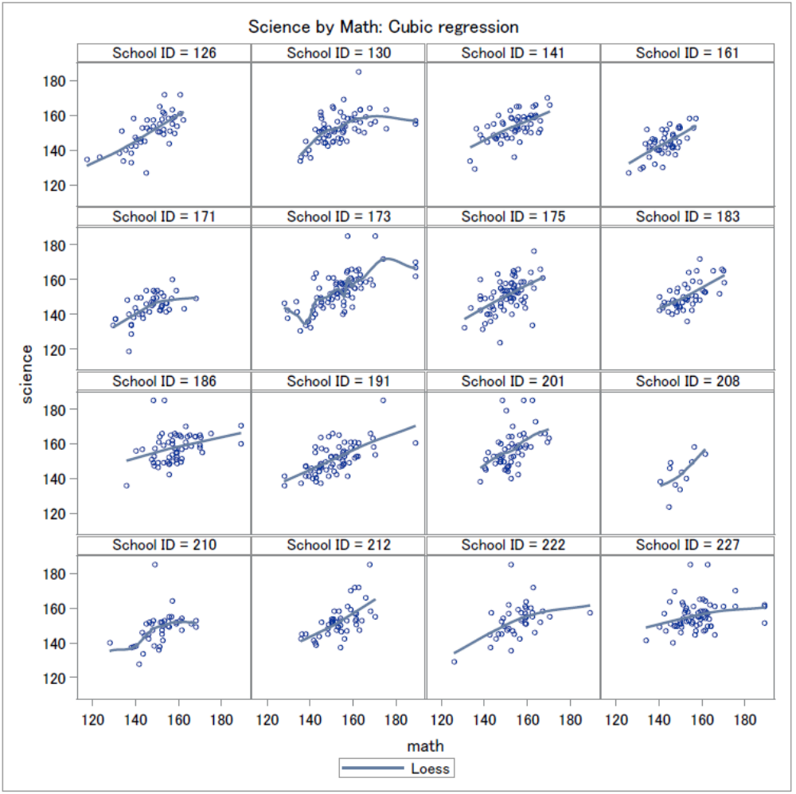
Above are cubic regressions (loess). A positive relationship can be observed, and many graphs look very linear.

Figure 3 (a)
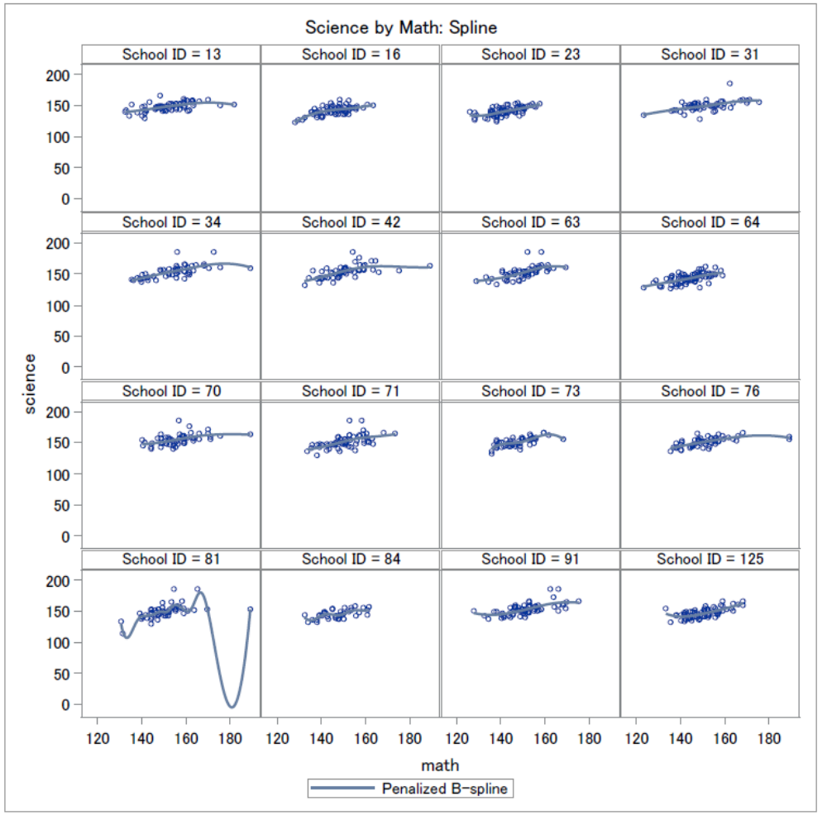

Figure 3 (b)
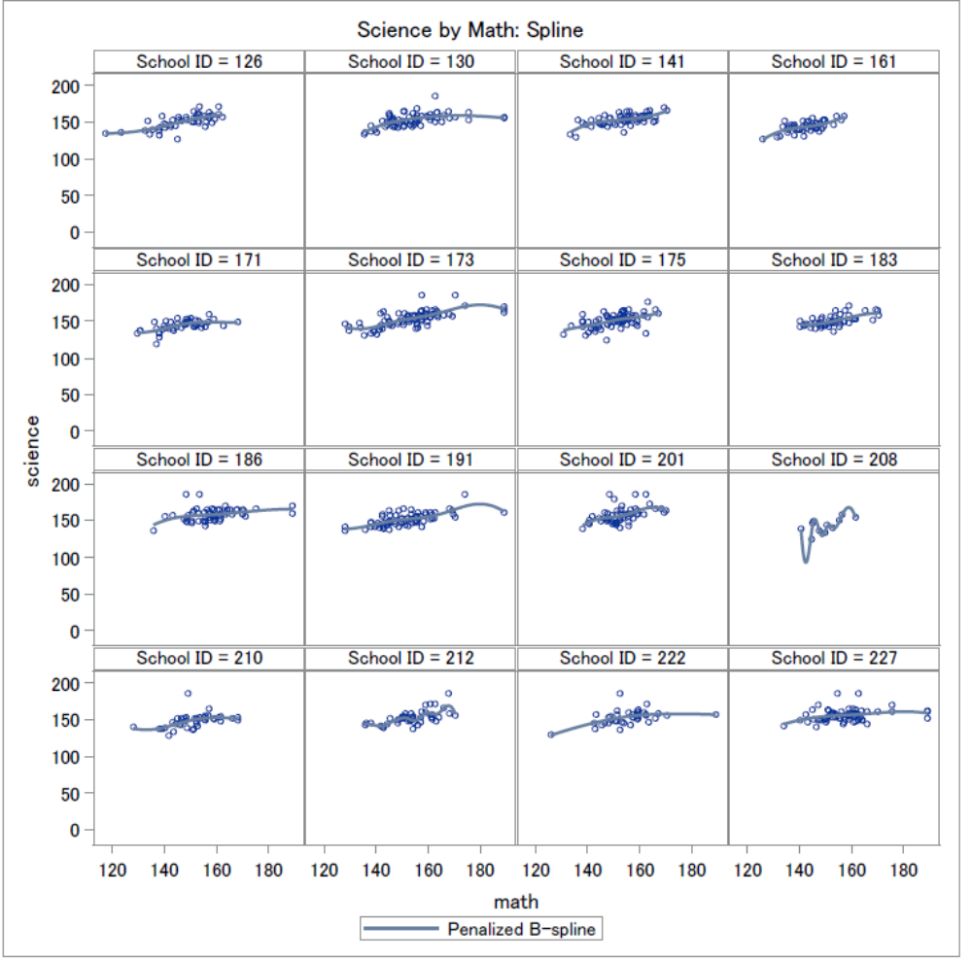
Cubic regression (penalized b-spline). Like Figure 2, we can observe a positive relationship between science and math, and many of the graphs look linear.

Summary: There’s a positive relationship between math scores and science scores. Slopes and intercepts are different among different schools.

- Hours TV by Science
Figure 4(a)
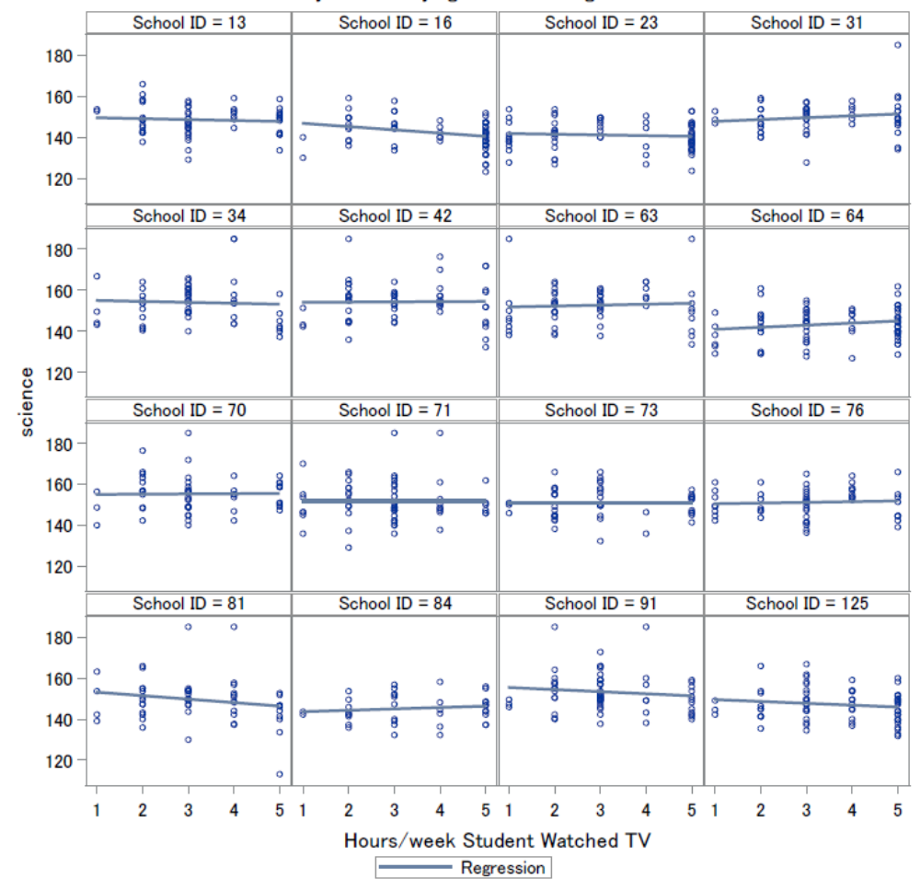

Figure 4(b)
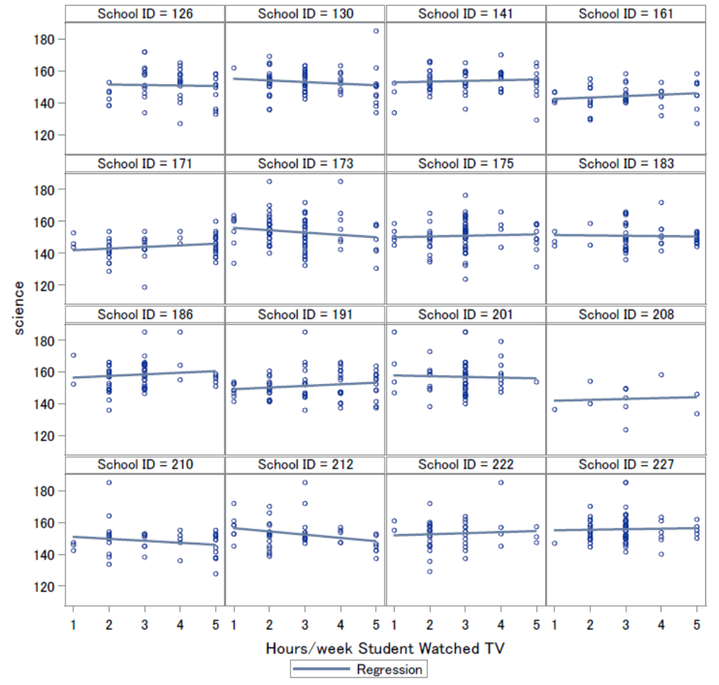
Regression lines are very flat, but can still tell that some have different slopes as well as different levels.

Figure 5(a)
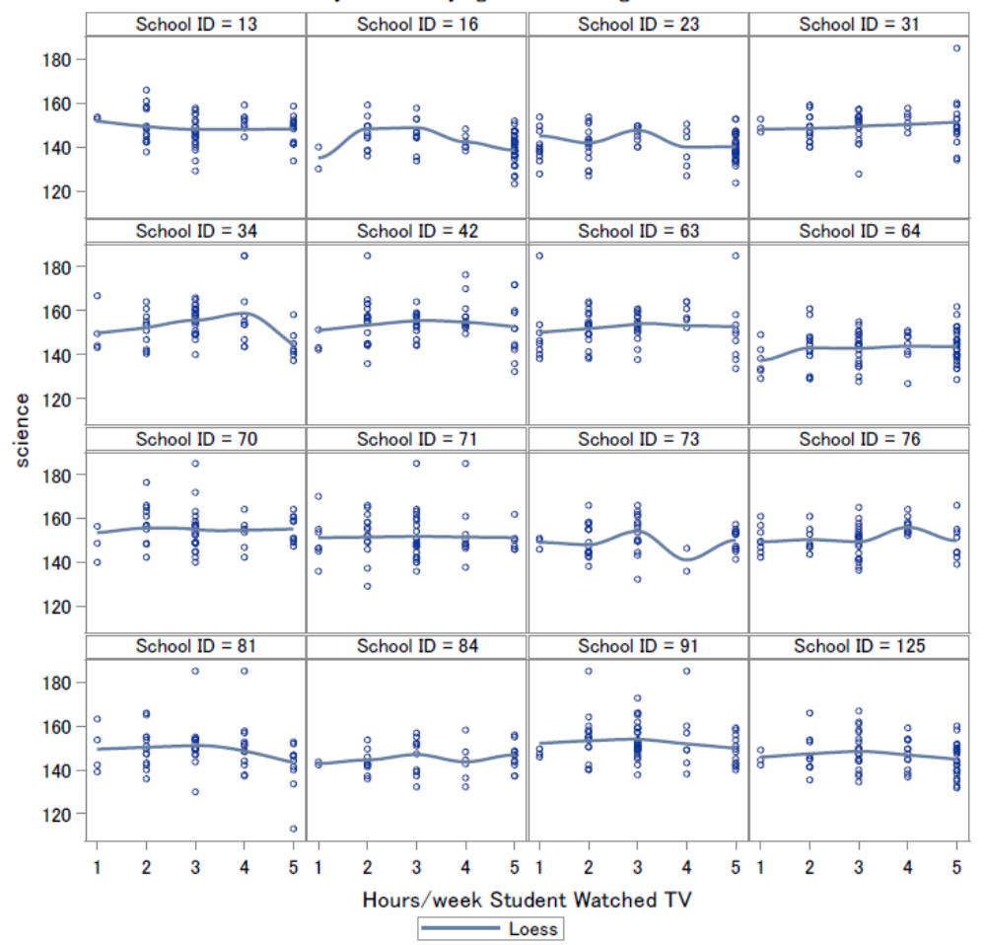

Figure 5(b)
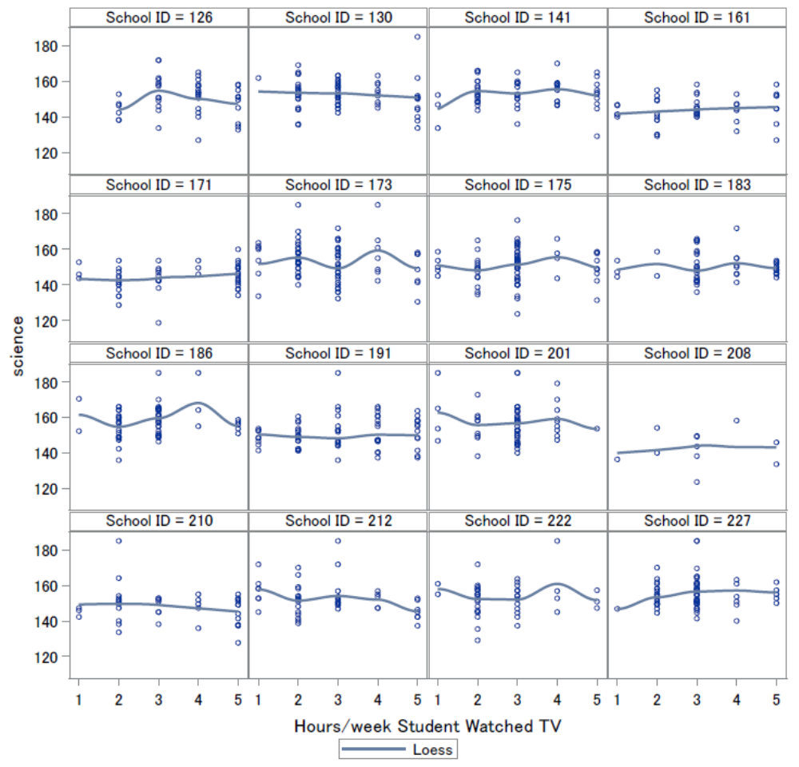
Some lines are flat, but some are not. We can still tell that they have different slopes and there are different levels.

Figure 6(a)
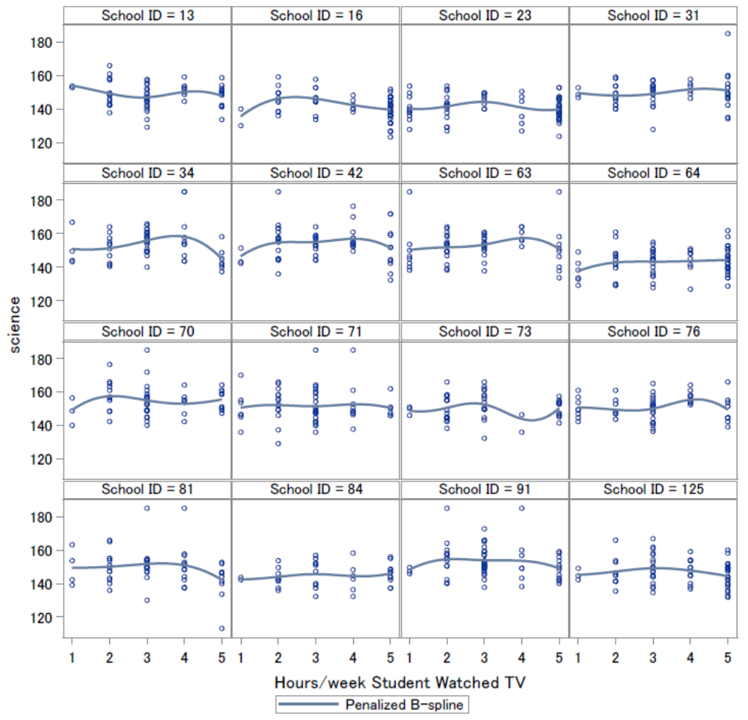

Figure 6(b)
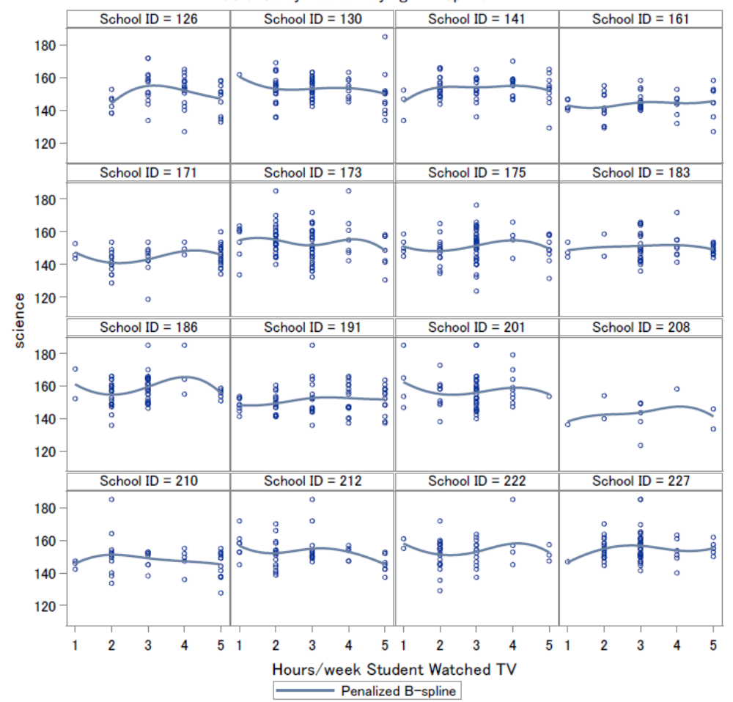
Lines are roughly flat and there are different levels. We can sort of tell that there’s a downward quadratic shape.

Figure 7
Overall mean science by hours TV. We can observe a quadratic relationship between science score and hours spent watching TV, which indicates that hours TV should be considered categorical.
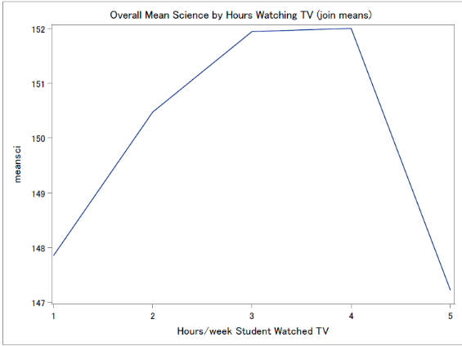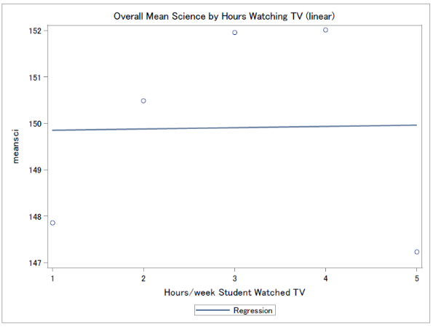

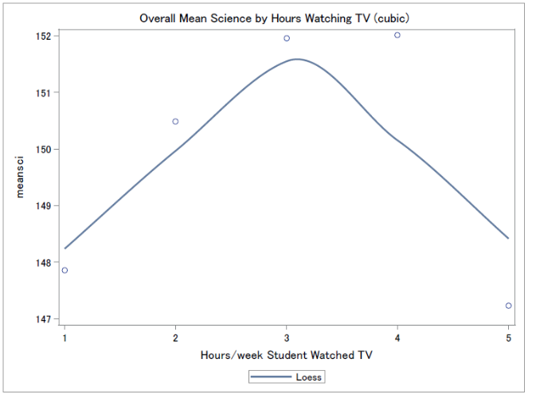

Figure 8
Mean science score by hours TV for each school (join, linear regression, and cubic). A quadratic relationship can be observed.
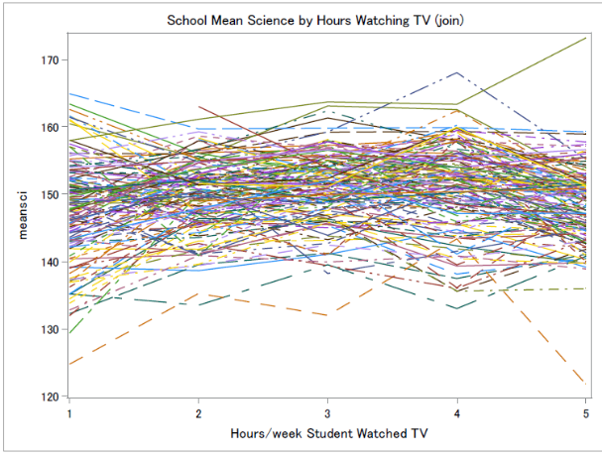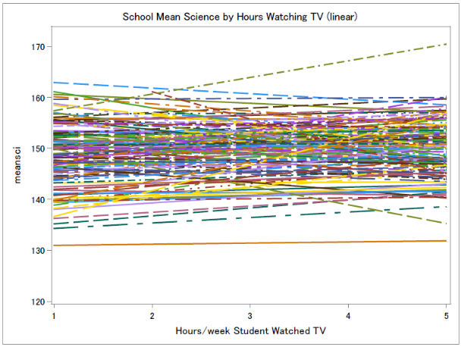

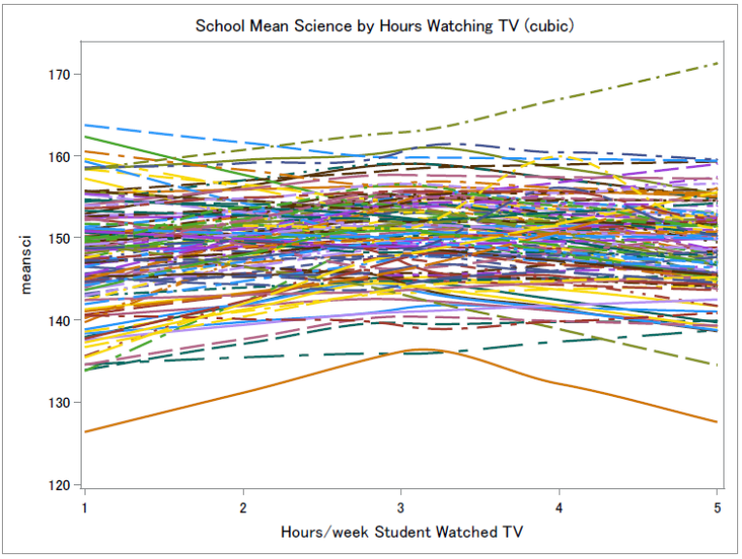
Summary: Even though the lines might look a little flat, there’s a quadratic relationship between hours TV and science scores, so hours TV should be treated as a categorical variable. There’s a difference on the overall level, too.

- Hours computer games by Science
Figure 9(a)

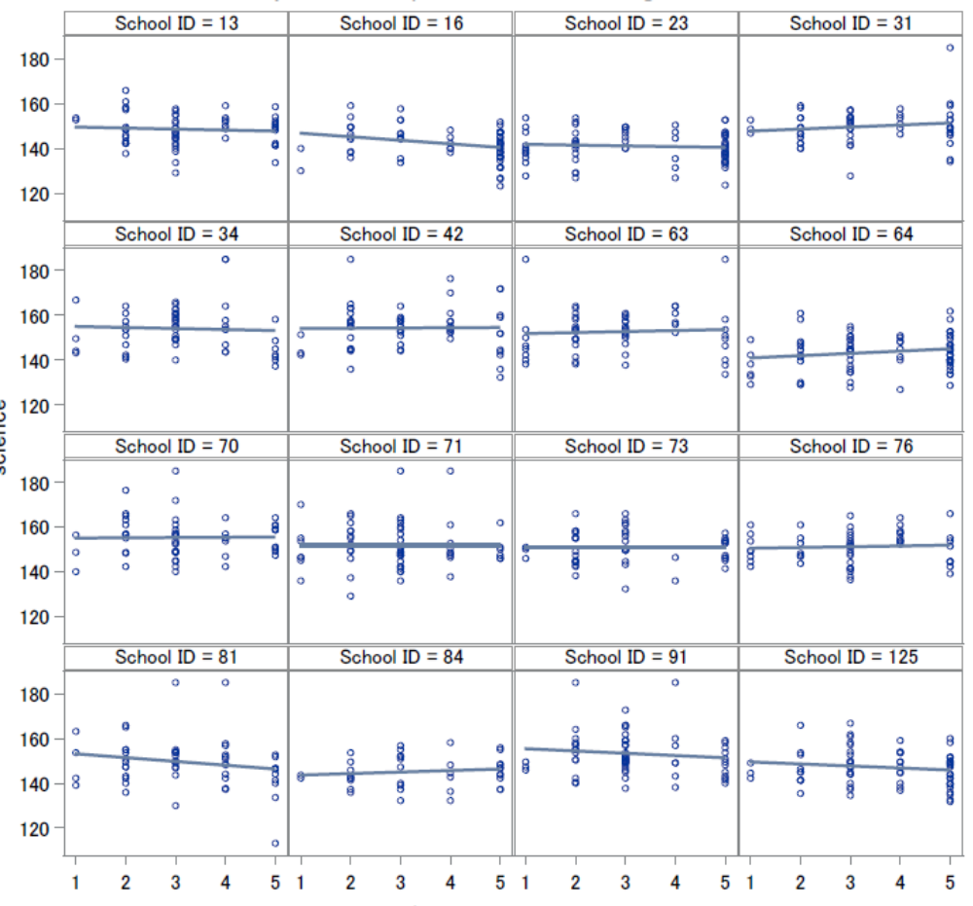

Figure 9(b)
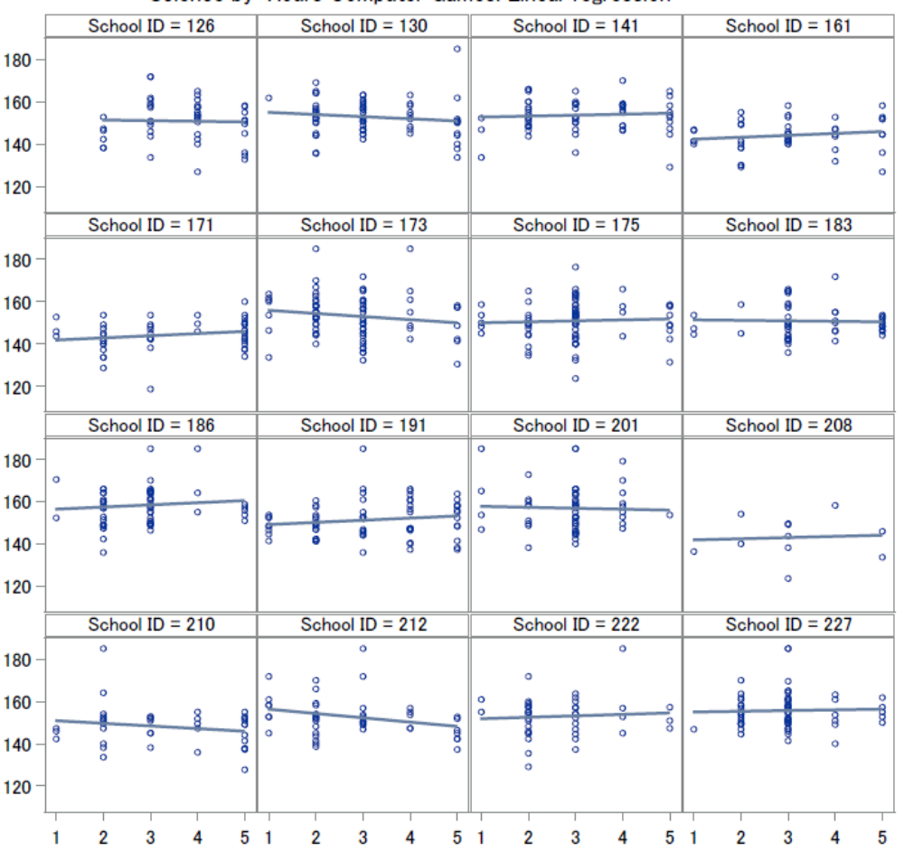
Linear regression lines are quite flat, and some have different slopes. Different levels can be observed.

Figure 10(a)
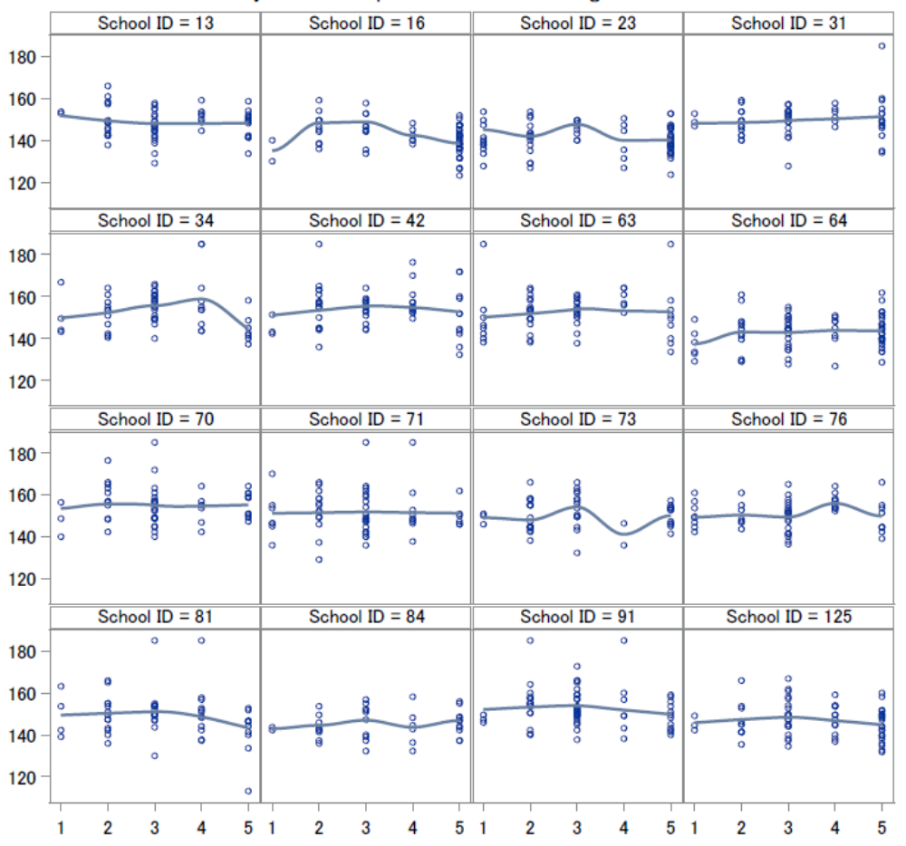

Figure 10(b)
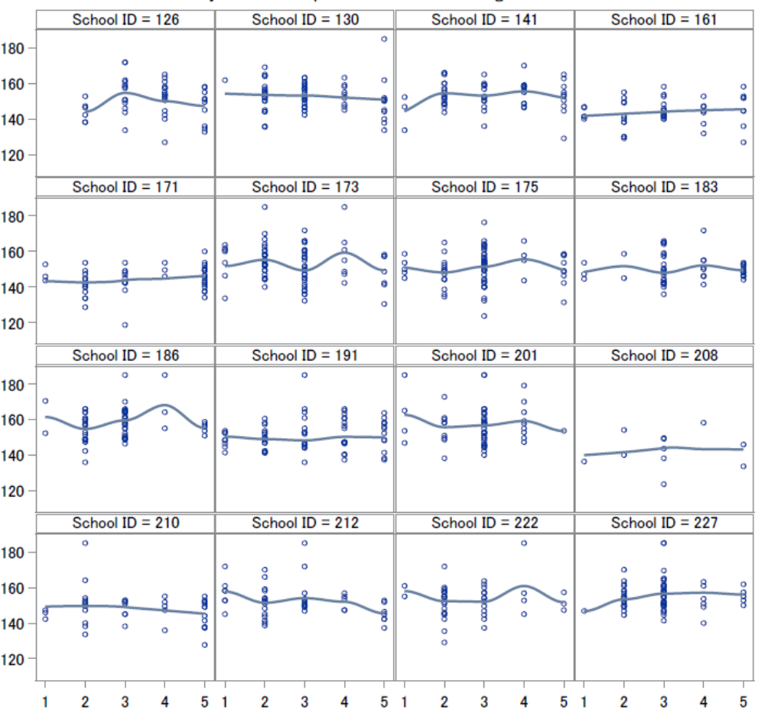
Cubic regression lines (LOESS): some are flat, but can still tell different levels.

Figure 11(a)
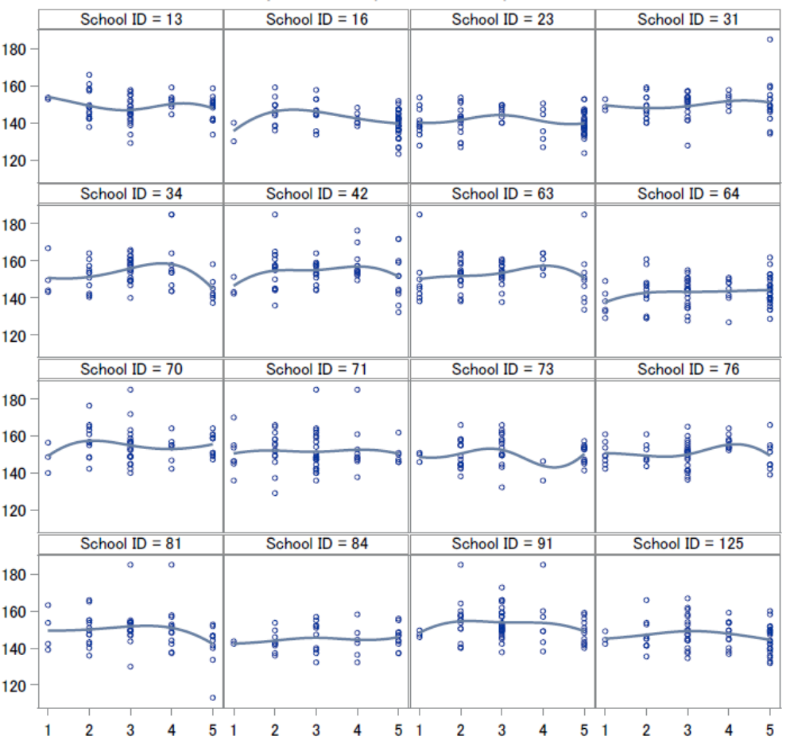

Figure 11(b)
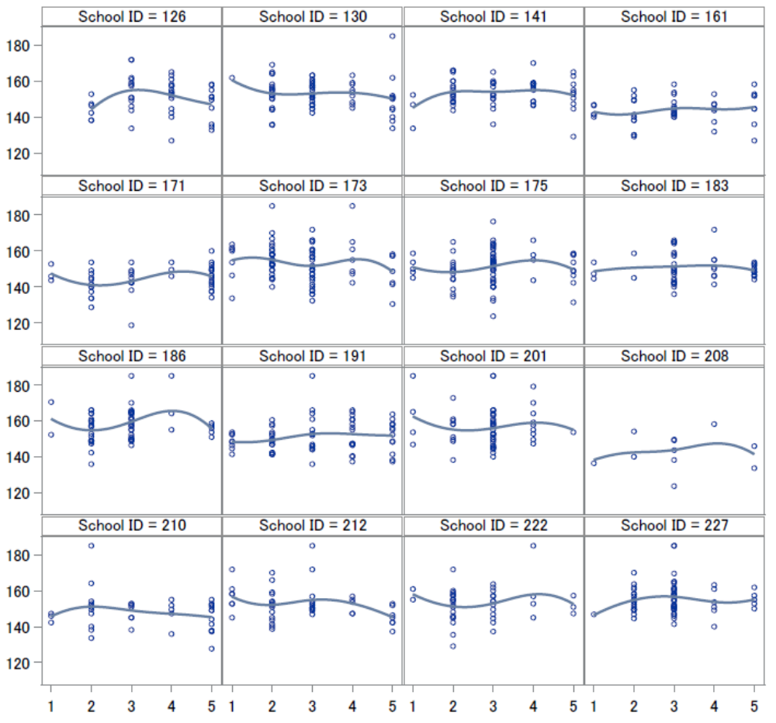
Cubic regression (penalized b-spline) lines are flat, too, but can tell different levels exist.

Figure 12
Overall mean science scores by hours computer games (join, linear, and loess). We can tell from the graphs below that when a large amount time is spent on computer games, there tends to be a big drop in science score.

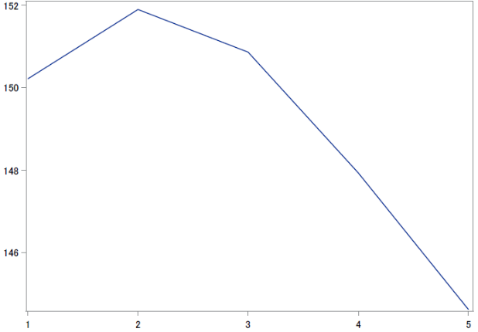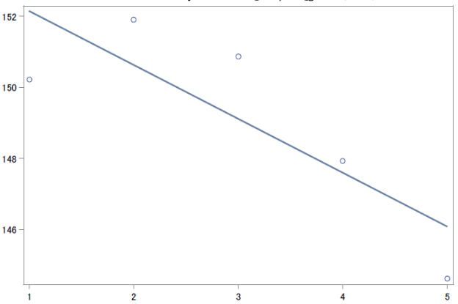
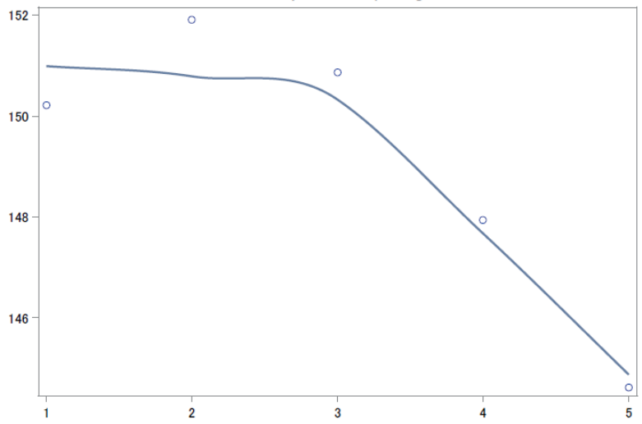

Figure 13
Mean science scores by hours computer games for each school (join, linear, and cubic). On the overall level, variability among schools is very large. Cubic regression lines are kind of flat.
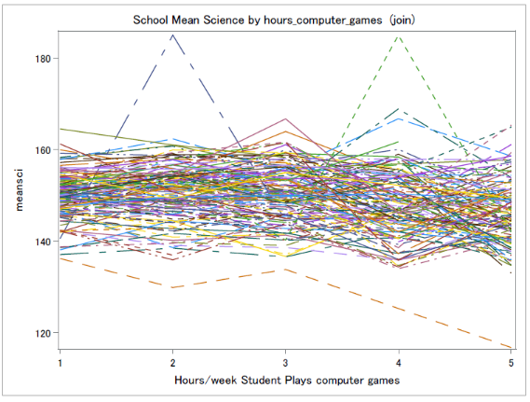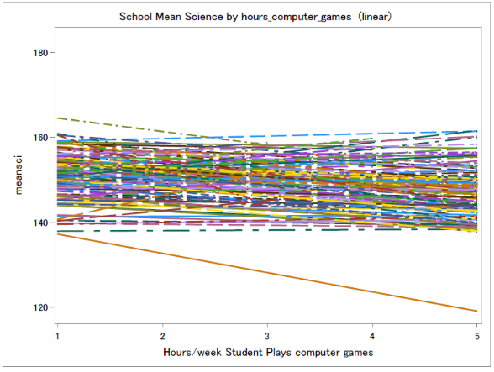
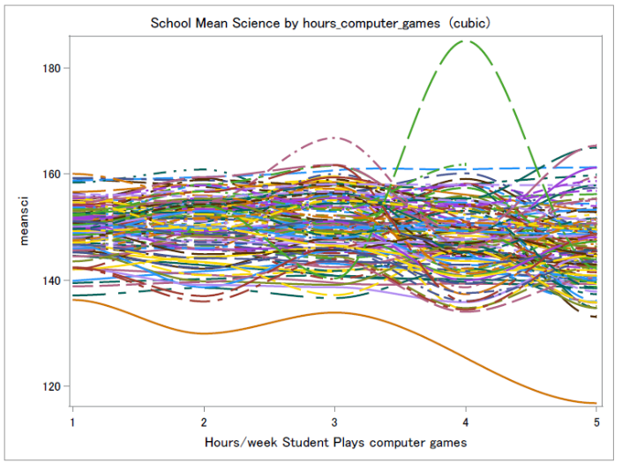
Summary: There’s a difference on the overall level, and when the level of hours computer games is pretty high, a large drop can be expected in science scores.

- Type of community
Figure 14

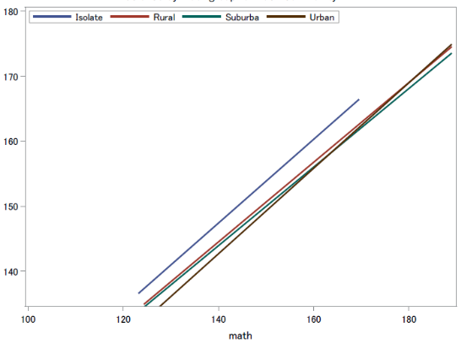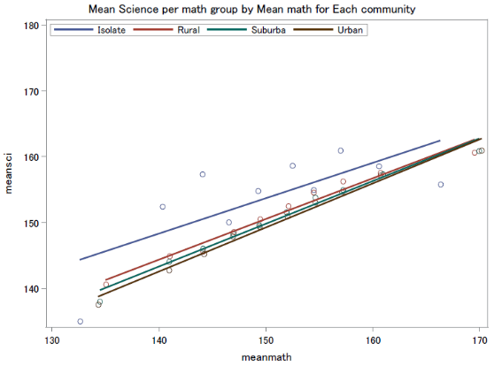

Summary:
Science by math for each type of community. We can learn from the graph that rural, suburban and urban have approximately the same math scores, while schools in isolated areas are higher than the other 3 types. Also, there doesn’t seem to be a strong interaction effect between type of community and math scores, because all 4 lines seem pretty parallel.
School mean math (the graph on the right) does not seem to have interaction with type of community either.

- Model comparison:
- When hours_TV and hours_computer_games are treated as numeric variables, r^2 (meta)=.39.
- When hours_TV and hours_computer_games are treated as categorical variables, r^2 (meta)=.47.
- The increase of the r^2 meta value indicates that it is appropriate to treat hours_TV and hours_computer_games as categorical variables rather than numerical ones.
- My preliminary HLM model would include all the main effect (hours_TV, hours_computer_games, type_community, and mean math), and I will treat hours_TV and hours_computer_games as categorical variables. The model will be a random intercept model at to start off.
- The model I get from this HW isn’t very different from the one that I got from the previous HW. I didn’t discover anything new this time.

- As the two graphs showing below, the random intercept (the upper panel) and the random slope roughly follow normal distribution, so the normality assumption is okay.
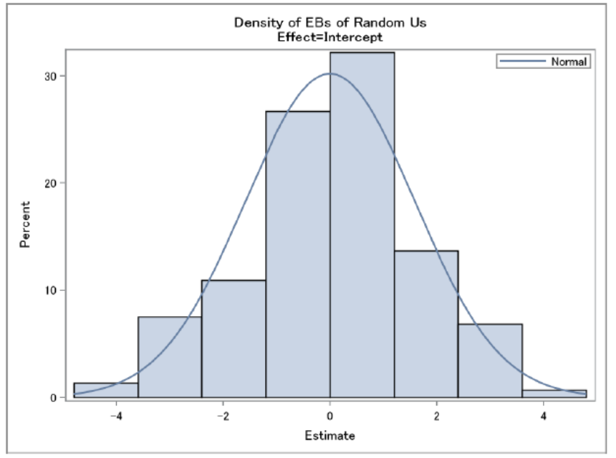

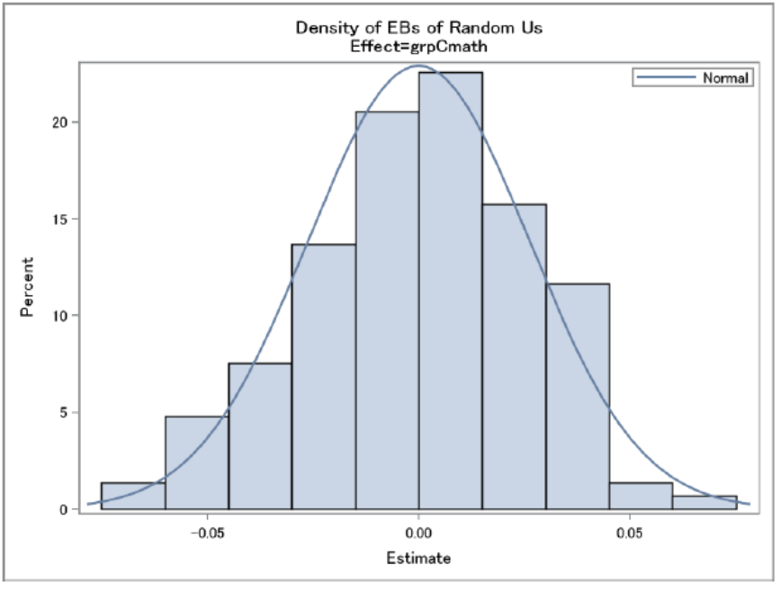

- Looking at the Pearson Residuals, we can tell there’s probably some ceiling effect (upper left graph), because of the “line” that is on the upper right of the graph. The histogram shows okay normality, but the Q-Q plot shows that the upper tail might not meet the assumption of normality. The conditional Pearson Residuals tell the same story.
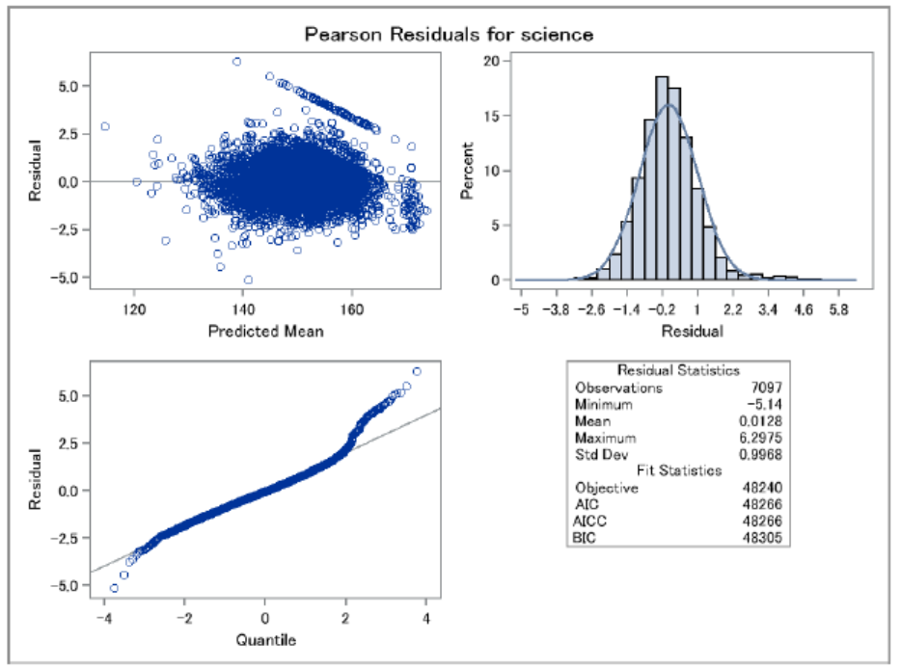
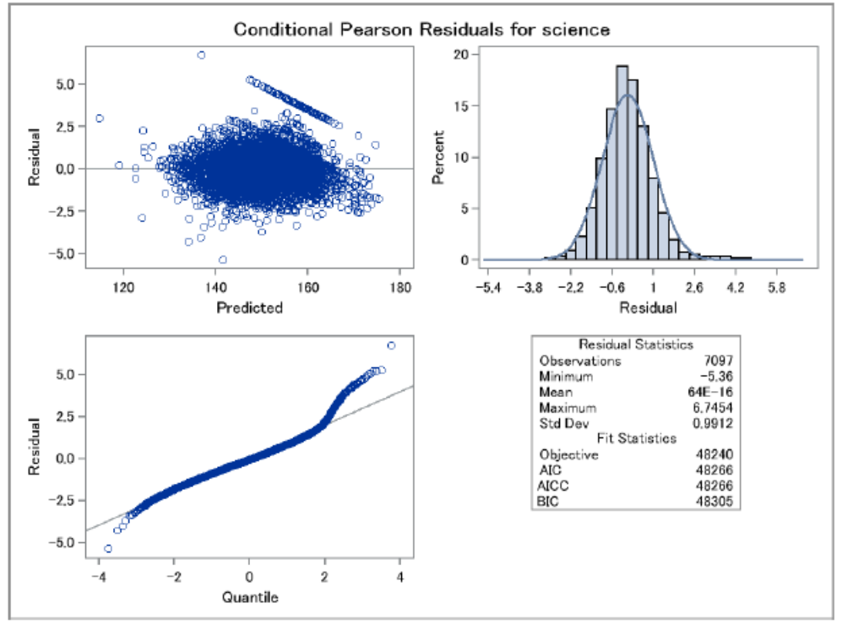

Plots of Influence Diagnostics: what are the consequences of deleting observations:
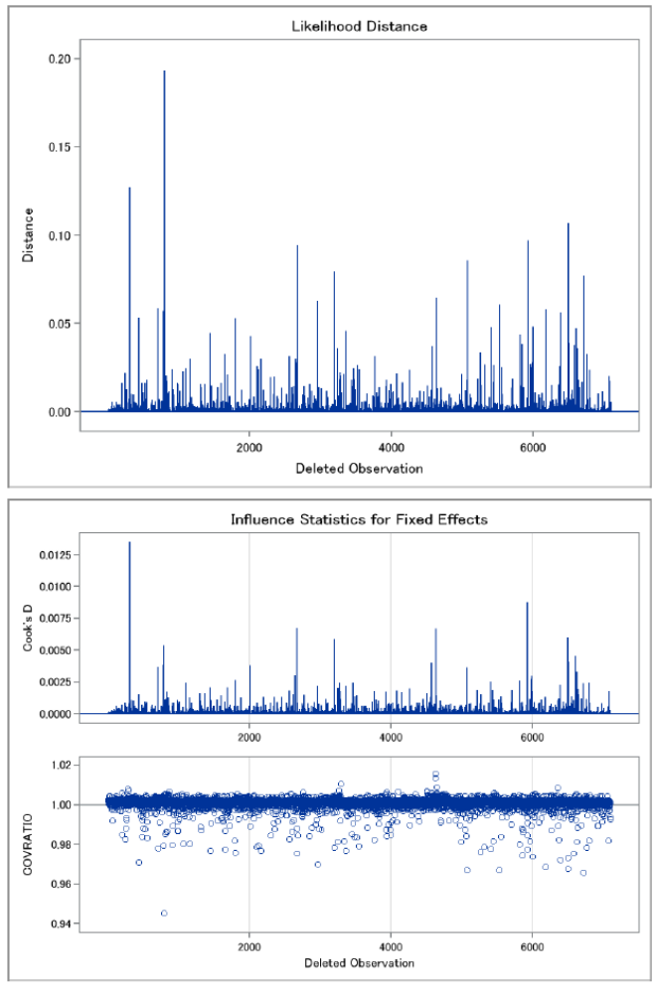

Here are the plots of Influence Diagnostics for schools (starting from top left clockwise: Cook’s D fixed effects, Cook’s D covariance parameters, CovRatio Fixed Effects, and CovRatio Covariance Parameters).
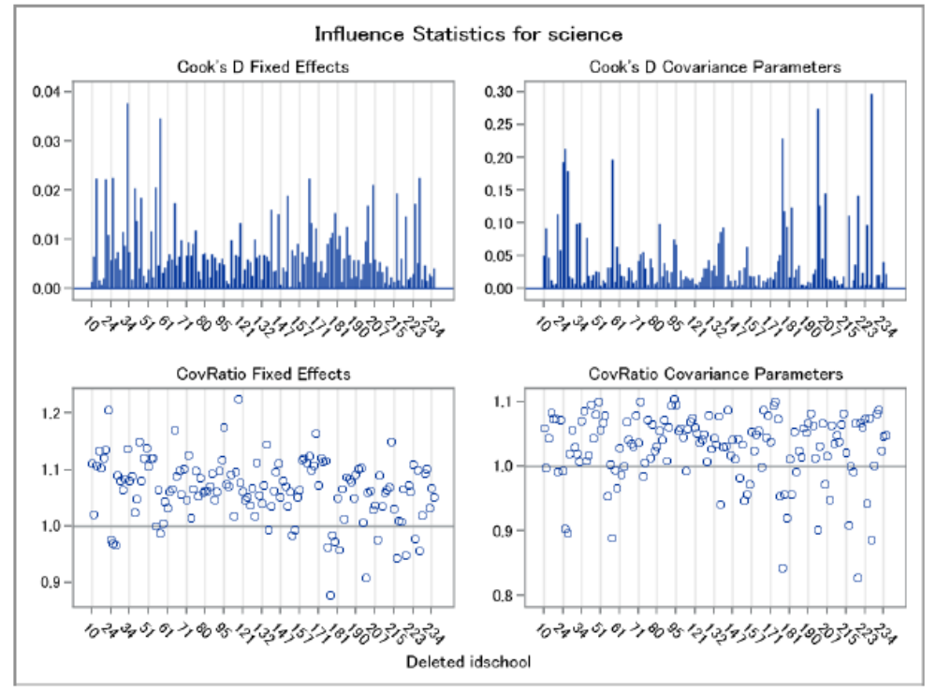

Below is the likelihood distance.
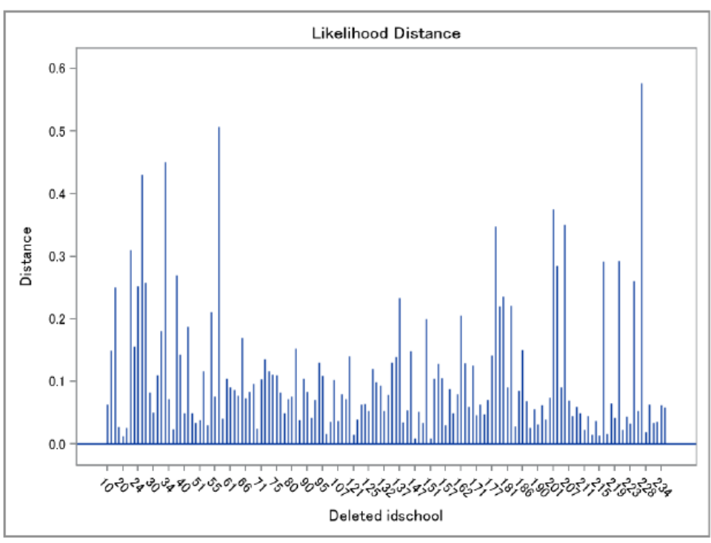
Distribution for all the schools:
