Number each pointer change in execution order, and cross out any old connection you replace.
Singly linked lists
1. Call Append(newNode), where newNode holds 37.
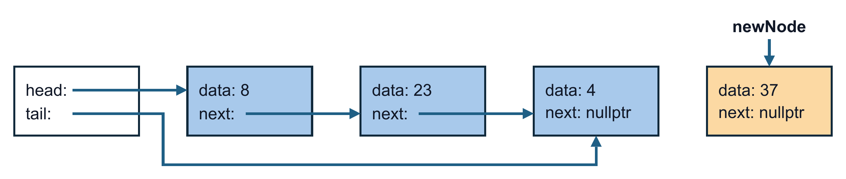
2. Call Prepend(newNode), where newNode holds 5.
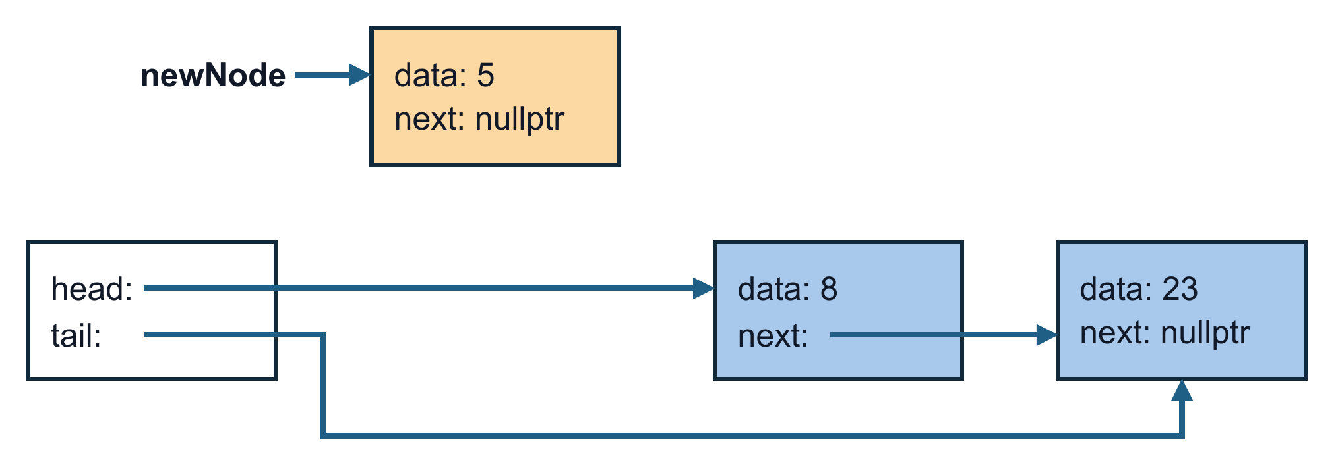
3. Call InsertAfter(currentNode, newNode), where currentNode points to 8 and newNode holds 50.
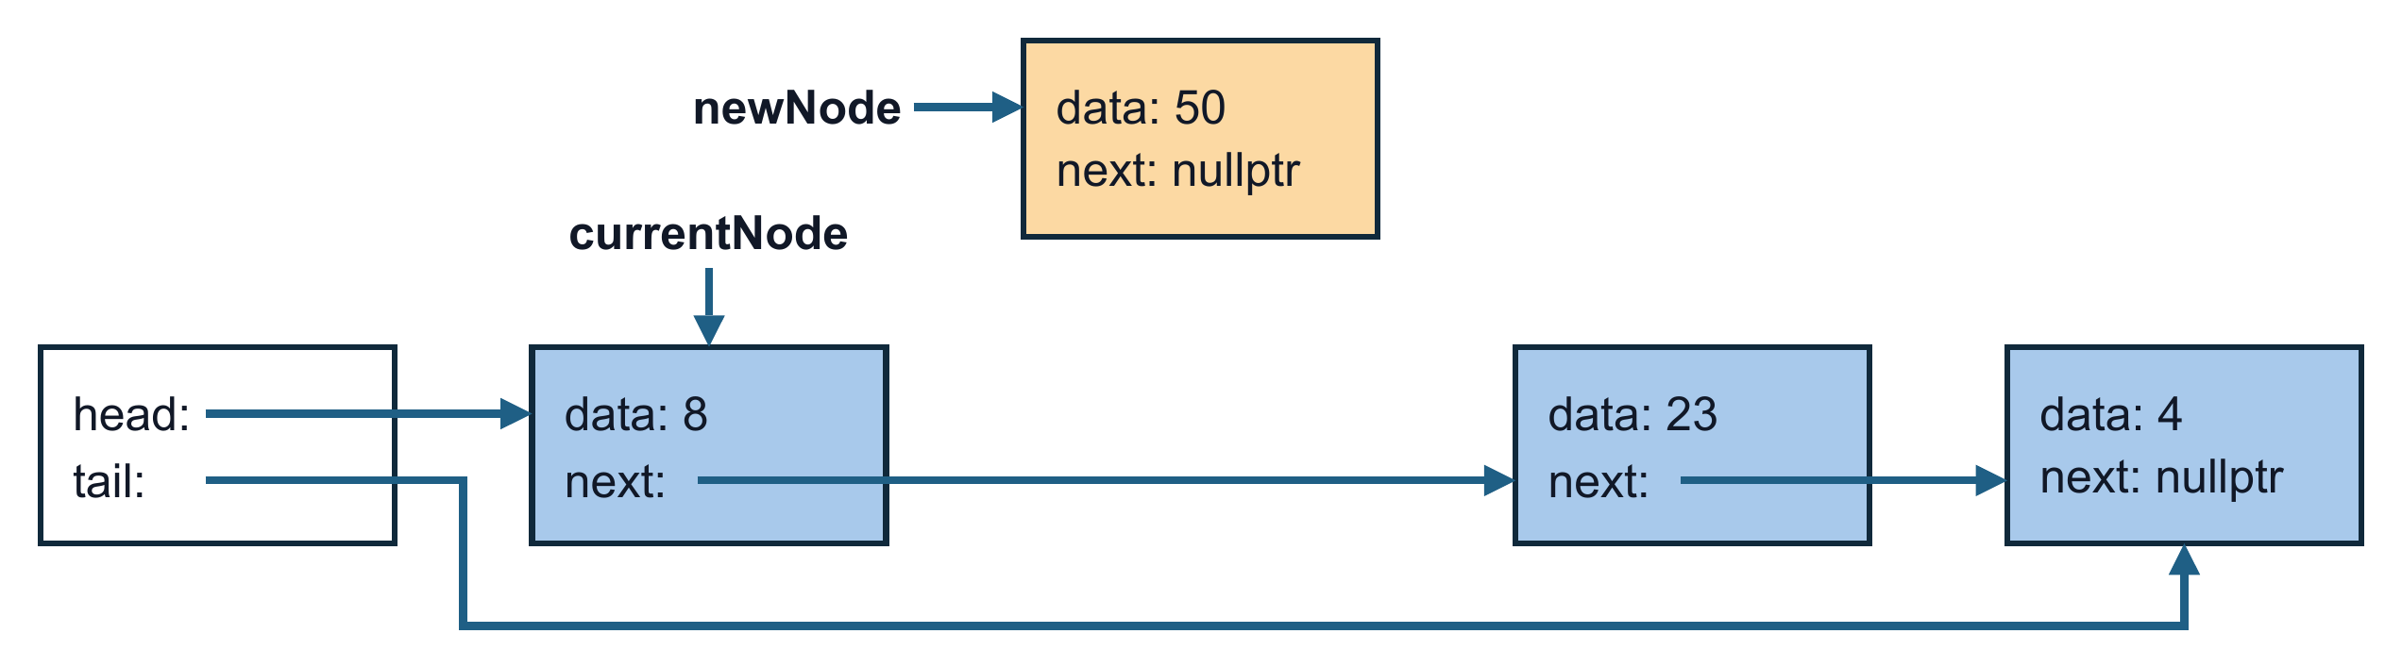
4. Call RemoveAfter(curNode), where curNode points to 8.
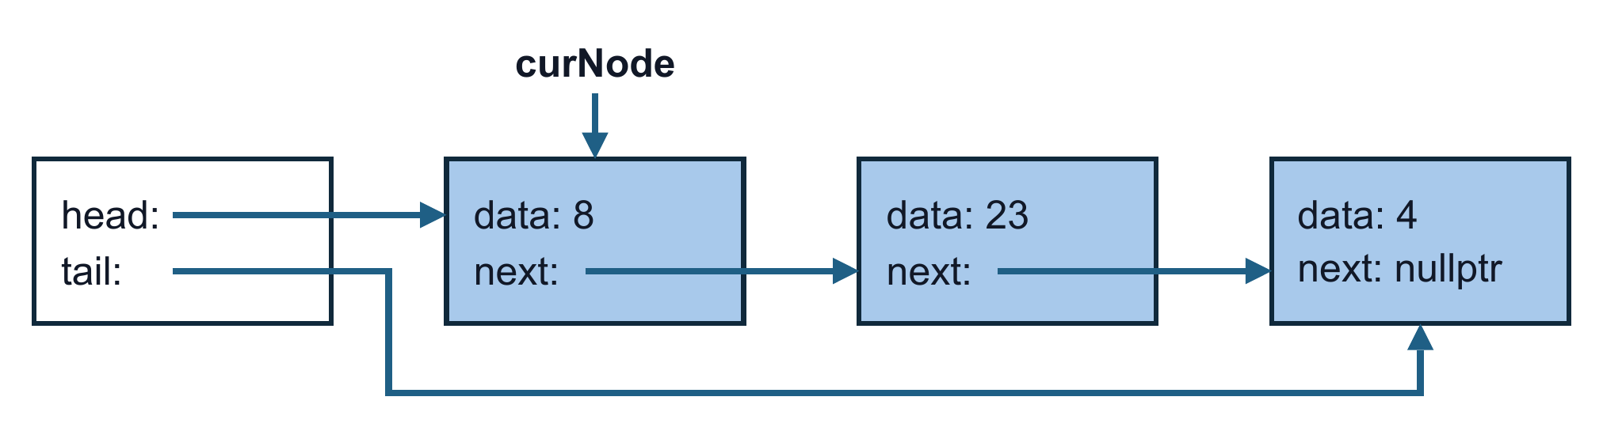
5. Call RemoveAfter(curNode), where curNode points to 23.
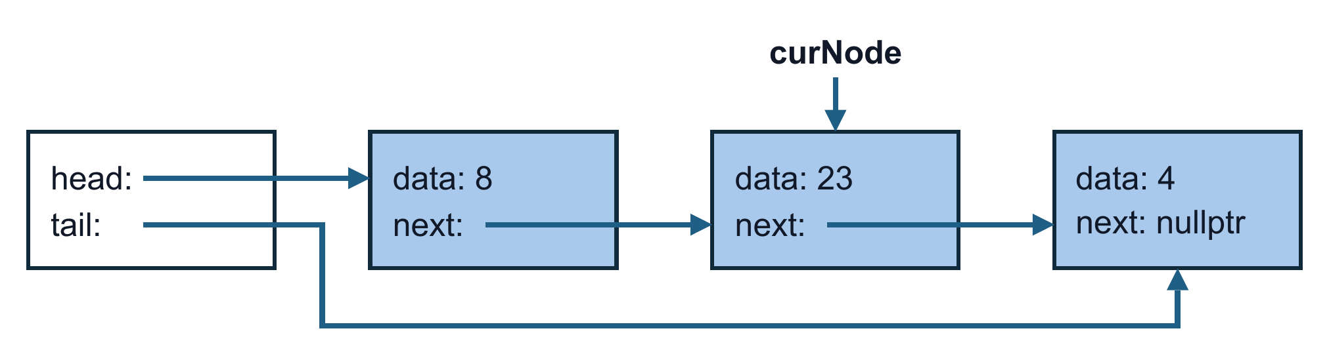
6. Call RemoveValue(23). Trace curNode and prevNode until the loop stops, then finish the call.
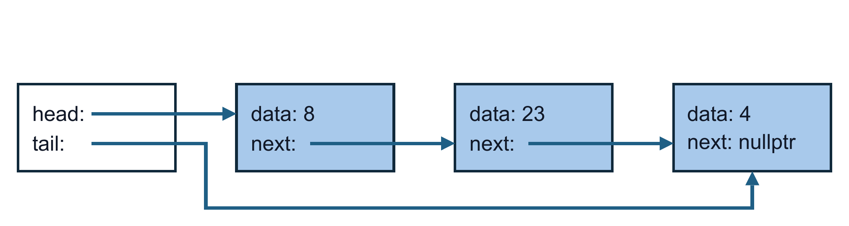
Doubly linked lists
7. Call InsertAfter(currentNode, newNode), where currentNode points to 23 and newNode holds 50. Update both next and prev pointers.
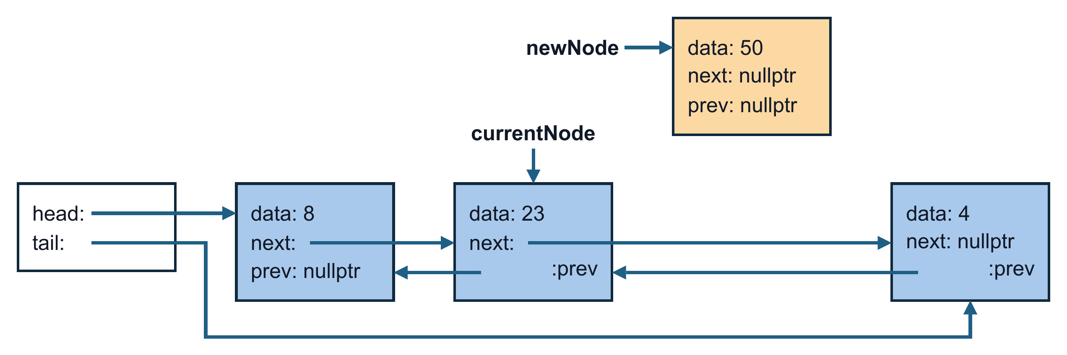
8. Call InsertAfter(currentNode, newNode), where currentNode points to 23 and newNode holds 50. Update both next and prev pointers.
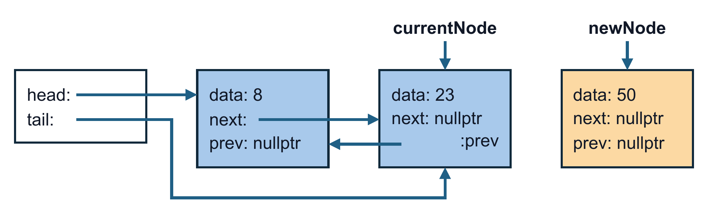
9. Call RemoveNode(target), where target points to 23.
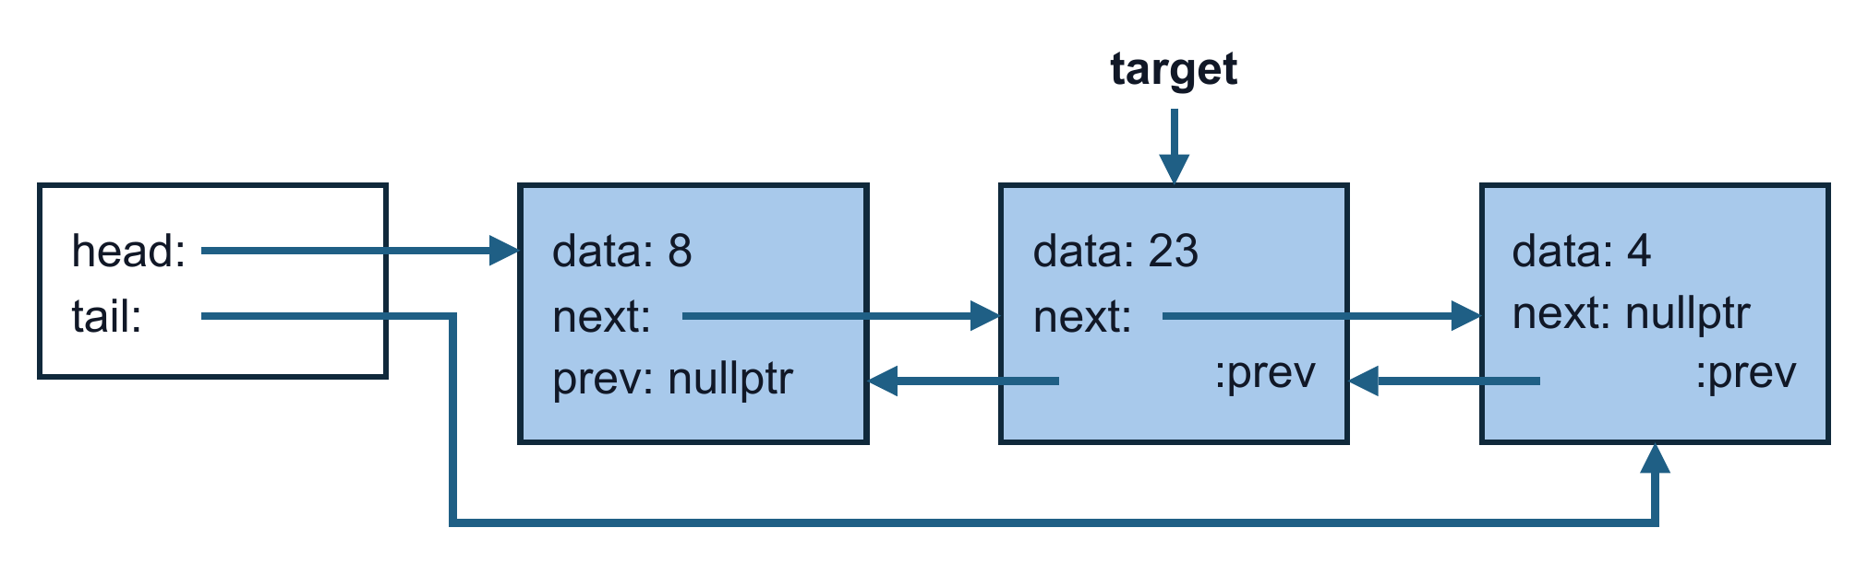
10. Call RemoveNode(target), where target points to 8.
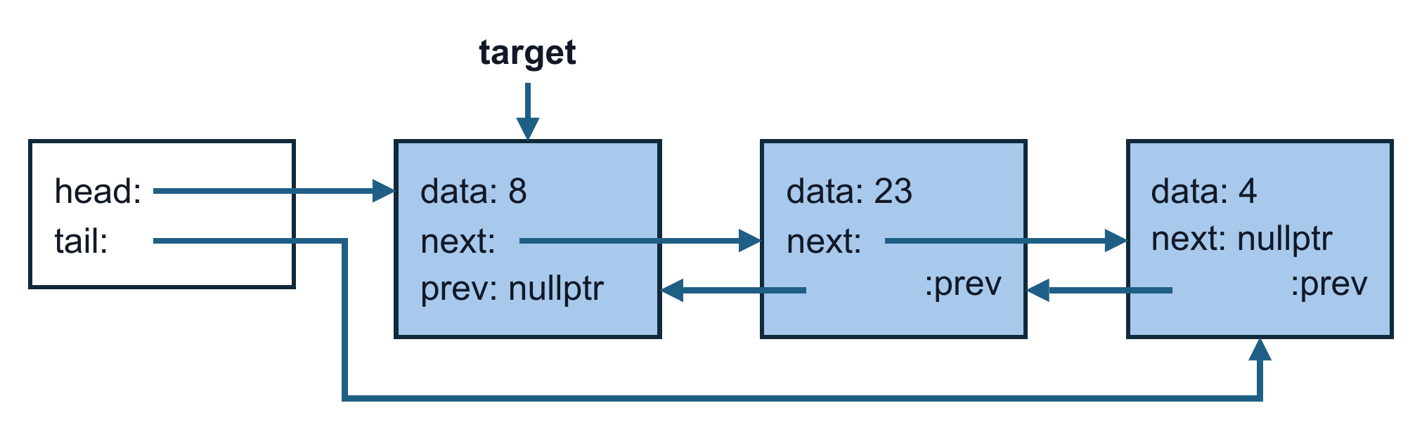
11. Call RemoveNode(target), where target points to 4.
