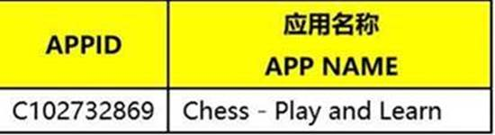

And Package name: com.chess.huawei

