代CP提问, 谢谢

I am using SENSOR_INFO_EXPOSURE_TIME_RANGE to calculate the range of supported exposure time：

https://developer.android.com/reference/android/hardware/camera2/CameraCharacteristics.html#SENSOR_INFO_EXPOSURE_TIME_RANGE

I tested this in Huawei P30 Pro and it seems like this API is giving wrong values (10000 - 1000000000).

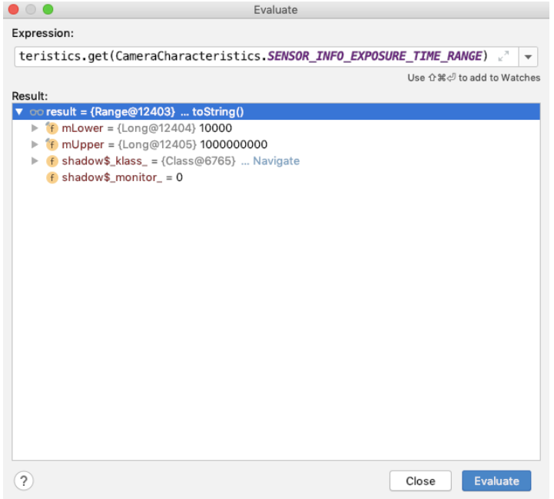

But when I use the built in camera app's pro mode, there I can set exposure value to 30s which is really larger than what is provided by the API.

How to get correct values for the range of supported exposure durations?