Lab 2 Report

1 Are there any differences when calling the APIs of different models? If yes, what are the differences?

1.1 Differences in access configuration
In this experiment, we built a unified visual chat interface with Gradio and connected two large language models from different companies: Qwen and DeepSeek. Although both of them use an OpenAI-compatible calling style, there are still clear differences in actual development, especially in access configuration. In the code, we used a PROVIDERS dictionary to define separate API key environment variables, default base URLs, default model names, and available model options for each provider.

1.2 Differences in authentication and model selection
Before making an API call, each model must complete authentication by reading its own API key. In my program, the function get_client_and_model() automatically reads the correct API key and base URL according to the provider selected by the user, and then creates the corresponding client object. If the required API key is missing, the program raises an error and reminds the user to configure the corresponding environment variable. This means that even though the user only changes a dropdown option on the interface, the backend is actually switching to a different model service configuration.

1.3 Similar parameter formats but different response characteristics
From the perspective of API format, both models can accept parameters such as messages, temperature, top_p, and max_tokens. Therefore, the same parameter control interface can be used in the frontend, and it is not necessary to design a completely separate control panel for each model. However, this does not mean that the two models perform exactly the same under identical parameter settings. Different models may vary in answer length, expression style, creativity, and reasoning behavior. Therefore, the unified parameter interface is mainly designed to make horizontal comparison easier, rather than to suggest that the models are completely equivalent.

2 My interface design ideas, the functions of page components, and user-friendly interaction features

2.1 Overall design idea of the interface
The main design idea of this interface is to take chat interaction as the core, while using model selection and parameter control as support, so that users can complete the whole process from asking questions to receiving answers and continuing the conversation on a single page. Since the most common use case of large language models is conversational question answering, we adopted a two-column layout. The left side mainly contains model configuration and parameter control components, while the right side contains the chat window, the input box, and the send button. This design naturally separates “setting operations” from “conversation operations,” allowing users to understand the page structure quickly and focus their attention on the chat area on the right.

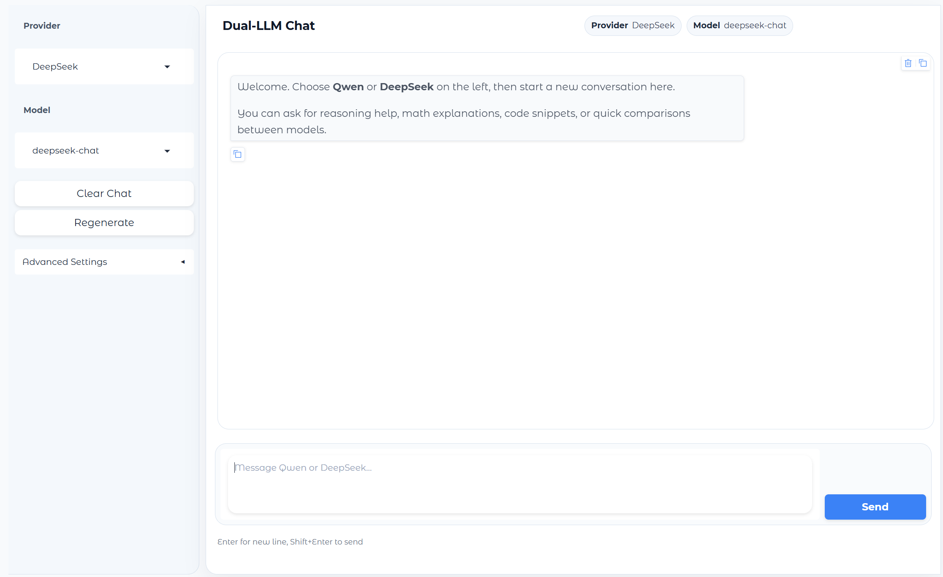
Figure1 Overall interface of the dual-LLM chat system

2.2 Functions of the model selection components
On the left side of the page, we first placed the LLM Provider dropdown, which is used to switch between Qwen and DeepSeek. Right below it is the Model Name dropdown, which automatically updates the available model list according to the selected provider.This linked design makes model switching clearer and also prevents users from choosing a model that does not belong to the current provider.

2.3 Functions of the system prompt and parameter components
The page also contains a System Prompt text box, which is used to control the system-level prompt. Its purpose is to define the overall response style and behavioral boundary of the model. For example, when the default system prompt includes a statement such as “You are a professional math teacher,” the model is more likely to generate professional mathematical explanations and proof steps when handling math-related questions.
In addition, we provided three parameter control components: Temperature, Top-p, and Max Tokens. We used sliders instead of ordinary text boxes because these parameters are numerical values within a range, and sliders are more intuitive. These three components together allow users to actively influence the model’s generation behavior.

2.4 Functions of the chat area components
The core component on the right side of the page is the Chatbot display area. This component is used to show the full conversation between the user and the model, and it is the main area for presenting information. To support the chat scenario, we also added a user input box and a Send button below it. The input box is used to type the current question, and the Send button is used to submit the request.
We also added a Status box to display the current calling status, such as whether the model is streaming output, which provider and model are currently in use, and whether the request has succeeded. The purpose of this component is to strengthen system feedback, so that users know what the system is doing instead of passively waiting without any visible indication.

2.5 Basic chat and multi-turn conversation functions
The first essential feature implemented in the system is the basic chat function. After the user enters a question, the program calls the API of the selected model and displays the generated answer in the chat window. This is the most fundamental capability of the whole application.
On top of this, we also implemented the multi-turn conversation function. In the code, history_state is used to store historical messages. When a new request is sent, the system prompt, conversation history, and current user input are combined into the messages list and then sent to the model. In this way, the model can answer not only the current question but also continue the conversation based on previous context.

2.6 Regenerate and clear history functions
The regenerate response function allows the model to generate a new answer while keeping the last user question unchanged. This function is useful when the user is not satisfied with the current answer and wants to compare another version.
The clear chat history function quickly clears the current conversation and resets the page to its initial state. In this way, users do not need to manually delete old messages when switching to a new testing topic, and previous context will not affect the next round of interaction.

2.7 Copy function and convenience of content reuse
In the chat window, we used the setting buttons=["copy", "copy_all"], which allows the page to support both copying a single message and copying the entire conversation.With copy buttons, users can reuse the generated content much more easily.

2.8 Streaming output function
This experiment also implements the streaming output function, which is a very important interaction improvement. Compared with waiting for the model to return the full result all at once, streaming output displays the content gradually while the model is generating it, so that users can read the answer as it is being produced. The advantage of this design is obvious. On the one hand, it reduces the sense of empty waiting and makes the system feel more responsive. On the other hand, it is closer to the interaction style of mainstream LLM products, so users feel that the interface is more natural rather than freezing for a long time and then showing a complete paragraph at once.

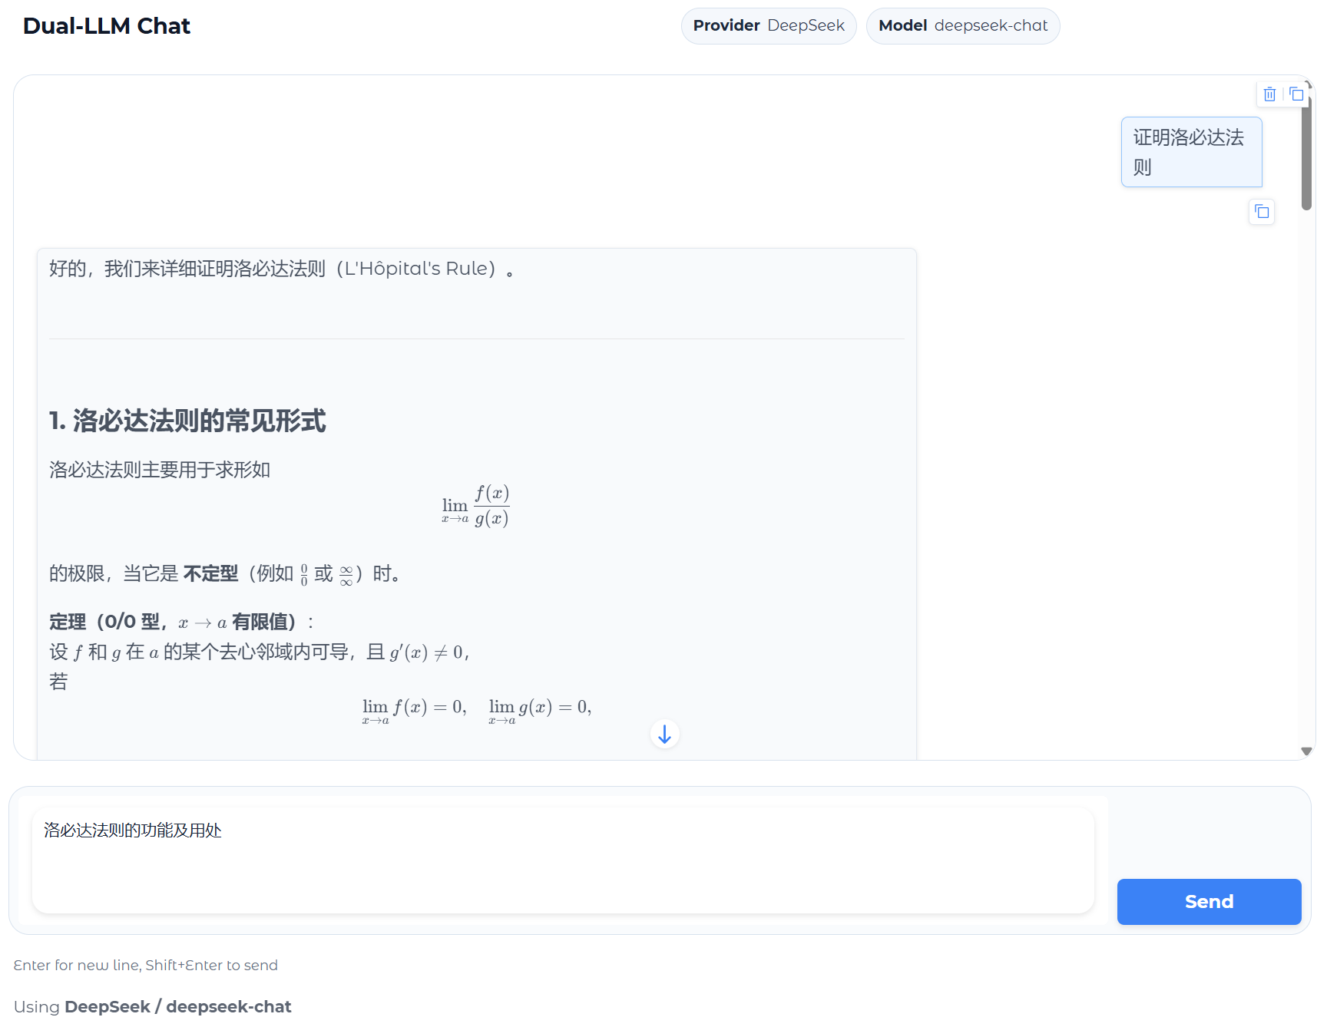
Figure2 Chat interaction with multi-turn conversation and streaming output

2.9 LaTeX mathematical formula rendering
To make the page more suitable for mathematical expressions, we configured multiple latex_delimiters in the Chatbot component, supporting formula formats such as $...$, $$...$$, $...$, and $$...$$. As a result, mathematical formulas generated by the model can be rendered directly on the page instead of appearing as plain text.

2.10 Feedback on thinking time
Another function in the feature list is feedback on the elapsed thinking time. From the perspective of interaction design, the core value of this type of function is that it gives users clearer process feedback, letting them know that the system is not unresponsive but is still processing the request. It enhances the user’s awareness of system status and reduces uncertainty during waiting.

3. The influence of LLM parameters on generated responses

3.1 The effect of Temperature on response style
Temperature is an important parameter that controls the randomness of model output. When the temperature is low, the model tends to choose words and expressions with higher probabilities, so the answer is usually more stable and conservative. This is more suitable for fact-based tasks such as concept explanation, definition description, and basic knowledge question answering. In contrast, when the temperature is high, the model becomes more divergent, and the output is more flexible. It may produce different wording or even different ideas, so it is more suitable for creative generation, open-ended writing, and brainstorming tasks.

3.2 The effect of Top-p on the sampling range
Top-p, also called nucleus sampling threshold, controls how large a range of candidate words the model considers during generation. A smaller top-p value means that the model selects words only from a small high-probability subset, so the result tends to be more focused and reliable. A larger top-p value means that more candidate words are retained, so the output becomes richer, but the uncertainty also increases.

3.3 The effect of Max Tokens on response length
Max Tokens mainly affects the maximum length of the model’s answer. If this value is set too small, the model may only produce a short response, which can lead to incomplete content, especially for questions that require step-by-step explanation or detailed discussion. If it is set larger, the model has enough space to provide a fuller analysis, but this may also result in longer response time and higher token consumption. Therefore, this parameter mainly affects the degree of elaboration and completeness of the answer.

3.4 The practical meaning of combining parameters
In actual use, these parameters do not work independently. Instead, they jointly affect the final output. For example, when both Temperature and Top-p are set relatively high, the model’s expression becomes more flexible and open-ended. When both are set low, the answer is usually more cautious and stable, although it may also sound somewhat rigid.

4. The influence of different prompts on LLM output, and what style of prompting is more suitable for daily use and professional tasks

4.1 Prompts directly influence output quality
Prompts are the core medium through which users communicate with large language models. Different prompt-writing styles directly affect how the model understands the task, what it focuses on, and what format it uses in the answer. For example,If the prompt is vague, the model may still produce an answer, but the result is often too general, lacks clear focus, or has a loose structure. Therefore, a prompt is not just a simple question, but also a way of defining the task and setting constraints.

4.2 Natural and direct prompts are more suitable for daily use
In daily use scenarios, such as asking for common knowledge, doing simple translation, generating ordinary text, or having casual conversation, we would recommend a natural, direct, and low-barrier prompt style. This is because the goals of such tasks are usually clear, and users care more about efficiency and convenience than about highly structured instructions. In this case, it is usually enough to simply state the request clearly, for example, “Please summarize this,” “Explain this in simple language,” or “Help me polish this paragraph.”

4.3 Structured and explicit prompts are more suitable for professional tasks
However, when dealing with professional tasks such as programming, academic writing, mathematical derivation, lab report writing, or complex analysis, we would recommend a structured, informative, and constraint-based prompt style. These tasks usually require higher accuracy, stronger logic, and more controlled formatting. If the user only gives a broad sentence, the model may not fully understand the actual need, and the result may not fit the task well. A better approach is to clearly state the background, objective, required output format, language requirements, and the key aspects that should be emphasized. For example, instructions such as “answer in numbered sections,” “use a formal academic tone,”“ or “keep the proof steps” can all significantly improve the answer quality.

4.4 The overall prompt-writing method we recommend
Overall, we do not think a good prompt should simply be long. Instead, we believe it should be clear, specific, and well-structured. For daily questions, a brief and direct style is usually enough. For professional tasks, it is better to provide more background, define the requirements clearly, limit the format when necessary, and point out which parts the model should focus on. Such prompts are not redundant; rather, they effectively improve the quality of the generated output.

