# 在oracle中将一个表的数据更新到另外一个表中:

update table a

set (a.column) = (select b.column from table b where a.key=b.key and a.key1 = b.key1)

where exists(

select b.column from table b where a.key=b.key and a.key1 = b.key1

)

# 在sqlserver中将一个表的数据更新到另外一个表中:

update table

set column = b.column

from table a ,table b

where a.key = b.key and a.key1=b.key1

# 数据查重

SELECT * FROM (

SELECT ROW_NUMBER()OVER(PARTITION BY key1,key2,key3 ORDER BY XXX ) AS ORDERVIEW ,* FROM table)TB

WHERE ORDERVIEW>1

# oracle – Merge用法

MERGE INTO table_name alias1

USING (table|view|sub_query) alias2

ON (join condition)

WHEN MATCHED THEN

UPDATE table_name

SET col1 = col_val1,

col2 = col_val2

WHEN NOT MATCHED THEN

INSERT (column_list) VALUES (column_values);

# Oracle使用指令备份与还原工具(expdb/impdp)

指令路径在10.2.0\client_1\BIN路径下.

1.创建Directories, create or replace directory dmpdir as 'XXX';其中XXX是系统中正式路径.

2.备份:expdp scott/tiger@orcl schemas=AAA DUMPFILE=expdp.dmp DIRECTORY= dmpdir

注: 用户名/密码@实例 ,如果当前使用的用户没有该文件目录是的使用权需要用指令为该用户添加权限.并且如果当前目录不存在则会报错.

grant read,write on directory dmpdir to scott

备份指令详解:

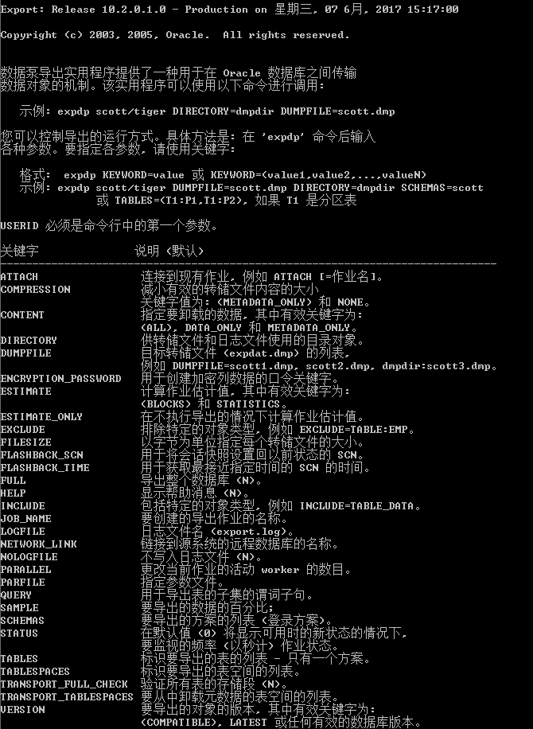

3.还原:impdp scott/tiger schemas=AAA DIRECTORY=dmpdir DUMPFILE=impdp.dmp

