DOCX Watermark Renderer Test

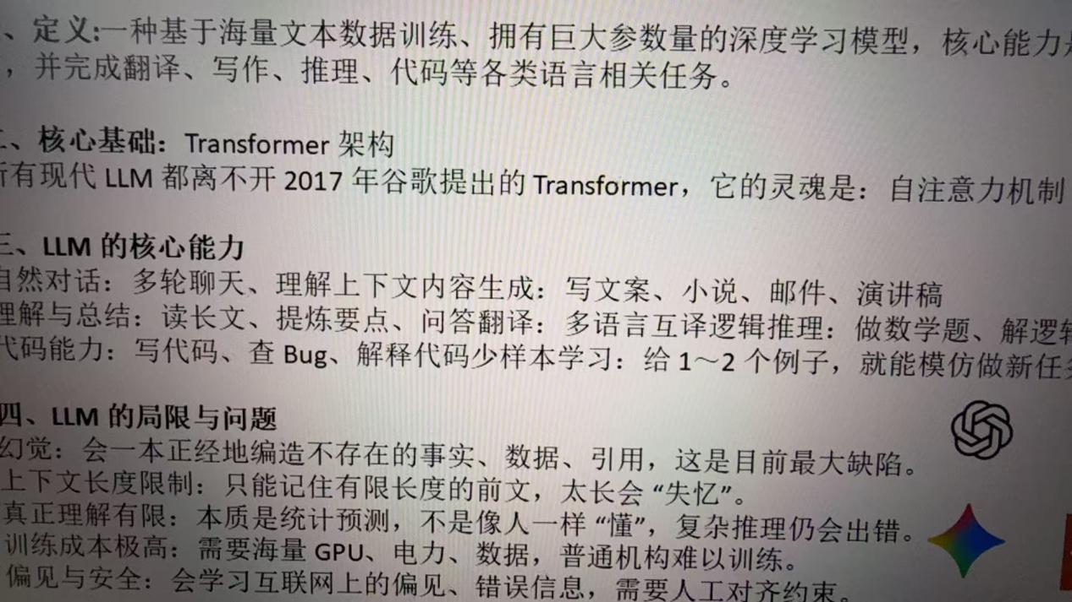

1 | 2
3 | 4

